Sentry – Central Monitoring Station
Part Number | Description |  | Price
8088001 | Sentry is Pima's state-of-the-art stand-alone Central Monitoring Station decoder. The product is based on Pima's extensive experience with cost-effective and sophisticated radio monitoring solutions.  The decoder is supplied in a metal case and can be connected to the Monitoring Management application using serial communication port (RS-232) or network (Ethernet) TCP/IP.  - 2 Radio inputs and 4 PSTN (telephone) inputs  - Basic channel configuration can be remotely upgraded  - TCP/IP (Ethernet) output, 2 RS-232 ports and 4 USB ports  - Signal strength measurement utility; battery backup facility  - Full remote desktop control  - Fine tuning of in/out protocols  - Detailed Event-log storage and display  - PimaGuard application |  | It is necessary to add $650 to Sentinel configuration
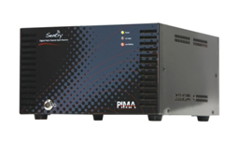 |  |  | It is necessary to add $650 to Sentinel configuration
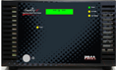 |  |  | It is necessary to add $650 to Sentinel configuration

SENTINEL Monitoring station Decoder
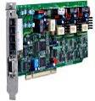 | Combined with a unique driver (Mcard-W) and Management software (like Andromeda) creates a cost-effective Central Monitoring Station (CMS). The same PC card with a different driver can be installed as a “Smart” Repeater System or BTS.  SENTINEL hardware contains a maximum of 2 Radio channels and 4 Telephone lines  SENTINEL hardware supports a maximum of 8,000 subscribers  The Mcard-W driver enables the different features of the SENTINEL hardware and can be ordered in various configuration combinations:  - Central Station, Smart Repeater or BTS  - 1/2 Radio channels and/or 1/2/3/4 Telephone lines  - PAF™ only and/or PAF + other formats  - 500 subscribers or unlimited subscribers  PimaGuard application
SENTINEL (unlimited number of subscribers)
One telephone line, supports various telephone formats |  | 400.00
First radio channel, PAF format only |  | 2000.00
Second radio channel, PAF format only |  | 900.00
Additional radio format |  | 450
SENTINEL Back Up (must be identical to the main station)
One telephone line, supports various telephone formats |  | 350.00
First radio channel, PAF format only |  | 1010.00
Second radio channel, PAF format only |  | 556.00
Additional radio format |  | 450
SENTINEL Junior 2.5 (250 subscribers)
Two telephone lines, support various telephone formats |  | 556.00
One radio channel, PAF format only |  | 800.00
Two radio channels, PAF format only |  | 900.00
Additional radio format |  | 450
SENTINEL Junior 5 (500 subscribers)
Two telephone lines, support various telephone formats |  | 654.00
One radio channel, PAF format only |  | 981.00
Two radio channels, PAF format only |  | 1090.00
Additional radio format |  | 450

Ретранслятор SAR
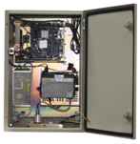 |  | SAR Stand-alone Repeater  For relaying radio reports of alarm systems to a remote Central Station. Communication via various channels, such as radio, network (Ethernet interface), PSTN and cellular.  Housed in a rugged metal box, equipped with AC voltage power supply (110V to 240V) and connector to transceiver, antenna and back-up battery (to be ordered separately). Fully programmable locally (with laptop) and remotely (over internet).
Part Number | Name |  |  | Description |  | Price
8087001 | SAR Stand-alone Repeater |  |  | SAR Stand-alone Repeater for radio to radio/PSTN/ethernet includes one radio chanell with PAF format. |  | 1295.00

BTS Protector
Part Number |  | Description |  |  |  | Price
8520001 |  | Integrated system for intruder protection and remote surveillance of Base Stations of Cellular Communication Providers. A versatile system that includes all the required equipment and can be connected to various additional components.  Call for further details.
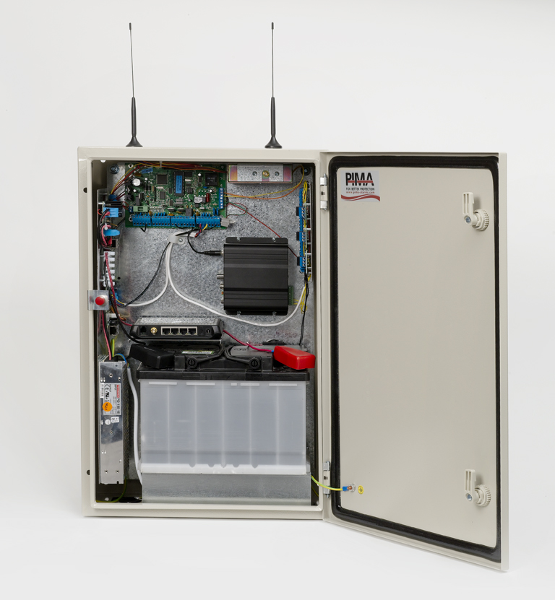

PIMA Professional Software

ANDROMEDA: Central Monitoring Station Management software for Windows (XP/7)
Part Number |  |  | Number of subscribers |  | Price
 |  |  | Up to 50 subscribers |  | Free of charge
 |  |  | Up to 250 subscribers |  | 580.00
4710060 |  |  | Up to 500 subscribers |  | 810.00
4710061 |  |  | Up to 1000 subscribers |  | 1525.00
 |  |  | Up to 1500 subscribers |  | 2160.00
4710062 |  |  | Up to 2000 subscribers |  | 2880.00
 |  |  | Up to 2500 subscribers |  | 3600.00
4710063 |  |  | Up to 3000 subscribers |  | 4320.00
4710064 |  |  | Up to 3500 subscribers |  | 5040.00
4710065 |  |  | Every additional 1000 subscribers |  | 1200.00

