**Hunter-Pro 832/896/8144**

**Captain 8**

**Security Systems**

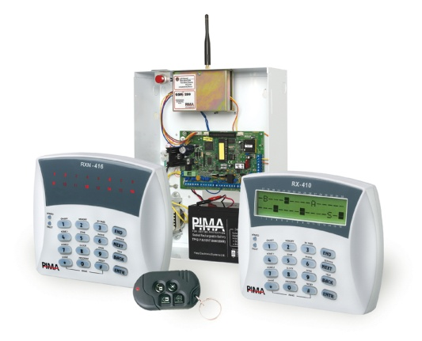

**User Guide**

**Quick Reference**

| **Key** | **Press  for 2 seconds, enter User code and press the key to...** | | **Press the key for 2 seconds**[1]* **to...** |
| --- | --- | --- | --- |
|  | Arm to full mode, disarm | | Quickly arm to full mode* |
|  | Display the log | | - |
|  | Temporarily bypass zones | | - |
|  | Arm to “Home 1” mode | | Quickly arm to “Home 1” mode* |
|  | Display modes menu | | Display the “All Zones” mode for a minute |
|  | Set the telephone numbers | | - |
|  | Arm to “Home 2” mode | | Quickly arm to “Home 2” mode* |
|  | Set time and date | | - |
|  | Set the user codes | | - |
|  | Set the chime per zone | | Turn ON/Off the chime feature in chime zones |
|  | Set auto-arming by day and inactivity | | - |
|  | - | | Reset smoke detectors.  Press briefly: display armed partitions |
|  | - | | Silence the keypad buzzer when it beeps |
|  | Display the system’s name & version | | Display the service provider |
|  | Initiate system tests | | - |
|  | - | | Display the system’s name & version |
| + | | Press for 2 seconds: create Panic alarm | |
| + | | Press briefly: turn ON/OFF the keypad chime | |

**Factory default codes**

Master: 5555

Technician: 1234

**Table of Contents**

1 Introduction 5

1.1 Hunter-Pro & Captain 8 mutual features 5

1.2 Hunter-Pro Series unique features 5

1.3 Captain 8 unique features 6

1.4 Safety & Security 6

1.5 Signs and conventions in this guide 6

1.6 System codes 7

1.6.1 The Master code 7

1.6.2 User codes 7

1.7 The User Menu 7

1.8 The LCD Keypad 7

2 Arming & Disarming the system (Key #1) 8

2.1 Arming 8

2.1.1 Via the keypad 9

2.1.2 Fast arming 9

2.2 Disarming 9

2.2.1 With the DURESS code 9

3 The system Log (Key #2) 10

3.1 Log list sorting options 10

4 Temporarily bypassing open zones (KEY #3) 11

4.1 When arming 11

4.2 Prior to arming 11

5 “HOME 1” & “HOME 2” Arming modes (Keys 4, 7) 12

6 Displaying Types (Key #5) 13

6.1 Fast 32-zone display 13

6.2 Scan open zones 14

6.3 Disable zone displaying 15

6.4 Other displaying types 15

6.4.1 All Zones 15

6.4.2 Bypassed Zones 15

6.4.3 Soaked Zones 16

6.4.4 Chime Zones 16

6.4.5 All Zones Status 16

6.5 Show partition names 17

7 phone Numbers, SMS settings & Dialer test (Key 6) 17

7.1 Phone numbers 17

7.2 SMS messages 18

7.2.1 A demo SMS message 18

7.3 Dialer test 18

8 Setting Time and Date (Key 8) 19

9 Codes (Key 9) 19

9.1 The Master Code 19

9.1.1 Changing the code 19

9.2 User codes 20

9.2.1 Adding or change a code 20

9.2.2 Deleting a code 20

9.3 User name 20

9.4 User settings 21

9.5 Disarming Time Frame 22

9.6 User’s partitions 22

9.7 Adding a key fob 23

9.8 Deleting a key fob 23

9.9 Adding RFID tag/keychain 23

9.10 Deleting RFID Tag 24

9.11 The DURESS code 24

9.12 The Short code 24

9.13 The Door code 24

10 Automatic Arming (Key 9) 25

10.1 By day and hour 25

10.1.1 Inactivity auto-arming 25

11 the chime feature (Key #) 26

11.1 Enabling and disabling the Chime globally 26

12 Other Topics 26

12.1 Partitions 26

12.1.1 Examples 27

12.1.2 Displaying armed partitions 29

12.2 Arming with key, key fob or RFID tag/key chain 29

12.2.1 Arming with a key fob 29

12.3 Enabling Remote Upload 30

12.4 Names and Characters 30

12.4.1 Example 31

12.5 PANIC alarm 31

12.6 Resetting Smoke/Fire/Anti-mask detectors 32

12.7 Turning the keypad chime ON/OFF 32

12.8 Comparison between the Hunter-Pro Series models 32

12.9 Comparison between the Hunter-Pro 896 & Captain 8 32

13 Manual System Tests (BACK key) 33

14 Remote Control via the phone 33

14.1 Basic mode 34

14.2 Full mode 34

14.2.1 Examples 35

15 Troubleshooting 36

16 Appendix: Zone Location Table 38

# Introduction

Congratulations on your purchase of the HUNTER-PRO Series and Captain 8 intruder alarm systems. Much care has been taken in developing these systems, to provide you with unprecedented peace of mind and security. The user-friendly menu with its advanced features will professionally help you to protect your premises.

We recommend reading this guide in its entirely in order to familiarize you with the system and take full advantage of its features.

To assure optimal safety and security, you should perform a system test once a week. See section ‎13 for details.

For any further questions, please contact your local PIMA distributor.

## Hunter-Pro & Captain 8 mutual features

* Hybrid systems with hardwired and wireless zones;
* Operating modes: full or partial, “HOME 1” & “HOME 2”;
* Equipped with menu-driven LCD and Graphic keypads, and cost-effective LED keypads;
* Optional use of partitions for perimeter zones and separate locations;
* Various automatic arming;
* Various codes & access options including RFID tag/keychain and key fob;
* Authorization settings per user;
* Up to four phone numbers to call the Monitoring Station and four to the owner;
* Optional disarming time frame per user;
* Constant zone, battery and phone line testing;
* Communication channels: phone, Long-range Radio, GSM, GPRS, Ethernet;
* Various ways to arm and disarm the system: keypad, key switch, RFID tag/keychain, auto-arming;
* Full wireless detectors supervision;
* Optional alarm voice messages and listen in microphone;
* Various methods for preventing false alarms;
* Full log, part is non-volatile.

## Hunter-Pro Series unique features

* 8 to 32/96/144 zones;
* Up to 32/96/144 user codes and RFID tags;
* Phone remote control;
* Various partitioning options:
* Up to 16 partitions;
* Up to 8 subsystems.

## CAPTAIN-I BOX (Transparent).jpgCaptain 8 unique features

* 8-16 zones;
* Up to 30 user codes & RFID tags;
* Various partitioning options:
* Up to 4 partitions;
* Up to 4 subsystems.

## Safety & Security

|  |  |
| --- | --- |
|  | Both the HUNTER-PRO Series & the Captain 8 systems have been registered in accordance with the EN60950 standard. |

We advise you the following:

* The alarm system as well as its wiring should be placed in a hidden and safe location, protected from rain or moisture.
* The alarm system may have hazards of electric shock and fire. Do not try to open the alarm system’s case: dangerous high voltages are present inside it. Refer servicing to qualified personnel only.
* This alarm system should be used with 230VAC 50Hz, protected by anti-electric shock breaker. To prevent electric shocks and fire hazards, do NOT use any other power source.

## Signs and conventions in this guide

|  |  |
| --- | --- |
| ☞ | Press a key briefly |
|  | Press a key for 2 seconds, until confirmation beep sounds |
|  | Warning |
|  | Note |
|  | In programming mode, moves the cursor to the right. |
|  | In programming mode, moves the cursor to the left. |
|  | Enter, Save |
|  | In programming mode, enables (‘+’) or disables (‘-‘) a parameter; erase character. |
|  | Press briefly: Cancel; Return. Press for 2 seconds: Silence the keypad chime in faults. |
|  | The numbers that are printed above and below the keypad’s screen stand for zone numbers and partition numbers. |

## System codes

### The Master code

* The Master code is a super user code with all the access authorizations.
* It is mainly used for changing the “Master Code” itself.
* The default factory Master Code is 5555.

|  |  |
| --- | --- |
|  | Replace the default Master code immediately after installation to prevent unauthorized and illegal operations. |

### User codes

* The User code is the user’s ID. It includes the User details, access authorizations, disarming time frame and it is reported and logged together with any action the User is taking.
* A User code can be restricted to only parts of the user menu, i.e., can only set these menus.

### Short Code

* A convenient, 2-digit code used only for arming the system.

### Duress Code

* A code for using in distress situations.
* Entering the code disarms the system when armed and generates a silent alarm to the Monitoring Station (if one is a subscriber) and to your phone.
* The code is a 4-6 digit code.

## The User Menu

* The User menu is where parameters such as Time & Date, User codes and User authorizations are set.
* It is accessed by pressing  for 2 seconds and entering a User code. See section ‎9.4 for restrictions.
* By default, entering a User code arms or disarms the alarm system (toggle mode). The Installer can program the system, so entering the code displays the User menu.
* After entering the User menu, the sub-menus are accessed directly, by pressing the keypad keys. Each key menu is printed above it, e.g. “Time”, “Codes”.

## The LCD Keypad

* RXN-400, RXN-410 and RXN-410 RFID are PIMA’s LCD keypads. They are designed for maximum simplicity and durability and present decorative design.   
  The RXN-400 & RXN-410 are identical, except for their screen size: 410’s is larger.
* The screen is made of 2 lines with 16 characters in each. The upper line displays the time and the date (depending on the display type). Both lines display data regarding the system, such as events, faults and zone status.

|  |  |
| --- | --- |
|  | * Up to 8 supervised keypads can be connected to the system simultaneously. * The message “Other Keypad in Use” is displayed when another keypad is in use, or when the system is remotely controlled. |

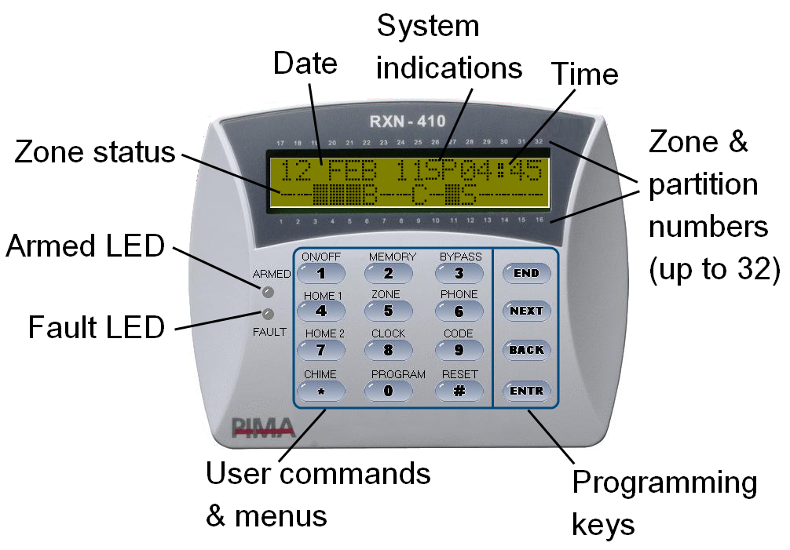

1. RXN-410 with the “Fast” display type

# Arming & Disarming the system (Key #1)

* The system can be armed in one of 4 ways:

1. Via the keypad;
2. Automatically;
3. Using Key fob, key switch and RFID tag/keychain;
4. In Hunter-Pro only: by a remote control and via the phone.

* As a rule, arming should be carried out only when all the zones are closed, but those on the exit route, and there are no alarms (e.g., fire, panic) or faults (e.g., low battery):
* In the “Fast zone” display type, no zone is indicated with a rectangle _ ;
* In the “Scan open zones” display type, no zone is indicated with “OP” (open).
* Zones like exit doors and areas near the keypad are delayed on the exit and the entry, so whoever arms (or disarms) the system will have enough time to walk from the keypad to the door, (or the other way, when entering) without triggering any detector.
* The Exit & Entry delay times are separate and programmed by the Installer. The Installer can also program two different Entry delays to different zones.

## Arming

* To arm your system, enter a user code (see section ‎9.4 for restrictions) or the Short code (a code programmed by the Installer. See section ‎9.12).
* If no zone is open and there are no faults, the Exit delay countdown starts, the keypad buzzer sounds beeps and the green ARMED LED flashes**.** You can now exit the premises and close the door behind you[2].
* When the Exit delay ends, the system becomes armed: the green ARMED LED stops to flash and stays on, the beeps stop, the message “System Armed” is briefly displayed and then the date and time are displayed.

### Via the keypad

☞ User code ...

* The Exit delay time span is set by the Installer.

### Fast arming

  until the Exit delay starts **-OR-**  Short code ...

* Fast/single keystroke arming must be enabled by the Installer.
* To set the Short code, see section .

## Disarming

☞ User code … 

* To disarm the system, enter a user code.
* If an “Access denied” message is displayed, the user may be trying to disarm it outside her/his “Disarming time frame”. See section

### With the DURESS code

☞ DURESS code … 

* The DURESS code is a code to be used in threat situations, where you are being forced to disarm the system. Hence, the code can be used only for disarming.
* Entering the DURESS code disarms the system and sends a silent alarm to the Monitoring Station (if you are subscribed to) and your phones.
* To set the code, refer to section ‎9.3.

# The system Log (Key #2)

  User code         

* The system logs alarms, arming & disarming, zone bypassing, faults, code changing and other actions, chronologically.
* Any action taken by a user is logged with the User name.
* Part of the log is non-volatile (see the table on page 32).

## Log list sorting options

* A log entry contains, on the upper line, a serial number and the date & time stamp when the entry (i.e., the event) was logged; the event details appear on the bottom line.
* The log has 4 list sorting options: “All the events”, which displays all the log entries in one list, “Faults only”, “Zone alarms” and “Arming/disarming”.
* When you view one of these lists, pressing a number between 0-3, transforms to corresponding list: 0-“All the events”, 1-“Faults only”, 2-“Zone alarms”, 3-“Arming/disarming”.
* Entry example: “Burglary” alarm in zone #4, called “Kitchen”; the two screens are displayed intermittently.



# Temporarily bypassing open zones (KEY #3)

|  |  |
| --- | --- |
|  | * Bypassing zones reduces the safety of your protected premises: a bypassed zone does not sound the alarm when violated, nor does it report the Monitoring Center! * It should be used carefully, only if there is no alternative and only for the shortest possible time. * If you bypass a zone due to a fault, a service technician should be called; * Beware not to bypass zones unintentionally; * Zones can be bypassed only when the system is disarmed; |

* Temporarily bypassed zones are automatically reinstated when the system is disarmed.
* The letter “B” in “Fast zone display" mode indicates a bypassed zone.
* A service technician can permanently bypass a zone, such in the case of a zone that no longer needs to be protected

## When arming

☞ User code  to temporarily bypass the open zone/s  .... **-OR-** to cancel arming 

* When you try to arm the system and a 24-hour zone[3] is open, the keypad sounds beeps and the message “Open Zone! Press END or Bypass”, with the zone/s details, is displayed in two intermittently changing screens.
* If you do not cancel arming or bypass the open zones, when the Exit delay ends the system will be armed, but the open zones instantly sound the alarm.
* Exit delayed zones are such, so they can be left open until the EXIT delay time ends.

## Prior to arming

* You can temporarily bypass zones in advance of arming the system.

|  |  |
| --- | --- |
|  | As a precaution, there is a time limit, set by the Installer, for a zone to be bypassed prior to arming. When this time ends and the system has not been armed yet, the zone is automatically reinstated. |

* To temporarily bypass a zone prior to arming:

  User code    zone number  … approval message is displayed.

* For example: 

|  |  |
| --- | --- |
|  | Be aware that a zone is bypassed immediately and stays so, until the system is disarmed the next time (unless bypass limit time is over). |

* To reinstate a bypassed zone:  
    User code    zone number  … approval message is displayed.
* For example: 

# “HOME 1” & “HOME 2” Arming modes (Keys 4, 7)

* “HOME 1” and “HOME 2” are arming modes, in which only some zones are armed, while others are not: while the armed zones sound the alarm if violated, the disarmed zones can be occupied at the same time.
* Common applications for the Home modes are perimeter detectors and nighttime zones.
* The zones included in each Home mode are set by the Installer and require no hardware installation.
* Arming to the Home modes is much like arming to full mode, and there is fast arming option too.
* To arm to “HOME 1” mode: 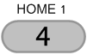   User/Short code   
  
* To arm to “HOME 2” mode:   User/Short code



* To arm to the Home modes via the User menu:   User code  for “Home 1” or  for “Home 2”.
* The Exit delay for both Home modes can be cancelled by the Installer.

# Displaying Types (Key #5)

 User code        



* Your keypad has few options for displaying information on zones, alarms, faults etc.
* There are two basic displaying types: single screen and scrolling.
* Other types display various information for a minute, before they return to one of the basic types.
* Zone names are programmed by the Installer.

## Fast 32-zone display

 User code   

* This display type is best used in systems with up to 32 zones. Each line displays 16 zones.
* The zones are displayed in a single screen, with their status represented by signs and letters.
* Each sign appears next to the related zone number, which is printed above & bellow the keypad screen. See .
* If the number of zones is no more than 16, information in the top line includes time, date and system status. If the system is configured with more than 16 zones, this information will not be displayed, but the other 16 zones.



1. Fast zone mode with 16 zones

* The system indicators on the top line (between the time and the date) are:

| **Indicator** | **Description** |
| --- | --- |
| **P** | The system is communicating or testing the phone line |
| **T** | The system is communicating over the Radio |
| **R** | The RELAY output is active |
| **S** | The SIREN output is active |

* The zone status indicators are:

| **Indicator** | **Description** |
| --- | --- |
| **-** | Closed (not triggered) zone |
| **_** | Open (triggered) zone. If the zone has more than one status (e.g., it is open and alarming), the indications are displayed intermittently. |
| **A** | Alarmed zone: the zone was violated when the system was armed, or is alarming now. |
| **B** | Bypassed zone |
| **C** | Chime zone |
| **F** | Zone failure (disconnection) or a TAMPER switch is open |
| **L** | Low battery in a wireless detector |
| **O** | Opened 24-hour zone or armed partition. Press  to display the armed partitions. |
| **S** | Short in the zone's wires |
| **T** | The zone is in soak (test) mode |
| **V** | A wireless detector is not responding |

## Scan open zones

  User code    



* The system continuously scans the zones and the system’s status, and displays open zones, faults and alarms.
* The information is displayed in scrolling mode.
* For example:



* The zones’ status indicators are:

| **Indicator** | **Description** |
| --- | --- |
| **OP** | Open zone |
| **AL** | The zone was violated when the system was armed, or is alarming now. |
| **BP** | Bypassed zone |
| **FL** | Zone Cut |
| **SH** | Zone Short |
| **SV** | Zone supervision |
| **LB** | Wireless zone low battery |
| **AM** | Anti-mask zone |

## Disable zone displaying

  User code   X2  

* The zones’ status is not displayed, only alarms and faults (if there are any).

## Other displaying types

*  to the next displaying types.
* The other types display various information. After pressing the information is displayed for a minute.
* See the display types menu in the beginning of section ‎6.

### All Zones

  User code  X3  zone number  repeatedly

* The properties of every programmed zone - name, partitions and type - are displayed when pressing repeatedly.

### Bypassed Zones

  User code  X4  to display other bypassed zones **- OR -**  repeatedly to display the zone’s name, partitions and type.

* Permanently and temporarily bypassed zones are displayed in this type.
* Permanently bypassed zones are set by the Installer.
* Temporarily bypassed zones will be automatically reinstated the next time the system is disarmed.

### Soaked Zones

  User code  X5  to display other soaked zones **- OR -**  repeatedly to display the zone’s name, partitions and type.

* A zone is set as Soak (test) zone by the Installer/Service technician, when it is repeatedly faulty.
* Soak zones, as well as soak period (up to a week), are set by the Installer/Service technician.
* Soak zones are automatically reinstated when the soak period is over.

### Chime Zones

  User code  X6  to display other chime zones **- OR -**  repeatedly to display the zone’s name, partitions and type.

* Chime zones trigger the keypad chime when opened.

### All Zones Status

  User code   X7 

☞ .... 

* This type is intended to display the status of all the programmed zones quickly.
* It is design the same as the “Fast zone” type, 10 zones in each line, and 20 in every screen. See section ‎6.1 for details on the signs.
* In the above screenshots, the first screen displays the status of zones 1 - 10 and 11 - 20. Statuses for example are:
* Zone #1: chime zone.
* Zones #2-3: closed zones.
* Zones #4-6: open zones.
* Zone #7: chime zone.
* Zone #8: bypassed zone.
* Zones #9-10: closed zones.
* Zone #12: zone fault.
* Zone #15: zone activated the siren.
* Zone #22: chime zone.
* Zone #34: bypassed zone.

## Show partition names

  User code    

* This is a toggle display type: when it is enabled, the names of the partition/s (see section ‎12.1 for details) this keypad is allocated to, are constantly displayed.
* To disable this mode, repeat the process.
* This mode requires the “Scan Open Zones” display mode to be selected first.

# phone Numbers, SMS settings & Dialer test (Key 6)

  User code    

* Key #6 has three sub-menus:
* “Edit Numbers”, to set your phone numbers for receiving alarms and other messages from the system;
* “SMS Settings”, to set which of your phones will receive SMS messages instead of alarm messages;
* “Test dialer”, for testing the numbers you have programmed (without triggering the sirens);

## Phone numbers

  User code   phone #1  or ....



* The HUNTER-PRO Series & the Captain 8 have an integrated phone dialer, that can call up to 4 numbers and sound an alarm, or send SMS alert or sound a recorded message.
* When an alarm is set off, the dialer attempts to call each number twice (i.e., a total of 8 attempts) [4].; when the call is answered, the system sounds a Hi/Lo siren, or a voice message[5].
* To set a number, enter it and 
* To use “+”, “*”, “#” and “P” for one second delay:  repeatedly
* The dialer aborts the dialing attempts in the following cases:
* The system is disarmed.
* All numbers were dialed, each number twice (i.e., no call was answered).
* In HUNTER-PRO Series only, a remote control command is received. See section ‎14.1.

## SMS messages

  User code       to select a number (set it to “+”).  to move to the next numbers.

* Text messages are an alternative way for you to receive alarms and faults reports.
* The numbers 1-4 stand for the corresponding phone numbers.
* A phone number that is set here to receive SMS messages will not receive the siren alarm.
* For example,  phone #2 will receive SMS messages.
* Sending SMS messages requires the purchasing of the SMS-100 module or the GSM-200 cellular module.

### A demo SMS message

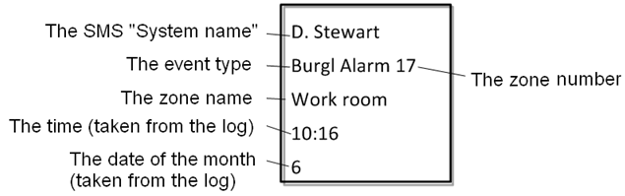

* The details in the SMS messages are all taken from the system log.
* In this figure, the time and date indicate when the event was registered in the log, and not when the message was sent.

## Dialer test

  User code      (//) ... ......

* Use the Dialer test menu to check the programmed phone numbers.
* Press a number between 1 and 4 to call the corresponding programmed number.
* If a call is not received, check that the number is correct; if it is, call a service technician.
* During the test, the system displays the communication process, as displayed above.

# Setting Time and Date (Key 8)

  User code   time in the following format: hh:mm    date in the following format: dd:mm:yy   

*  / to move to the left and right.
* To correct data,   and start over.
* You must keep the system’s clock accurate at all times, for maintaining a detailed log and for functions such as user disarming time frame.
* If the clock is not set, a “Clock Not Set” error is displayed and the keypad beeps.

# Codes (Key 9)

* Codes in the Hunter-Pro Series and Captain 8 systems are made of 4-6 digits (except for the Short code).
* Duplicate codes or codes that start with same two digits as the Short code are not allowed.
* Codes are concealed with asterisks and cannot be revealed or restored in any way.

## The Master Code

|  |  |
| --- | --- |
|  | The default Master (5555) should be replaced immediately after installation (see how in this section). |

* The Master code is a super user code, with all access authorizations. See section ‎1.6.1 for more details.
* Its main use is changing the Master code itself.

### Changing the code

☞ Master code        4-6 digits number 

* The “Master code” menu is visible only when entering the User menu with the Master code.
* Therefore, to change the code, you can only use the Master code.
* When entering the User menu with a User code and pressing “9”, the “User Codes” menu is displayed.

## User codes

* See section ‎1.6.2 for details about user codes.

### Adding or change a code

  User code     
User number      4-6 digit number 



* An asterisk (*) appears to the right of the user’s name, notes the user code has been assigned to this user. For example, “Linda” is user number 16:  
  

### Deleting a code

  User code       
User number    



* Once a code is deleted, the asterisk is deleted too and the code is available to be used for another user.

## User name

  User code     user number  X2     
name (up to 8 characters)  



## User settings

  User code     user number  X3   

*  / to move to the left and right.
*   to set to “+” or “-” (toggle mode): “+” means the user is authorized to perform this action; “-” means the user is NOT authorized to perform this action.
*   to save.
* The user settings determine the user authorizations to enter menus and change data, or receive system information.
* Each letter stands for a different authorization. The letters and authorizations are:

| **Letter** | **Onscreen** | **Set to “+”, so the user will be…** |
| --- | --- | --- |
| **U** | Code Programming | Authorized to set/change user codes |
| **T** | Tel. Programming | Authorized to set/change phone numbers |
| **C** | Date Programming | Authorized to set/change time and date |
| **M** | Memory view | Authorized to view the memory log |
| **B** | Zone Bypass | Authorized to temporary bypass zones |
| **K** | Use any Keypad | In a system that uses partitions, the user can use any keypad, regardless of the partitions the keypad is assigned to (by the Installer). |
| **A** | Auto-arming Prog | Authorized to set/change the auto-arming time |
| **O** | OP/CL Report-SMS | Authorized to receive SMS reports, anytime the system is armed and disarmed |
| **R** | Remote control | In Hunter-Pro Series only, authorized to control the system remotely, via the phone |
| **W** | RFID tag + Code | Required to enter the user code, when disarming with RFID tag/keychain (as a precaution). |

* If a user tries to enter a menu it is not authorized to, an “Access Denied” message is displayed.

## Disarming Time Frame

  User code     user number  X4     start and end time, in the following format: hh:mm 

*  / to correct data.
* A user can be limited to disarm the system only inside a time frame. Arming, however, is not restricted.
* If the user tries to disarm the system in any other time, the message “Access Denied! Press END” is displayed and the system remains armed.
* For example, the user “James D.” can disarm the system only between 07:30-09:30:

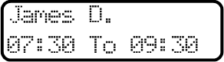

## User’s partitions

  User code      user number   X5    in Hunter-Pro Series in Captain 8    
Set to which partitions the user will be assigned to  



*  / to move to the left and right.
*   to assign the user to a partition (set to “+”), or cancel its assignment (set to “-”).
*   to save.
* Setting a letter to “+” means, the user is authorized to arm and disarm that partition.
* Setting a partition to “-” means, the user will NOT be able to arm and disarm that partition.
* The partition’s number is printed on the keypad, bellow the screen.
* There can be up to 16 partitions in Hunter-Pro Series, 4 in Captain 8. See section ‎12.1 for details about partitions.
* To enable a user to control its partitions from any keypad (and not just the keypads that are assigned to the partitions its assigned to), see parameter “K” in the “User Settings”, section ‎9.4.

## Adding a key fob

  User code       user number   X6   press one of the Key fob’s buttons .... 



* The key fob is assigned per user, so any use of it is logged under the user code.
* The letter “K” in the user code screen indicates that the User has a key fob assigned to it. For example, Martha is assigned with a key fob: 
* The use of the key fob is subject to the user’s settings. See section ‎9.4.
* For more details on key fobs, see section ‎12.2.

## Deleting a key fob

  User code       user number   X7  ....  



## Adding RFID tag/keychain

  User code       user number   X8  

Bring the keychain or tag near the left side of the RFID keypad (where the RFID reader is located, inside. See the next illustration), until a confirmation message “TAG Received! Press END” is displayed  

* The letter “A” in the user code screen indicates that an RFID tag/keychain is assigned to that user. For example, 
* To force the user to enter its code when it disarms the system using an RFID tag/keychain, see the “User Settings” in section ‎9.4.

## Deleting RFID Tag

  User code       user number   X9  

## The DURESS code

  User code  X2  4-6 digit number 

* For details on the DURESS code, see section ‎2.2.1.

## The Short code

  User code   X3   2 digit number 



* The Short code is a 2-digit arming only code.
* Entering the code sets off the Exit delay, after which the system is being armed.

## The Door code

  User code    X4    4-6 digit number 



* The door code is mainly used for opening electric doors and gates, but can be used to set off anything that is triggered by a RELAY.

# Automatic Arming (Key 9)

* The Hunter-Pro Series & Captain 8 systems offer two ways to arm the system to full mode automatically: by day and hour, or by lack of activity.
* Automatic arming can be used once a day only.

## By day and hour

  User code  

☞ the time for the auto-arming in the following format hh:mm **-OR-**     
set a different day 

* You can set the system to be automatically armed every day, at a certain hour.
* At this time, a special 45 seconds delay will start and the keypad will sound beeps. When the delay ends, the normal Exit delay will start and then the system will be armed to full mode.
* The Installer can program the system, so the auto-arming will arm the system to “Home 1” mode instead of full.

### Inactivity auto-arming

  User code    inactivity time in minutes (up to 250)   set the partitions that will be armed 

*  / to move to the left and right.
*  to select a partition (set to “+”), or deselect it (set to “-”).
*   to save.
* The system can be automatically armed, after a period, in which no detector was activated, i.e., the premises is probably vacant and the alarm system was not armed.
* This feature can help you ensure, that the premises will always be armed when it is no longer occupied, e.g., during the night.
* This feature can be set per partition, so some partitions can be armed automatically, while others are not.
* When “Inactivity to Arming” time is due, the partitions that are about to be armed (or are already armed) are displayed as “X”, above the partition’s number. See the next example.
* A sample auto-arming countdown screen: “45” is the auto-arming delay; “X” are partitions that are either armed or about to be armed automatically: 2, 7-9.   
  
* When the auto-arming delay ends, the Exit delay starts, after which the system is armed.

|  |  |
| --- | --- |
|  | The Installer can enable auto-arming with open zones and faults. |

# the chime feature (Key #)

  User code    zone number :



☞ to assign the chime to the zone **-OR-**

☞ to cancel a zone assignment

* The chime helps supervising the opening of doors and windows by sounding a series of beeps, anytime one of them is opened.
* This feature is especially useful with small children in the house and in shops.
* The chime is active only when the system is disarmed.
* The letter “C” in the “Fast zone” display type indicates the chime is assigned to that zone.

## Enabling and disabling the Chime globally

* Pressing the  key for 2 seconds enables and disables (toggle mode) the chime globally, to all the chime zones.
* A verification message, “Chime ON”/“Chime OFF”, is displayed.

# Other Topics

## Partitions

* A partition (or sub-system) is a logic or physical area, made of several zones, e.g., a separate compound, a house floor, an office, a perimeter zone.
* A partition can be armed, while others (i.e., other zones) are not. In this way, only those zones that are allocated to the armed partition/s will activate the alarm, when they are opened; zones outside the armed partitions can be occupied at the same time.
* Partitions are programmed by the Installer.
* There can be up to 16 partitions in Hunter-Pro Series and 4 in Captain 8.
* Monitored keypads can also be assigned per partition.
* Users can also be allocated to partitions, i.e., control (e.g., arm & disarm) only some of the zones.

### Examples

Example A: private premises, single keypad

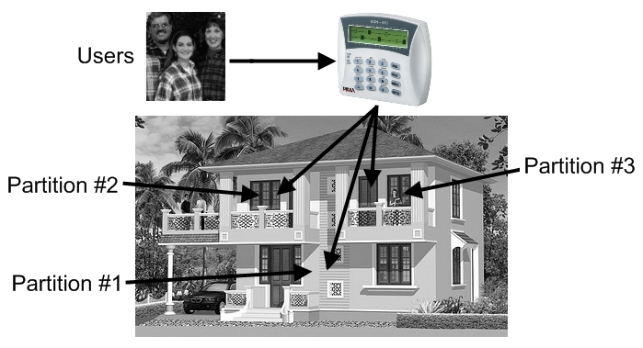

1. Implementing partitions - Example A[6]

* In this example, a single keypad controls all 3 partitions
* The users are all assigned to all 3 partitions and can therefore control them all.

|  |  |
| --- | --- |
|  | A user can control several partitions using a single code. |

Example B: private premises, 3 keypads

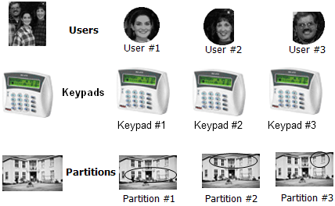

1. Implementing partitions - Example B

* The system is divided into partitions, each controlled by a separate keypad. The users have authorization levels based on partition/s, e.g., user 12 can only control Partition #3 & #14.
* Every keypad displays the status of its assigned partitions only.

Example C: variable options[7]

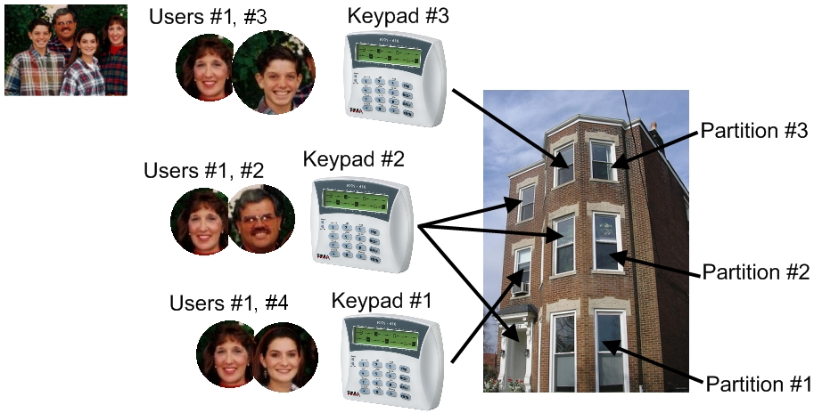

1. Implementing partitions - Example C

* In a 3 floors building, the first floor is defined as Partition #1, the second as Partition #2 and the third as Partition #3. There are 3 users and 3 keypads, with different authorization levels:
* User #2 is authorized to use all three keypads;
* User #4 is authorized to use only keypad #1, which controls and displays partition #2 only;
* Users #1 & #2 are authorized to use only Keypad #2 which controls and displays all 3 partitions;
* User #3 is authorized to use only keypad #3 which controls and displays partition #3 only;

Example D: office compound



1. Implementing partitions - Example D

* A compound is made of 16 offices; each is located in a separate room. Each room is assigned as a partition and can be controlled by different users, remote controls, key switches and RFID tags.
* The single keypad in this example will display the status of all partitions, though the users will only be able to control their authorized partition/s.
* A detector located at the entrance and allocated to all partitions protects the entrance, as soon as all partitions are armed. This detector will be disarmed as soon as the first partition is disarmed.

Example E: business installation

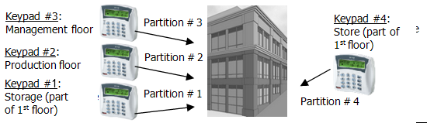

1. Common application for partitions

* The headquarters of a company is divided into 4 departments: each has its own keypad, employees, working hours, etc.
* The employees (i.e. users) can have access only to their department/partition, or to several.

### Displaying armed partitions

* The Installer can enable the displaying of the status of the partition.
* Armed partitions are displayed with “X”, above the corresponding number.



## Arming with key, key fob or RFID tag/key chain

* You can arm your system using key switch, key fob and RFID tag/keychain.
* The three accessories are assigned per user.
* A key switch requires no other module and is used mostly in businesses.
* Key fobs require the installation of a wireless module, the I/O-WN that supports up to 24 key fobs. The module can be purchased from your Installer.
* RFID tags and key chains require the use of RFID keypad. The keypad can be purchased from your Installer. Depending on your system model, up to 32/96/144 RFID users can be supported.

### Arming with a key fob

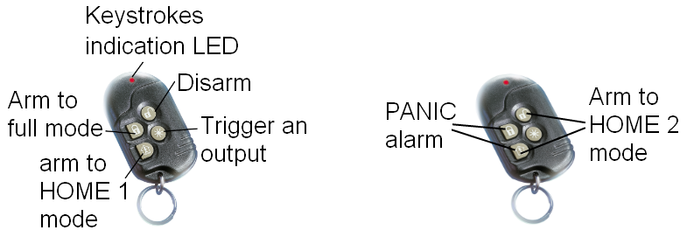

1. The MCT-234 key fob

* The Visonic MCT-234 key fob has 4 push buttons. Pushing each button, or a combination of two, performs the next actions:

|  |  |
| --- | --- |
| **Action** | **Push button/s** |
| Arm to full mode |  |
| Arm to “Home 1” mode |  |
| Arm to “Home 2” mode | + |
| Disarm |  |
| Generate PANIC alarm | + |
| Trigger one of the system’s outputs (to open a gate, turn on a spotlight, etc.) |  |

* Up to 24 key fobs can be assigned to users.

## Enabling Remote Upload

* Your alarm system can be uploaded (i.e. programmed) remotely, by a service technician, over the phone line or the network.
* For security reasons, this feature is disabled by default. If the technician needs to use it, you have to approve it.
* To do so: just before the technician calls the system, enter the Master code (only the

Master code can enable it) and press  twice.

## Names and Characters

* Names and characters are entered the same way as in cell phones: each key has letters and characters associated with it.

|  |  |
| --- | --- |
|  | * A Username can have up to 8 characters. * Each arming & disarming is registered in the memory log along with the user name, date and time (see section ‎3). |

* The number of keystrokes determines which character is selected.
* To enter some characters using the same key, wait 2 seconds between each keystroke.
* For example, key  is used for typing the letters M, N, O and number 6. To select “M”, press the key once; to select “O”, press the key three times.
* See the keys and their associated characters in the next table.

|  | **Keystrokes** | | | | | | | | |
| --- | --- | --- | --- | --- | --- | --- | --- | --- | --- |
| **Key** | **1** | **2** | **3** | **4** | **5** | | **6** | **7** | **8** |
| **[1]** | . | , | ? | ! | 1 | |  |  |  |
| **[2]** | A | B | C | 2 |  | |  |  |  |
| **[3]** | D | E | F | 3 |  | |  |  |  |
| **[4]** | G | H | I | 4 |  | |  |  |  |
| **[5]** | J | K | L | 5 |  | |  |  |  |
| **[6]** | M | N | O | 6 |  | |  |  |  |
| **[7]** | P | Q | R | S | 7 | |  |  |  |
| **[8]** | T | U | V | 8 |  | |  |  |  |
| **[9]** | W | X | Y | Z | 9 | |  |  |  |
| **[0]** | Space | 0 |  |  |  | |  |  |  |
| **[*]** | ( | ) | / | * | : | | - | + | # |
| **[#]** | Uppercase/Lowercase letters (toggle) | | | | | | | | |
| **[END]** | Cancel/Return to previous screen without saving | | | | | | | | |
| **[NEXT]** | Next character | | | | |  | | | |
| **[BACK]** | Previous character | | | | |  | | | |
| **[ENTR]** | Select/Save | | | | |  | | | |

### Example

* The following demonstrates writing the word “KITCHEN”:

| **Key** | **Keystrokes** | **Character** | ☞ |
| --- | --- | --- | --- |
| **[5]** | 2 | **K** |  |
| **[4]** | 3 | **I** |  |
| **[8]** | 1 | **T** |  |
| **[2]** | 3 | **C** |  |
| **[4]** | 2 | **H** |  |
| **[3]** | 2 | **E** |  |
| **[6]** | 2 | **N** |  |

## PANIC alarm

  + 

* To manually generate a PANIC alarm, press and hold for 2 seconds (until a confirmation tone is sounded), the Asterisk and the Hash Keys.
* PANIC alarm is immediately reported to the Monitoring Station (if you are a subscriber) and your phones.
* In addition to activating the sirens, the Installer can set the system to response in various ways.

## Resetting Smoke/Fire/Anti-mask detectors

* Smoke, Fire and Anti-mask detectors need to be reset if they are activated.
* They can be reset automatically or manually. To manually reset them:   (press and hold the hash key for 2 seconds, until a confirmation tone is sounded).

## Turning the keypad chime ON/OFF

☞  + 

* Pressing these keys together turns the keypad’s chime ON/OFF (toggle mode).
* Note that turning the chime off disables vocal indication of faults and opening Chime zones.
* The chime is set separately in each keypad.
* To silence the chime in case of faults,  

## Comparison between the Hunter-Pro Series models

|  |  |  |  |
| --- | --- | --- | --- |
| **Feature** | **Hunter-Pro** | | |
| **832** | **896** | **8144** |
| Zones (8 basic) | 32 | 96 | 144 |
| Users | 32 | 96 | 144 |
| Partitions | 16 | 16 | 16 |
| Wireless zones | 24 | 32 | 32 |
| Key fobs | 24 | 24 | 24 |
| Memory total  of which non-volatile | 500  250 | 500  250 | 999  512 |

## Comparison between the Hunter-Pro 896 & Captain 8

| **Feature** | **Captain 8** | **Hunter-Pro** |
| --- | --- | --- |
| Zones (using expanders | 16 | 96 |
| Zone doubling (of the onboard zones) | √ | √ |
| Keypads | 8 | 8 |
| Partitions | 4 | 16 |
| EXP-PRO | - | √ |
| I/O-8N/PS | 1 | 11 |
| I/O-16/PS | - | 5 |
| Outputs  of which onboard | 12  3 | 58  7 |
| OUT-1000 | - | √ |
| I/O-R | 1 | 4 |
| I/O-WN  Wireless zones  Key fobs | √  8  24 | √  32  24 |
| Users | 30 | 96 |
| RFiD tags | 30 | 96 |
| VVR devices | 1 | 4 |
| Events Log  of which non-volatile | 160  128 | 500  250 |

# Manual System Tests (BACK key)

☞ Master code  ……… .

* The system constantly tests the backup battery, the voltage and the phone line. However, you can perform a manual test too.
* A manual test is reported to the Monitoring Station.
* If the tests fail, the following messages appear:   
   and/or 



|  |  |
| --- | --- |
|  | If your alarm system is connected to a Monitoring Station via Ethernet or GPRS, some additional test screens are displayed. |

# Remote Control via the phone

|  |  |
| --- | --- |
| RX-410 (ENG).jpg | * Remote control is not available in Captain 8. * This section refers to Hunter-Pro Series only. |

* The Hunter-Pro Series alarm system can be remotely controlled via any touchtone or cellular phone.
* A remote control call can be initiated by both calling the panel and receiving a call from the panel.
* There are two modes to remote control (they are set by the Installer):
* Basic mode: includes arming, disarming, deactivating the sirens, and more. That’s the default mode;
* Full mode: includes the basic mode and in addition, activating RELAY switches.

## Basic mode

* To control the system remotely:

1. Call the phone number to which the system is connected (or pick a call from the system).
2. Wait for a confirmation tone: a long tone followed by 2 beeps.
3. Dial the Master code or authorized User code (see section ‎9.4);
4. Wait for a status tone:

|  |  |
| --- | --- |
| Continuous: The system is disarmed; | |
| Beeps: The system is armed; | |
|  | | **The system does not recognize phone commands (tones) while sounding the confirmation tone. Therefore, you must wait until the confirmation tone is over, before pressing any phone key.** | |

1. Dial a number, according to the next table. The panel confirms every command with two beeps.

|  |  |
| --- | --- |
| **Dial** | **Action** |
| 0 | Stop the external siren and the dialer |
| 1 | Arm the system |
| 2 | Disarm the system (if enabled by the technician) |
| 4 | Arm the system to “Home 1” mode |
| 5 | Switch on the onboard relay |
| 6 | Switch off the onboard relay |
| 7 | Arm the system to “Home 2” mode |
| 8 | Listen in for one minute (using MIC-200). Any more press will extend the listen in time in one minute |

|  |  |
| --- | --- |
|  | * While the system is communicating, the message “Other keypad in use” is displayed on all the keypads. * If the panel does not receive any command for a period of 60 seconds, it disconnects the call. It then remains in standby mode (with the above message displayed on the keypads) for another 60 seconds, before the message disappears. * During listen in, all other remote control commands are disabled. |

## Full mode

* To control the panel in full mode:

1. Repeat steps 1-4 in the previous Basic mode section.
2. To trigger an output, press [*] and the corresponding command, as listed in the following tables.
3. To deactivate an output, press [#] and the corresponding command from the following tables.

|  |  |  |  |  |  |  |  |  |  |  |  |  |  |  |  |  |  |  |  |  |  |  |  |  |  |  |  |  |  |  |  |  |  |  |  |  |  |
| --- | --- | --- | --- | --- | --- | --- | --- | --- | --- | --- | --- | --- | --- | --- | --- | --- | --- | --- | --- | --- | --- | --- | --- | --- | --- | --- | --- | --- | --- | --- | --- | --- | --- | --- | --- | --- | --- |
| |  |  | | --- | --- | | **General** | | | **Command** | **Dial** | | Turn off the external siren and stop the dialer | *00 | | Arm the system | *01 | | Disarm the system | #01 | | Arm to “Home 1” mode | *04 | | Arm to “Home 2” mode | *07 | | Start listen in for 1 min. | *08 | | | |  |  | | --- | --- | | **System’s outputs** | | | **Output** | **Dial** | | Ext. SIREN | 11 | | Int. SIREN | 12 | | RELAY | 13 | | SMOKE | 14 | | ON/OFF | 15 | | ALARM | 16 | | AUDIO Ctrl | 17 | |  |
| |  |  | | --- | --- | | **RELAYs on I/O-8N zone expanders** | | | **I/O-8N** | **Dial** | | 1 | 31 | | 2 | 32 | | 3 | 33 | | 4 | 34 | | 5 | 35 | | 6 | 36 | | 7 | 37 | | 8 | 38 | | 9 | 39 | | 10 | 40 | | 11 | 41 | | 12 | 42 | | 13 | 43 | | 14 | 44 | | 15 | 45 | | 16 | 46 | | |  |  |  |  |  | | --- | --- | --- | --- | --- | | **I/O-R RELAY expanders** | | | | | | **Expander no. 1** | |  | **Expander no. 3** | | | **RELAY no.** | **Dial** |  | **RELAY no.** | **Dial** | | 1 | 51 |  | 1 | 67 | | 2 | 52 |  | 2 | 68 | | 3 | 53 |  | 3 | 69 | | 4 | 54 |  | 4 | 70 | | 5 | 55 |  | 5 | 71 | | 6 | 56 |  | 6 | 72 | | 7 | 57 |  | 7 | 73 | | 8 | 58 |  | 8 | 74 | |  | |  |  | | | **Expander no.** **2** | |  | **Expander no. 4** | | | **RELAY no.** | **Dial** |  | **RELAY no.** | **Dial** | | 1 | 59 |  | 1 | 75 | | 2 | 60 |  | 2 | 76 | | 3 | 61 |  | 3 | 77 | | 4 | 62 |  | 4 | 78 | | 5 | 63 |  | 5 | 79 | | 6 | 64 |  | 6 | 80 | | 7 | 65 |  | 7 | 81 | | 8 | 66 |  | 8 | 82 | | | |
| |  |  | | --- | --- | | **Send SMS message with the system status to your phones** | | | **Phone no.** | **Dial** | | 1 | 91 | | 2 | 92 | | 3 | 93 | | 4 | 94 | | | |  |

### Examples

Activate the ‘Ext. SIREN’ output:  
Dial the panel’s phone number 🡪 the panel picks up the call 🡪 wait for the confirmation tone to end 🡪 dial the Master code 🡪 wait for command confirmation tone to end 🡪 dial *11

Deactivate RELAY#2 in I/O-R #2:

Dial the panel’s phone number 🡪 the panel picks up the call 🡪 wait for the confirmation tone to end 🡪 dial the Master code 🡪 wait for command confirmation tone to end 🡪 dial #60.

# Troubleshooting

* Faults are indicated by the flashing red LED in the keypad, a description of the fault is displayed, the buzzer sounds beeps and the system logs it. In addition, the service technician can set the system to report it to the Central Monitoring Station, to send an alert by the telephone, to trigger an output and more.
* If more than a single fault occurs, the display will scroll between them.
* Unless instructed otherwise, call a service technician when the system reports on faults.

| **Fault** | **Description and troubleshoot** |
| --- | --- |
| Low Battery | Occurs after a prolonged power failure or when the battery is outdated. If the fault lasts more than one day, or there was no previous power failure, call a service technician. |
| Mains Fault | Appears during a power failure. |
| Clock Not Set | Appears following a prolonged power failure during which the backup battery was completely discharged. Set time and date (see page 19). |
| Phone Line Fault | Perform phone line test (see on page 33). Make sure no other telephone appliance is using the line. If the fault persists, call a service technician. |
| Tamper 1 | Tamper switch 1 is open. |
| Tamper 2 | Tamper switch 2 is open. |
| Expander X Tamper | Expander X’s box or tamper is open. |
| Expander X Fault | Expander X is faulty. |
| EXP X Voltage | Low voltage to the I/O-8N zone expander. |
| Expander X Mains | Expander X has no Mains voltage. |
| Expander X Batt | Expander X has low battery fault. |
| Keypad X Tamper | Keypad X’s tamper switch is open. |
| Low Voltage | Appears before the backup battery is completely discharged, usually during a prolonged power failure. Call a service technician immediately! |
| Wireless Z Fault | A wireless detector (zone) is faulty (no supervision signal). |
| MS COM Fault | Failure to communicate with the Central Monitoring Station over the phone. |
| KEYPAD NOT CONNECTED | No communication between the keypad and the control panel. |
| GSM Unit Fault | The GSM-200 module cannot be detected or is faulty. |
| GSM Link Fault | GSM limited or no reception. |
| GSM Comm. Fault | GSM communication failure with Central Monitoring Station #1. |
| GSM Comm. 2 Fault | GSM communication failure with Central Monitoring Station #2. |
| SIM Card Fault | SIM card is not detected or is faulty. |
| Wireless System | I/O-WN module cannot be detected or is faulty. |
| W/L Unit Tamper | I/O-WN box tamper is open or faulty. |
| Other keypad in use | Other keypad is in use or the system is remotely controlled via the telephone. |
| Check Keypad Number | The keypad’s ID is not configured properly. |
| Keypad X Fault | Keypad X is faulty. |
| Zone Fault | A zone (include. Wireless zone) is tampered or faulty. **Possible tampering!** |
| Detec Vol. Fault | Detector voltage is faulty due to **possible tampering**. Call a service technician immediately! |
| SMS Com. Failure | SMS communication fault. |
| Install SMS Unit | No SMS unit is detected or the unit is faulty. |
| Network Fault | Network communication with the Central Monitoring Station is faulty. |
| IO-R X Fault | The I/O-R relay expander is faulty. |
| IO-R X Tamper | The I/O-R relay expander tamper is open. |
| IO-R X Voltage | Low voltage in the I/O-R relay expander. |
| IO-R X Mains | IO-R X has no Mains voltage. |
| IO-R X Batt | IO-R X has low battery. |
| Wireless Jamming | The wireless receiver (I/O-WN) is jammed. |
| Supervision | A wireless detector “life signal” has not been received. |
| Int. siren fault | The internal siren is faulty. |
| Ext. siren fault | The external siren is faulty. |
| Video X fault | Communication fault between the panel and the video unit VVR #X. |
| Video X power fault | Voltage fault in VVR #X. |
| net4pro fault | Communication fault between the panel and the net4pro network card. |

# Appendix: Zone Location Table

|  |  |  |  |  |  |  |  |  |  |  |  |  |  |  |  |  |  |  |  |  |  |  |  |  |  |  |  |  |  |  |  |  |  |  |  |  |  |  |  |  |  |  |  |  |  |  |  |  |  |  |  |  |  |  |  |  |  |  |  |  |  |  |  |  |  |  |  |  |  |  |  |  |  |  |  |  |  |  |  |  |  |  |  |  |  |  |  |  |  |  |  |  |  |  |  |  |  |  |  |  |  |  |  |  |  |  |  |  |  |  |  |  |  |  |  |  |  |  |  |  |  |  |  |  |  |  |  |  |  |  |  |  |  |  |  |  |  |  |  |  |  |  |  |  |  |  |  |  |  |  |  |  |  |  |  |  |  |  |  |  |  |  |  |  |  |  |  |  |  |  |  |  |  |  |  |  |  |  |  |  |  |  |  |  |  |  |  |  |  |  |  |  |  |  |  |  |  |  |  |  |  |  |  |  |  |  |  |  |  |  |  |  |  |  |  |  |  |  |  |  |  |  |  |  |  |  |  |  |  |  |  |  |  |  |  |  |  |  |  |  |  |  |  |  |  |  |  |  |  |  |  |  |  |  |  |  |  |  |  |  |  |  |  |  |  |  |  |  |  |  |  |
| --- | --- | --- | --- | --- | --- | --- | --- | --- | --- | --- | --- | --- | --- | --- | --- | --- | --- | --- | --- | --- | --- | --- | --- | --- | --- | --- | --- | --- | --- | --- | --- | --- | --- | --- | --- | --- | --- | --- | --- | --- | --- | --- | --- | --- | --- | --- | --- | --- | --- | --- | --- | --- | --- | --- | --- | --- | --- | --- | --- | --- | --- | --- | --- | --- | --- | --- | --- | --- | --- | --- | --- | --- | --- | --- | --- | --- | --- | --- | --- | --- | --- | --- | --- | --- | --- | --- | --- | --- | --- | --- | --- | --- | --- | --- | --- | --- | --- | --- | --- | --- | --- | --- | --- | --- | --- | --- | --- | --- | --- | --- | --- | --- | --- | --- | --- | --- | --- | --- | --- | --- | --- | --- | --- | --- | --- | --- | --- | --- | --- | --- | --- | --- | --- | --- | --- | --- | --- | --- | --- | --- | --- | --- | --- | --- | --- | --- | --- | --- | --- | --- | --- | --- | --- | --- | --- | --- | --- | --- | --- | --- | --- | --- | --- | --- | --- | --- | --- | --- | --- | --- | --- | --- | --- | --- | --- | --- | --- | --- | --- | --- | --- | --- | --- | --- | --- | --- | --- | --- | --- | --- | --- | --- | --- | --- | --- | --- | --- | --- | --- | --- | --- | --- | --- | --- | --- | --- | --- | --- | --- | --- | --- | --- | --- | --- | --- | --- | --- | --- | --- | --- | --- | --- | --- | --- | --- | --- | --- | --- | --- | --- | --- | --- | --- | --- | --- | --- | --- | --- | --- | --- | --- | --- | --- | --- | --- | --- | --- | --- | --- | --- | --- | --- | --- | --- | --- | --- | --- | --- | --- | --- | --- | --- | --- | --- | --- | --- | --- | --- | --- | --- | --- |
| |  |  |  | | --- | --- | --- | | **No.** | **Zone** | **Location** | |  |  |  | |  |  |  | |  |  |  | |  |  |  | |  |  |  | |  |  |  | |  |  |  | |  |  |  | |  |  |  | |  |  |  | |  |  |  | |  |  |  | |  |  |  | |  |  |  | |  |  |  | |  |  |  | |  |  |  | |  |  |  | |  |  |  | |  |  |  | |  |  |  | |  |  |  | |  |  |  | |  |  |  | |  |  |  | |  |  |  | |  |  |  | |  |  |  | |  |  |  | |  |  |  | |  |  |  | |  |  |  | |  |  |  | |  |  |  | |  |  |  | |  |  |  | |  |  |  | |  |  |  | |  |  |  | |  |  |  | |  |  |  | |  |  |  | |  |  |  | |  |  |  | | |  |  |  | | --- | --- | --- | | **No.** | **Zone** | **Location** | |  |  |  | |  |  |  | |  |  |  | |  |  |  | |  |  |  | |  |  |  | |  |  |  | |  |  |  | |  |  |  | |  |  |  | |  |  |  | |  |  |  | |  |  |  | |  |  |  | |  |  |  | |  |  |  | |  |  |  | |  |  |  | |  |  |  | |  |  |  | |  |  |  | |  |  |  | |  |  |  | |  |  |  | |  |  |  | |  |  |  | |  |  |  | |  |  |  | |  |  |  | |  |  |  | |  |  |  | |  |  |  | |  |  |  | |  |  |  | |  |  |  | |  |  |  | |  |  |  | |  |  |  | |  |  |  | |  |  |  | |  |  |  | |  |  |  | |  |  |  | |  |  |  | |
| |  |  |  | | --- | --- | --- | | **No.** | **Zone** | **Location** | |  |  |  | |  |  |  | |  |  |  | |  |  |  | |  |  |  | |  |  |  | |  |  |  | |  |  |  | |  |  |  | |  |  |  | |  |  |  | |  |  |  | |  |  |  | |  |  |  | |  |  |  | |  |  |  | |  |  |  | |  |  |  | |  |  |  | |  |  |  | |  |  |  | |  |  |  | |  |  |  | |  |  |  | |  |  |  | |  |  |  | |  |  |  | |  |  |  | |  |  |  | | |  |  |  | | --- | --- | --- | | **No.** | **Zone** | **Location** | |  |  |  | |  |  |  | |  |  |  | |  |  |  | |  |  |  | |  |  |  | |  |  |  | |  |  |  | |  |  |  | |  |  |  | |  |  |  | |  |  |  | |  |  |  | |  |  |  | |  |  |  | |  |  |  | |  |  |  | |  |  |  | |  |  |  | |  |  |  | |  |  |  | |  |  |  | |  |  |  | |  |  |  | |  |  |  | |  |  |  | |  |  |  | |

Installer Details:

Name: ________________________ Phone: ____________________________

Cellular: ___________________________

Company: ­­­­­­­­­­­­­­­­_________________________________________________________

Phone no.: _________________________

Date of installation: Day _____ Month _____ Year _______

End of service: Day _____ Month _____ Year _______

P/N 4410250 XX en B (Dec-2007)

PIMA Electronic Systems Ltd. does not represent that its product may not be compromised and/or circumvented, or that the Product will prevent any death, personal and/or bodily injury and/or damage to property resulting from burglary, robbery, fire or otherwise, or that the Product will in all cases provide adequate warning or protection. The User understands that a properly installed and maintained equipment may only reduce the risk of events such as burglary, robbery, and fire without warning, but it is not insurance or a guarantee that such will not occur or that there will be no death, personal damage and/or damage to property as a result.

PIMA Electronic Systems Ltd. shall have no liability for any death, personal and/or bodily injury and/or damage to property or other loss whether direct, indirect, incidental, consequential or otherwise, based on a claim that the Product failed to function.

Please refer to a separate warranty statement found on PIMA website at:

<http://www.pima-alarms.com/site/Content/t1.asp?pid=472&sid=57>

**Warning:** The user should follow the installation and operation instructions and among other things test the Product and the whole system at least once a week. For various reasons, including, but not limited to, changes in environment conditions, electric or electronic disruptions and tampering, the Product may not perform as expected. The user is advised to take all necessary precautions for his/her safety and the protection of his/her property.

This document may not be duplicated, circulated, altered, modified, translated, reduced to any form or otherwise changed; unless PIMA’s prior written consent is granted.

All efforts have been made to ensure that the content of this manual is accurate. Pima retains the right to modify this manual or any part thereof, from time to time, without serving any prior notice of such modification.

Please read this manual in its entirety before attempting to program or operate your system. Should you misunderstand any part of this manual, please contact the supplier or installer of this system.

Copyright © 2011 PIMA Electronic Systems Ltd. All rights reserved.

PIMA Electronic Systems Ltd.

5 Hatzoref Street, Holon 58856, Israel

Tel: +972.3.6506414

Fax: +972.3.5500442

Email: [support@pima-alarms.com](mailto:support@pima-alarms.com)

Web: <http://www.pima-alarms.com>

Partner’s website: <http://www.pima-alarms.com/site/modules/login.asp>

4410280

*4410280*

Version : B2, XX en, September 2011

1. * Commands marked with an asterisk must be enabled by the Installer.
2. The Exit delay countdown can start immediately as soon as the final door is closed. Refer to the Installer.
3. 24-Hour zones sound the alarm whenever they are violated, regardless of the system status.
4. SMS messages are sent only once to each number.
5. This feature requires the purchasing of the VU-20 voice module.
6. Published under ‘Creative Commons’ license (source: <http://www.flickr.com/photos/axiomestates/3081558445/>)
7. Published under Creative Commons license (source: [http://awkwardfamilyphotos.com/wp-content/  
   uploads/2009/07/shari-awkward-plaid-family-photo.jpg](http://awkwardfamilyphotos.com/wp-content/uploads/2009/07/shari-awkward-plaid-family-photo.jpg))