**DSS Platform Initialization User’s Manual**

**V1.3.0**

Table of Contents

1 Installation and Connections 1

1.1 Check Unpacked Device 1

1.2 Front Panel 1

1.3 Rear Panel 3

2 Initialization Setup 5

2.1 System Time and IP Address 5

2.2 Master/Slave Mode 6

**Welcome**

Thank you for using our DSS platform!

This initialization user’s manual is designed to be a reference tool for the installation and operation of your system.

Before installation and operation please read the following safeguards and warnings carefully!

Please keep it for future reference!

**Important Safeguards and Warnings**

**1．Electrical safety**

All installation and operation here should conform to your local electrical safety codes.

We assume no liability or responsibility for all the fires or electrical shock caused by improper handling or installation.

**2．Transportation security**

Heavy stress, violent vibration or water splash are not allowed during transportation, storage and installation.

**3．Installation**

Keep upwards. Handle with care.

Do not apply power to the device before completing installation.

Do not place objects on the device.

**4．Qualified engineers needed**

All the examination and repair work should be done by the qualified service engineers.

We are not liable for any problems caused by unauthorized modifications or attempted repair.

**5．Environment**

The device should be installed in a cool, dry place away from direct sunlight, inflammable, explosive substances and etc.

This series product shall be transported, storage and used in the specified environments.

**6. Lithium battery**

Improper battery use may result in fire, explosion, or personal injury!

When replace the battery, please make sure you are using the same model!

**7. Accessories**

Be sure to use all the accessories recommended by manufacturer.

Before installation, please open the package and check all the components are included.

Contact your local retailer ASAP if something is broken in your package.

# Installation and Connections

**Note: All the installation and operations here should conform to your local electric safety rules.**

## Check Unpacked Device

When you receive the device from the forwarding agent, please check whether there is any visible damage. The protective materials used for the package of the device can protect most accidental clashes during transportation. Then you can open the box to check the accessories.

Please check the items in accordance with the list. Finally you can remove the protective film of the device.

## Front Panel

The front panels of DSS are shown as below. See and .

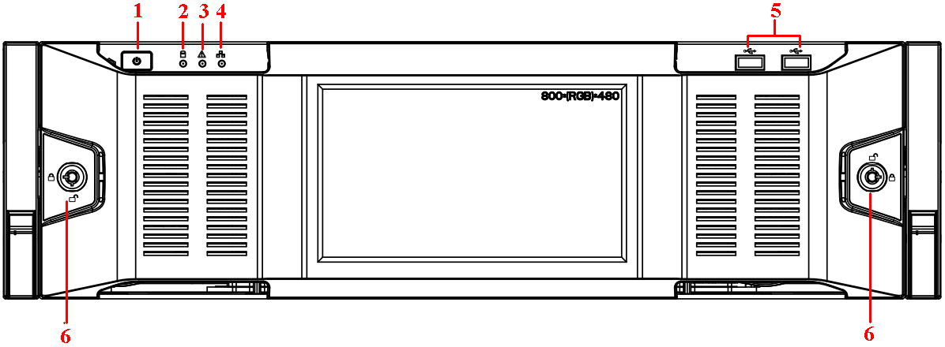

Figure 1- Front Panel 1 (7016)

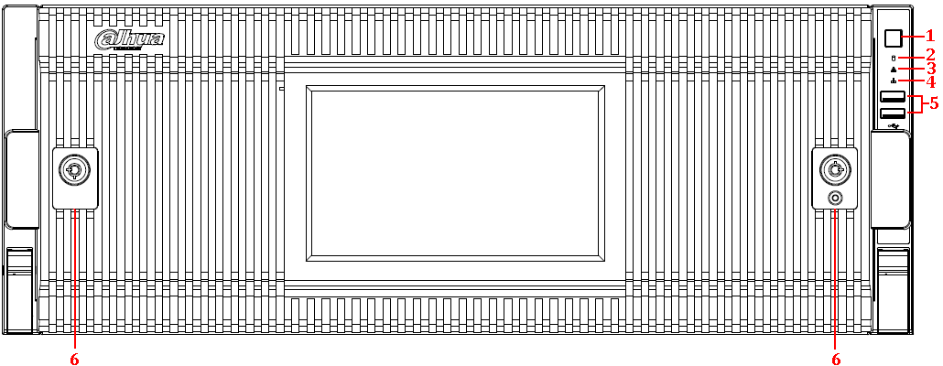

Figure 1- 2 Front Panel 2 (7024)

Please refer to the following sheet for front panel button information.

|  |  |  |
| --- | --- | --- |
| SN | Name | Function |
| 1 | Power button | Press it once to turn on the device.  Press it for a long time to turn off the device. (**Usually we do not recommend**).  Press power button for a long time or pull out the power cable may result in device auto restart. |
| 2 | System HDD Indicator light | The blue light flashes when system is reading or writing the system HDD.  In the system HDD, there are device important configuration file, factory default configuration file, and device initial boot up data. |
| 3 | Alarm Indicator light | The alarm Indicator light becomes on once an alarm occurred. It becomes on via the software detection. The alarm includes local alarm, no disk and etc. |
| 4 | Network Indicator light | The network Indicator light is blue and it flashes when you connect the device to the network. |
| 5 | USB port | / |
| 6 | Front panel lock | / |

After you remove the front panel, see and Figure 1- 3 Front Panel 3 (7016 with 16HDDs)and . Insert first HDD into system. You can see there are two indication lights on the HDD bracket. The power indicator light is at the top. The light is yellow after you connected the device to the power. The read-write indicator light is at the bottom. The blue light flashes when system is reading or writing the data.

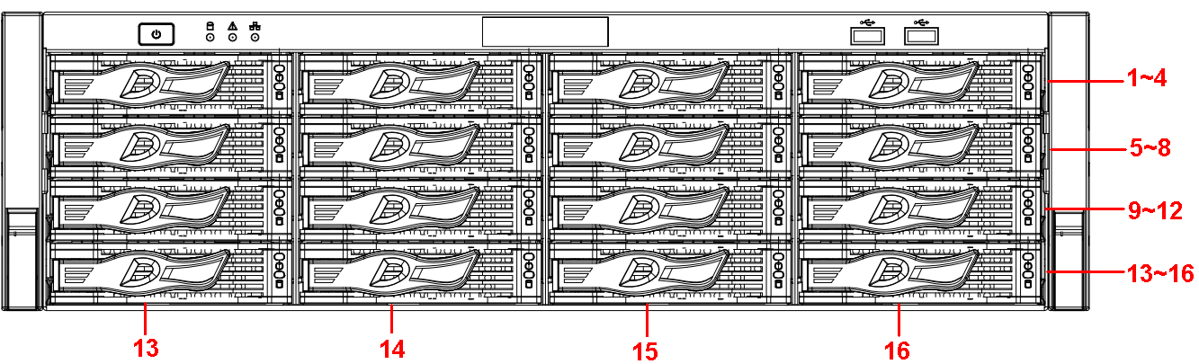

Figure 1- 3 Front Panel 3 (7016 with 16HDDs)

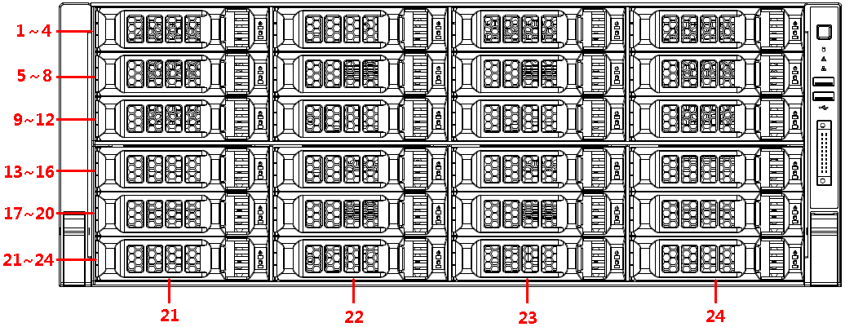

Figure 1- 4 Front Panel 4 (7024 with 24HDDs)

## Rear Panel

The rear panels of DSS are shown as in.

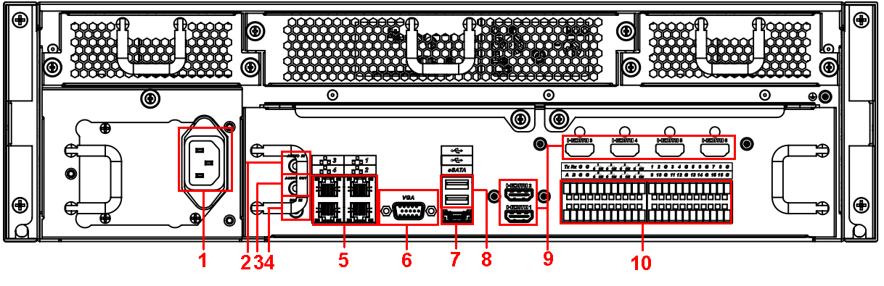

Figure 1- 5 Rear Panel 1 (7016)

Please refer to the following sheet for rear panel button information.

|  |  |  |  |
| --- | --- | --- | --- |
| SN | Function | SN | Function |
| 1 | Power socket | 6 | Video VGA output |
| 2 | Audio input | 7 | eSATA port |
| 3 | Audio output | 8 | USB port |
| 4 | Bidirectional talk input | 9 | HDMI port |
| 5 | Network port | 10 | Alarm input, alarm output, RS485 port. |

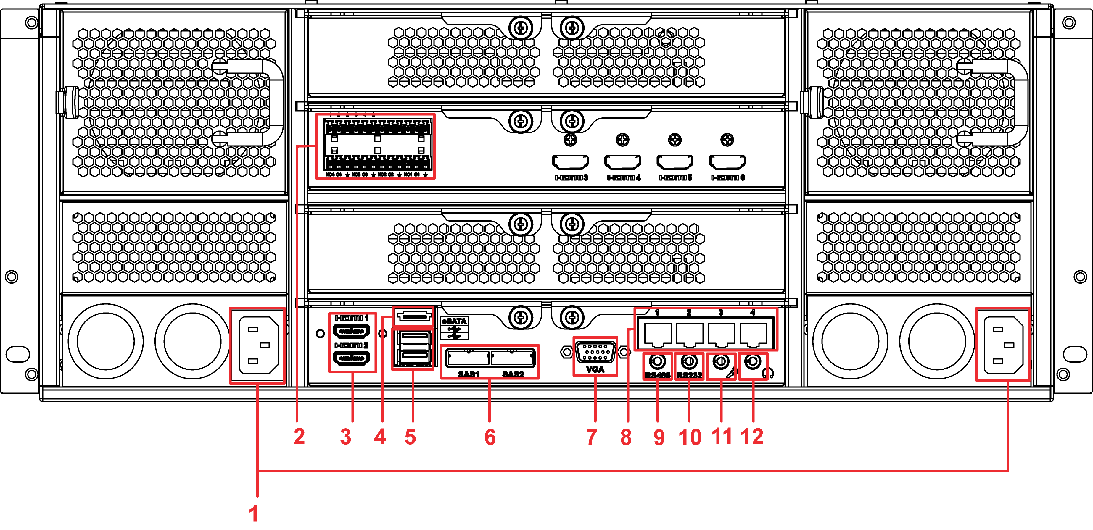

Figure 1- Rear Panel 2 (7024 dual power)

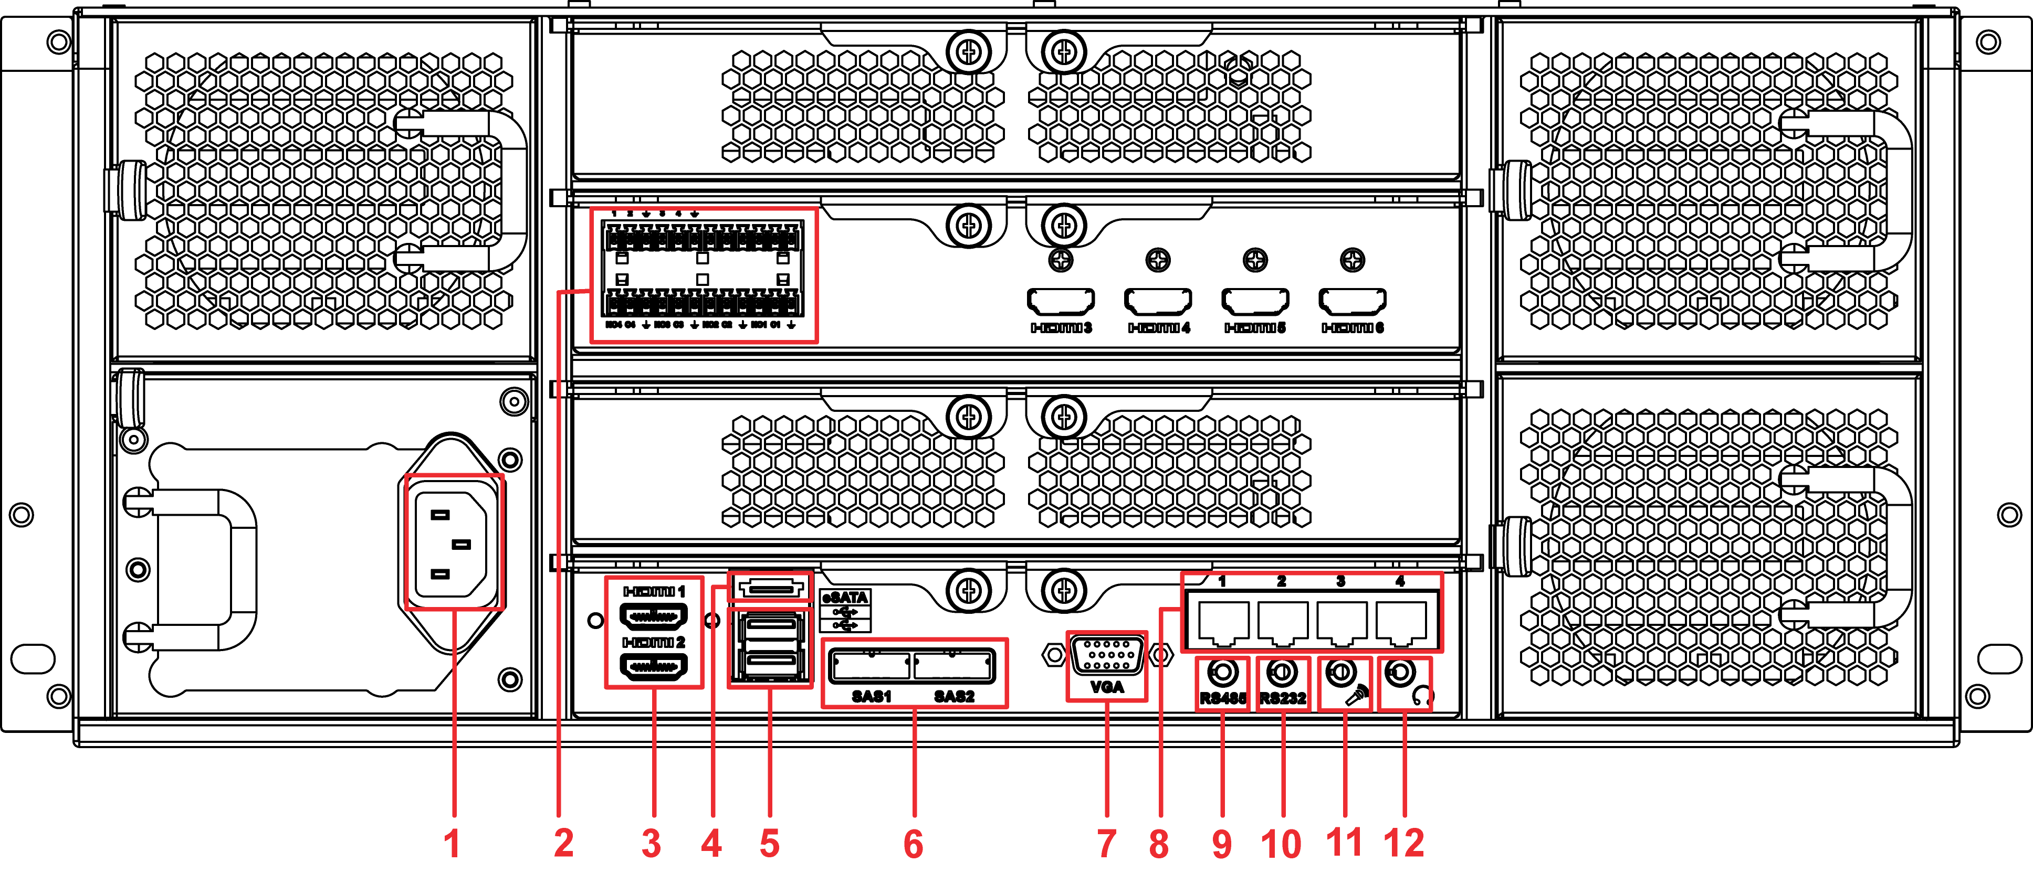

Figure 1- Rear Panel 3 (7024 single power)

Please refer to the following sheet for rear panel button information.

|  |  |  |  |
| --- | --- | --- | --- |
| SN | Function | SN | Function |
| 1 | Power socket | 7 | Video VGA output |
| 2 | Audio input, audio output | 8 | Network port |
| 3 | HDMI port | 9 | RS485 port |
| 4 | eSATA port | 10 | RS232 port |
| 5 | USB port | 11 | Audio input |
| 6 | HDD port | 12 | Audio output |

# Initialization Setup

Before you use the platform, please follow the steps listed below to set system time, IP address, master/slave mode and etc. of DSS.

## System Time and IP Address

Before you use the platform, please set system time, IP address and etc.

1. Take the device out of the package.
2. Open the accessories bag and then take out the disk (system disk).
3. Install the system disk to the first slot. See .

**Note**

* Do not install the storage disk on the first slot.
* We **STRONGLY** recommend the enterprise class disk. We are not liable for any problem (such as data loss) resulting from the HDD instability.
* Please use the HDDs of the same brand and of the same space specifications.

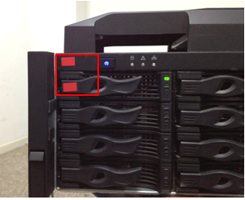

Figure 2-

1. Connect the network cable and power cable. Boot up the device. Now you can see system pops up the startup wizard after it boots up.
2. Click Next button, system pops up the General interface. See .

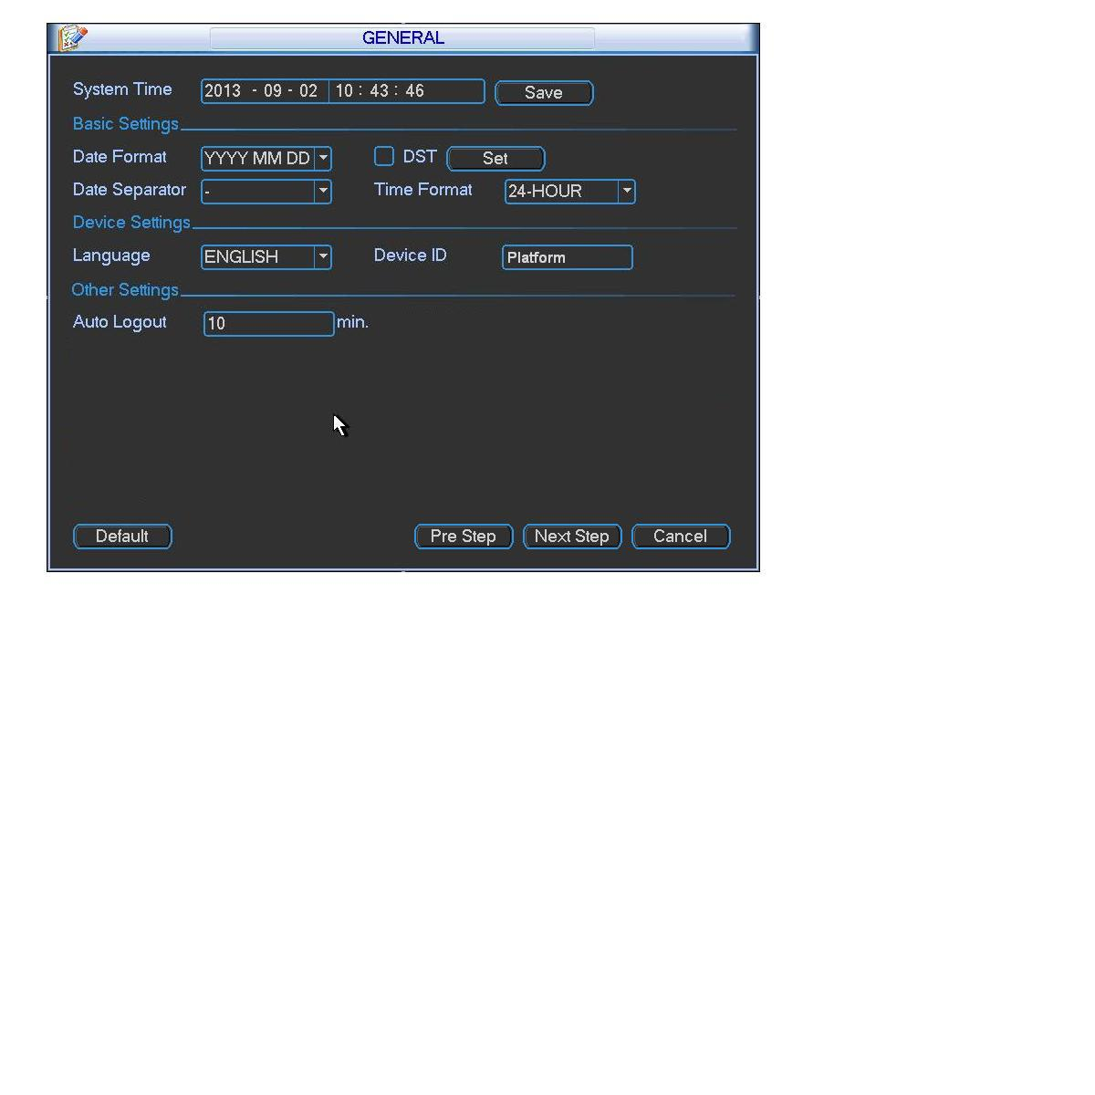

Figure 2-

1. Please set system time and then click Save button. Click Next button to continue. System pops up Network interface. See .

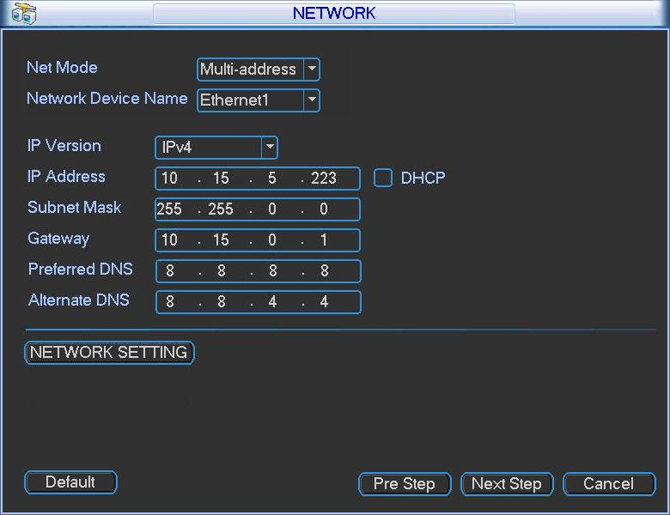

Figure 2-

**Note**

Network mode has three types:

* Load balance: It is called the network adapter binding mode. It can be used when there is high requirments or there is no iSCSI storage plan.
* Multiple-address: It is the multiple-network adapter mode. It can be used in the iSCSI extemsion storage plan. The network adapter 1 is for service communication. The network adapter 2 is reserved. The network adapter 3 and 4 is for iSCSI storage.
* Fault-tolerance: Usually we **do not** **recommend** this mode.

1. Set network mode, IP address and etc. Click Next button to continue. System pops up disk check dialogue box.
2. Click Next button to continue, system pops up the format dialogue box.
3. Click OK button. The format process may take about 30 minutes. System pops up a dialogue box to restart and then begins boot up again.

**Note**

**When system is restarting or running, do not hotswap the first disk (system disk).**

## Master/Slave Mode

After you set DSS platform system time, IP address and network mode, please access the platform via a PC to set master/slave mode and disk storage setup.

Please follow the steps listed below.

1. Donwoload and install Server Assistant.
   1. Please input the IP address you set in chapter on the IE and then click Enter button. System pops up the following dialogue box. See Figure 2- 4.

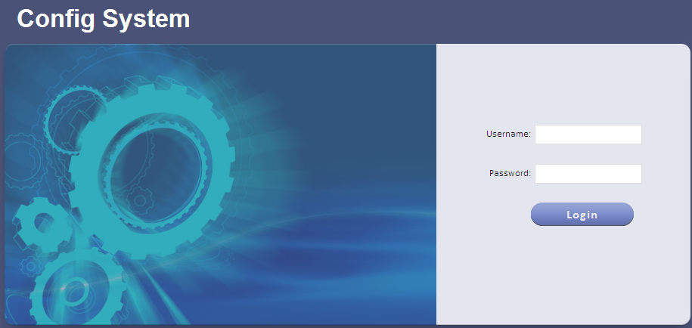

Figure 2-

* 1. Please input user name and password. System default user name is **admin** and password is **123456**.
  2. Click Login. See .

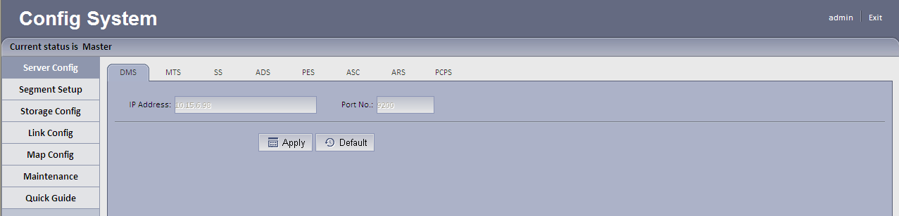

Figure 2-

* 1. Quick guide.
* Master mode

1. Select quick guide tab. See .

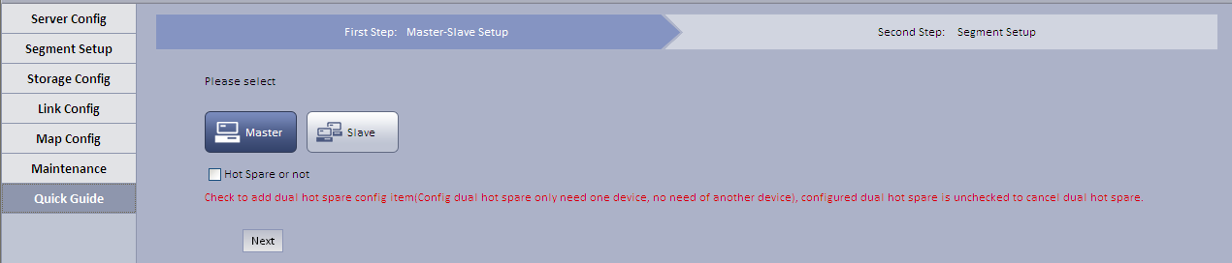

Figure 2-

1. Select master mode, and click Next.

System shows Segment Setup interface, see .

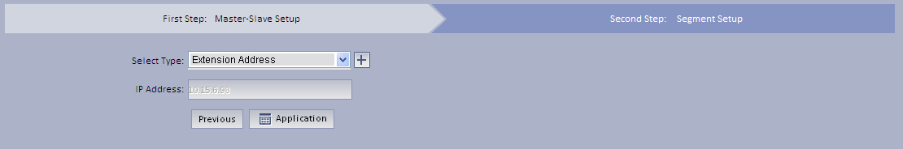

Figure 2-

1. Configure parameter, and set segment.

* Click  or  to increase/decrease parameter.
* Click  or  to adjust parameter location.

See .

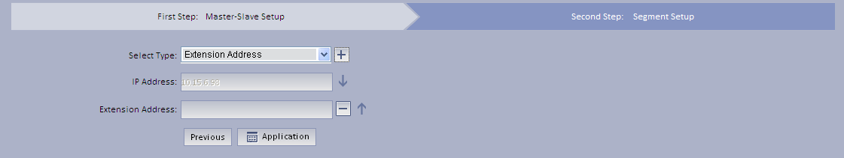

Figure 2-

1. Click Application.

* Slave mode

1. Click Slave Mode.

System shows master/slave mode setup interface, see .

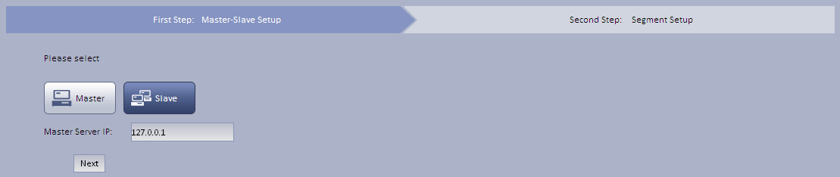

Figure 2-

1. Enter master control IP, click Next. System shows type setup, see .

Note:

Enter master/slave mode server IP, so slave mode can sign in master mode and run properly.

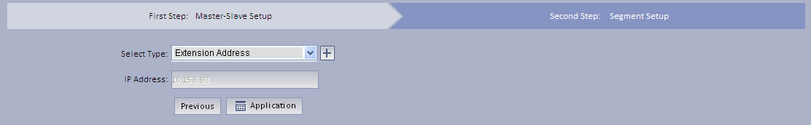

Figure 2-

1. Select *select type*, and click Application.
   1. Maintenance.
2. Select system maintenance>Account tab, manage account/password.
3. Select system maintenance>system maintenance tab, switch master/slave mode, shut down, reboot and restore default.
4. Select system maintenance> network card tab, configure network mode, network card, IP address, subnet mask, default gateway, preferred DNS, alternate DNS and etc.
5. Select system maintenance>time setup tab, set time zone, period and time.
6. Select system maintenance>port setup tab, set WEB server port.
7. Select system maintenance>router setup tab, manually add statics route.
   1. Server config.

It mainly configures device, media forwarding, storage, alarm dispatch, environment, alarm scheme center, auto registration, device agent and etc.

* 1. Segment setup.

Select extension address or mapping address. Click Application to set segment. See .

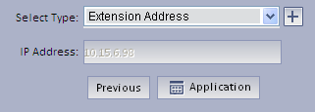

Figure 2-

* 1. Storage config.

Storage config has local disk and network disk.

1. Select storage config>local config, support refresh, format local disk and etc.
2. Select storage config>network disk, support to manually add, format refresh network disk and etc.
   1. Link config.

Link config email and SMS.

* Select link config>email link interface. See . When config alarm scheme at manager-end, select link email and set recipient’s email address. When alarm occurs, he/she will receive email.

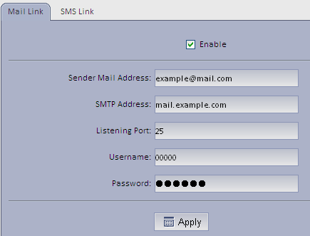

Figure 2-

1. Configure corresponding parameter, click Apply.

SMPT server’s listening port has default as 25.

1. Check Enable.

* Select link config>SMS link interface. See . After config SMS, when manager-end configures alarm scheme, select link SMS and set receipt number. Once alarm occurs, he/she will receive SMS of alarm.

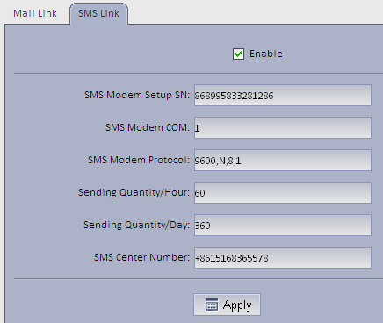

Figure 2-

1. Configure parameter, click Apply.

Note:

SMS modem COM: USB’s COM no. of DSS series communicating with SMS mode.

1. Check Enable.
   1. Map config.

System supports super map, raster map, google and google offline map config.

1. Select super map, configure parameter, click Application. See .

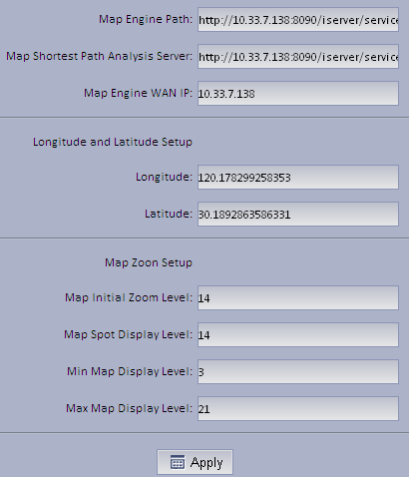

Figure 2-

1. Select raster map, click Application.
2. Select Google, configure parameter, click Application.

Note:

When you add Google map, please make sure DSS client is connected to the Internet, however, DSS server end may be in LAN.

See .

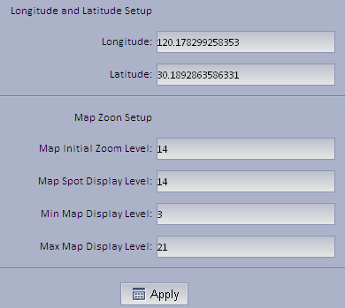

Figure 2-

1. Select Google offline map, configure parameter, click on Application. See .

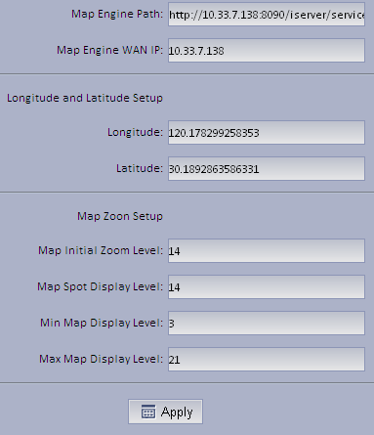

Figure 2-

**Note:**

* **This user’s manual is for reference only. Slight difference may be found in the user interface.**
* **All the designs and software here are subject to change without prior written notice.**
* **All trademarks and registered trademarks mentioned are the properties of their respective owners.**
* **If there is any uncertainty or controversy, please refer to the final explanation of us.**
* **Please visit our website or contact your local retailer for more information.**