**EVS connect to DSS as central storage**

1. Login EVS to manage the disk

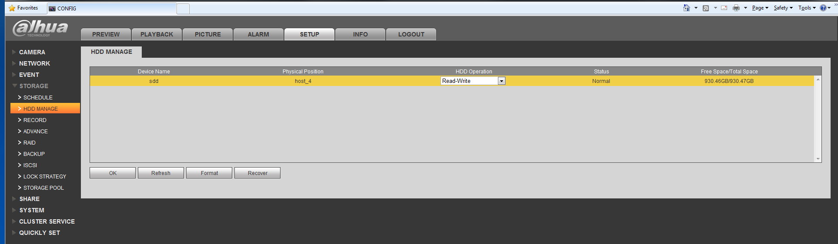

Here will show the disk you insert to EVS, if the disk already been used to create storage pool, it will not show here.

1. If you want create RAID, you should create raid first before you create storage pool.

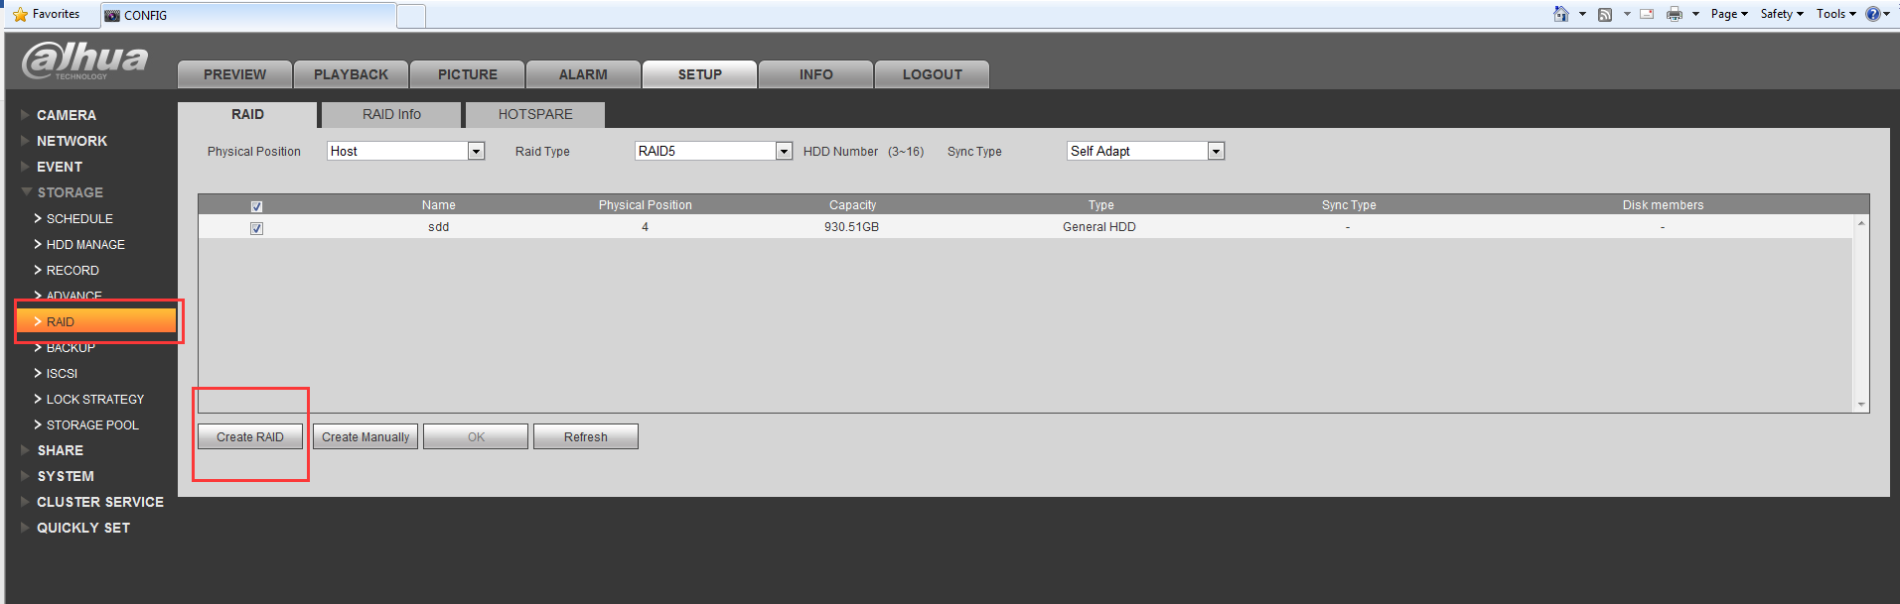

1. Then you can create storage pool

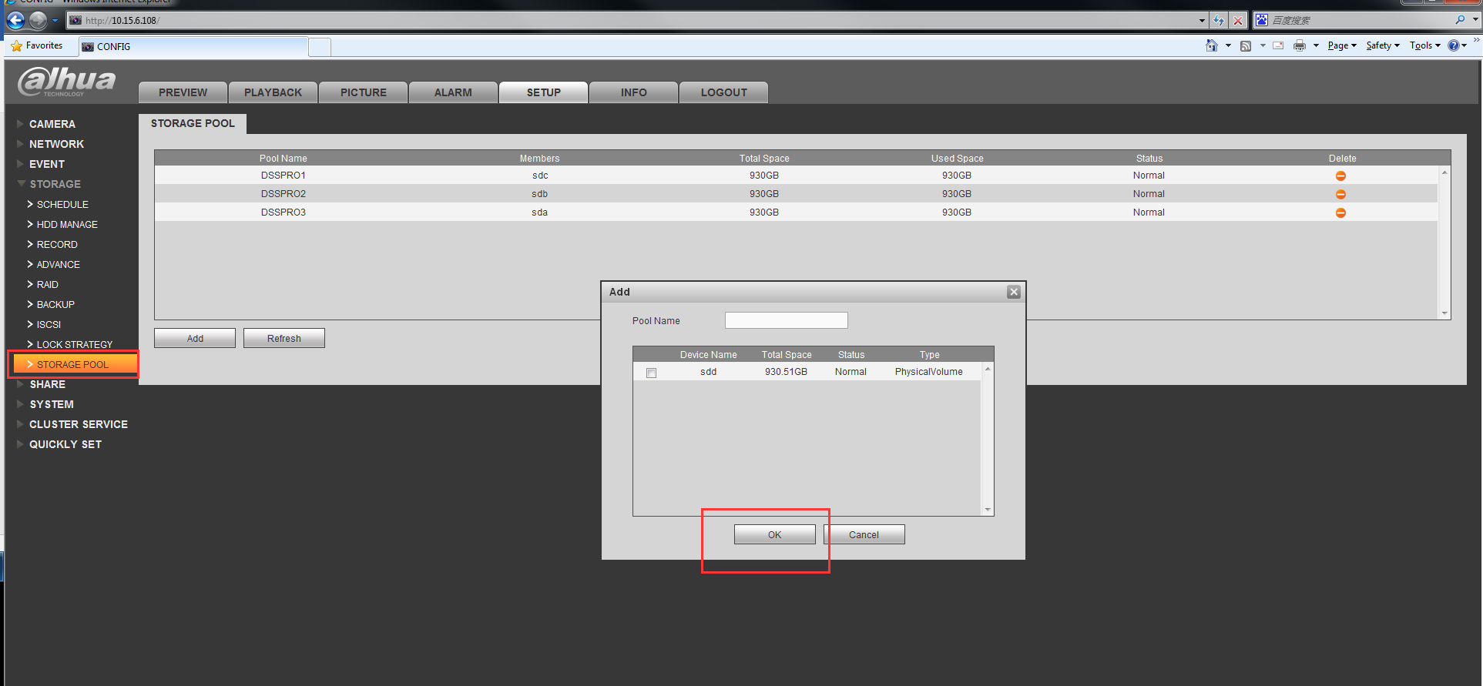

1. Create Share folder: you can input the share capacity, for one storage can create more than one share folders.

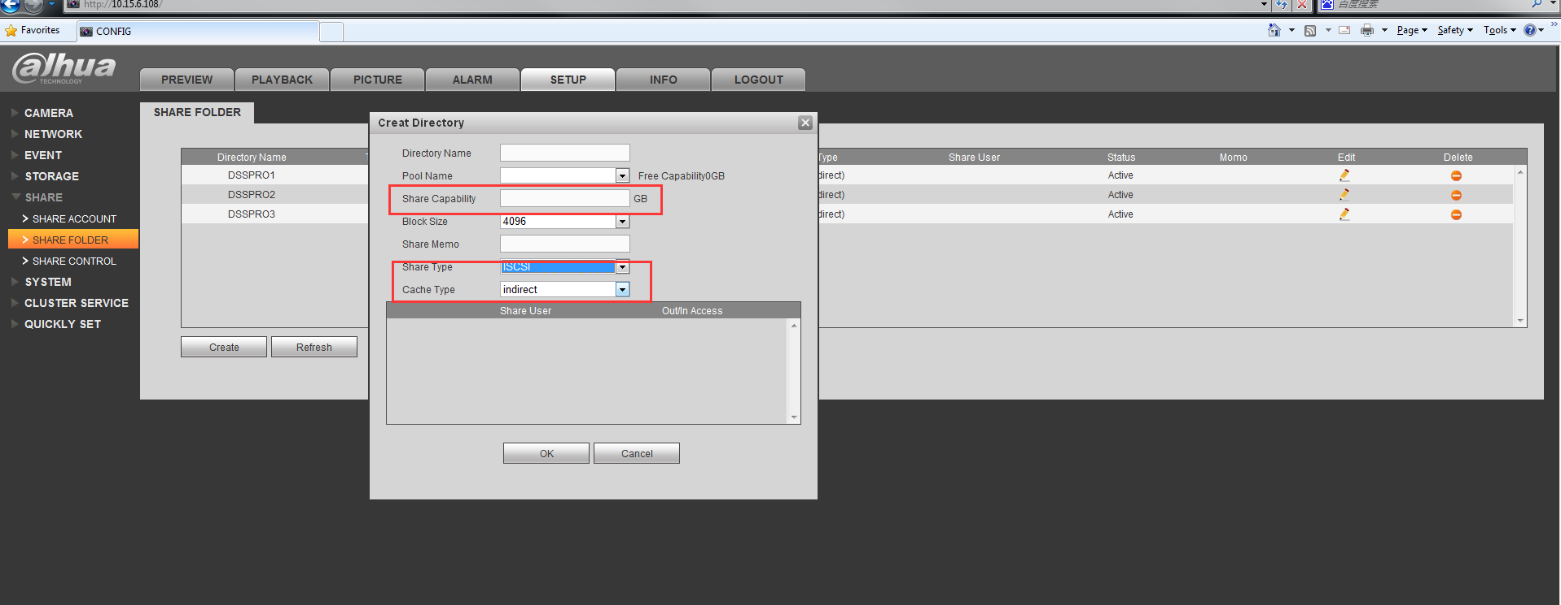

1. Change the IP address of EVS, make sure IP address of EVS and IP address of dss port3 or port4 in the same segment. (depend on which port of DSS you use to connect EVS ).

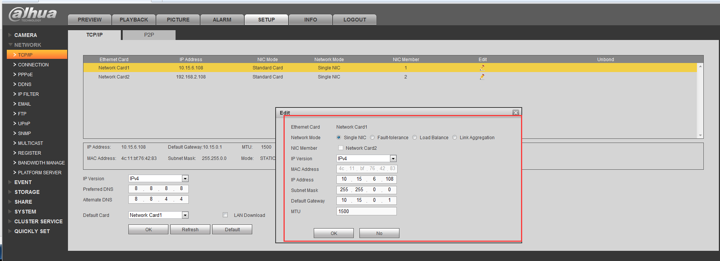

1. Connect the EVS to DSS port 3 or port 4 Directly.



1. Login config system of DSS: ip/config

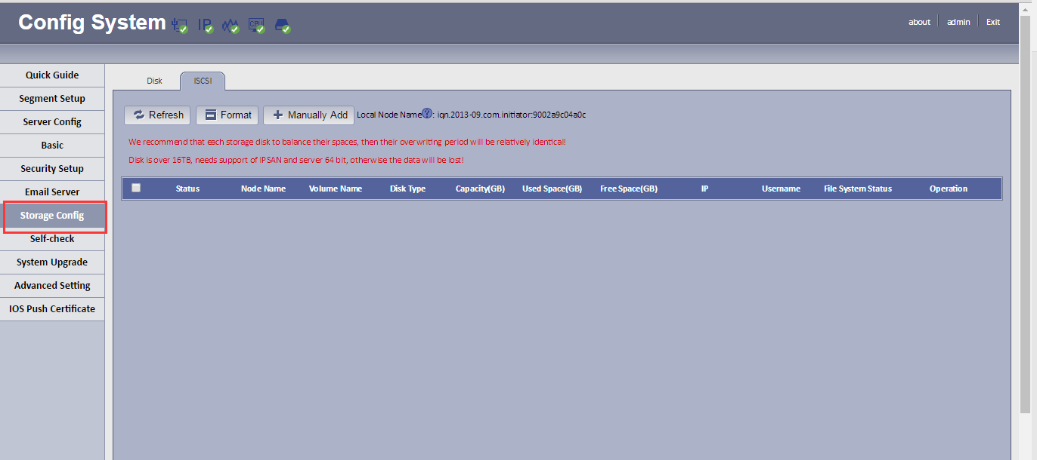

9. Manually Add IPSAN:

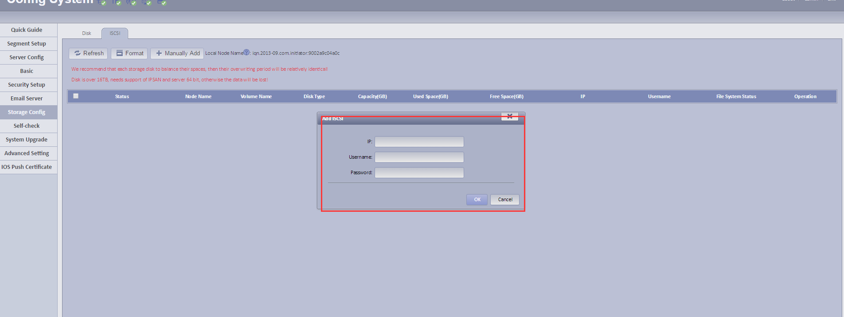

1. The list will show the storage, if first add, you should format the disk.

