Smart Box DVR Quick Start Guide

Version 1.0.0

Welcome
Thank you for purchasing our DVR!
This quick start guide will help you become familiar with our DVR in a very short time.
Before installation and operation, please read the following safeguard and warning carefully!

Important Safeguard and Warning
- All installation and operation here should conform to your local electrical safety codes.
- We assume no liability or responsibility for all the fires or electrical shock caused by improper handling or installation.
- We are not liable for any problems caused by unauthorized modifications or attempted repair.
- Improper battery use may result in fire, explosion, or personal injury!
- When replace the battery, please make sure you are using the same model!

Note: All the installation and operations here should conform to your local electric safety rules.

Check Unpacked DVR
When you receive the DVR from the forwarding agent, please check whether there is any visible damage. The protective materials used for the package of the DVR can protect most accidental clashes during transportation. Then you can open the box to check the accessories.
Please check the items in accordance with the list. (Remote control is optional). Finally you can remove the protective film of the DVR.

About Front Panel and Rear Panel
For detailed information of the function keys in the front panel and the ports in the rear panel, please refer to the User’s Manual included in the resource CD.
The model in the front panel is very important; please check according to your purchase order.
The label in the rear panel is very important too. Usually we need you to represent the serial number when we provide the service after sales.

HDD Installation

Shut down the device and then unplug the power cable before you replace the HDD!
Please make sure the metal surface of the HDD is facing up when you are installing!

This series DVR has only one 2.5-inch SATA HDD. Please use HDD of 7200rpm or higher.
You can refer to the User’s Manual for recommended HDD brand.
Please follow the instructions below to install HDD.
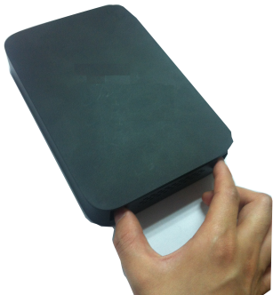 | 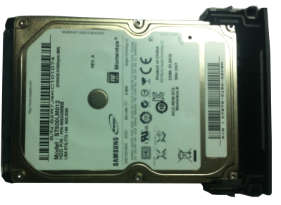 | 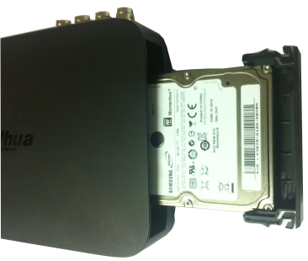
Draw out the HDD bracket | Make sure the HDD metal surface is facing up and then put the HDD into the bracket horizontally. After the HDD is in the proper position, the columns on the two sides can lock the screw holes of the HDD to secure it. | Put the HDD into the device.
When you remove the HDD, please refer to the following figure to pull the spring up and then remove the HDD.
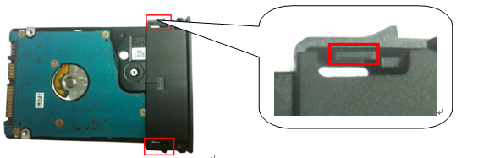
Figure 1

Rear Panel
The rear panel of 2CIF series DVR and 960H series DVR is shown as in Figure 2.
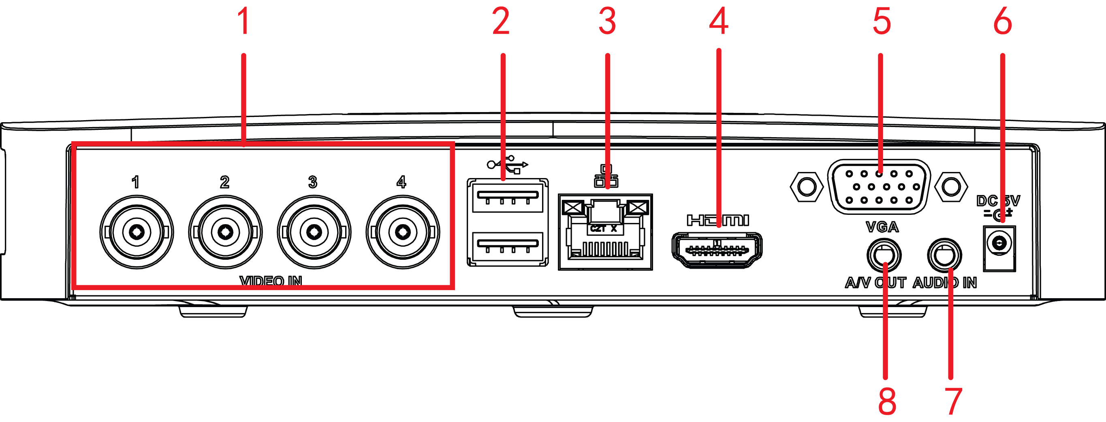
Figure 2
The rear panel of 720P HDCVI Series DVR is shown as in Figure 3.
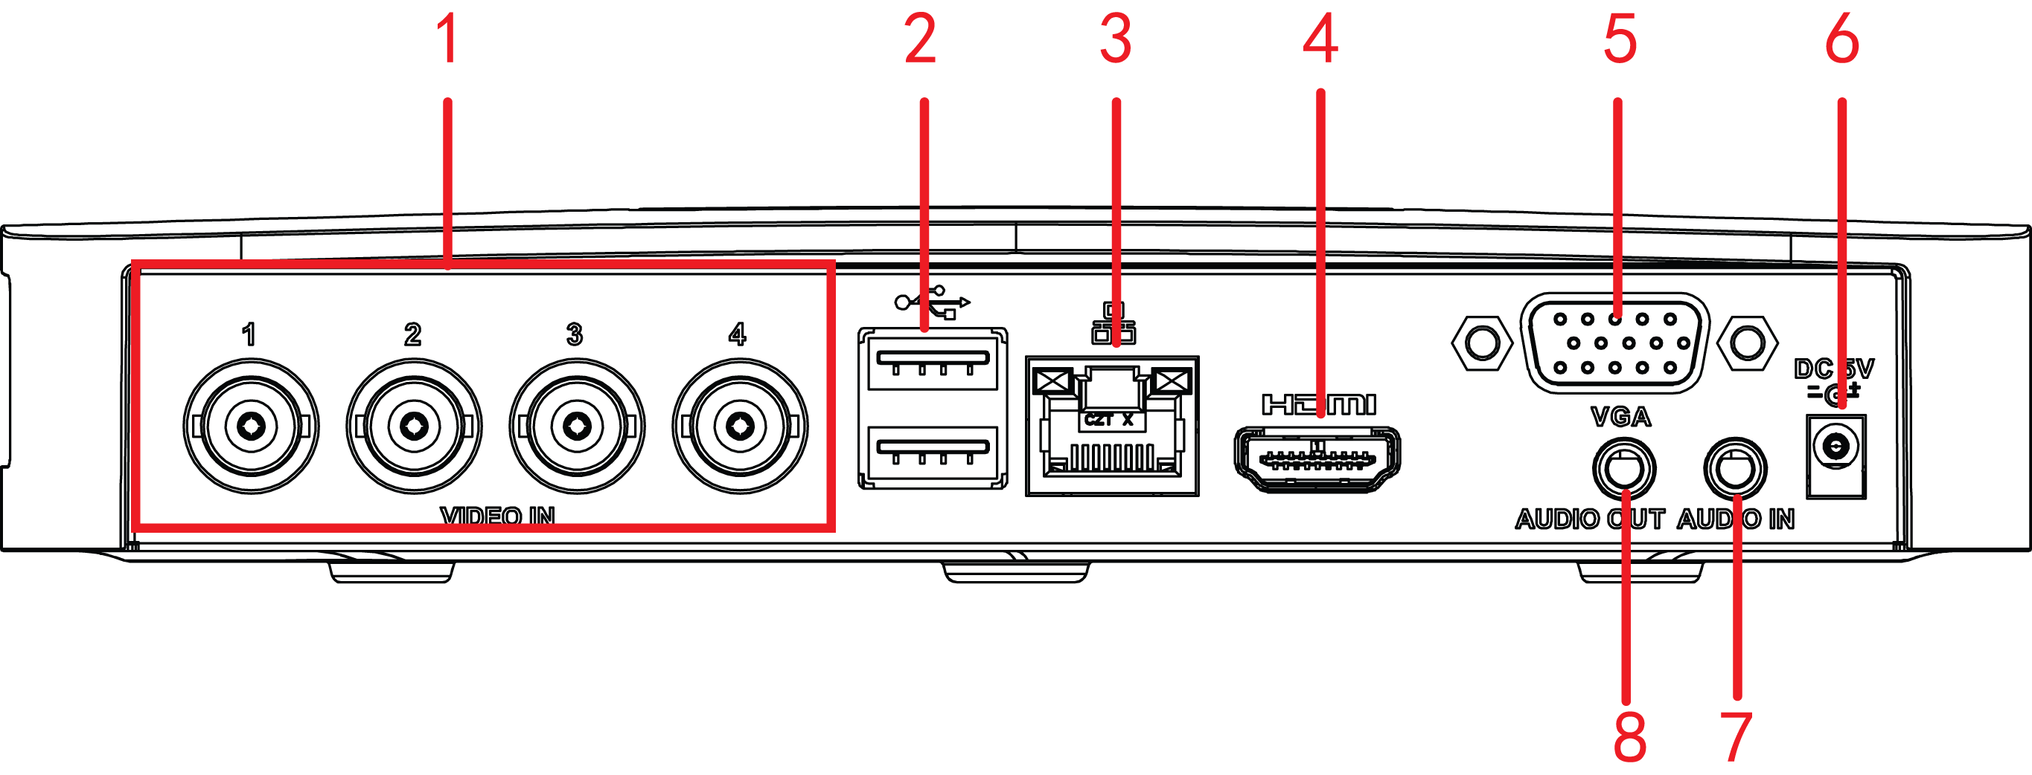
Figure 3
Please refer to the following sheet for detailed information.
SN | Icon | Name | Note
1 | VIDEO IN | Video input | Connect to analog camera, video input signal.
2 |  | USB port | Connect to USB storage device, mouse, burning DVD-ROM and etc.
3 |  | Network port | 100M Ethernet port
4 | HDMI | HDMI port | High definition audio and video signal output port. It transmits uncompressed high definition video and multiple-channel data to the HDMI port of the display device.
5 | VGA | Video VGA output | VGA video output port. Output analog video signal. Can connect to the monitor to view ananlog video output.
6 |  | Power socket | Power socket 5V2AΦ4.0×Φ1.7.
7 | AUDIO IN | Audio input | Connect to audio input port.
8 | A/V OUT | Audio/Video output | Connec to TV audio/video cable. Output analog audio signal and video signal to the TV.  This port is for 2CIF series DVR and 960H series DVR only.
8 | AUDIO OUT | Audio output | Connect to audio output device.  This port is for 720P HDCVI Series DVR only.

Local Login
After system booted up, default video display is in multiple-window mode.
Click Enter or left click mouse, you can see the login interface. See Figure 4.
System consists of four accounts:
- Username: admin. Password: admin. (administrator, local and network)
- Username: 888888. Password: 888888. (administrator, local only)
- Username: 666666. Password: 666666(Lower authority user who can only monitor, playback, backup and etc.)
- Username: default. Password: default(hidden user)
Note:
For security reason, please modify password after you first login.
Within 30 minutes, three times login failure will result in system alarm and five times login failure will result in account lock!
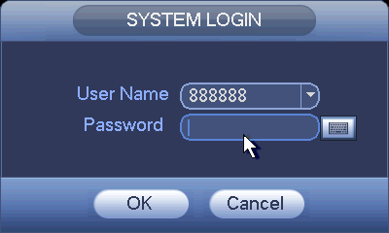
Figure 4

Web
Open IE and input DVR address in the address column. For example, if your DVR IP is 10.10.3.16, then please input http:// 10.10.3.16 in IE address column.
System pops up warning information to ask you whether install webrec.cab control or not. Please click yes button.
If you can’t download the ActiveX file, please modify your IE security setup.
After installation, the interface is shown as below. See Figure 5.
Please input your user name and password.
Default factory name is admin and password is admin.
Note: For security reasons, please modify your password after you first login.
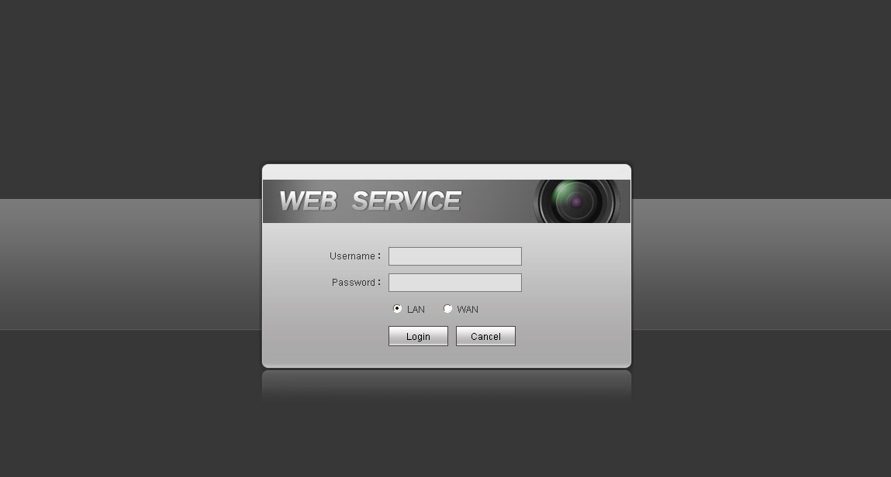
Figure 5
For detailed operation information, please refer to the User’s Manual included in the resources CD.

Appendix Toxic or Hazardous Materials or Elements
Component Name | Toxic or Hazardous Materials or Elements
Component Name | Pb | Hg | Cd | Cr VI | PBB | PBDE
Sheet Metal(Case) | ○ | ○ | ○ | ○ | ○ | ○
Plastic Parts（Panel） | ○ | ○ | ○ | ○ | ○ | ○
Circuit Board | ○ | ○ | ○ | ○ | ○ | ○
Fastener | ○ | ○ | ○ | ○ | ○ | ○
Wire and Cable/AC Adapter | ○ | ○ | ○ | ○ | ○ | ○
Packing Material | ○ | ○ | ○ | ○ | ○ | ○
Accessories | ○ | ○ | ○ | ○ | ○ | ○
Note
O: Indicates that the concentration of the hazardous substance in all homogeneous materials in the parts is below the relevant threshold of the SJ/T11363-2006 standard.

X: Indicates that the concentration of the hazardous substance of at least one of all homogeneous materials in the parts is above the relevant threshold of the SJ/T11363-2006 standard. During the environmental-friendly use period (EFUP) period, the toxic or hazardous substance or elements contained in products will not leak or mutate so that the use of these (substances or elements) will not result in any severe environmental pollution, any bodily injury or damage to any assets. The consumer is not authorized to process such kind of substances or elements, please return to the corresponding local authorities to process according to your local government statutes.

Note
- For detailed operation introduction, please refer to our resource CD included in your package for electronic version of the User’s Manual.
- This quick start guide is for reference only. Slight difference may be found in the user interface.
- All the designs and software here are subject to change without prior written notice.
- All trademarks and registered trademarks mentioned are the properties of their respective owners.
- If there is any uncertainty or controversy, please refer to the final explanation of us.
- Please visit our website or contact your local service engineer for more information.

