Network Keyboard Quick Start Guide

V1.2.0

Table of Contents
1 Overview and Controls 5
1.1 Front Panel 5
1.2 Function Buttons List 5
1.3 Rear Panel 7
2 Overview of Navigation and Controls 8
2.1 Login, Logout & Shutdown 8
2.1.1 Login 8
2.1.2 Shutdown 11
2.2 Admin Operation Menu 11
2.2.1 Main Menu 11
2.2.2 System Settings 11
2.2.3 Device Manager 18
2.2.4 Input Settings 21
2.2.5 Output Settings 22
2.2.6 Account 23
2.2.7 Shutdown 24
2.3 User Operation Menu 25
2.3.1 Main Menu 25
2.3.2 Device List 25
2.3.3 Input List 26
2.3.4 Output List 27
2.3.5 Remote Operation (Network Connection) 29
2.3.6 Remote Operation (RS232) 37
2.3.7 Remote Operation (RS485) 38
2.3.8 Remote Control 38
2.3.9 Advanced 40
2.3.10 Playback 45
2.3.11 Matrix Control 46
2.3.12 Keyboard Simulator 46
2.4 Matrix Mode Detailed operation 47
2.4.1 Set Scheme 49
2.4.2 PTZ Control 52
2.5 Platform Mode Detailed Operation 52
2.5.1 Output video to the wall 60
2.5.2 PTZ Control 62
Appendix Toxic or Hazardous Materials or Elements 64

Welcome
Thank you for purchasing our network keyboard!
This quick start guide is designed to be a reference tool for the operation of your system.
Before the operation please read the following safeguards and warnings carefully!
Please keep it well for future reference.

Important Safeguards and Warnings
1．Electrical safety
All installation and operation here should conform to your local electrical safety codes.
We assume no liability or responsibility for all the fires or electrical shock caused by improper handling or installation.
2．Transportation security
Heavy stress, violent vibration or water splash are not allowed during transportation, storage and installation.
3．Installation
Keep upwards. Handle with care.
Do not place objects on the network keyboard.
4．Qualified engineers needed
All the examination and repair work should be done by the qualified service engineers.
We are not liable for any problems caused by unauthorized modifications or attempted repair.
5．Environment
The network keyboard should be used in a cool, dry place away from direct sunlight, inflammable, explosive substances and etc.

6. Accessories
Be sure to use all the accessories recommended by manufacturer.
Before installation, please open the package and check all the components are included.

Overview and Controls

Front Panel
This series products’ front panel is shown as below. See Figure 1-1.
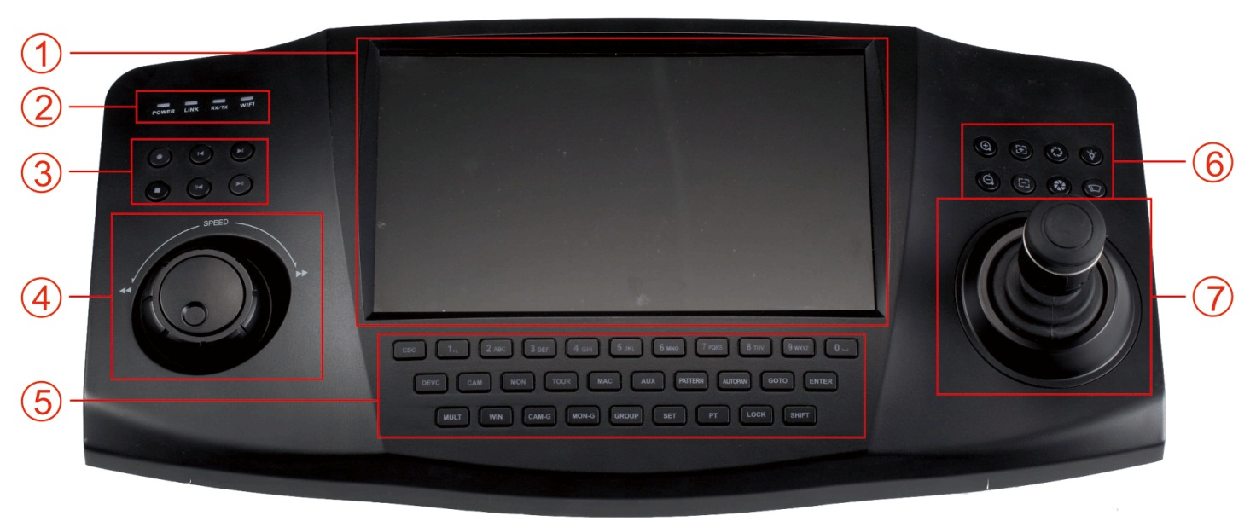
Figure 1-1
It includes seven panes.
SN | Name | SN | Name
1 | Touch panel | 2 | Indication light
3 | Record playback | 4 | Shuttle(Outer ring)  Jog(Inner dial)
5 | Function buttons | 6 | PTZ control
7 | Joystick

Function Buttons List
Please refer to the following sheet for function button information.
SN | Name | Symbol | Function
Function key | Number and character | 0-9 | It is to input number and character. Click the Shift button to switch.
Function key | ESC |  | Cancel/exit
Function key | ENTER |  | Confirm
Function key | SHIFT |  | Switch
Function key | LOCK |  | Work with SHIFT button to lock/unlock the device.
Indication light | Working power indication light | POWER | The light becomes on when the keyboard connects to the power.
Indication light | Wire network indication light | LINK | The light becomes on when the keyboard connect to the wire network properly.
Indication light | Indication light | RX/TX | The light becomes on when the wire network data is sending or receiving properly.
Indication light | Wireless indication light | WIFI | The light becomes ion when it connects to the wireless network properly.
PTZ control | PT |  | PTZ shortcut button
PTZ control | GOTO |  | Preset
PTZ control | AUTO PAN |  | Pan
PTZ control | PATTERN |  | Pattern
PTZ control | ZOOM+ |  | PTZ lens zoom in.
PTZ control | ZOOM- |  | PTZ lens zoom out.
PTZ control | FOCUS+ |  | Focus of the PTZ lens zoom in.
PTZ control | FOCUS- |  | Focus of the PTZ lens zoom out.
PTZ control | IRIS+ |  | Aperture of the PTZ lens zoom in.
PTZ control | IRIS- |  | Aperture of the PTZ lens zoom out.
PTZ control | LIGHT |  | Speed dome light shortcut button
PTZ control | WIPER |  | Speed dome wiper shortcut button.
Decoder | CAM |  | Working with the number button to select the input channel.
Decoder | MON |  | Working with the number button to select the output channel.
Decoder | WIN |  | Working with the number button to select the output window.
Decoder | MULT |  | Working with the number button to select the window split mode.
Decoder | CAM-G |  | Working with the number button to select the input group.
Decoder | MON-G |  | Working with the number button to select the output group.
DVR Buttons | TOUR |  | PTZ control, tour.
DVR Buttons | MULT |  | Window split mode.
DVR Buttons | DEVC |  | Working with number button to select remote device.
DVR Buttons | Record |  | Record/playback.
DVR Buttons | Stop record |  | Stop record/playback.
DVR Buttons | Play/pause |  | - Play normally when it is backward playing or in pause mode.  - Play when it is in pause mode.
DVR Buttons | Backward/Pause |  | - Play backward when it is in normal playback or in pause mode.  - Click it to pause playback when it plays backward.
DVR Buttons | Play previous |  | - When playback, click it to play the previous file.  - In menu setup interface, you can skip to the previous item.
DVR Buttons | Play next |  | - When playback, click it to play the next file.  - In menu setup interface, you can skip to the next item.
AUX buttons | AUX |  | AUX button. Working with number buttons.
AUX buttons | MAC |  | Macro setup.
Others | Touch panel |  | Display OSD.
Others | Jog |  | AUX menu or function buttons operation.

Rear Panel
This series products’ rear panel is shown as below. See Figure 1-2.
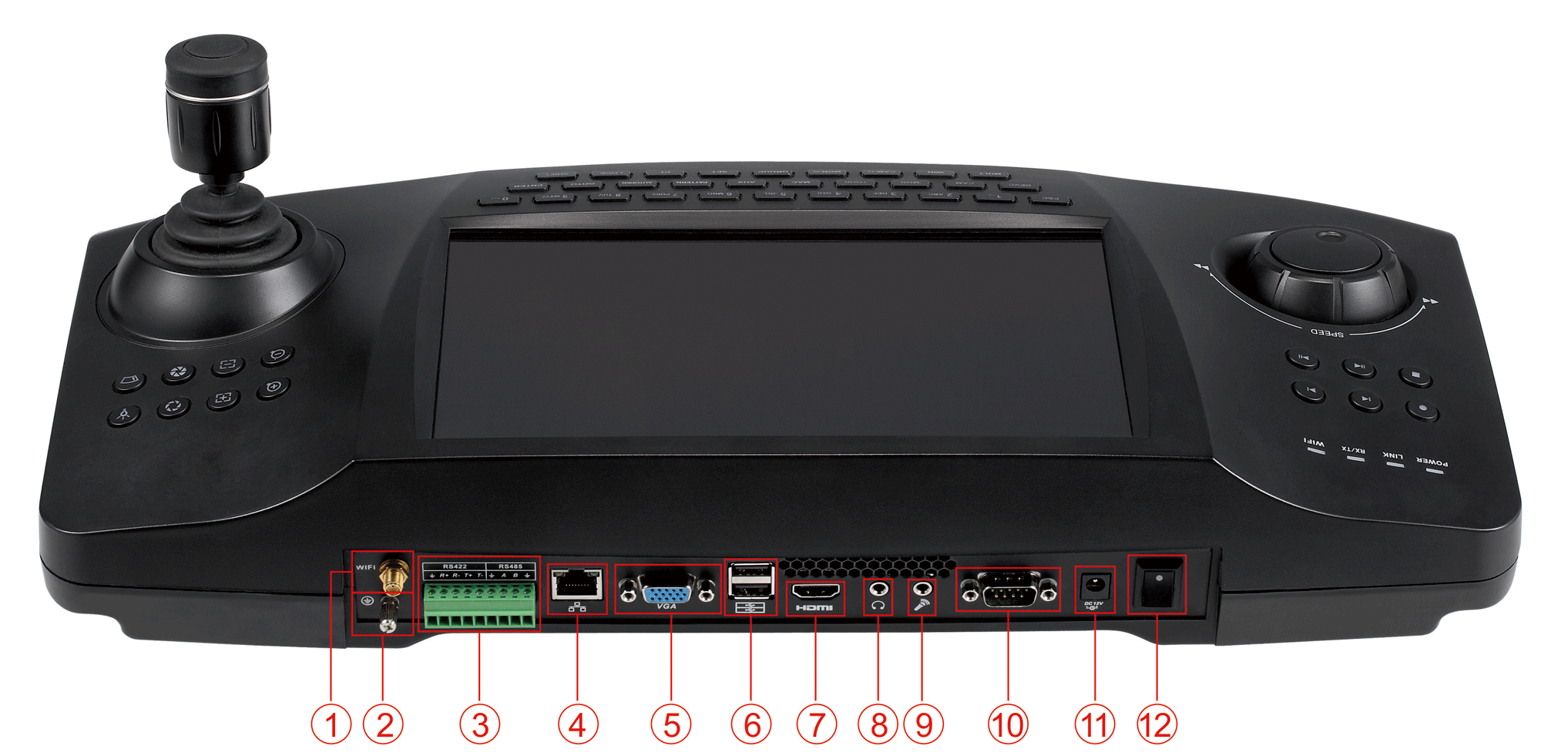
Figure 1-2
Please refer to the following sheet for detailed information.
1 | WIFI antenna
2 | GND stud
3 | RS422/RS485 port
4 | Network port
5 | VGA port
6 | USB port
7 | HDMI port
8 | Audio output
9 | Audio input
10 | RS232 port
11 | Power port
12 | Power on-off button

Overview of Navigation and Controls
Before operation, please make sure:
- The supplying power and the device power are matched.

Login, Logout & Shutdown

Login
Connect the power to the keyboard, you can see the power indicator light becomes on. You can see mode selection interface on the LCD after it properly boots up. See Figure 2-3.
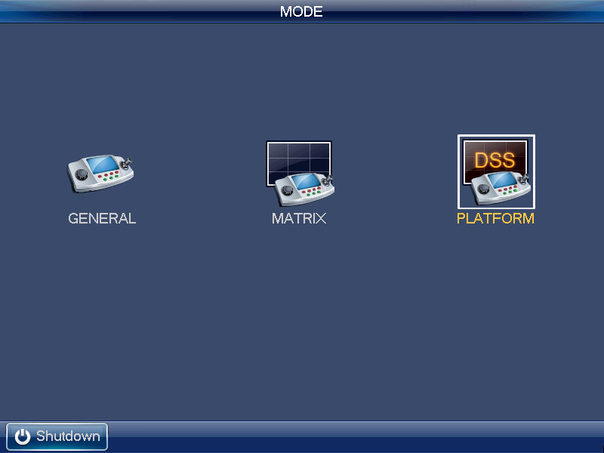
Figure 2-3

General Mode
Click General button you can see the login interface. The factory default user name is admin and password is admin. See Figure 2-4.
- Turn the jog (inner dial) to select the user name.
- Turn the shutter (outer ring) to move the cursor to input the password. Or you can use the mouse or touch panel to move the cursor to input the password.
- Click the SHIFT button to switch the input method. The input method includes number, capitalized character, small character and etc.
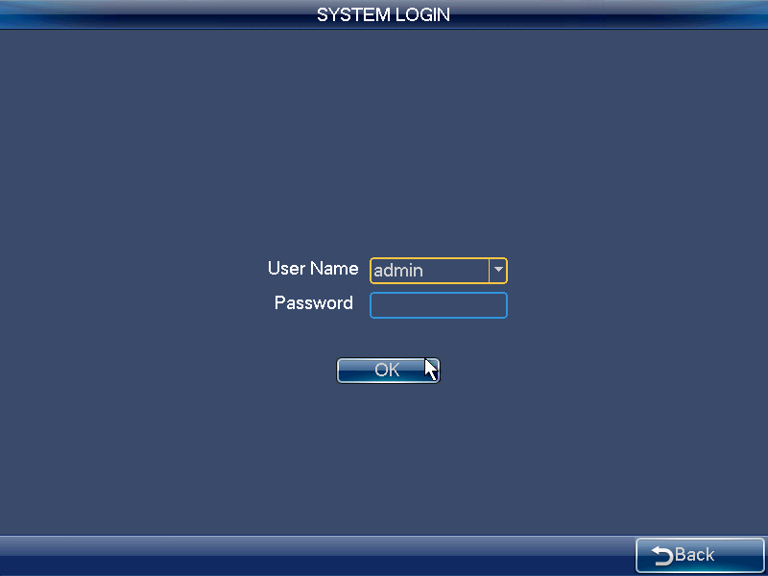
Figure 2-4
The administrator account has only one user: User name: admin. Password: admin. The admin can add the ordinary user account and set corresponding devices for each account. For detailed operation contents, please refer to Chapter 2.2 Admin Operation Menu and Chapter 2.3 User Operation Menu.

Matrix Mode
Click Matrix button，you can see the following interface. See Figure 2-5. Please input matrix information here. Please refer to chapter 2.4 for detailed matrix mode operation.
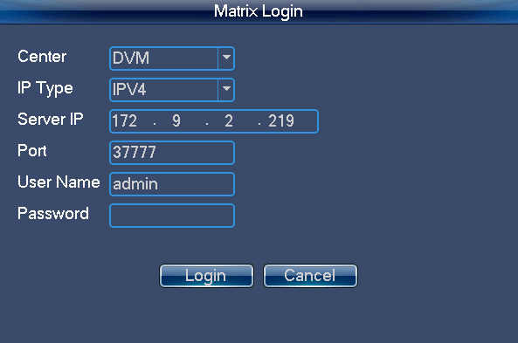
Figure 2-5

Platform Mode
Click Platform button, you can see DSS login interface. Please input DSS platform information here. See Figure 2-6.
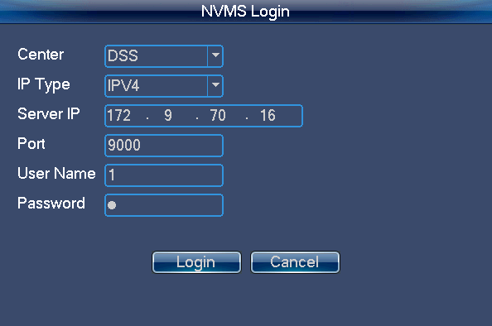
Figure 2-6
Click Login button, you can see the following interface. Here you can select TV wall you want to login from the dropdown list and then click OK button. See Figure 2-7.
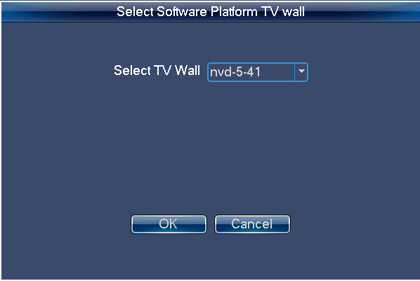
Figure 2-7
Note
You need to go to the DSS client-end to set TV wall. Please refer to the DSS manager user’s manual for detailed information.

Shutdown
After you logged out the system, you can press the Shutdown button at the left corner of the touch panel or press the power button on the rear panel of the device to turn off the keyboard.

Admin Operation Menu

Main Menu
After you login, you can see the main interface includes six buttons: Setting, Device, Input, Output, Account and Shutdown. See Figure 2-8.
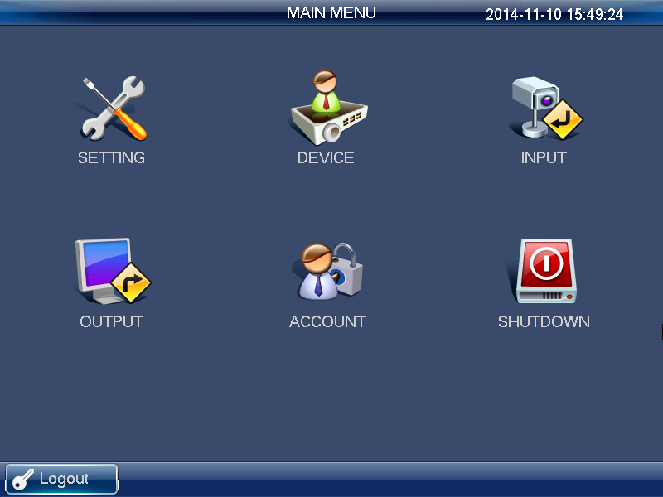
Figure 2-8
There are three ways for you to set.
- You can set the device via the touch panel of the keyboard.
- You can connect the mouse to the keyboard to use.
- You can use the joystick to move the cursor or select the item. For special menu item, you can follow the prompt to click the ENTER button to confirm the operation or the ESC button to cancel current setup.

System Settings
The system settings include the following buttons: general settings, network setting, hardware settings, default, screen calibration, config backup and version. See Figure 2-9.
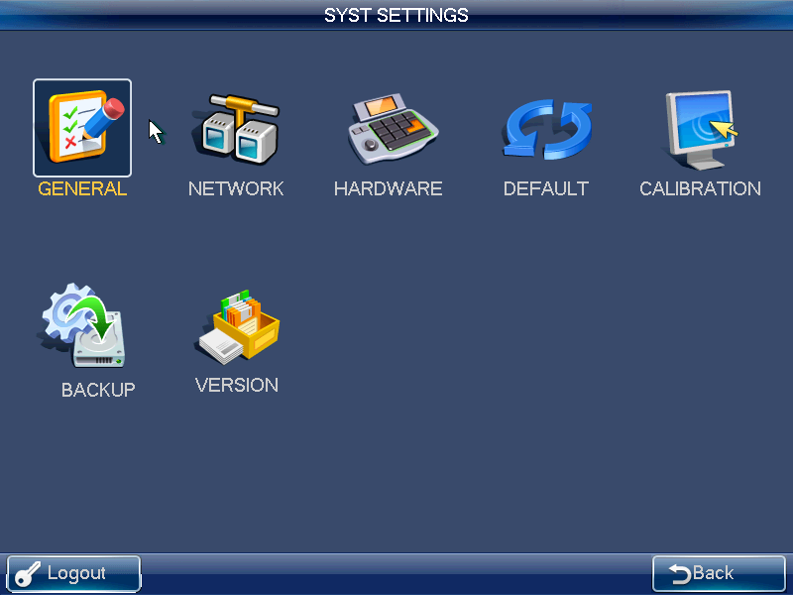
Figure 2-9

General Settings
In this interface, you can set system time, date, language, name and etc. It includes the Y-M-D-H-M-S setup. You can move your cursor to the corresponding position and then input. See Figure 2-10.
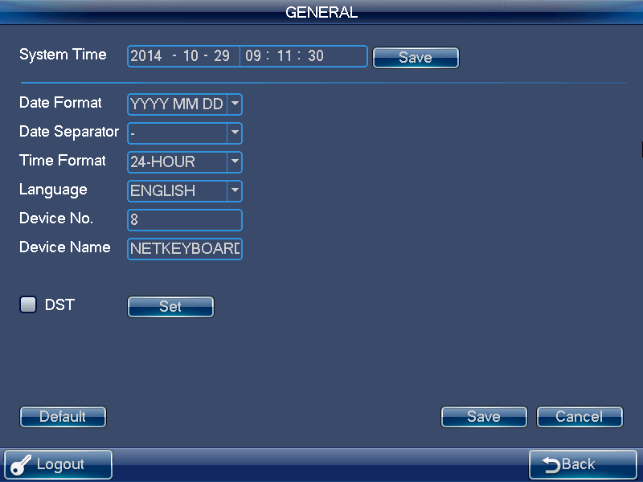
Figure 2-10

Network
There are two ways for you to select: LAN and WLAN. .

LAN
The wire network interface is shown as below. See Figure 2-11.
On the wire network interface, you can use the direction keys and number keys to set IP address, subnet mask, gateway, port(default value 3777), preferred DNS and alternate DNS. You can use the touch panel or the left/right button to move the cursor to the corresponding position and then use the number keys to change the setup.
Note
Please note you need to have the router and enable the DHCP function before you use this function.
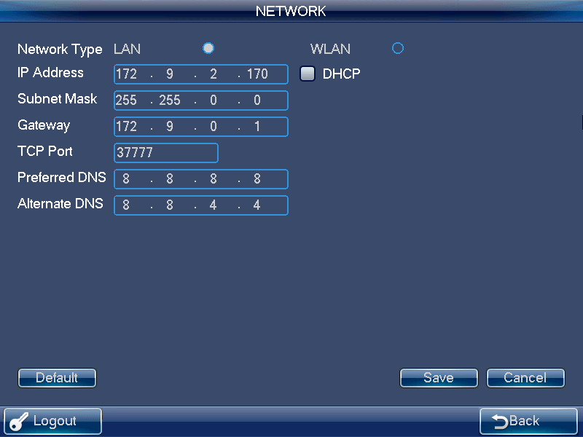
Figure 2-11

WLAN
The wireless network is shown as in Figure 2-12.
The wireless network setup steps are listed below.
- Click Refresh button, system begins search hotspot again and automatically add password information and etc (If you have added it in the past).
- Select hotspot you want to connect and then click Connect button. You can see WIFI new hotspot setup interface.
Note
You need to disconnect current connection if you want to connect again. If you connect another station directly, system needs to disconnect current connection first and then connect again.
- Click OK button, the WIFI working information can display current connection status after it successfully established the connection.
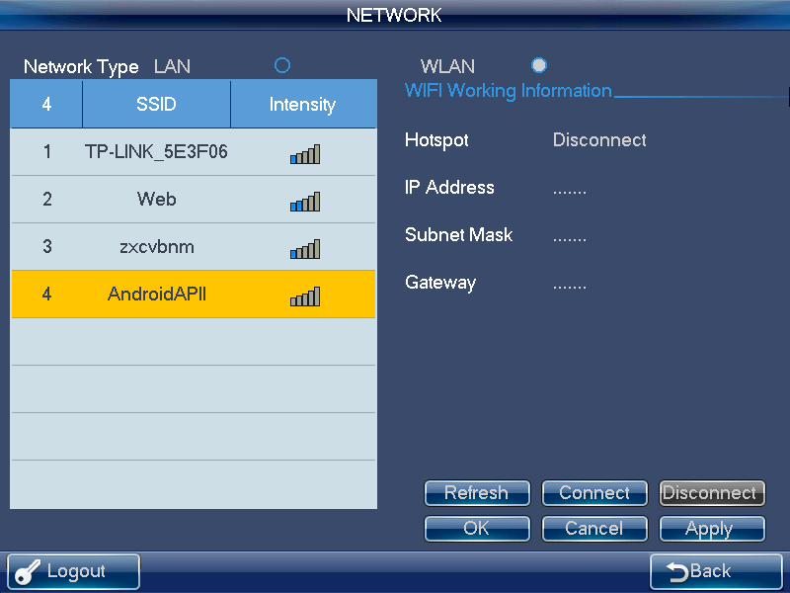
Figure 2-12

Hardware Settings
Here you can set key sound, key backlight, auto lock time, screen auto off time and etc. See Figure 2-13.
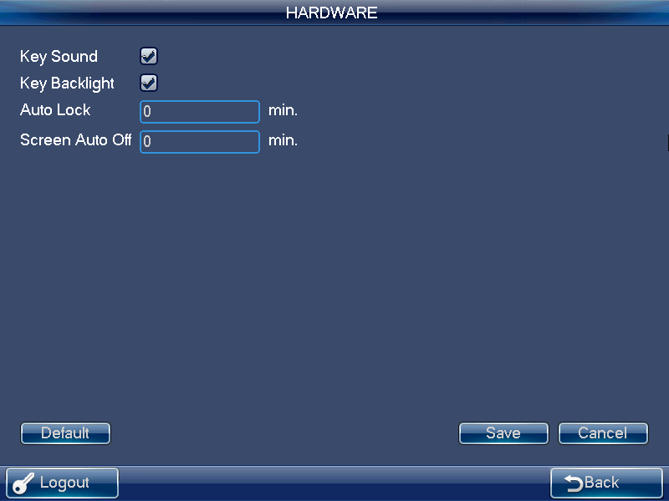
Figure 2-13

Default
Here you can check the corresponding item to restore factory default setup. See Figure 2-14.
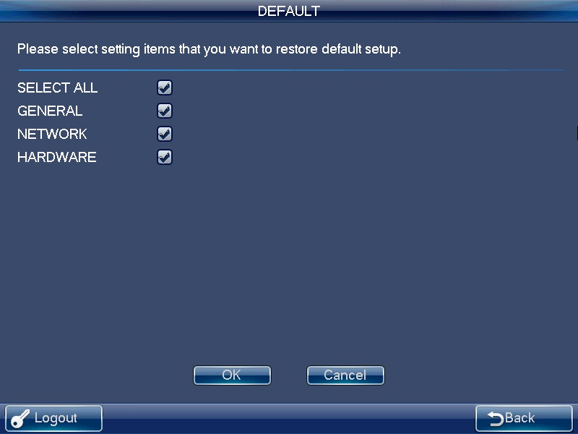
Figure 2-14

Screen Calibration
Note
This function is for resistive screen only. The capacitive screen does not need to calibrate.

You can use the screen calibration function if the touch position is not accurate with the actual position.
On the main menu, click Calibration, system pops up the following dialogue box. See Figure 2-15.Click OK to calibrate the screen.
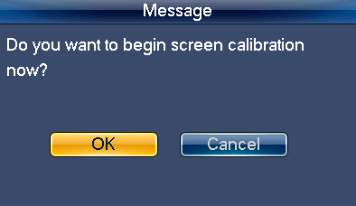
Figure 2-15
Here you can view four + icons. Please follow the prompt in the screen to complete the calibration. Then you can see the corresponding prompt “Successfully calibrated.”

Backup
From General settings->Backup, the admin can go to the USB device backup list interface. See Figure 2-16.
- Import: Please connect the USB device to the USB port and then check the box before the device name. Click the Import box to import the configuration.
- Export: Please connect the USB device to the USB port and then check the box before the device name. Click the Export box to export the configuration.
Note
- System can replace the original file if there are configuration files in the USB device.
- Please make sure you configuration file name is “Config”; otherwise you can see a dialogue box says “Invalid configuration file.”
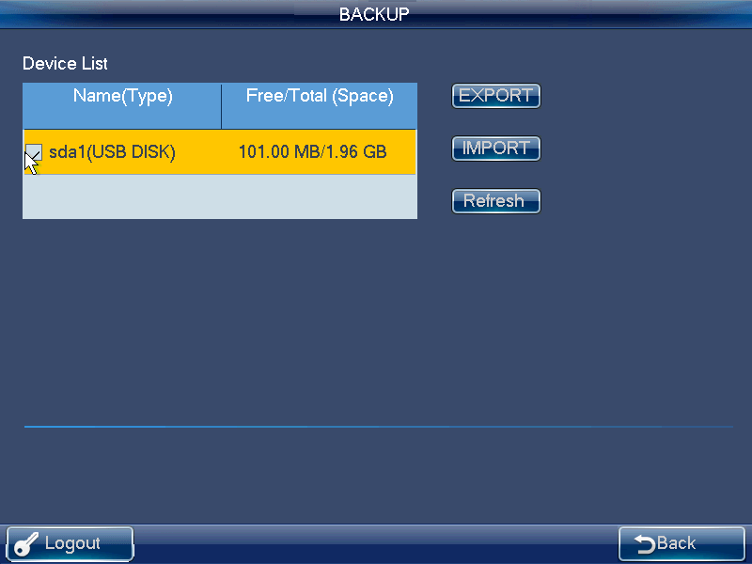
Figure 2-16

Version
In this interface, you can view system version, build date, SN information. You can also upgrade the system. See Figure 2-17.
Please connect the device to the USB port and then click the Start button to begin the upgrade operation.
Note
Before the operation, please make sure your upgrade file name is update.bin.
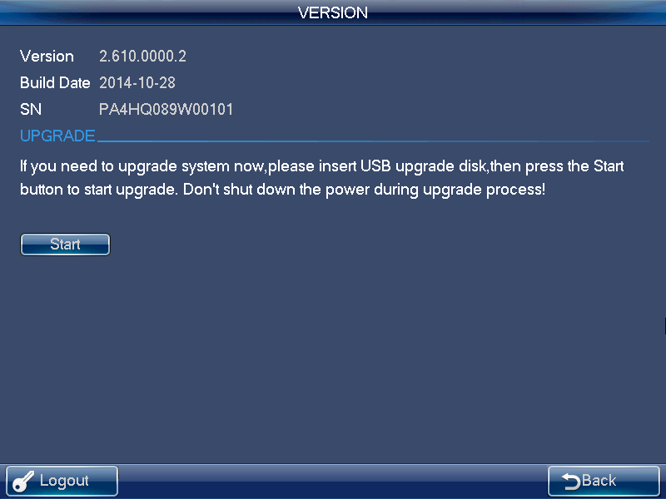
Figure 2-17

Device Manager
Click Device manager button, you can see system begins device detect. .
After the detect, you can see device manager interface.
Here you can see controlled device name, IP address, port, device type, status and etc. You can add, modify and delete the device. See Figure 2-18.
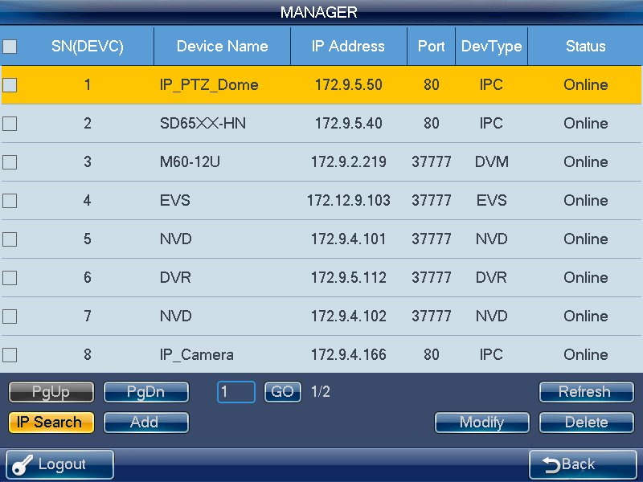
Figure 2-18
IP Search
- Click IP search button, you can go to the IP search interface. See Figure 2-19.
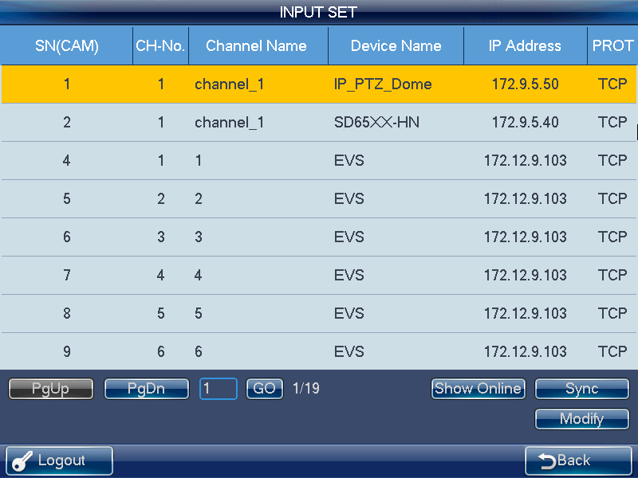
Figure 2-19
- Please click the Refresh button to begin search and you can view the searched result in the IP search interface.
- You can check the box to select a device and then input the user name and password, click the Add button to add a device.
You can use the IP segment setup function on the IP search interface to quickly find the device IP you want to add. It supports 8 criteria. In this way, you can narrow the IP segment and quickly and accurately find the device. See Figure 2-20.
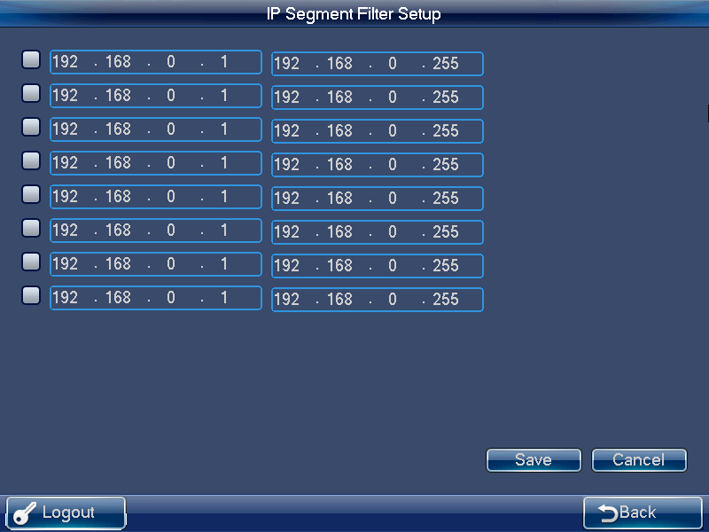
Figure 2-20
Note
- Please make sure the device and the keyboard are in the same network section. Otherwise the search may fail.
- After you searched the device, its initial status is null. You can view the device current status after you added it. System says the device has been added means it is in the Device manager list now.

Manual Add
Note
The manual add function supports private protocol and ONVIF function.
- Click Manual Add button, system pops up the following interface. See Figure 2-21.

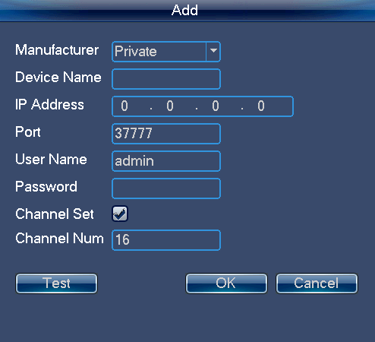
Figure 2-21
- Here you can input manufacturer name, device name, IP address, port, user name and password.
Note
  - You can input customized device name here.
  - For NVR of various channels, you can check the channel setup box to specify the channels you want to add here.
- Please click Test button, you can see the corresponding dialogue box if you input information is wrong or current device is offline.
- Click OK button to complete add process.
Modify and delete
Modify:
Select the device first and then click the Modify button, you can see system pops up an interface for you to change the information. Here you can modify device SN, port number, user name and password.
Note
The user name and password here is for the keyboard to login the device. It does not change the user name and password of the keyboard itself.

Delete
Select the device you want to delete and then click the delete button, you can remove the device form the list.

Input Settings
Click Input settings button, you can go to the following interface. Here you can view the device channel information you can control. See Figure 2-22.
Sync
Click Sync button, you can system automatically synchronizes the channel name with the online device.
Modify
Click the Modify button; you can go to modify interface. Here you can change serial number, main stream and extra stream, and protocol.
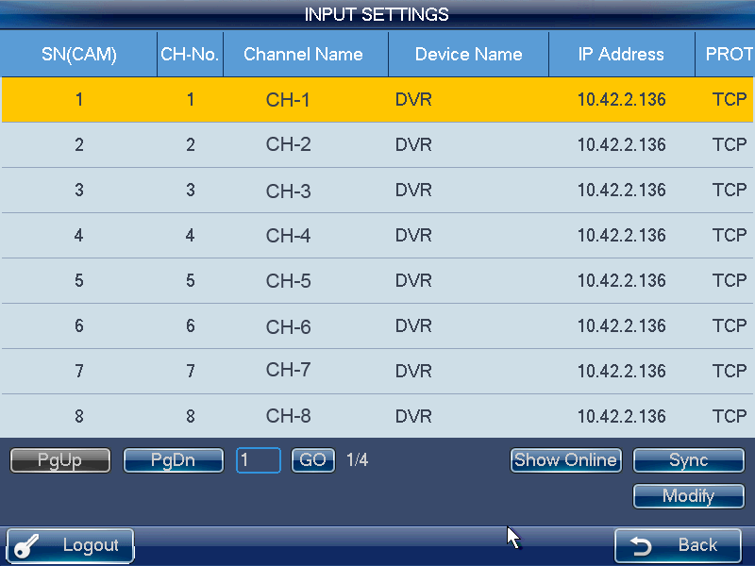
Figure 2-22
Note
- The channel name is the corresponding channel name of the device.
- The SN of the monitor position name shall unique. Otherwise system may pop up a dialogue box “The channel name shall be unique. Please input again.”

Output Settings
Click output settings button, you can go to the corresponding interface. See Figure 2-23.
Modify
In output settings interface, click Modify button, you can go to the corresponding interface to change the output SN.
Note
Please make sure the output SN is unique. System may pop up a dialogue box says” Current input SN already exists, please input again.”
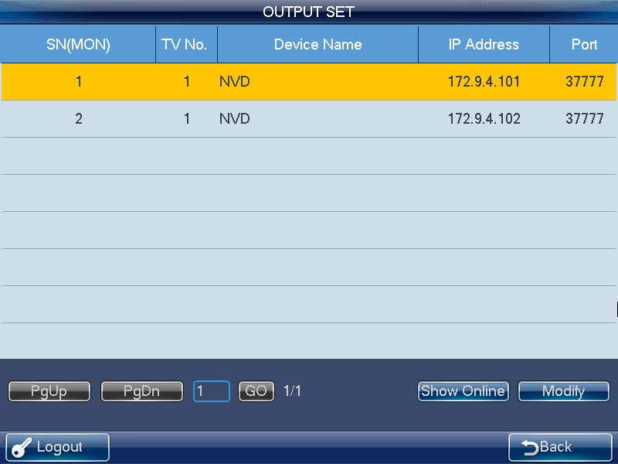
Figure 2-23

Account
The keyboard account has two levels. One is admin and the other is ordinary user. See Figure 2-24.
- The admin account can set keyboard parameter, manage device and ordinary users. The admin can add max 20 users.
- The device management rights include: add/delete/modify device.
- The user management rights include: add/delete/modify user, and set devices for each user. There are two modes for you to allocate the devices to the user: By device/by channel.
Note
You can switch to allocate devices by channel mode from by device mode. But you can not switch to allocate devices by device mode from by channel mode.
- The user account can only have the operation rights and control the assigned devices. Each ordinary user can max control 256 devices.
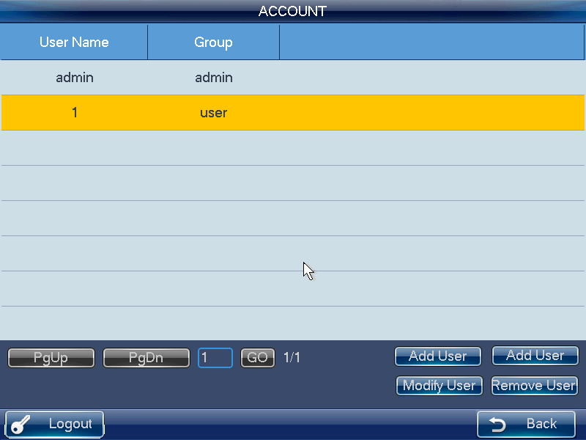
Figure 2-24
Modify Password
Please select an account and then click the Modify user button; you can go to the corresponding interface. Here you can change the password.
Add User
Click Add user button, you can go to the corresponding interface to add the new user. You need to input the user name and password.
Modify User
Select an ordinary user from the list and then click the Modify user button; you can go to the corresponding interface. Here you can add or delete the device current user controls.

Shutdown
Click the Shutdown button; you can see system pops up a dialogue for you to confirm the operation. You can logout the menu, shutdown the device or reboot the system. See Figure 2-25.
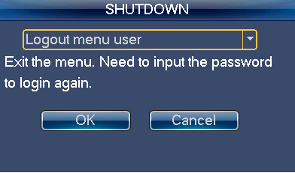
Figure 2-25

User Operation Menu

Main Menu
The user menu includes: device list, input list, output list, operation, advanced, control, playback, matrix control and analog keyboard. See Figure 2-26.
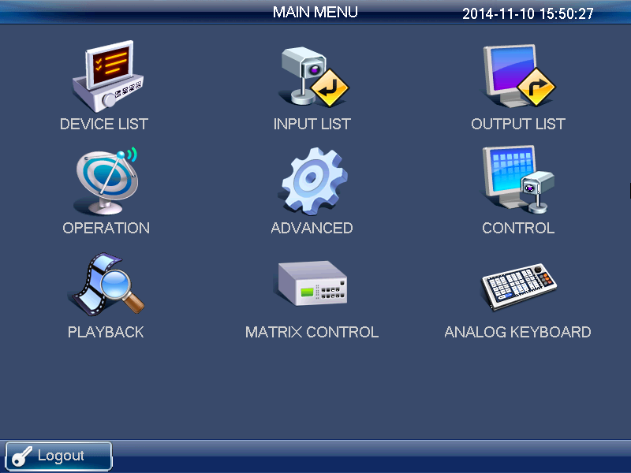
Figure 2-26

Device List
Click Device List button, you can view the device that current user can control. See Figure 2-27.
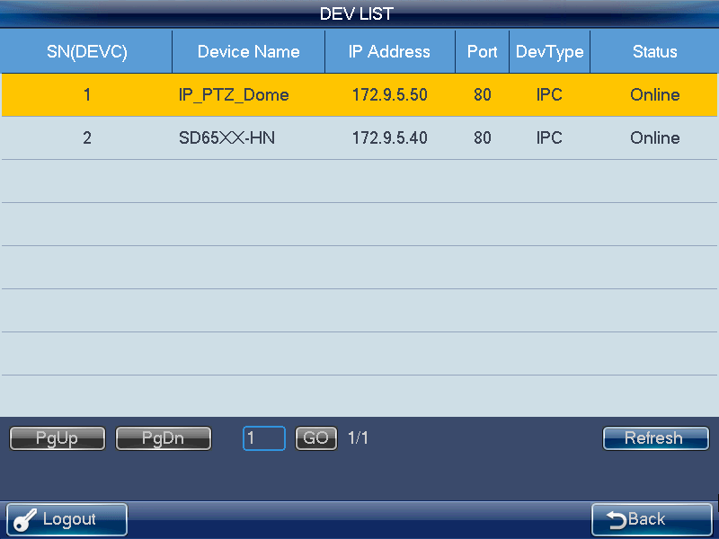
Figure 2-27

Input List
Here you can view the channel information of controlled device. See Figure 2-28.
Note
The channel name displayed here is the name system gets from the device.
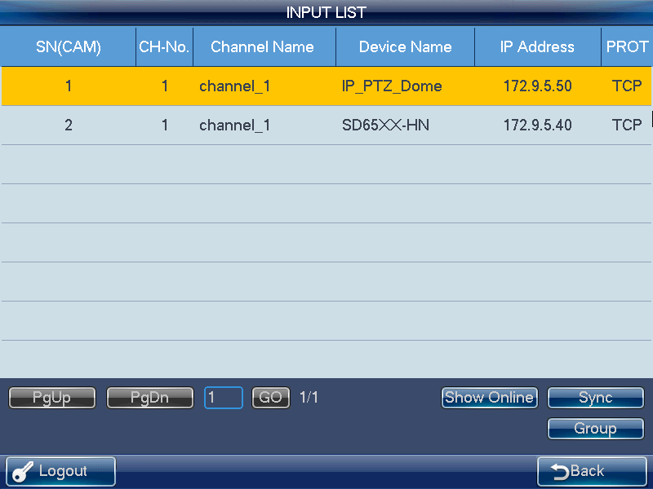
Figure 2-28
Sync
Click the Sync button; the device input list can synchronize the channel device monitor position name.
Group
Click Group button, you can go to the following interface. See Figure 2-29. You can select the group SN and then go to the group interface. There are 16 input groups and you can add/delete the monitor positions. You can also set the tour interval.
Note
This operation is mainly for the decoder group. Please refer to chapter 2.3.5.3 Decoder Operation for detailed information.
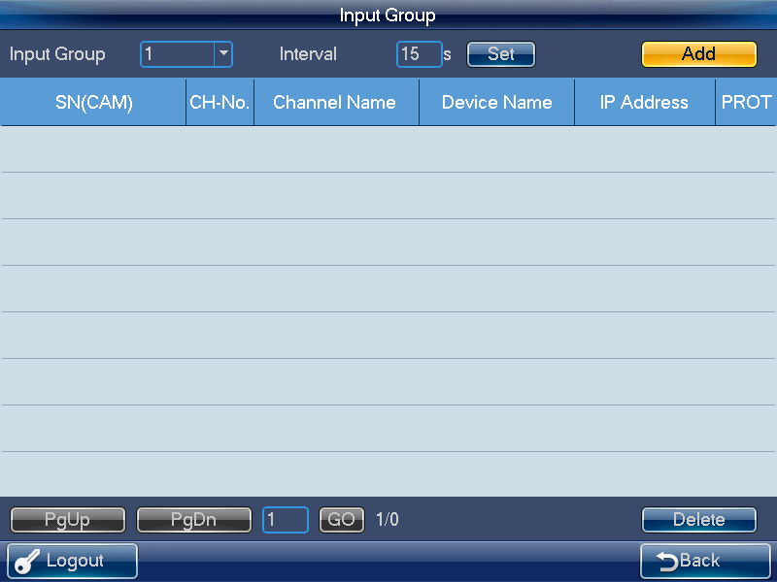
Figure 2-29

Output List
Click Output list button, you can go to the following interface See Figure 2-30.
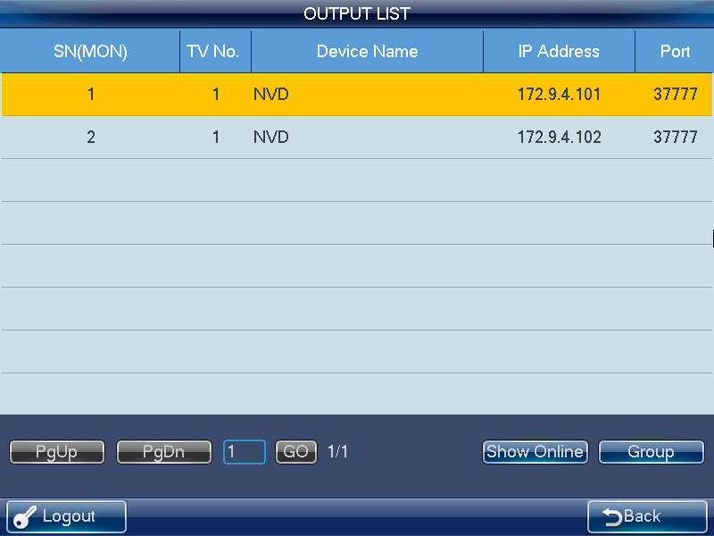
Figure 2-30
Group
Click Group button, you can go to the following interface. See Figure 2-31.
You can select the group SN and then go to the group interface. There are 16 output groups and you can add/delete.
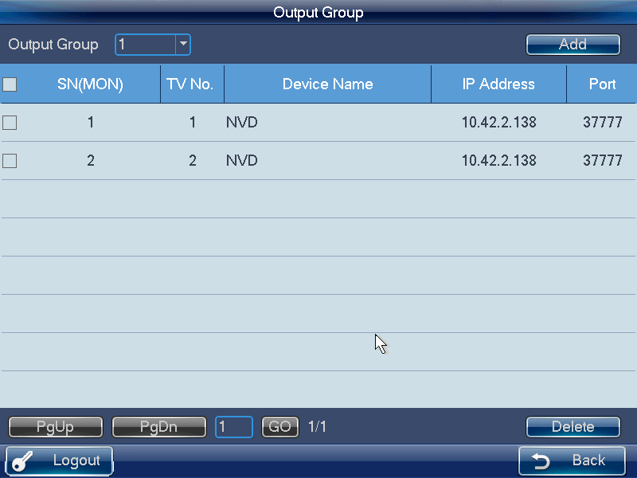
Figure 2-31
Delete
Check the corresponding box first and then click Delete button, you can delete the output port from the list.
Add
Click Add button, you can go to the corresponding interface.
Please check the corresponding output port and then click the Add button.

Remote Operation (Network Connection)
Basic operation
- Keyboard lock:: It is to lock the keys and mouse. The keys, joystick and touch panel are all null once you lock the keyboard. You need to click the unlock button to unlock the keyboard.
- Keyboard lock/unlock button: Click LOCK button first and then click the SHIFT button.
- The keyboard lock operation has the highest priority in the shortcut operations. During any operation in any interface, click the LOCK+SHIFT button, you can lock the keyboard.
Note
The keyboard becomes locked after screen automatically turns off.
- Delete: During the keyboard remote operation, ESC button have the delete function. You can use it to remove the latest input number.
Output screen No.+MON | Select output screen
Input source No.+CAM | Select video source to output to the wall.
Input source No.+PT | Open video from one channel
0+MON | Open local preview
0+CAM | Close video source of one window
0+PT | Go to 485 control
0+DEV | Go to 232 control device
SHIFT | Full-screen

Shortcut Operation
Remote operation
You can view current selected output channel on the left pane. Here you can select window display mode, the decoded input channel of each window and set other shortcut ways. You can view current input information and some shortcut setups on the right pane.

Local Preview
Local preview is to decode and playback the signal from the input channel at the keyboard local-end. You can implement other shortcut operations during the local preview process.
Please follow the steps listed below.
- Input number 0+MON, select the local preview operation.
- Input number i+MULT, select the window display amount. System now supports 1/4/8/9 /16-window mode.
- Input number j+WIN, select the output window j.
- Input number k+CAM, it is to output the signal from the channel k to window j via the keyboard decode.
For example, 0+MON+4+MULT+2+WIN+1+CAM means: Display in 4-window mode; output the video from channel 1 to the window 2 to preview.
- Input Number j+WIN+0+CAM, it can stop local preview function of window j.
Note
If the split mode remains the same, you can skip step 2), 3). You can use number+MON, number +CAM to output the video source to the wall to preview.
Select one window and click （NEXT）or （PREV）, you can increase or decrease the previous local decode video source number and then output it to current select window.

Decoder Operation
Window split Mode
Here is for you to set the window display mode. It is to output the selected channel to the specified windows.
Please follow the steps listed below.
- Input number i+MON, it is to select the output channel i. Please note 0+MON is the keyboard local preview.
- Input number j+MULT, it is to output the signal from channel i to display in j-window mode.

Output to the video wall
It is to display the signal from the selected channel via the decode output channel.
Please follow the steps listed below.
- Input number i+MON, it is to select output channel i.
- Input number j+WIN, it is to select current output window.
- Input number k+CAM, it is to output the input signal from channel k to the video wall via the output channel i of window j.
If you want to enable local video preview function, there are two ways:
- Input number j+WIN to select window and click ENTER button, click ENTER button again to close current preview.
- Input number j+WIN.
Select one window and click （NEXT）or （PREV）, you can increase or decrease current video channel number and then output it to current select window.
Note
Input number j+WIN+0+CAM, you can stop dynamic decode function of window j.

Output decoded video group to the video wall (Input group->output channel).
The function of the decoder is to output a selected group via the output decoded channel.
Detailed function:
- When the channel n in the group is smaller than the output channel window amount m, it is to decode dynamically. System outputs the input channel from the group to display in the windows respectively.
- When the channel n in the group is larger than the output channel window amount m, it is to realize the tour function from group to screen. The output channel window m is one output group and system decodes and outputs the input channel m by once. System repeats the output until the remaining input channel amount is smaller than the m.
Please follow the steps listed below.
- Input i+MON, it is to select output channel i.
- Input j+CAM-G, it is to output current input group j via the output channel i.

Decoded video group to the video wall (Input group->output window)
You can refer to the above contents for detailed information. The difference is that you need to select a window for the output channel. You need to set the input channel of the input group to one window of the output channel to enable the tour function. If there is only one input channel, it is just like the dynamical decode in the output window.
Please follow the steps listed below.
- Input i+MON, it is to select the output channel i.
- Input j+WIN, select the window j for current output channel.
- Input k+CAM-G, select to output the current input group k to the output channel window j to enable the tour function.

Decode video to the video wall (Input group->output group)
You can refer to the above contents for detailed information. If the channel amount n in the input group is smaller than or equal to the output window amount m in the output group (for example, output group 1 has two output channels, and each output channel has 4-window. There is total 8-window. Here you need to compare n and 8.). It is to decode the signal from the input channel to the output channel respectively. If the n is larger than m, system decodes and outputs m output channel until the remaining input channel is smaller than m.
Please follow the steps listed below.
- Input m+MON-G, it is to select the output group m.
- Input n+CAM-G, it is to output the input group n to the output group m to enable the tour function.

Playback of the decoder record
It is to control the output channel to playback the record file of the decoded input channel remotely. You need to select the output channel and input channel and set the corresponding playback time.
Please follow the steps listed below.
- Input i+MON, it is to select the output channel i.
- Input j+WIN, it is to select the window of current output channel.
- Input k+CAM, select input channel k. You can skip to the next step if current channel already decodes in current playback channel.
- Click  (PLAY/PAUSE), you can go to the decoder record file playback setting interface. (Right now, there is no playback in current window).
- Set playback start time and end time. Please input the time (second-minute-hour) and select the day-month-year. Click the OK button to begin the playback.
- During the playback process, you can click  (PLAY/PAUSE）to pause current operation, click ▀ (STOP) to stop playback. Click （ZOOM+） to enhance speed by one level and click （ZOOM-）slow speed by one level. See Figure 2-32.
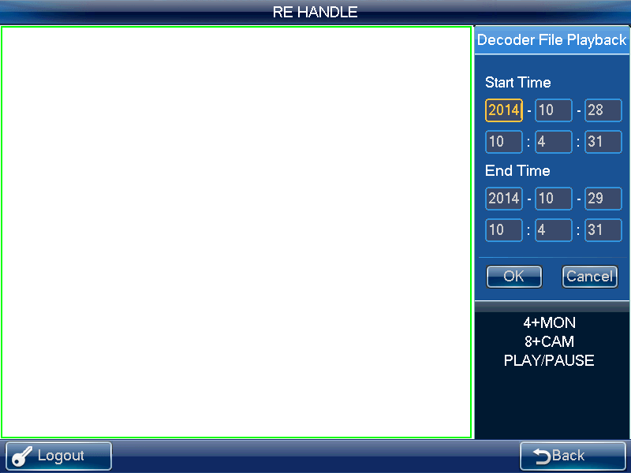
Figure 2-32
If you click (PLAY/PAUSE）or ▀ （STOP）without selecting a window, system begins or stops playback of the first window by default.
Note
Right now, system supports control decoder playback remotely. It does not support the local playback function.

PTZ
In the PTZ control mode, you cam use the network keyboard to control the PTZ operation. The interface is the same as when you are controlling via the Web. You can view the video from the control channel on the left pane and the PTZ control interface on the right pane.
You can input number i+PT to open PTZ operation interface. The number i refer to the channel number you input.
The PTZ interface is shown as below. See Figure 2-33.
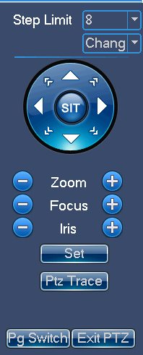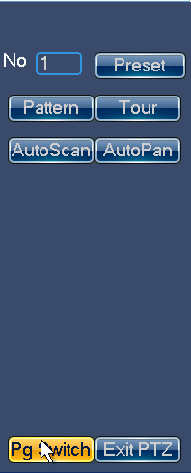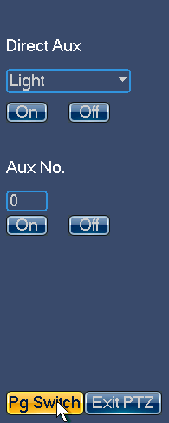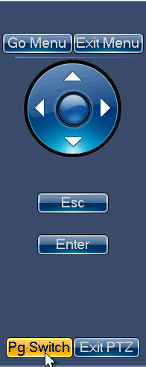
Figure 2-33
You can input the number (Step, preset and etc) from the panel. You can use the keyboard to control the PTZ, zoom, and use joystick to control the direction. You can also use mouse and touch panel. You can use the touch panel to control the positioning and PTZ.
Please refer to the following sheet for detailed information.
Button | Function
Number | Input step, preset and etc.
Joystick | Control PTZ direction.
Shuttle (Outer ring)// | Zoom +/-
Jog(Inner dial)// | Focus +/-
/  | Aperture+/-
 | Light
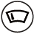 | Wiper
GOTO | Call preset
PATTERN | Pattern start /Stop
TOUR | Tour start /Stop
AUTOPAN | Pan start /Stop
ESC | Esc

Audio Talk
You can use the audio talk function to realize the bidirectional talk between the keyboard and the selected device.
Here we use “a+AUX” to enable the audio talk function. See chapter 2.3.9.3 for audio talk function setup.
In the local preview mode, you can follow the steps listed below.
- Input number i+WIN, you can select channel of one device for current window.
- Input number a+AUX, it is to enable the bidirectional talk with the selected window. Click AUX to exit audio talk.
Note
In the local preview mode, input number a+AUX, you can enable the bidirectional talk with device in the first window.

In any mode
- Input number i+DEVC, it is to select device on the keyboard device list.
- Input number a+AUX, it is to enable the bidirectional talk with the specified device. See Figure 2-34. Click AUX button to stop the bidirectional talk.
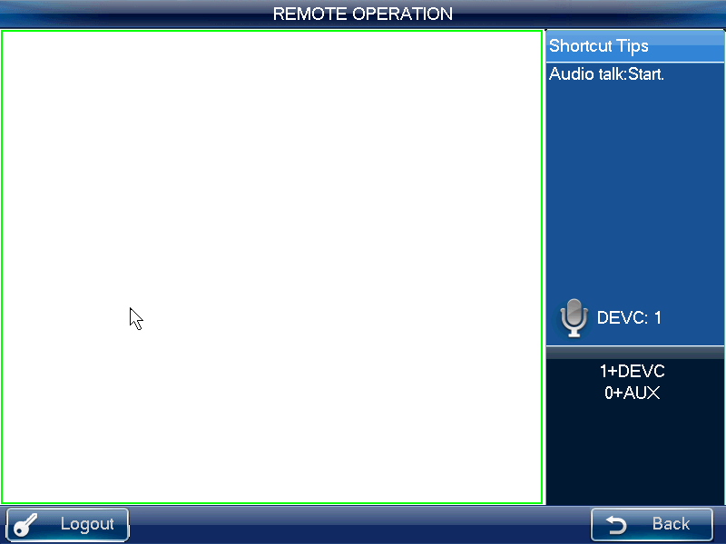
Figure 2-34

Snapshot
The snap function can only be valid in preview mode. The snap picture saved in the USB device or a FTP server (USB device has the higher priority). Please refer to chapter 2.3.9.3 for snapshot setup.
Please follow the steps listed below.
- Input number i+WIN, it is to select the window i for the output channel.
- Input a+AUX (Please make sure you have set a+AUX as the snap shortcut button) or button at the top of the joystick to enable network snap.
Note
- Snapshot function is valid in remote operation, remote control, and matrix mode.
- If you click the snapshot shortcut button directly, system snapshots the video in the first window by default.

Record
Download the record to the USB device (has higher priority) or the FTP server, you can playback the record from the remote storage device or USB device on the local keyboard.
- Local USB device record: During the preview process, you can select a preview window to record.
- Remote storage device record: You can select an input channel to record.
Please follow the steps listed below.
Open remote operation/remote control->local real-time preview, click the button on the top left.
- Click  to start record,
- Click to stop record.
- Click ESC button, system pops up the dialogue box asking you want to stop record and delete it now. Click the ENTER button or click the OK button on the dialogue box to delete.
Note
- In the preview mode, click the  button directly; system begins record the first window by default.
- In anytime, system can only record in one mode. You can not enable these two modes at the same time. The remote record stops once you exit the remote control interface.
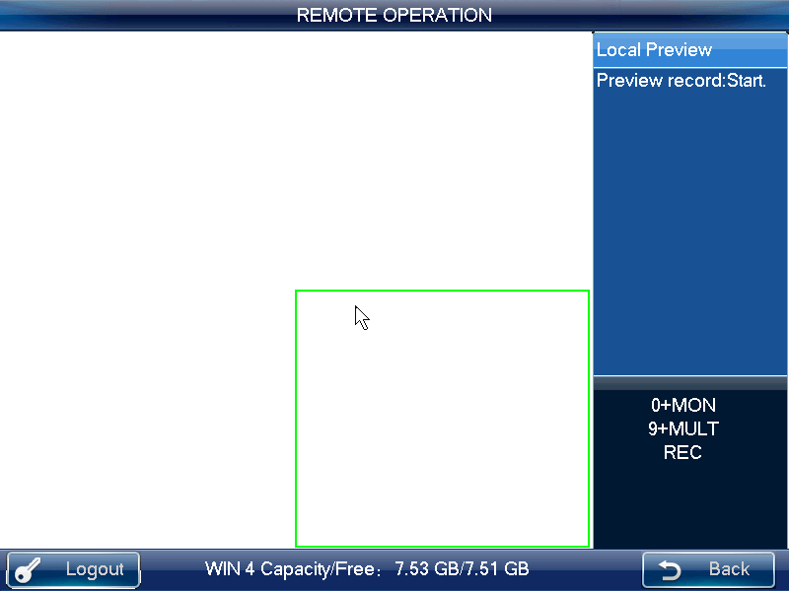
Figure 2-35
The local USB device record automatically stops when you switch the mode. The local record function can only be valid in the preview mode.

When one record is in process, if you enable the other mode, you can see system pops up a dialogue box for confirmation. You can click the OK button to stop current record and then enable the new one.

Remote Panel Simulation
In this mode, it works as the front panel. It simulates the front panel of the DVR. It supports shuttle/jog, number, record, playback, PTZ, OK, ESC and etc.
Please follow the steps listed below.
Input number i+DEVC+ENTER, number i is the DVR SN in the Device manager interface or the device list. You can click the DEVC to exit. See Figure 2-36.
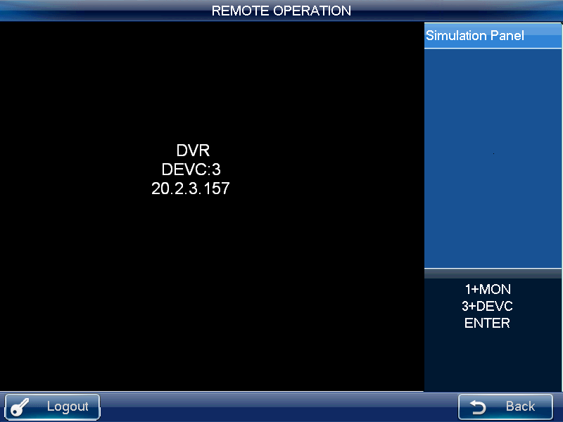
Figure 2-36
Please refer to the following sheet for detailed shortcut button information.
Button | Function
ENTER/Joystick button | Main menu
 | Record control
PT | Open the AUX function: PTZ control and color.
Play/pause | - Play normally when it is backward playing or in pause mode.  - Play when it is in pause mode.
Backward play/pause | - Play backward when it is in normal playback or in pause mode.  - Click it to pause playback when it plays backward.
Play previous | - When playback, click it to play the previous file.  - In menu setup interface, you can skip to the previous item.
Play next | - When playback, click it to play the next file.  - In menu setup interface, you can skip to the next item.

Record
Click the record button, you can see Record interface. You can use the shuttle/jog to set the channel number and status. Click the ENTER button to save current setup and click the ESC button to exit.
One-window/multiple-window mode switch
- Number+MULT: Set video window split amount.
- Number+CAM: Set channel number.
- Jog up/down: Change split amount.
- Jog left/right: Keep current split mode white change the video channel.
Operation mode:Number+CAM to select channel. System max supports 65535 channels.
PTZ control and color
In window-display mode, there are two ways for you to go to the PTZ control.
- Click the PT button in the keyboard to enable the AUX function: PTZ control and color. Select the PTZ control to see DVR PTZ control menu.
- Input number+PT, you can go to the PTZ control mode, now you can control the PTZ you previous specified in number+CAM. .

Remote Operation (RS232)

The keyboard setup after COM Connection
Before the operation, please make sure:
- The keyboard and the DVR connection are right.
- The DVR settings are right. In the DVR main menu, from Setting->RS232, in the Function item, please select net keyboard from the dropdown list. You need to set the baud rate, stop bit, data bit, parity and etc. System default setup is:
- Baud rate:9600:
- Data bit:8,
- Stop bit:1,
- Parity: none.
- For the keyboard, from the Advanced->COM, here you can input remote address, baud rate, data bit, stop bit and parity.
Note
- Remote address: It is a SN for the front-end to detect. It is the DVR No. in the General interface (Main menu->General).

Operation
In this interface, you can use the keyboard to control the DVR interface operation. It supports shutter (outer ring), jog (inner dial), number, record, playback, PTZ, confirm, ESC and etc.
Please follow the steps listed below.
Input number 0+DEVC+ENTER. Click the DEVC button to exit.
Important
Please logout the DVR local menu user before you login since the DVR local user has the higher priority than the keyboard user!

Refer to chapter 2.3.5.9 for record, 1-window/multiple-window mode switch, PTZ control and color setup information.

Remote Operation (RS485)

The keyboard settings after PTZ connection
Before the operation, please make sure:
- The A, B cable of the keyboard properly connects to the A, B cable of the speed dome.
- Turn on the speed dome and connect the video cable to the monitor.
- Set the speed dome address. Please make sure your keyboard RS485 address shall be the same with the speed dome address here.
- In the keyboard menu, from the Advanced->PTZ, you can set protocol, address, baud rate, data bit, stop bit, parity and etc. You can select the protocol according to your speed dome and RS485 address is the same as the speed dome.
- Please save current setup.

Operation
In this mode, you can use the network keyboard to control the PTZ of the speed dome.
Please input the number 0+PT to enable PTZ control.
Please refer to chapter 2.3.5.5 Pan/Tilt/Zoom for detailed information.

Remote Control
Remote control interface is shown as in Figure 2-37.
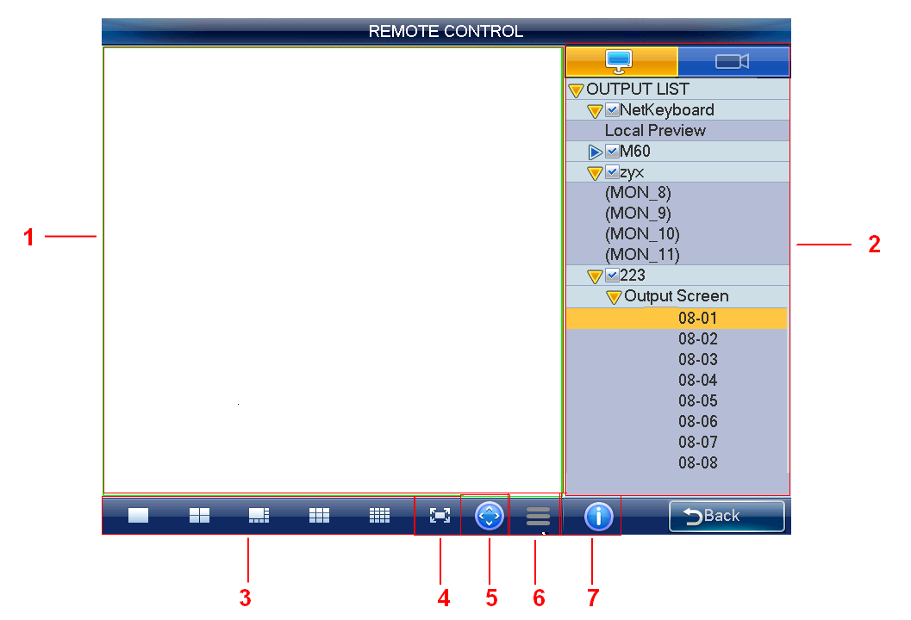
Figure 2-37
Please refer to the following sheet for detailed information.
SN | Name | Function
 | Preview | You can preview in the pane.
 | Input/output list | You can select input channel and output channel in the pane.
 | Window split | Set window display mode in current pane.
 | Full screen | Click it to preview in full-screen.
 | PTZ control | Click it to realize PTZ control.
 | Menu | Click it to record, snapshot and etc.
 | Device information | Click it to view connected device information.
Note
Except PTZ control and record/snapshot function of the local preview mode can use button, joystick, shuttle, the rest functions listed here do not support shortcut button.

Local preview mode
Local preview is to decode and playback the input channel signal on the keyboard. Please follow the steps listed below.
- From output list, network keyboard->local preview, and then double click local preview.
- Select window display mode on the window split pane.
- Select a window; double click an input channel on the input list or you can drag one channel to a window directly. Now you can preview the video from the selected channel on current window.

Decoder Mode
On the decoder mode, the video from one input channel can be decoded and then output to an output channel. Please follow the steps listed below.
- Double click an output channel from an output list. (Not local preview).
- Select window display mode on the window split pane.
Note
The screen of the decoder will change window display mode at the same time.
- Select a window; double click an input channel on the input list or you can drag one channel to a window directly. You can go to  to open preview if you want to enable keyboard local preview function. Now you can view the input channel video on current window.

PTZ Control
Important
You can only control PTZ after you open preview interface.
In the PTZ control mode, you cam use the network keyboard to control the PTZ operation. The interface is the same as when you are controlling via the Web. You can view the video from the control channel on the left pane and the PTZ control interface on the right pane.
Please refer to the chapter 2.3.5.5 for detailed information.

Menu Operation
The menu interface includes the following items.
- Start record: Click it to record current preview video. Or you can click (REC) to record.
Please note you need to insert USB device before you begin record operation, otherwise you can not record. The record files will be saved on the USB device.
- Snapshot: Click it to snapshot current video and save as one picture. You can press button at the top of the joystick to snapshot. The picture can be saved on the flash disk or on a FTP server. For detailed snapshot setup information, please refer to chapter 2.3.9.6.
- Close preview: Click it to close current preview video.
- Close window: Click it to close current window.
- Close all: Click it to close all windows.
- Open all: Click it to open all windows.

Advanced
The advanced interface includes: RS23, password, AUX, decode, MAC, snap, and backup. See Figure 2-38.
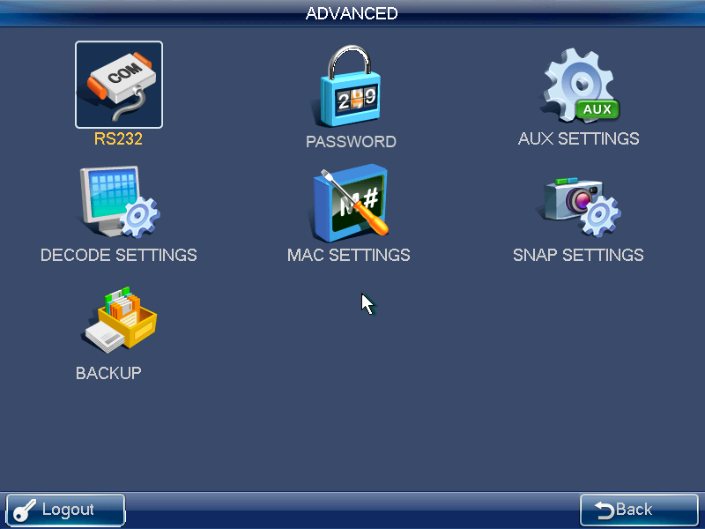
Figure 2-38

RS232
Click RS232 button, you can go to the following interface. See Figure 2-39.
Here you can set remote address, baud rate, data bit, stop bit, and parity.
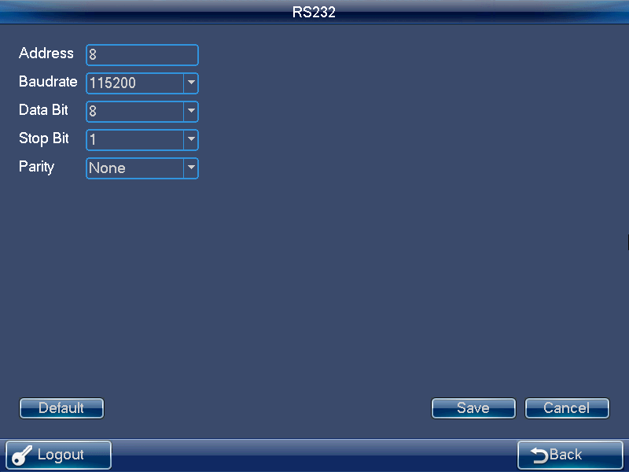
Figure 2-39

Password
The modify password interface is for you to change the password of current user. Please input the old password first, and then input the new password and confirm. You can click OK button to save new password. See Figure 2-40.
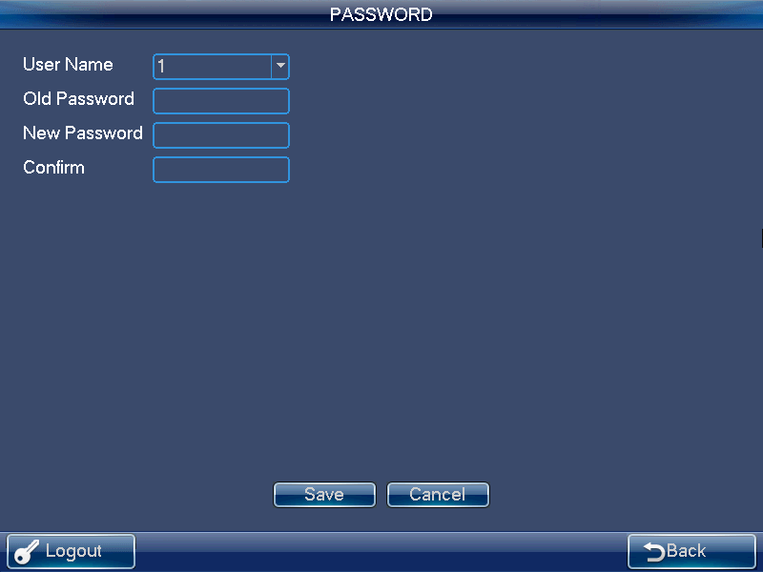
Figure 2-40

AUX Settings
The AUX settings interface is shown as below. See Figure 2-41.
The aux button ranges from 0 to 9. The shortcut operation supports audio talk and the snap. You can select the AUX button and click the OK button to realize the corresponding function. You can input the corresponding number+AUX to enable the function.
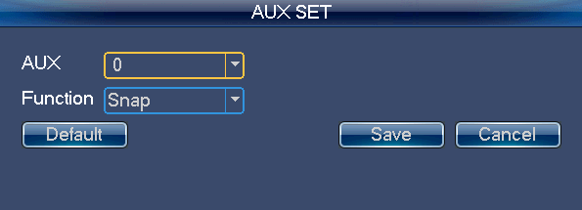
Figure 2-41
Note
System default AUX button setup is: 0 to enable snapshot and 1 to enable bidirectional talk.

Decode Settings
Click decode settings button, you can go to decode setting interface. See Figure 2-42.
You can select the channel name and decode type from the dropdown list.
The type includes: RT (real-time) priority, RT good, general RT and fluent (default), fluent good, fluent priority.
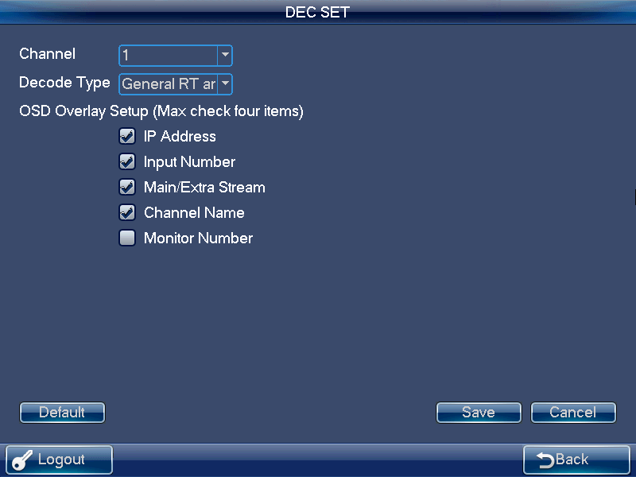
Figure 2-42

MAC Settings
On MAC interface, you can enjoy a shortcut to implement a series of operations. See Figure 2-43.
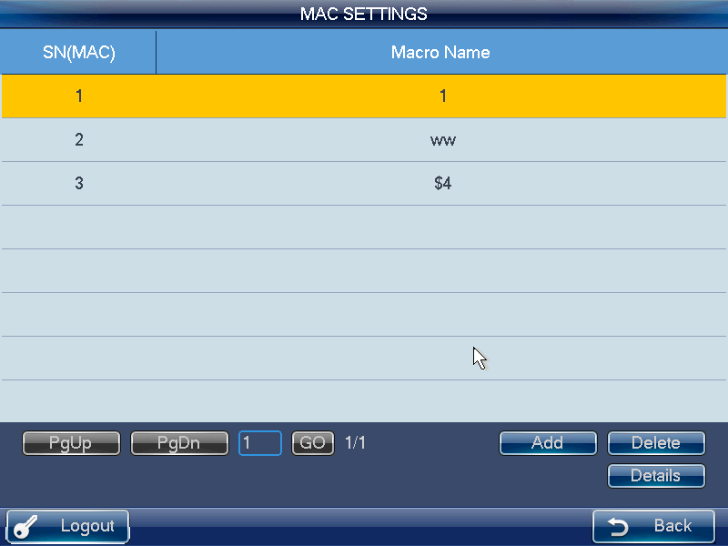
Figure 2-43
When the user is in the remote operation mode, click the previously set “Number+MAC” button, you can call the specified macro.
Click Add button, you can go to the corresponding interface. You can input customized macro name one by one and then click the Save button.
Note
For the macro already exists, it is read-only. Some keys do not support macro.

Snapshot
In this interface, you can save snapshot picture on a FTP server. Please follow the steps listed below.
- Click Snapshot button on the Advanced interface. You can see an interface. See Figure 2-44.
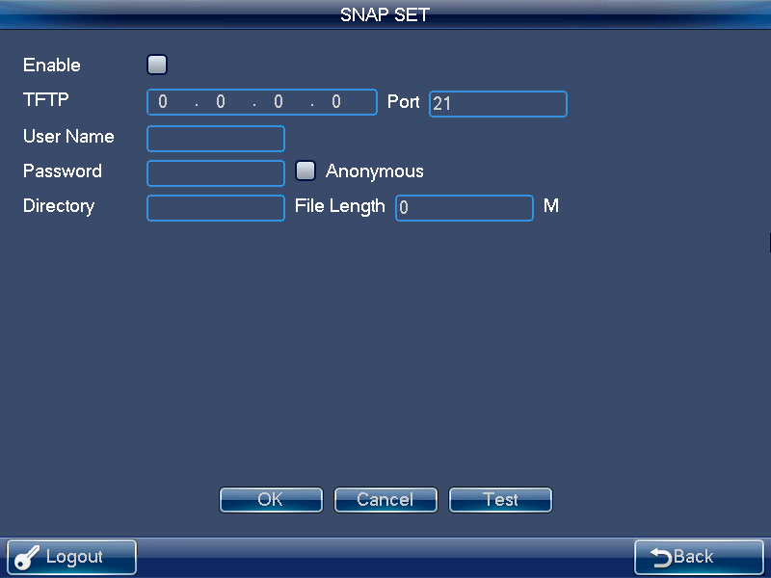
Figure 2-44
- Check the Enable box to open snapshot function and input FTP server IP, port, username, password and etc.
Note
- If you do not check the Enable box here, system does not connect to the FTP server. At the same time, if you have inserted a flash disk, all the snapshot pictures will be saved on the flash disk.
- If the FTP service and flash disk are both available at the same time, the FTP has the higher priority. That is to say, all snapshot pictures will be saved on the FTP server.
- The snapshot function is null if the FTP service and the flash disk are not available.
- Click Test button, system begins FTP test. You can see connection is OK once you see the corresponding interface.
- Click OK button, you can complete snapshot function.

Backup
In this interface, you can set pre-record time of the monitor video. See Figure 2-45. Please follow the steps listed below.
- Click Backup button on the Advanced interface. You can see an interface.
- Input pre-record value (such as 0 s to 5s) and click OK button to complete setup.
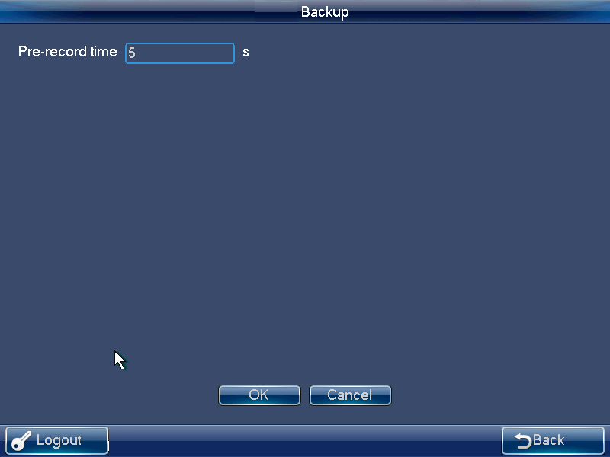
Figure 2-45

Playback
On the operator main menu, click playback, you can see the following interface. See Figure 2-46. Here you can search, playback, detect, backup, or delete the saved records.

The playback function supports record from local USB device record playback or the record from the remote storage device to be playback on the network keyboard. During the playback, it supports fast play, slow play or backup the records to the USB device.
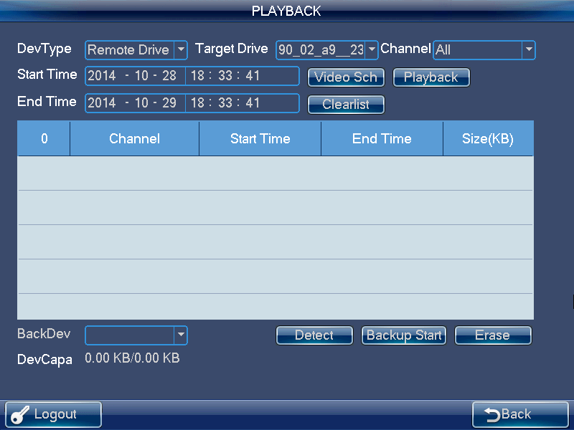
Figure 2-46

Matrix Control
On the main menu of the operator interface, click the Matrix control button; you can see the following interface. See Figure 2-47 .Here you can switch channel.
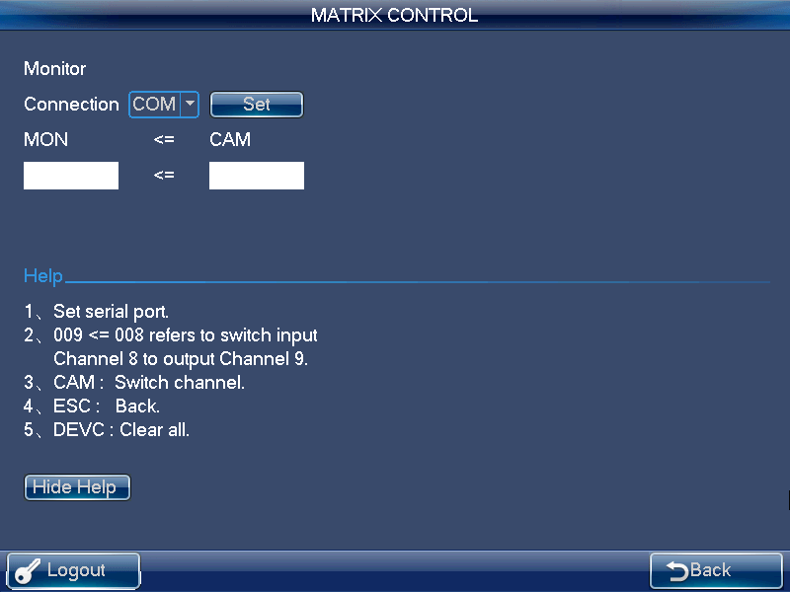
Figure 2-47

Keyboard Simulator
Note
Please makes sure your setup such as baud rate, data bit on the RS232 (Main menu-Advanced-RS232) are the same as the setup of the M60.

On the operator main menu, click keyboard simulator, you can see the following interface. See Figure 2-48. You can u control the M60.
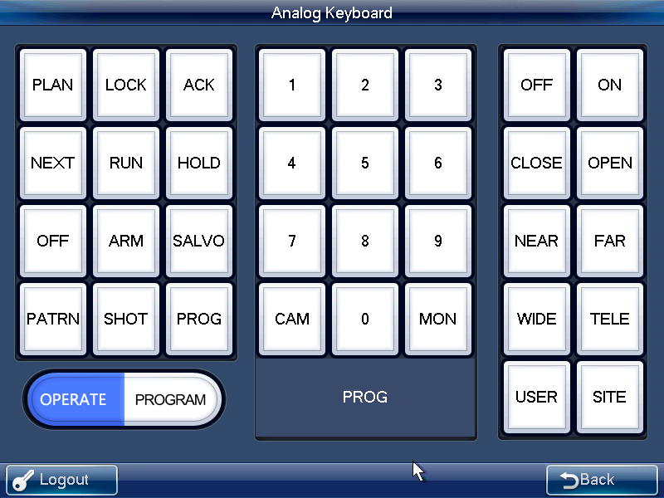
Figure 2-48
Open M60, from system->RS232, and then select matrix control.
Select OPERATE mode on the left corner.
Scheme No.+PLAN | Switch scheme
Output screen No.+MON | Switch output screen
Input source No.+CAM | Switch input source
Click OPEN button | Use PTZ control
Preset No.+SHOT | Call preset
Select PROGRAM mode on the left corner.
Preset No.+SHOT | Set preset

Matrix Mode Detailed operation
Matrix mode interface is shown as in Figure 2-49.
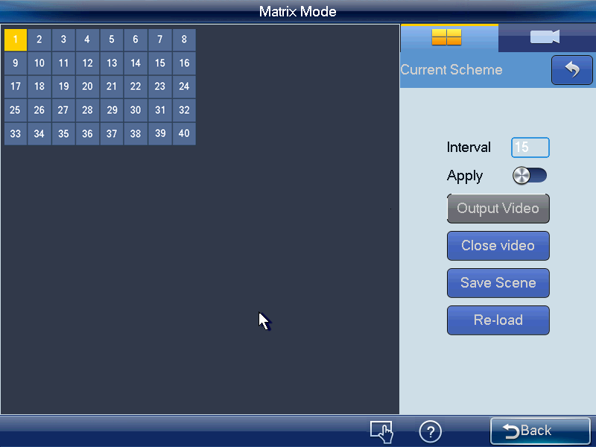
Figure 2-49
Note
In Figure 2-49, the grid length=100/ (max grid number of the length and width), the grid number of the column and the line shall be the same (recommended).
In this interface, the control tour and close preview operation of  is for the whole selected area. Click number 0+MON is to close all video source on the selected screen, and at the same time system updates the contents of the screen such as window split mode, tour time and etc.
Double click the splicing video wall you want to operate or input number i+MON on the keyboard, you can see an interface shown as below. See Figure 2-50.
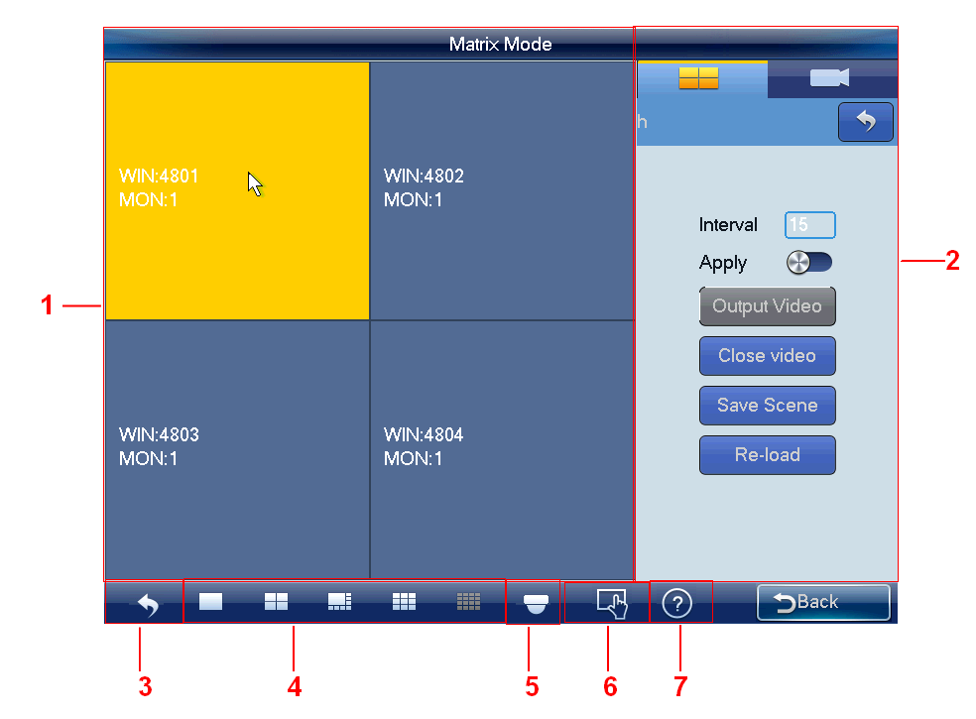
Figure 2-50
Please refer to the following sheet for detailed information.
SN | Name | Function
 | Preview | Real-time display screen, window, video source, tour and etc.
 | Input/output setting | Here is for you to implement scheme operation.
 | Return | Click it to return TV wall.
 | Window split | It is for you to set preview window display mode.
 | PTZ | Click it to realize PTZ control.
 | Menu | Implement tour control and close preview operation.
 | Device information | Click it to view device information or scheme SN．
Note
Here is to open all the contents you set on the matrix end. Click number 0+MON on the keyboard is to close all video sources of current screen.

Set Scheme
Scheme is for you to set video wall information such as window display mode, video source information, tour setup and etc.
Split mode: In this pane, you can set different window display modes.
You can also click number j+MULT to operate. There are two situations:
- You have selected a screen under the scheme mode, but there is no display, input number j+MULT to update screen contents.
- Once you switch to one screen, input number j+MULT, you can see screen display on j-window.
Video source information: Click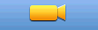, you can switch to input list interface. See Figure 2-51.
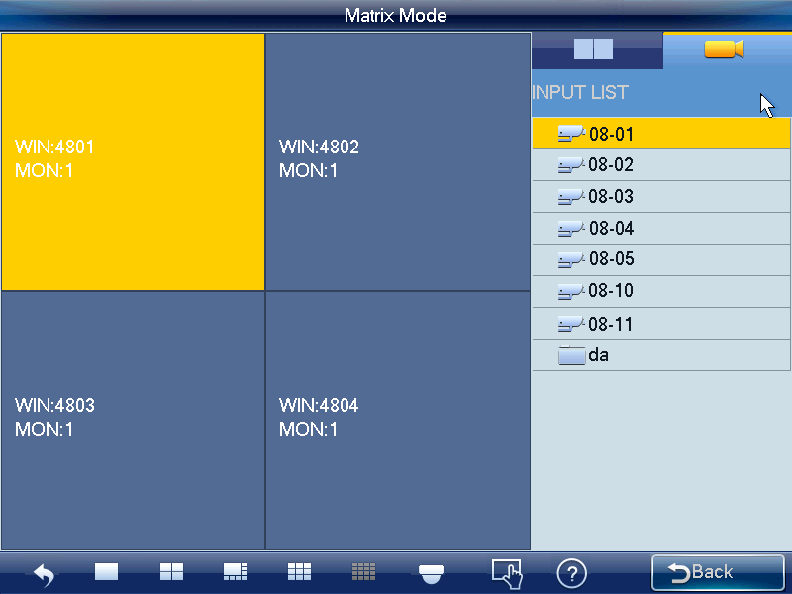
Figure 2-51
- Use mouse, touch panel or the keyboard to input number j+WIN to select one window. There are three situations:
- If there is no screen available, system switches to screen that contains this window and set this window as current one.
- If there is a screen available and the window is in current screen, set this window as current one.
- If there is a screen available but the window is not in the screen, then system switches to the screen that contains the window and set this window as current one.
- Input number k+CAM on the keyboard or select one channel and drag it to the window you selected in the first step; you can output the video to the window you specified at the matrix end. Or you can drag whole customized folder to the window, or click number k+CAM-G on the keyboard to output a group of video sources to the TV wall.
Select one window, click close preview of the , system closes the preview video of the output channel of the decoder.
Select one window, click （NEXT）or （PREV）, you can output the previous or next video source to the selected window.
Tour setup: In the Input and output setup interface, you can set tour time. When input the customized folder and the channel amount on the folder is larger than the output channel amount, system enables tour automatically. See Figure 2-52.
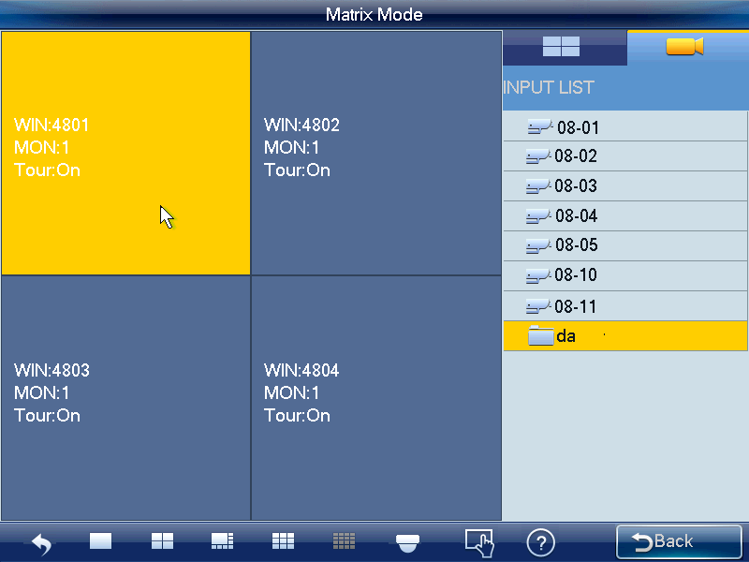
Figure 2-52
Click the control tour of the or click the TOUR on the keyboard, you can close the tour of the whole screen. Click Control tour or TOUR button again, you can enable tour function again.
Free window: On the matrix mode, you can use network keyboard to open window at anywhere you want. See Figure 2-53.
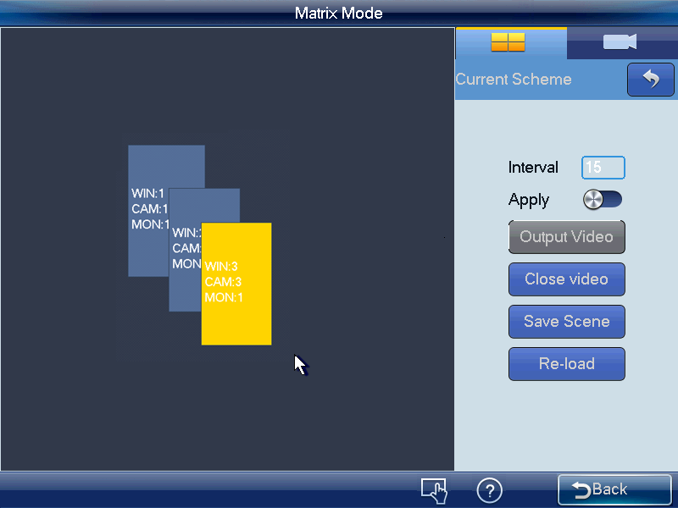
Figure 2-53
Please go to the WEB of the M60 to set the window amount and the position information, please refer to the M60 user’s manual for detailed information. You can only use keyboard to read the information, you can not set.
Note:
- On the Apply mode, all matrix setups can be changed automatically once you change the keyboard setup.
- On the output all mode, except window split mode, the rest setup can only be applied to the matrix end once you set on the keyboard and click output video button.
Click save scheme button, you can save current scheme setup. If you have not save, click reload button, you can go back to previous setup.
Click Close video button, you can close splicing video on the matrix end.

PTZ Control
In the PTZ control mode, you cam use the network keyboard to control the PTZ operation. The interface is the same as when you are controlling via the Web. You can view the video from the control channel on the left pane and the PTZ control interface on the right pane.
Click 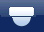 button, you can go to PTZ interface. Please refer to chapter 2.3.5.5 for detailed information.

Platform Mode Detailed Operation
Network keyboard works as a client of the platform. You can use platform to add, manage device, set TV wall and scheme. Please follow the steps listed below.
- Open IE browser, input DSS7016 server IP address on the address column. After successful connection, you can see the following interface. See Figure 2-54.
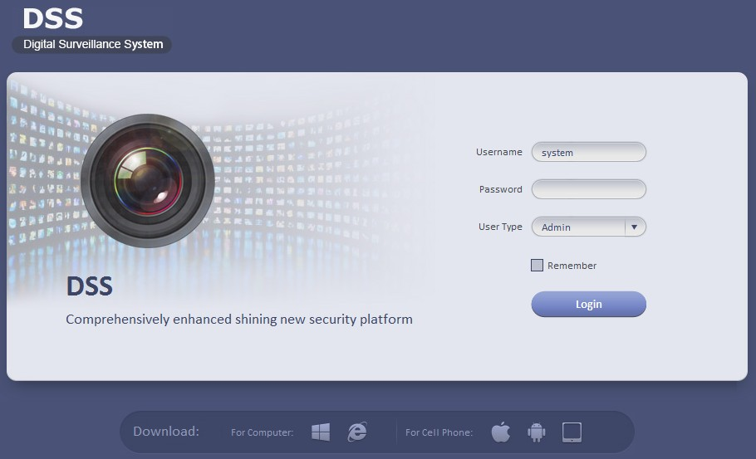
Figure 2-54
- Click the red highlighted button in Figure 2-55 , you can download and install client on your PC.
Figure 2-55
- In Figure 2-55, input user name and password, click Login button. System default admin user name is system and the password is 123456. For your security, please change your password after first login.

- On the WEB, from General->Account, you can click Add button to add a new role. See Figure 2-56. Here you can add a new role and use it to create new user. Check the reuse button in Figure 2-57 so that this account can be used by multiple uses at the same time.
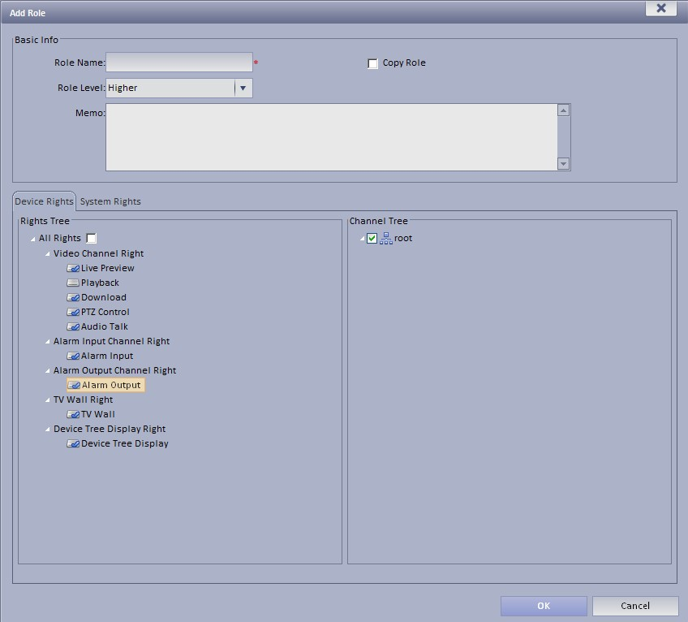
Figure 2-56
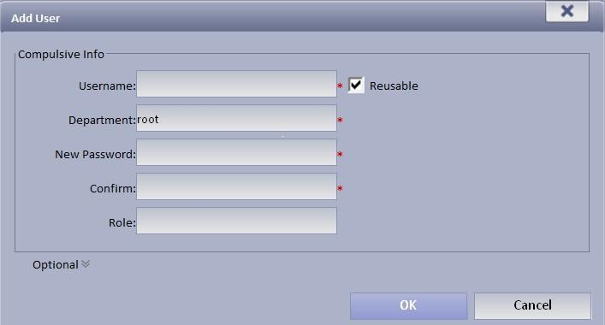
Figure 2-57
- On the WEB, from System->Parameters, check the Org/channel box and then submit. See Figure 2-58.
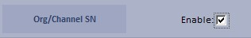
Figure 2-58
- On the WEB, from General->Device, add encoder (DVR/IPC), decoder(NVD/UDS), video wall(M30), matrix(M60).
Note
  - You can only see the Org/Channel SN after you implement according to step 5. This control SN can be modified if necessary. The keyboard can use it to switch videi source in the future. Click the edit button red highlighted in Figure 2-59, you can select camera type.
Figure 2-59
Figure 2-60
  - Please check the box to enable splicing function when you are adding the decoder. See Figure 2-61.
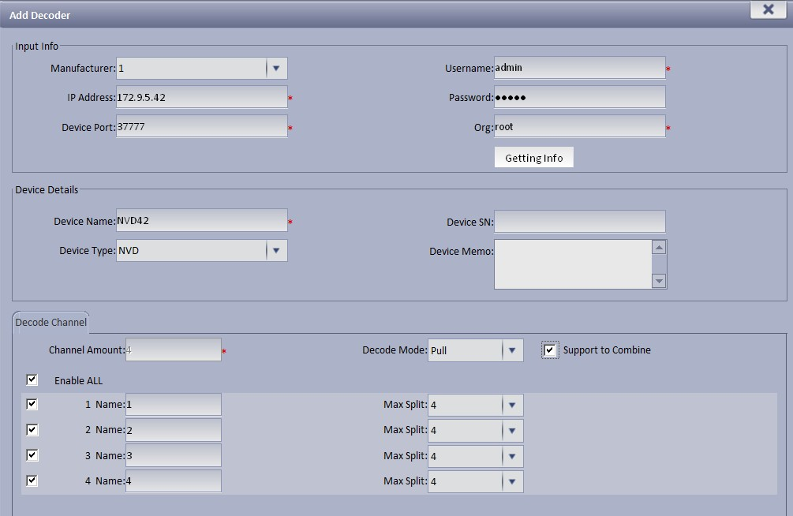
Figure 2-61
- On the WEB, from Business->TV wall, you can add TV wall, layout, splicing, bind decode channel and etc. See Figure 2-62.
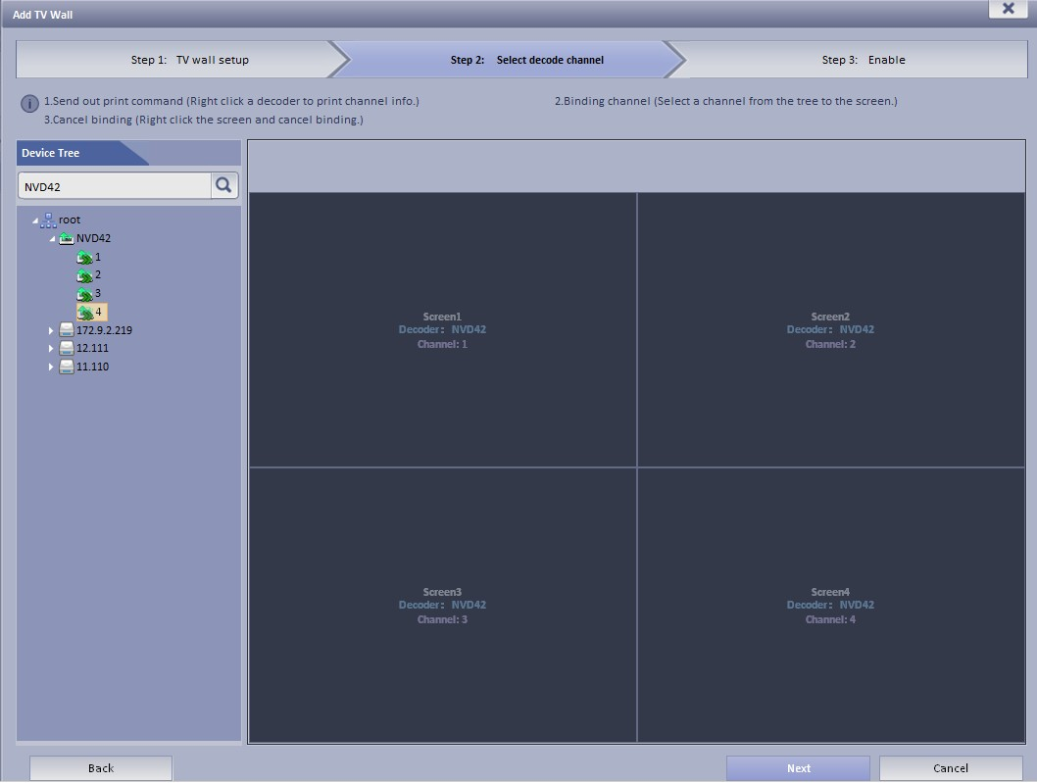
Figure 2-62
- Open the platform client you downloaded at step 2 and use the account you created in step 4 to login. See Figure 2-63.
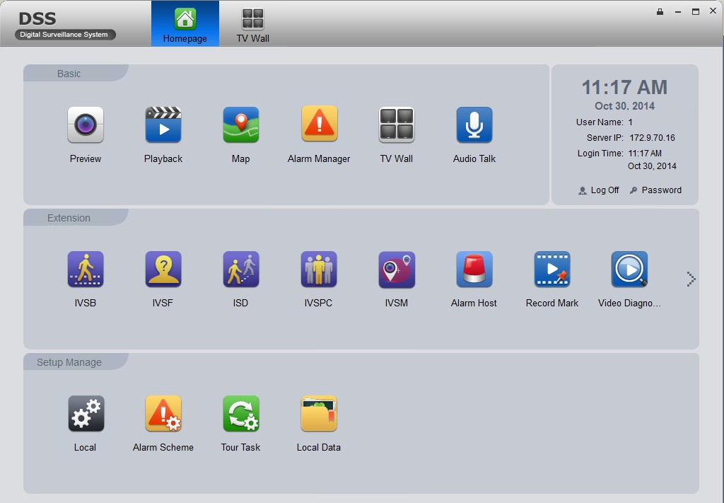
Figure 2-63
- From Basic->TV wall, you can select video source on the right pane of Figure 2-64 and then bind to save it as a task.
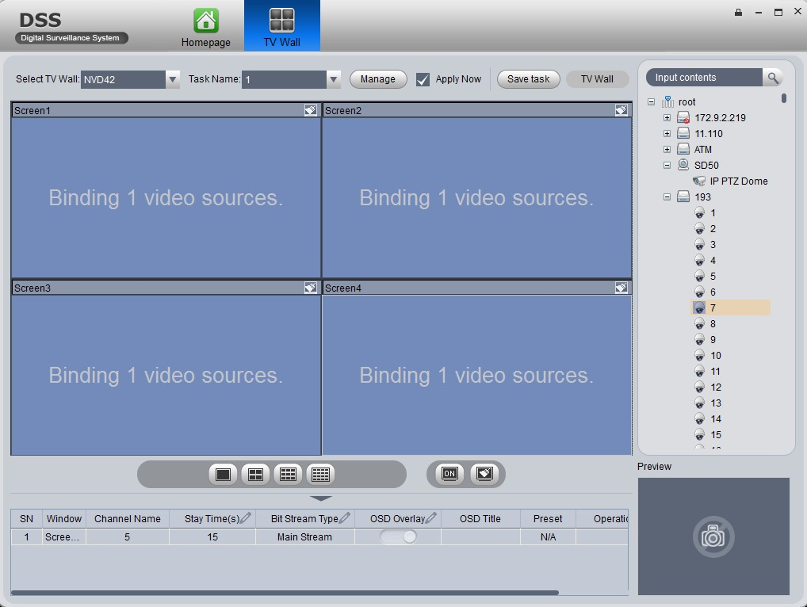
Figure 2-64
- On the network keyboard, select platform mode, you can see an interface shown as in Figure 2-65.
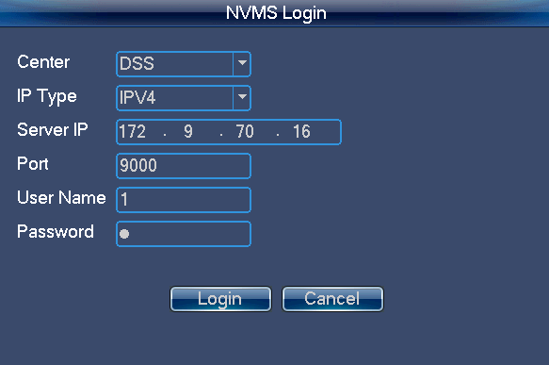
Figure 2-65
- Input DSS platform IP address, user name, password according to the information in step 1 and step3, click login. See Figure 2-66.
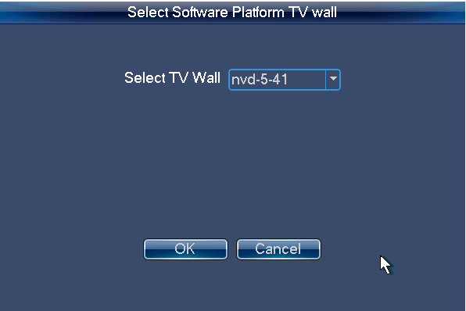
Figure 2-66
- Select the TV wall you set in step 7 and then click OK button. You can go to the platform control mode via the network keyboard. See Figure 2-67.
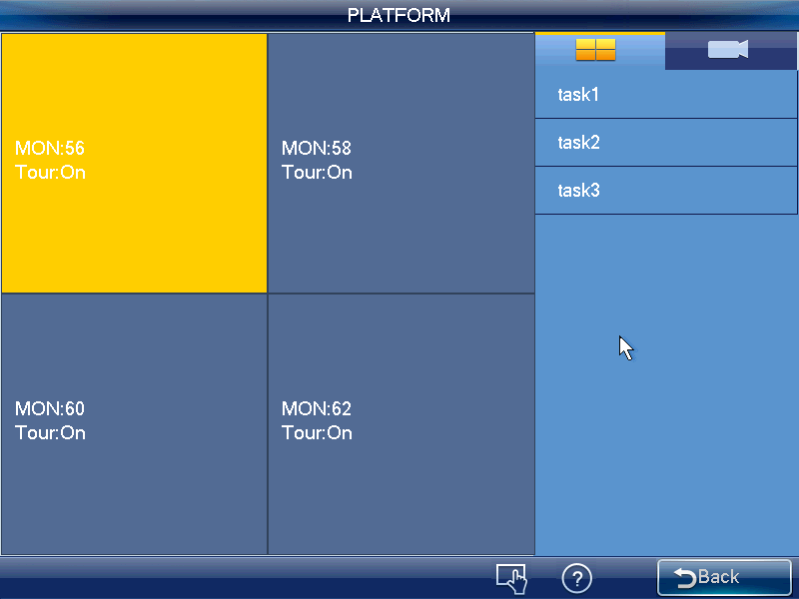
Figure 2-67
- Select the task list on the right pane and double click to load the scheme. See Figure 2-68.
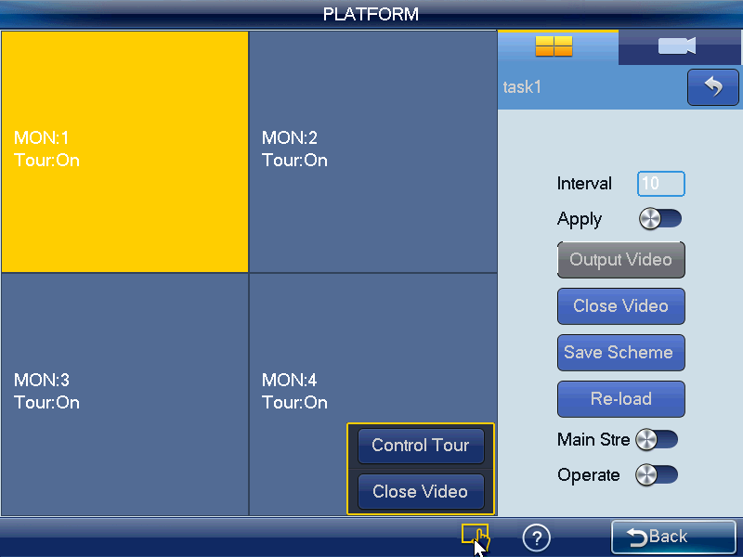
Figure 2-68
Double click a screen or click number i+MON, you can see an interface shown as in Figure 2-69.
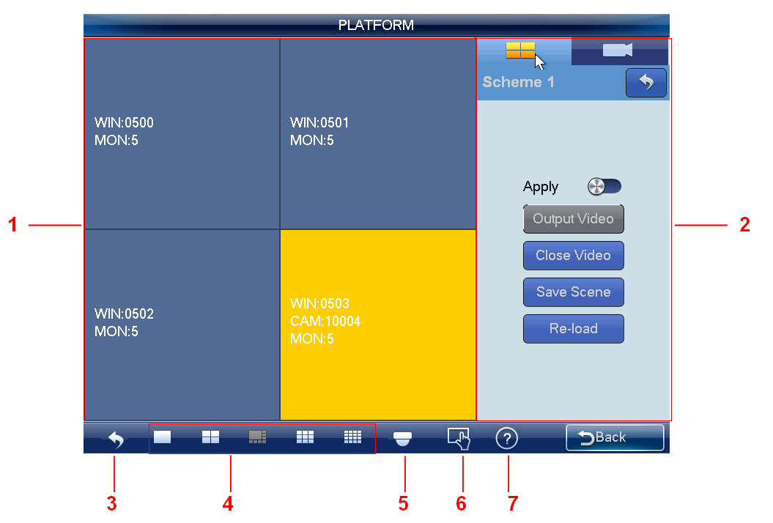
Figure 2-69
Please refer to the following sheet for detailed information.
SN | Name | Function
 | Preview | It is to display real-time information such as screen, window, and video source.
 | I/O setup | Here you can set scheme.
 | Back | Click it to back to TV wall.
 | Window split | It is to set preview window display mode.  Note  Splicing screen operation does not support 8-window display mode under platform mode.
 | PTZ | Support PTZ lock function for one window. Click LOCK button to lock or unlock. You can see the corresponding dialogue box if you have successfully locked current window. Otherwise the lock function fails.  Note  The user of higher authority can take the PTZ control right from the user of the lower authority. System automatically unlocks if there is no operation for 30 seconds.
 | Menu | There are two buttons: tour control/close preview.  - Enable/disable tour function: Keyboard has the operation mode/edit mode. In edit mode, you can modify tour plan and add video source to the tour group.  - Maximize decode window: Select a screen, double click or click ENTER button, you can maximize the screen or restore original size.  - Close the video source of one window: Select a window, click Close preview button, or input 0+CAM.  - Close all video sources on the whole screen: Select a screen, click Close preview button or input 0+CAM.
 | Device information | Click it to view device channel name or control SN.

Output video to the wall
Scheme is for you to set video wall information such as window display mode, video source information and etc.
Split mode: In this pane, you can set different window display modes.
You can also click number j+MULT to operate. There are two situations:
- You have selected a screen under the scheme mode, but there is no display, input number j+MULT to update screen contents.
- Once you switch to one screen, input number j+MULT, you can see screen display on j-window.
Video source information: Click, you can switch to input list interface. See Figure 2-70.
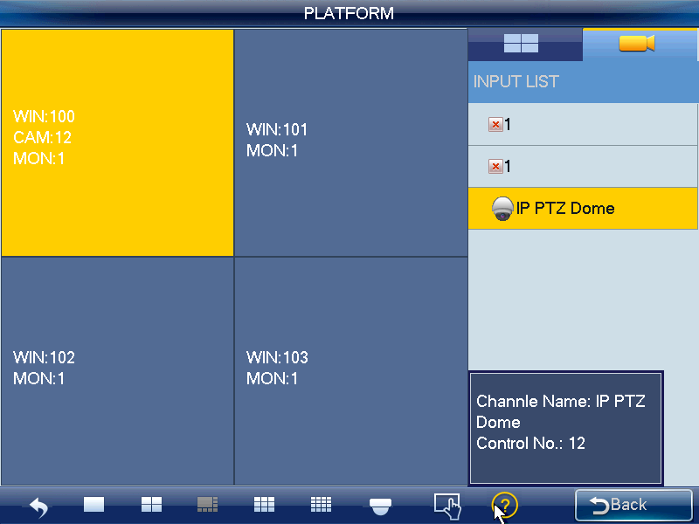
Figure 2-70
- Use mouse, touch panel or the keyboard to input number j+WIN to select one window. There are three situations:
- If there is no screen available, system switches to screen that contains this window and set this window as current one.
- If there is a screen available and the window is in current screen, set this window as current one.
- If there is a screen available but the window is not in the screen, then system switches to the screen that contains the window and set this window as current one.
- Input number k+CAM on the keyboard or select one channel and drag it to the window you selected in the first step; you can output the video to the window you specified at the DSS. Or select one window, click （NEXT）or （PREV）, you can output the previous or next video source to the selected window.
Open Window: System supports open window function under platform mode. See Figure 2-71.
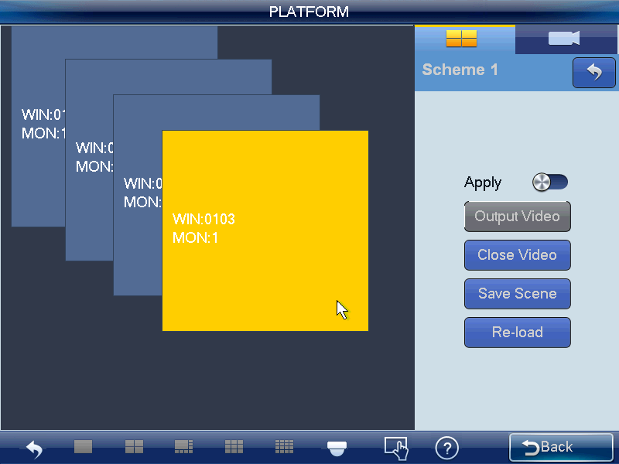
Figure 2-71
Note
When this function is on, you can not set window display mode; the window split mode button at the button of the interface is grey and null.

The window amount and window positions shall be set at the DSS client-end. You need to refer to the DSS manager user’s manual for detailed information. The keyboard can only read and can not set.

Note:
- On the Apply mode, all DSS setups can be changed automatically once you change the keyboard setup.
- On the output all mode, except window split mode, the rest setup can only be applied to the DSS once you set on the keyboard and click output video button.
Click save scheme button, you can save current scheme setup. If you have not save, click reload button, you can go back to previous setup.
Click Close video button, you can close current selected video on the TV wall.

PTZ Control
In the PTZ control mode, you can use the network keyboard to control the PTZ operation. The interface is the same as when you are controlling via the Web. You can view the video from the control channel on the left pane and the PTZ control interface on the right pane.
Please refer to chapter 2.3.5.5 for PTZ control, interface introduction and operation information.
Note
Tour function is null under platform mode and the tour button is invalid.

Appendix Toxic or Hazardous Materials or Elements
Component Name | Toxic or Hazardous Materials or Elements
Component Name | Pb | Hg | Cd | Cr VI | PBB | PBDE
Sheet Metal(Case) | ○ | ○ | ○ | ○ | ○ | ○
Plastic Parts（Panel） | ○ | ○ | ○ | ○ | ○ | ○
Circuit Board | ○ | ○ | ○ | ○ | ○ | ○
Fastener | ○ | ○ | ○ | ○ | ○ | ○
Wire and Cable/AC Adapter | ○ | ○ | ○ | ○ | ○ | ○
Packing Material | ○ | ○ | ○ | ○ | ○ | ○
Accessories | ○ | ○ | ○ | ○ | ○ | ○

O: Indicates that the concentration of the hazardous substance in all homogeneous materials in the parts is below the relevant threshold of the SJ/T11363-2006 standard.

X: Indicates that the concentration of the hazardous substance of at least one of all homogeneous materials in the parts is above the relevant threshold of the SJ/T11363-2006 standard.

Note:
- This quick start guide for reference only, Slight difference may be found in user interface..
- All the designs and software here are subject to change without prior written notice.
- All trademarks and registered trademarks mentioned are the properties of their respective owners.
- If there is any uncertainty or controversy, please refer to the final explanation of us.
- Please visit our website or contact your local retailer for more information.

