Keyboard Operating Manual

Version 1.2

Table of Contents
Welcome 5
Important Safeguarding and Warnings 6
1 Features and Specifications 7
1.1 Features 7
1.2 Specifications 7
2 Keyboard Function 8
2.1 Keyboard Appearance 8
2.2 Key Function List 8
2.3 Keyboard Ports 10
2.4 Port Features 11
2.5 Power 11
3 Menu Tree 12
3.1 Input Method 13
3.2 Log In 13
4 Menu Operation 14
4.1 Local Setup 14
4.1.1 Network Setup (for network keyboard only) 14
4.1.2 Time Setup 14
4.1.3 Address Setup 14
4.2 CTL Point 14
4.2.1 ID 15
4.2.2 Device Name 15
4.2.3 Device Type 15
4.2.4 Connection Type 15
4.3 Advanced 16
4.3.1 Password 16
4.3.2 User Management 17
4.3.3 Set Local as Default 18
4.3.4 Empty Control Point 18
4.4 Assistant Setup 18
4.4.1 Backlight Setup 18
4.4.2 Alarm Setup 18
4.4.3 Language 18
4.5 System Information 18
4.6 Control Point 19
4.6.1 ID 20
4.6.2 Machine Name 20
4.6.3 IP Address 20
4.6.4 RS232 20
4.6.5 RS485 20
5 Keyboard Control DVR 21
5.1 Serial Port Connection 21
5.1.1 RS232 Serial Port Connection 21
5.1.2 Via RS485 Connection 21
5.1.3 Multi-keyboard link via RS485 22
5.2 Network Connection (For network keyboard only) 22
5.2.1 RJ45 port connection 23
5.3 DVR and Keyboard Setup 23
5.3.1 DVR Setup 23
5.3.2 Keyboard Setup after Serial Port Connection 24
5.3.3 Keyboard Setup after Network Connection 25
5.4 Operation 25
5.4.1 Login 25
5.4.2 Logout 25
5.4.3 Record 25
5.4.4 PTZ Control and Image Color 25
5.4.5 Tour and Single/Multiple Window Switch. 25
5.4.6 Network keyboard backup (USB backup) 26
6 Network Keyboard Control Dome 27
6.1 Cable Connection 27
6.2 Keyboard Setup 27
6.3 Operation 27
6.3.1 Direction Setup 28
6.3.2 Preset 28
6.3.3 Scan 28
6.3.4 Tour 29
6.3.5 PATTERN 29
6.3.6 Pan Rotation 30
7 Keyboard Upgrade 31
7.1 Control Keyboard Upgrade 31
7.2 Network Keyboard Upgrade 31
8 Make COM Cable 33
8.1 Make RS232 COM Cable 33
8.2 Make RS485 COM Cable 33
8.3 25-pin Port and Switch Box Connection 33

Welcome
Thank you for purchasing our network keyboard!
This operating manual is designed to be a reference tool for the operation of your keyboard.
Here you can find information about this keyboard features and functions, as well as a detailed menu tree.
Before operation please read the following safeguards and warnings carefully!
Please keep this operating manual well for future reference!

Tips
You can refer to chapter 8 for COM cable connection information.

Important Safeguarding and Warnings
All installation and operation should conform to your local electrical safety codes.
We assume no liability or responsibility for all the fires or electrical shock caused by improper handling or installation
All the examination and repair should be done by the qualified service engineers.
We are not liable for any problems caused by unauthorized modifications or attempted repair.

Features and Specifications

Features
This series keyboard has the following features
- One keyboard can control multiple DVRs, or you can use multiple keyboards to control one DVR.
- Support dome operation.
- Support RS485 port and RS232 port.
- Support PTZ operation via joystick
- Support all operations you get from DVR front panel function keys
- Support keyboard lock function
- Support multiple-level operation rights
- Support level-link
- Support single or multiple DVRs’s menu setup
- On-screen menu, user-friendly procedure. It is very easy for you to operate
Besides above mentioned features, network keyboard also has the following features:
- can control network video server and network video decoder
- support network ports connection
- can receive DVR alarm information, support one-channel activation on alarm,
- USB port support network backup DVR video data.

Specifications
Working Temperature | 0℃-+55℃
Weight | 2．5Kg
Dimension | 320mmx190mmx50mm（Includes joystick height 100mm）
Working Power | 12VDC 1200mA
LCD Dimension | 84mm x 31 mm

Keyboard Function

Keyboard Appearance
The keyboard appearance is shown as below. See Figure 2-1.
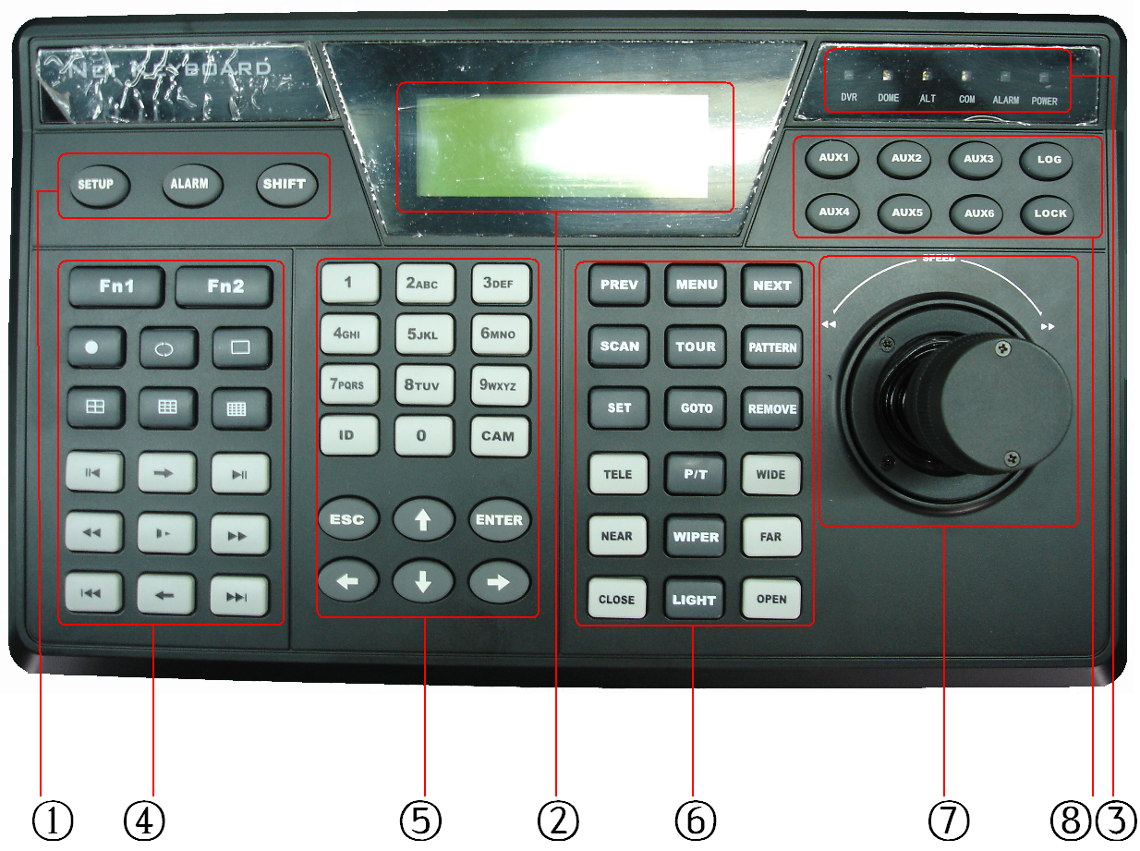
Figure 2-1
  - Function key: There are three function keys: SETUP/ALARM/SHIFT
  - LCD: Here is to display on-screen menu.
  - Indication light: There are six indication lights. DVR/DOME/ALT/COM/ALARM/POWER.
  - DVR function: Here are operation keys for you to control DVR.
  - Public function: Here includes ten numeral keys, four direction keys, ESC/ENTER and ID/CAM.
  - Dome matrix function: Here are operation keys for you to control dome or matrix.
  - Joystick
  - Assistant function: from AUX1 to AUX 6, log and lock key.

Key Function List
Serial number | Name | Symbol | Function
Function  key | Setup | SETUP | Shortcut key to enter function setup menu
Function  key | Alarm | ALARM | Shortcut key to enter alarm setup menu
Function  key | Shift | SHIFT | Switch between input methods
LCD | Liquid crystal displayer |  | Display on-screen menu
Indication  light | DVR indication  light | DVR | Light turns on when connected with DVR
Indication  light | Dome indication  light | DOME | Light turns on when connected with dome
Indication  light | Other indication  light | ALT | Light turns on when connected with other devices
Indication  light | Serial port indication light | COM | Light turns on when connected with serial port device
Indication  light | Alarm indication light | ALARM | Light turns on when connected with alarm  devices
Indication  light | Power indication light | POWER | Light turns on when keyboard connected with power and works properly.
DVR  function key | Assistant function  key | Fn1 | In single surveillance mode, click Fn1 to display PTZ and image color setup menu.
DVR  function key | Assistant function  key | Fn1 | In motion detection setup, working with other  keys
DVR  function key | Assistant function  key | Fn1 | When playback, click Fn1 to display or hide process bar.
DVR  function key | DVR assistant function  key 2 | Fn2 | In DVR menu, click Fn2 to select an input  method.
DVR  function key | Tour |  | Activate tour function
DVR  function key | Single window display mode |  | Single window display mode
DVR  function key | Four  window display mode | ⊞ | Turn to four window display mode
DVR  function key | Nine  window display mode | ▦ | Turn to nine window display mode
DVR  function key | Sixteen window display mode | ▦ | Turn to sixteen window display mode
DVR  function key | Record |  | Record/play
DVR  function key | Backward  /Pause | / | Video backward play or pause
DVR  function key | Play frame by frame | → | Play video frame by frame
DVR  function key | Play/Pause | II | Play/pause
DVR  function key | Play/Pause | II | When DVR is in real-time surveillance mode, system goes  to video search menu,.
DVR  function key | Fast backward |  | Fast backward playback
DVR  function key | Slow play | ► | Various slow play speeds
DVR  function key | Fast  forward |  | Various fast play speeds
DVR  function key | Previous |  | Play the previous video
DVR  function key | Next |  | Play next video
DVR  function key | Reverse play frame by frame | ← | Reverse play frame by frame
Public  function | Character and numerals | 0-9 | Switch between numeral/characters, click Shift  to switch.
Public  function | Device ID | ID | Shortcut key to go to ID control point search
Public  function | Device channel number | CAM | Control DVR channel.
Public  function | Cancel | ESC | Cancel current operation
Public  function | Cancel | ESC | In playback mode, click this key to go back to dynamic surveillance mode.
Public  function | Confirm | ENTER | Confirm current operation
Public  function | Direction keys | up   down | In single surveillance mode, click up/down to switch between various channels.
Public  function | Direction keys | up   down | Modify numeral
Public  function | Direction keys | up   down | Modify setup
Public  function | Direction keys | up   down | PTZ control switch
Public  function | Direction keys |  left  right | In dynamic surveillance mode, click left/right  key to switch between single window display  and multiple window display mode.
Public  function | Direction keys |  left  right | PTZ control switch
Dome/  Matrix key function | Previous page | PREV | In dome menu, working with other keys.
Dome/  Matrix key function | Dome  menu | MENU | In dome menu, click this key to enter dome  menu shortcut key.
Dome/  Matrix key function | Next page | NEXT | In dome menu, working with other keys.
Dome/  Matrix key function | Scan | SCAN | System pops up scan menu
Dome/  Matrix key function | Tour | AUTO-PAN | System pops up auto tour menu
Dome/  Matrix key function | Pattern | PATTERN | System pops up pattern menu
Dome/  Matrix key function | Set  preset | SET | System pops up preset setup menu
Dome/  Matrix key function | GOTO preset | GOTO | System pops up go to preset menu
Dome/  Matrix key function | Remove preset | REMOVE | System pops up delete preset menu
Dome/  Matrix key function | Iris  zoom in | TELE | PTZ iris zooms in
Dome/  Matrix key function | PTZ | P/T | PTZ operation shortcut key
Dome/  Matrix key function | Iris  zoom out | WIDE | PTZ iris zooms out
Dome/  Matrix key function | Focus  zoom in | NEAR | PTZ focus zooms in
Dome/  Matrix key function | Wiper | WIPER | Shortcut key to control dome wiper operation
Dome/  Matrix key function | Focus  zoom out | FAR | PTZ focus zooms out
Dome/  Matrix key function | Lens  zoom out | CLOSE | PTZ lens zoom out
Dome/  Matrix key function | Lens  zoom in | OPEN | PTZ lens zoom in
Dome/  Matrix key function | Light | LIGHT | Control dome light
 | Joystick |  | Assistant menu and function key operation.
Assistant function  key | AUX1-----  AUX6 |  | Assistant key
Assistant function  key | LOG | LOG | Shortcut key to search log files
Assistant function  key | LOCK | LOCK | Shortcut key to lock keyboard

Keyboard Ports
Please refer to Figure 2-2 for keyboard port information.
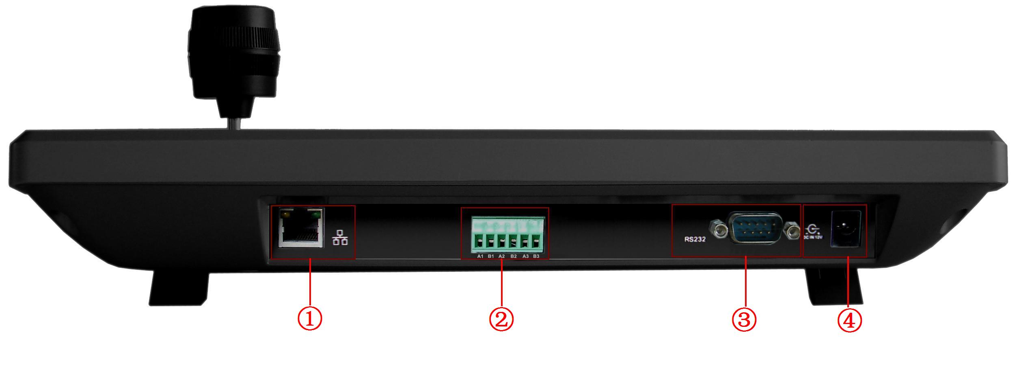
Figure 2-2
① RJ45 network port ② RS485 port ③ RS232 port ④ Power socket

Port Features
RS232 can directly connect with DVR. The distance should be within 10m.
One RS232 port could only connect with one DVR. You must use 485-> 232 converters to connect more DVRs.
RS-485 transmission distance is 1200 m（9600bps），max 3000 m.
In level-link mode, one RS-485 port can connect with as many as 16 keyboards.
You can connect RJ45 with DVR and realize front device multiplex control via the network keyboard.

Power
The keyboard uses +12V DC, you can use +12V adapter included in the accessories package. See Figure 2-3.
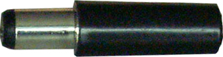
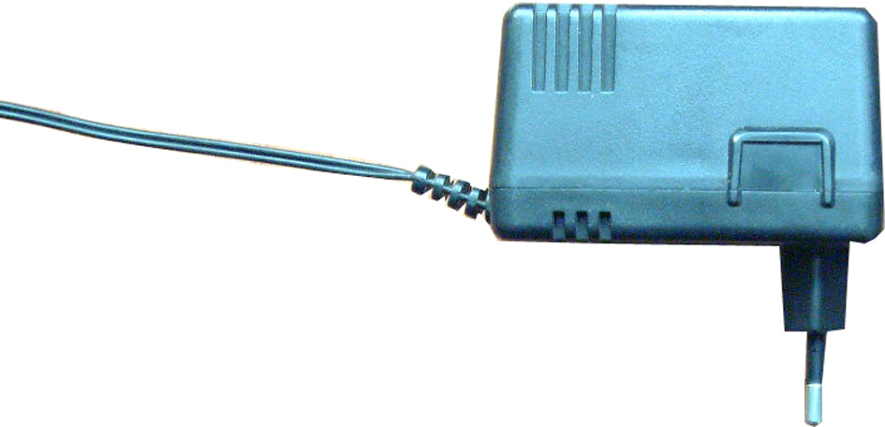
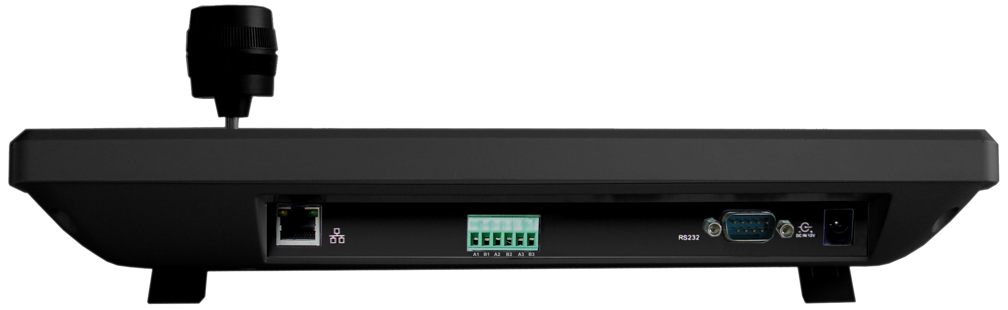

Figure 2-3

Menu Tree
Net setting
Time setting
Key board menu tree is shown as below.
Address setting
Local
ID
Device name
Menu operation
CTL Point
Device type
Network connection
Connection type
RS232

Password

RS485

User management
Advanced
Default

MENU
MENU
Empty point
Backlight

Assistant
Alarm setup

Language

Version
Date
System Info
Connection type

Point Information

ID

Machine

IP

Control point
RS232

RS485

Input Method
Click SHIFT, you can switch between numeral/capitalized character/small character.
- : Numeral
- A: Capitalized character
- @ Small character.

Log In
Plug in power socket, power indication light is on. You can see welcome information in LCD.
Network keyboard
2006-12-20 14.00.00

Click Enter or SETUP, system pops up a dialogue box. Now you can input user name and password.
The default user is admin, password is 888888.
User name:
Password:

Menu Operation
Menu operation includes five items:
- Local setup
- CTL point
- Advance
- Assistant
- System information

Local Setup
Local setup includes the following items
- Network setup
- Time setup
- Address setup

Network Setup (for network keyboard only)
Network setup is for you to input the following information.
- IP
- Sub mask
- Net gate
- Port
You can use left/right key to highlight corresponding item and then input numeral.
IP ADD: 192.168.000.118
Sub Mask: 255.255.255.000
Net Gate: 192.168.000.001
Port:: 377

Time Setup
Here is for you to input local device time. Move the cursor to highlight corresponding item and then input the numeral.
YY: 2006 Mo: 12 DD31
HH: 14 MI: 13 SE: 22

Address Setup
Address value ranges from 0 to 255. Default factory setup is 0.
When in level-link mode, 0 has the highest priority.
Address setting: 0

CTL Point
CTL point includes the following items:
- ID
- Device name
- Device type
- Connection type

Network connection

RS232

RS485
ID:*3
Dev name: DVR-1
Dev Type: DVR
Connection type: RS232

ID
Here is for you to input front device ID.
Move the cursor to highlight ID and then use input numeral.
If there is a * before the ID number (such as *3), it means that front device has control point setup.
You can view device *3 corresponding type and name.

Device Name
Here is for you to input device name. You can use various input methods to give a name to the front device,

Device Type
There are several options: DVR/dome/matrix/NVS. You can use left/right key to select.

Connection Type
There are several options: network/RS232/RS485. You can use left/right key to select corresponding connection type.
After you have selected connection type, please click ENTER to go on connection setup.

Network
When connection type is network, click ENTER key you can see an interface ask you to input the following information
- IP
- Port
- Protocol
IP: 000.000.000.000
Port::00000
Protocol: DH--1

RS232
When connection type is RS232, click ENTER key you can see an interface ask you to input the following information
- 232ADD
- PRTCL
- Baud
- D-bit
- O_E VFY
- S-bit

232ADD:
PRTCL:
Baud:
D-bit:
O_E VFY:
S-Bit:

RS485
When connection type is RS485, click ENTER key you can see an interface ask you to input the following information
- 232ADD
- PRTCL
- Baud
- D-bit
- O_E VFY
- S-bit
485ADD:
PRTCL:
Baud: 300
D-bit: 8
O_E VFY: None
S-Bit: 1

Note:
All the setup here should conform to you current connection type.
If you input connection type is RS232, you front device should connect with keyboard via RS 232 port. Otherwise you can not use keyboard to control current device!
All listed items here should not leave in blank, otherwise you can not use fast search function.
After all the setup, click ESC to exit, system prompt you to save current setting.
Save current setup?
YES: ENTER NO: ESC

Advanced

Password
Here is for you to modify password.
We recommend you input a six-bit password including numeral and characters.
Administrator can modify password for all users.
Ordinary user can only modify login account password.

User: admin
Password: 
Confirm

User Management
User management is for administrator only.
Administrator can add, delete or modify user, set power for each user.
Ordinary user can only modify its own password and operate all functions within power setting limit.
Guest can not operate functions. He can only review DVR video or check version information.
Add user
Delete user
Power setting

Add User
Here is for you to add a new user. You can input new user name and password.
Move the cursor to highlight Pwer, please use left key to modify user property (User/guest) and then use right key to highlight user power and click Enter to confirm. You can see there is an icon after your option.
- Pan ctrl
- System
- BAK
- Senior
User
Password
Confirm
Pwer:User 

Delete user
You can select corresponding user and then click ENTER to delete.

Power setting
Here you can select power for each user.
Use left and right key to highlight correspond right and click ENTER to confirm..
Icon ○ means current user does not have this right
Icon  means current user has current right.
In the following image, current user is 1 and this account can operate Pan Ctrl and system function, BAK and senior right is disabled.
User:1 Pan Ctrl 
Pwer:User System 
BAK ○
Senior ○

Set Local as Default
Here is for you to restore factory default setup.
Note: when you operate this function, please be careful!
Set Local as Default?
Yes: ENTER No: Esc

Empty Control Point
Here is for you to delete all control point information.
Click ENTER to clear all.
Clear ALL CTL Point?
Yes: ENTER No: Esc

Assistant Setup
Assistant setup includes the following items:
Back light: ON
Alarm: ON
Language: English

Backlight Setup
You can open LCD backlight. It will last for ten minutes.
When you log in the next time, backlight automatically turns on

Alarm Setup
You can turn on alarm function.

Language
There are three options: English/Simplified Chinese/Traditional Chinese.

System Information
System information includes the following items.
- Version: here is to display system version.(for reference only)
- Date: here is to display system released date(for reference only)
- Connection type: here is to display current connection type.
You can click ENTER to view type (serial port or network)
- Point information
Version: 1.10
Date: 2006-12-29
Connection type: Network
Point Info: 0

Control Point

You can input either of the following information to search one device. System can automatically connect with that device and you can use keyboard to control it.
For control keyboard:
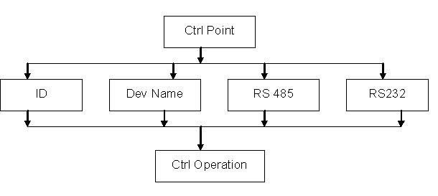
For network keyboard
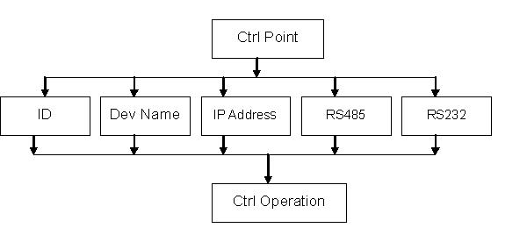
You can click ENTER to go to the above menu and then input corresponding property to search.
E.g.: If you want to search a device of ID3. Input ID as 3 and then click ENTER to confirm.
System pops up the following interface, ID 3 is a dome and its RS232 address is 3.
System automatically connects the dome. Now you can use keyboard to control current dome.
Current Dev：Dome
RS232：3

ID：3

Note:
- When you use keyboard to control DVR, please click ID and then click ESC to go back to previous menu.
- When you use keyboard to control other device, click ESC to go back to previous menu.
Control point includes the following items.
- ID
- Machine name
- IP address
- RS232
- RS485
ID
Machine
IP
RS232
RS485

ID
Use left/right to highlight ID and then click ENTER.
Here is for you to input device ID.

Machine Name
Use left/right to highlight Machine and then click ENTER.
Here is for you to input machine name.

IP Address
Use left/right to highlight IP address and then click ENTER.
Here is for you to input device IP address.

RS232
Use left/right to highlight RS232 and then click ENTER.
Here is for you to input RS 232 address.

RS485
Use left/right key to highlight RS485 and then click ENTER.
Here is for you to input RS485 address.

Keyboard Control DVR

Serial Port Connection

RS232 Serial Port Connection
You can use one RS232 cable to connect DVR serial port and keyboard serial port together. See Figure 5-4.
DVR address number ranges from 1 to 255，please refer to DVR manual for more information.
RS232 cable

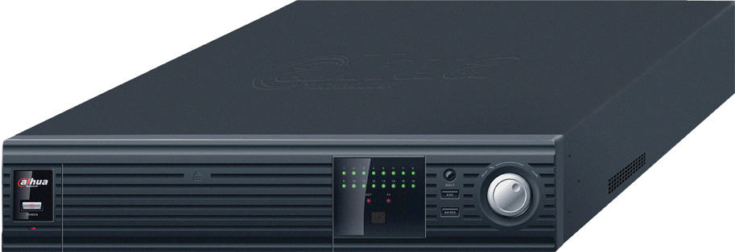
DVR
Figure 5-4

Via RS485 Connection
You can use one RS232 port can only connect with one DVR. See Figure 5-5.
You need to use RS 485 port once you want to control more than one DVRs.
You can user one standad RS485 to RS 232 box connect with DVR 232 port.
RS 485 port pins definition：
PIN1
PIN21
PIN321
PIN421
PIN521
PIN621

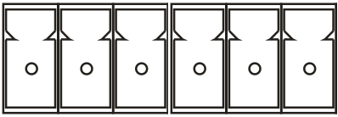
PIN9
PIN6

Figure 5-5

PIN1 ：RS485 B1 line
PIN2 ：RS485 A1 line
PIN3 ：RS485 B2 line
PIN4 ：RS485 A2 line
PIN5 ：RS485 B3 line
PIN6 ：RS485 A3 line

You can use if you use RS485 connection via converter. See Figure 5-6.

485->232 converter
485->232 converter

A
B
485->232 converter

……

……
Figure 5-6
One 485 bus can connect with thirty-two RS485->232 converters，one RS485->232 converter can connect with twelve DVRs.

Multi-keyboard link via RS485
You can use the following figure if you are connecting multiple keyboards via RS485 port. See Figure 5-7.
Other 485 devices
……
A
B

Figure 5-7
Multi-converter connection：
The last converter on RS 485 port must be short circuited. (E.g.: open converter). See Figure 5-8.
See the image below, you need to change [1-2] short circuit to [2-3] short circuit.
Note:
Menu serial setup should conform to the device you connected; otherwise keyboard can not control the device!
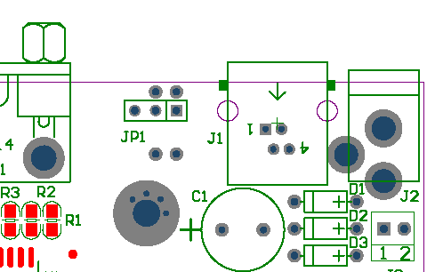
Short circuit
1 2 3

Figure 5-8

Network Connection (For network keyboard only)
Connect RJ45 port to the network to realize network control and upgrade.

RJ45 port connection

Direct connection
Please refer to the Figure 5-9.for direct connection information.

Crossover cable

Figure 5-9

Connect via HUB
Please refer to the following figure if you are connecting via the hub. See Figure 5-10.
……
Straight-through cable

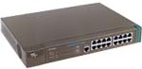
Switch

……
Figure 5-10

DVR and Keyboard Setup

DVR Setup
Before operation, please make sure cable connection is proper.
In DVR menu, from “Setting” to RS232. See Figure 5-11.
The default setup is shown as below.
- Function: network keyboard
- Baud rate: 9600
- Data bit: 8
- Stop bit: 1
- Parity: none.
Please note keyboard setup should conform to DVR setup.
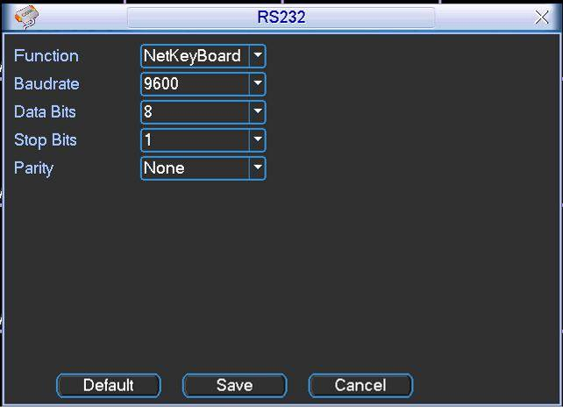
Figure 5-11

Keyboard Setup after Serial Port Connection
In menu, go to control point setup. Here you need to input the following information.
ID: *3
Dev name: DVR-1
Dev type: DVR
Connection type: RS232

- ID:
If there is a * before the ID number (such as *3), it means this front device has control point setup.
You can view device *3 corresponding type and name.
- Device name:
Here is for you to give a name to the front device.
- Device type
There are several selections such as DVR/Dome/CMS/NVS. You can use left/right key to select device type and then click up/down to go on setup.
- Connection type
Please use up/down to highlight connection type and then use left/right to select type.
Click “ENTER” to set the following items:
- 232 address
- Parity
- Protocol
- Stop bit
- Baud rate
- Data bit
232 Add: 8 Parity: None
Protocol: DH2 Stop bit: 1
Baud rate: 9600
Data bit: 8

Note: 232 address and 485 address are corresponding DVR local number.
DH2 is network keyboard/2nd generation control keyboard protocol, its corresponding DVR serial port protocol is network keyboard protocol.
DH1 is the first generation keyboard protocol, its corresponding DVR serial port is control keyboard protocol or Dahua protocol.

Keyboard Setup after Network Connection
ID, device name and device type setup please refer to 6.3.2.
Use up/down to highlight connection type and then use left/right to select connection type.
Click “ENTER” to go to setup.
After all the setup, click ESC to exit. System pops up the dialogue box to prompt you save setup.
CTL point IP”192.168.090.111
CTL port: 3777
Protocol”DH-2

Save data?
YES: ENTER NO: ESC

Operation

Login
You can use the following ways to login: ID, device name, IP, 232 address, 485 address.
Click ENTER to go to setup interface, input you information and click ENTER to begin search.
System automatically begin login if search is OK.
System pops up the alert information if there is no search result.
Note:
Before you login, please log off DVR local user menu, local user priority is higher than the keyboard user!
ID 485 Add
Dev name
IP ADD
232 ADD

Logout
Click ID key and then click ESC, you can logout current control menu.

Record
Click record button （）to go to record interface. You can use direction keys to modify channel name and status. Click ENTER to save modification, click ESC to exit without saving modification you have done.

PTZ Control and Image Color
In single window display mode, click Fn1, system pops up PTZ and image color menu. Or you can click P/T in the keyboard to go to DVR control menu.

Tour and Single/Multiple Window Switch.
Note: before click tour key, please make sure your current series DVR supports tour function.
You can click tour key () to begin touring.
、⊞、▦、▦ are corresponding to :One/four/nine/sixteen window display modes.
You can click numeral key to go to corresponding channel. E.g. you can click numeral 1 to go to channel one.
For channel number more than two-digit (such as numeral 11), you need work with CAM key.
E.g., you want to go to channel 12 then you input CAM+12+CAM.

Network keyboard backup (USB backup)
Connect network keyboard RJ45 port with DVR. Please refer to 6.2 Network Connection.
You can follow the procedures below：
- Insert external hard disk into USB port.
- After successfully login, click AUX1 in the keyboard. You can see the interface,
Date：Year：2006 Month：09 Day：20
Start：H：08 M：30 S：00
End：H：17 M：30 S：00
Ch：1 Type：Recording

  - Date
  - Start time
  - End time
  - Channel name
  - Video type: recording/alarm/motion detection/card number
- After setup, please click ENTER. Network keyboard sends search results to DVR. You can see the following interface if there are matched results.
NO.1-0 08:30:01 09:30:30
NO.1-1 09:30:01 10:30:00
NO.1-2 10:30:00 11:30:00
NO.1-3 11:30:00 12:30:00
NO.1-4 12:30:00 13:30:00

- Please use up/down to select one path to save video files.
X here range from 0 to 4. Click ENTER to save video and system pops up process bar.
Download NO.X file ？
YES：ENTER， NO：ESC

If there is no USB device connected, system pops up message to alert you.
No USB device connected
OK

Network Keyboard Control Dome

Cable Connection
Please make sure keyboard AB line and dome AB line connection is right.
Connect dome to power, and then connect dome video cable to the monitor.
Before operating, please go to dome menu to go on setup. If dome address is 1,
then keyboard RS 485 address is 1.

Keyboard Setup
In keyboard menu, go to control point.
Here you can input ID, device name.
You can use left/right key to select device type.
Use up/down to highlight connection type, then click ENTER to go to RS 485 setup.
485 address is 1, default protocol is DH-SD. You can select in accordance with you actual demands.
After all the setup, click Enter to save setup or you can click ESC to exit without saving the modification you have done.
ID:0
Device name: qiuji ①
Device type: dome
Connection type: RS485

485 Add: 1 O_E VFY: None
PRTCL: DH-SD S-bit: 1
Baud: 9600
D-bit: 8

Operation
Before operation please note:
- X value varies due to different protocols.
- Please use up/down to move dome operation menu.
- Use left/right to move cursor.
- All the operation here is based on DH-SD protocol. There may be some difference for various protocols.

Now you can click ID key and input ID number to enter current device connection interface.
Current device：Dome
RS485 ADD：1
ID：0

Click MENU, the image is shown as below.
The menu here should work with dome menu.
1. up 5.Previous menu
2. down 6.Next menu
3. Left 7.Confirm
4. Right 8.Exit

Direction Setup

Speed
It is to control direction. The value ranges from one to eight. Please use the number buttons of the keyboard to input value (between 0~8) and press ENTER
Speed：5
〈Zoom〉
〈Direction〉 〈Focus〉
〈Iris〉
to confirm. (Operation here is only active with key-press. You can use joystick to control speed directly. )
PTZ movement direction
- For joystick: up/down/left/right/up left/right down/up right/left down.
- For keyboard: up/down/left/right

Zoom/focus/Iris
- Zoom: please use WIDE and TELE to control PTZ zoom.
- Focus: please use FAR and NEAR to control PTZ focus.
- Iris: Please use CLOSE and OPEN to control PTZ aperture.
You can use joystick to control lens, clockwise is to zoom out and anti-clockwise is to zoom in.
Preset setup ＞value：1
GOTO
Remove

Preset

Preset setup
After zoom and PTZ setup, input value and click ENTER to confirm.
Now you have set one preset.

GOTO
Move cursor to highlight GOTO.
Preset setup ＞Value：1
GOTO
Remove
Input preset value and click ENTER.
System goes to specified preset.

REMOVE
Move cursor to highlight REMOVE. Input preset value and click ENTER. Now you have removed one preset.
Note: Some protocols do not support remove preset function. You can modify to replace the previous one.
Scan Value ：1
Scan setup ＞Left limit
Versatile scan Right limit
Random scan Speed

Scan

Scan setup
- Input value and then move cursor to highlight left limit.
Or you can use joystick to move camera to left limit and then click ENTER.
②、Repeat procedure one to set right limit.
Scan Value ：1
Scan setup ＞ Begin
Versatile scan Stop
Random scan
③、Move cursor to highlight speed. Input speed value and click ENTER to confirm.

Scan operation
④、Use up/down to highlight scan. Input scan value and click ENTER to begin scanning.
⑤、Use left/right keys to highlight stop. Click ENTER to stop scanning.
Note: for versatile scan and random scan, you need corresponding
Scan Value ：1
Scan setup ＞ start
Versatile scan Stop
Random scan Speed
protocols to support.

Tour

Tour setup
Use up/down keys to highlight add to tour. Input value in tour group.
For example, here we want to add tour point 2 and 3 in tour group 1.
Tour
Tour setup ＞ Tour group：1
Add to tour Tour：
Remove tour
- Firstly, input 1 in tour group.
- Secondly, input 2 to tour and then click ENTER.
Now you have added tour point 2 to tour group 1.
- Thirdly, input 3 to tour and then click ENTER.
Now you have added tour point 3 to tour group 1.
You can repeat the above procedures to add more tour point.
Tour Value ：1
Tour setup ＞ Speed
Add to tour Duration
Remove tour Remove tour group

Tour operation
- Speed
Please use up/down keys to highlight tour setup.
When cursor is before speed, you can input speed value.
- Duration
Use left/right keys to highlight duration and then you can input interval value.
Tour Value ：1
Tour setup ＞ Start
Add to tour Stop
Remove tour
- Begin touring
Use up/down to highlight tour and then input value.
Now you can click ENTER to begin tour.
- Stop touring
Move cursor to highlight stop and then click ENTER. Now you have stopped touring

Remove
Tour Value ：1
Tour setup Speed
Add to tour Duration
Remove tour ＞ Remove tour group

Remove tour
Move cursor to highlight remove tour and
then input corresponding value.
Click ENTER to delete current tour.

Remove tour point
- Move cursor to highlight tour group and then input corresponding value.
- Please click Enter to confirm all the operation below is active to current tour group.
Tour
Tour setup ＞ Tour group：1
Add to tour point Tour point：
Remove tour point
- Move cursor to highlight tour point and input corresponding value (such as 2).
- Now click ENTER to delete.
For example, you want to remove tour point 5 and 6 from tour group 2.
- Firstly, input 2 in tour group and click ENTER.
- Secondly, input 5 in tour point and click ENTER. Now you have deleted tour point 5.
- Thirdly, input 6 in tour point and click ENTER. You have deleted tour point 6.

PATTERN

Pattern setup
- Move cursor to highlight pattern and then input pattern value.
Input value is the pattern path you want to set (Maximally support five paths).
Pattern Value：1
Patter setup ＞ Start
Rotation Stop
Click ENTER to confirm.
- Move cursor to highlight start and then input pattern value.
Now click ENTER to confirm.
- Move cursor to highlight stop. Input pattern value and click ENTER to stop pattern.
Pattern Value：1
Pattern setup ＞Start
Rotation Stop
Dome will automatically memorize all the operations you have done.

Pattern operation
- Pleas use up/down keys to highlight pattern. When cursor is before start, please input pattern value and then click ENTER to begin pattering.
- Move cursor to highlight stop and then click ENTER. System stop pattern.
Pattern Value：1
Pattern setup Start
Pan rotation Stop
＞Speed

Pan Rotation
Move cursor to highlight speed. Input speed value (the speed you want) and click ENTER.
Then move cursor to highlight start and then click ENTER. Dome begins pan rotation.
Move cursor to highlight stop and then click ENTER. Dome stops rotation.

Keyboard Upgrade

Control Keyboard Upgrade
Control keyboard does not support remote upgrade. Please ship your control keyboard back to our factory to upgrade.

Network Keyboard Upgrade
Before upgrade, please make sure your network keyboard is well connected. You can use command “PING” to test network connection, the return value TTL should be less than 255.
Please download upgrade file to your local PC. You can download upgrade file from our website or from our local service engineer.
Double click RECUpgrade.exe to begin upgrade. See Figure 7-12.
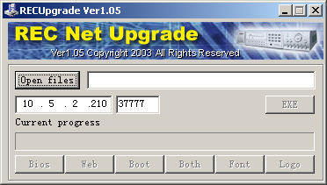
Figure 7-12
Please input network keyboard IP address and port. Then click open files button to select upgrade file. See Figure 7-13.
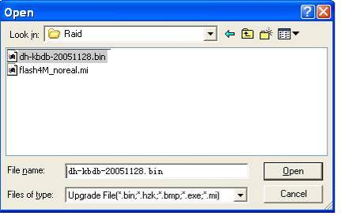
Figure 7-13
After selection, click open to add current file to the address column.
System automatically recognizes upgrade file, you can click BIOS button to begin upgrade. System pops up upgrade process bar for your reference.
After successful upgrade, click OK to finish operation. See Figure 7-14.
Tips:
Use you mouse to click the upgrade file; drag it to the “open files” column and then release. You can see the file path and current file is open.
System pops up alert information if it is not keyboard upgrade file.

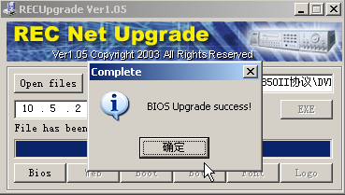
Figure 7-14

Make COM Cable
The keyboard standard accessories package includes the following items.
- One DB9
- Seven DB9
- One six-pin crystal port
- One 25-pin (DB25)
- One 485 transmission box. (Including one power source.)

Make RS232 COM Cable
Please refer to the following figure for RS232 port information. See Figure 8-15.
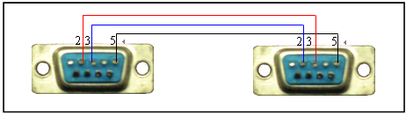
RS232 serial port RS232serial port
（DB9） （DB9）
Figure 8-15

Make RS485 COM Cable
You can refer to Figure 8-16 if you are connecting the keyboard with the switcher box.
RS485 port of keyboard RS485 switch box port
（Green alarm socket） （6-pin crystal ）
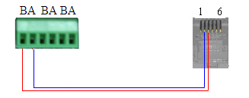
Figure 8-16
PIN1 ： RS485 B line
PIN2 ：RS485 A line
PIN3 ：RS485 B line
PIN4 ：RS485 A line
PIN5 ：RS485 B line
PIN6 ：RS485 A line

25-pin Port and Switch Box Connection

Connect switch 25-pin box RS232 port with DVR RS232 port. (25-pin outlet supports maximum twelve RS232 ports. Switch is just for sending not for receiving. So you can use two cables: GND and TXD)
Please refer to the following sheet if you are connecting 485 switch box to DVR See Figure 8-17.

RS485switch box 25-pin port RS232 port
（DB25） （DB9）
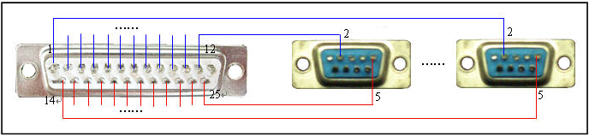
Figure 8-17

Note: you can use standard RS232 port to connect keyboard with DVR.

Note:
- This manual is for reference only. Slight difference may be found in the user interface.
- All the designs and software here are subject to change without prior written notice.
- If there is any uncertainty or controversy, please refer to the final explanation of us.
- Please visit our website for more information.

