High-Speed Positioning System User’s Manual

Version 1.0.1

Welcome
Thank you for purchasing our high-speed positioning system!
This user’s manual is designed to be a reference tool for your system.
Please read the following safeguard and warnings carefully before you use this series product!
Please keep this user’s manual well for future reference!

Important Safeguards and Warnings
1．Electrical safety
- All installation and operation here should conform to your local electrical safety codes.
- We assume no liability or responsibility for all the fires or electrical shock caused by improper handling or installation.
- We are not liable for any problems caused by unauthorized modification or attempted repair.

2．Transportation Security
- No heavy stress, violent vibration or water splash are allowed during transportation, storage and installation.
- Please use the original packing material (or the material of the same quality) when you ship it back to the manufacturer.
3．Installation
- Do not apply power to the product before completing installation.
- Do not put object on the product.

4．Environment
- This series product should be installed in a cool, dry place away from direct sunlight, inflammable, explosive substances and etc.
- Please keep it away from the electromagnetic radiation object and environment.
- Please keep the sound ventilation.
- Do not allow the water and other liquid falling into the device.
- Please make sure the CCD (CMOS) component is out of the radiation of the laser beam device. Otherwise it may result in CCD (CMOS) optical component damage.

5. Daily Maintenance
- Current series product has no power button. Please unplug all corresponding power cables before your begin installation or daily maintenance work.
- Please keep the dustproof cap back to protect the CCD or CMOS part if the device does not work for a long time.
- Do not touch CCD (CMOS) component. You can use the blower to clean the dust on the surface of the device. You can use the dry cloth with some alcohol or mild detergent to clear if necessary.
- Do not use the volatility solvent such as the benzene or thinner, or detergent with strong abradibility. It may result in lens damage or it may adversely affect the device performance.
- If there is too much dust, please use the water to dilute the mild detergent first and then use it to clean the device. Finally use the dry cloth to clean the device

6. About Accessories
Always use all the accessories recommended by manufacturer.
Before installation, please open the package and check that all the components are included in the package:
Contact you local retailer ASAP if something is missing in your package.

Table of Contents
1 General Introduction 1
1.1 Overview 1
1.2 Features 1
2 Quick Configuration Tool 3
2.1 Overview 3
2.2 Operation 3
3 Web Operation 6
3.1 Network Connection 6
3.2 Login and Logout 6
4 FAQ 9
Appendix Toxic or Hazardous Materials or Elements 10

General Introduction

Overview
This series high-speed positioning system integrates the traditional camera and network video technology. It adopts audio/video data collection, transmission, and storage together.

This series system uses standard H.264 video compression technology, PCM, G.711a/u audio compression technology and etc.

This series product has megapixel resolution and supports 24V AC power. It supports bidirectional talk, digital water mark and etc.

This series high-speed positioning system is widely used in many environments such as electric power, customs, water conservancy, bank, and etc.

Features
User Management | - Different user rights for each group, one user belongs to one group.  - The user right can not exceed the group right.
Data Transmission | - Support Ethernet transmission.  - Support RS485 control function.  - Support BNC analog video transmission.
Network Management | - Realize device configuration and management via Ethernet.  - Support device management via web.  - Support various network protocols.
Storage  Function | - Support local storage and Micro SD card storage.  - Support centralized storage.
Alarm Function | - Support real-time video detect, internal abnormality detect, external alarm input detect and etc.  - Alarm can activate snapshot, record, alarm output, email and etc.
Proportional Pan and Tilt | This function keeps the image from moving too fast when there is a large amount of zoom.  High-speed positioning system continually decreases or increases pan and tilt speeds in proportion to depth of zoom. It is to maintain clear video.
Preset | Preset function is to save the address information (such as PTZ pan/tilt, focus and etc) to the memory so that you can quickly adjust the high-Speed positioning system and PTZ to the correct position.
Auto scan | High-speed positioning system scans back and forth regularly in a horizontal field. Here you need to set left and right limit and scan speed.
Auto pattern | Memorize high-speed positioning system operation such as pan, tilt, and zoom to repeat. Focus and iris are in auto mode during auto pattern.
Auto touring | Add addresses into a routine in a desired order and then set time and stop duration for each address. The high-speed positioning system will begin an auto touring between these addresses.
Privacy Masking | Privacy masking is a user-defined, four-sided area that can not be viewed by you. The masking area will move with pan and tilt functions and automatically adjust in size as the lens zooms.
Self-diagnosis | There is a self diagnosis procedure for the engine and the camera when high-speed positioning system boots up.
Day/Night Mode (B/W & Color Mode) | System can automatically switch to between black/white and color mode according to environment illumination.
Auto focus | In auto focus mode, the high-speed positioning system can automatically adjust focus distance to keep clear video.
Backlight Compensation | Under strong light environment, high-speed positioning system can balance the brightest and darkest sections of a scene to produce a more vivid picture.
3D Intelligent Location | Just one click, part of the current scene will be displayed in the central window and automatically zooms. All of these allow you to trace precisely.
Power up | After reboot, the high-speed positioning system can automatically implement power up operation.
Image Flip | This series high-speed positioning system supports video flip function so that you can see the video conveniently.

Quick Configuration Tool

Overview
Quick configuration tool can search current IP address, modify IP address. At the same time, you can use it to upgrade the device.
Please note the tool only applies to the IP addresses in the same segment.

Operation
Double click the “ConfigTools.exe”icon, you can see an interface is shown as in Figure 2-1.
In the device list interface, you can view device IP address, port number, subnet mask, default gateway, MAC address and etc.
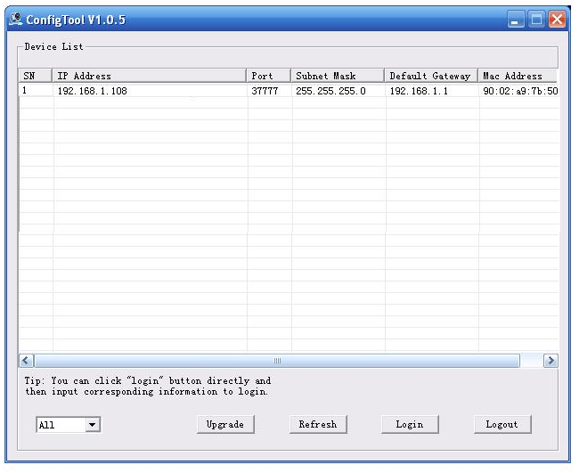
Figure 2-1
Select one IP address and then right click mouse, you can see an interface is shown as in Figure 2-2.
Note:
You can set the IP address, subnet mask and gateway for the high-speed positioning system and PC. Please note high-speed positioning system IP address and PC IP address shall be in the same network segment if there is no router. High-Speed positioning system default IP address is 192.168.1.108. If there is a router, please set the corresponding gateway and subnet mask.
The factory default user name is admin and password is admin. For security reasons, please modify your password after you first login.
For detailed WEB operation, please refer to the High-Speed Positioning System Web Operation Manual in the resource CD.

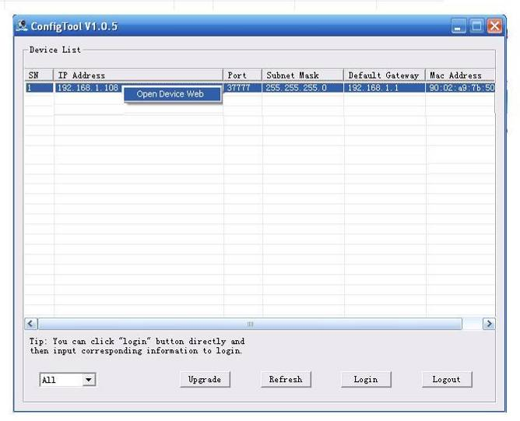
Figure 2-2
Select the “Open Device Web” item; you can go to the corresponding web login interface. See Figure 2-3.
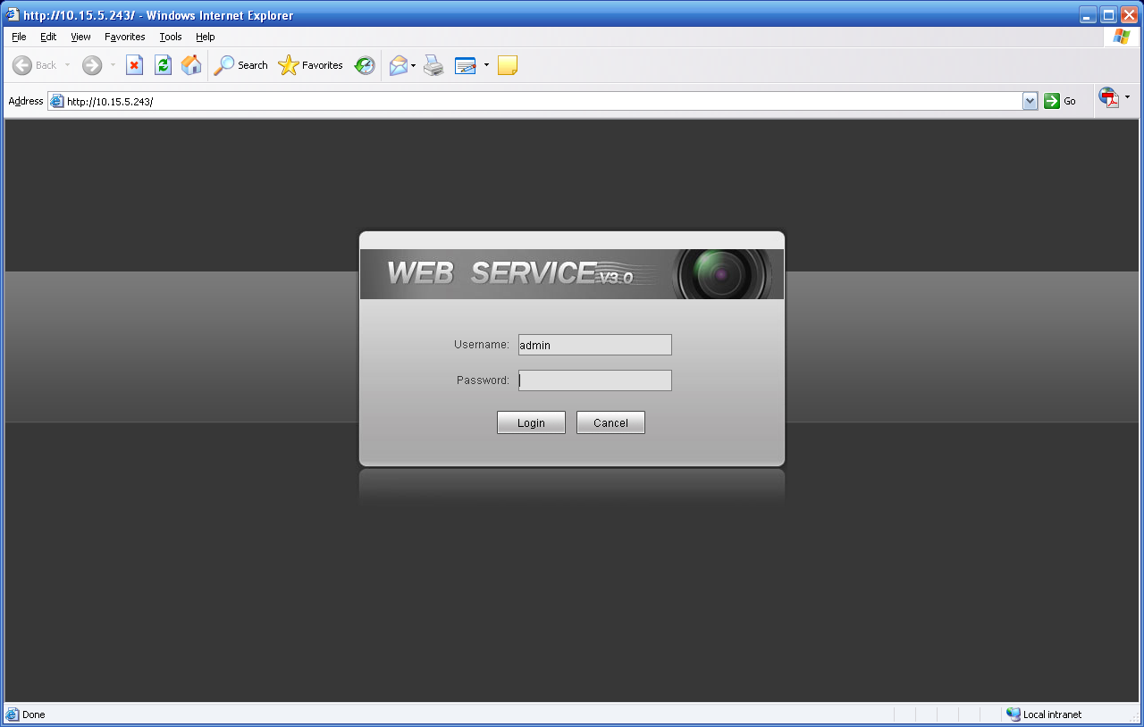
Figure 2-3
If you want to modify the device IP address without logging in the device web interface, you can go to the configuration tool main interface to set.
In the configuration tool search interface (Figure 2-1), please select a device IP address and then double click it to open the login interface. Or you can select an IP address and then click the Login button to go to the login interface. See Figure 2-4.
In Figure 2-4, you can view device IP address, user name, password and port. Please modify the corresponding information to login.
Please note the port information here shall be identical with the port value you set in TCP port in Web Network interface. Otherwise, you can not login the device.
If you are using device background upgrade port 3800 to login, other setups are all invalid.
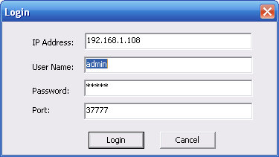
Figure 2-4
After you logged in, the configuration tool main interface is shown as below. See Figure 2-5.
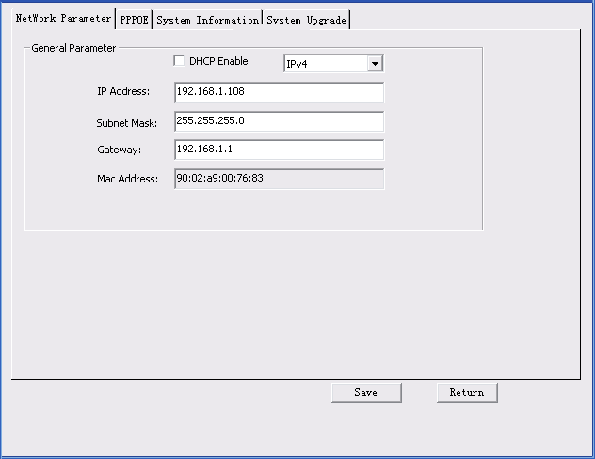
Figure 2-5
For detailed information and operation instruction of the quick configuration tool, please refer to the Quick Configuration Tool User’s Manual included in the resources CD.

Web Operation
These series high-speed positioning system products support the Web access and management via PC.
Web includes six modules: .encode setup bar, window adjust bar, system menu bar, window function option bar, PTZ control bar, PTZ setup/menu.

Network Connection
Please follow the steps listed below for network connection.
- Make sure the high-speed positioning system has connected to the network properly.
- Please set the IP address, subnet mask and gateway of the PC and the high-speed positioning system respectively. (Please set the same segment for the device and PC if there is no router. Please set gateway and subnet mask if there is a router in the network. ).Device default IP address is 192.168.1.108.
- Use order ping ***.***.***.***(* high-speed positioning system address) to check connection is OK or not.

Login and Logout
Open IE and input high-speed positioning system address in the address bar.
For example, if your system IP is 192.168.1.108, then please input http:// 192.168.1.108 in IE address bar. See Figure 3-1.

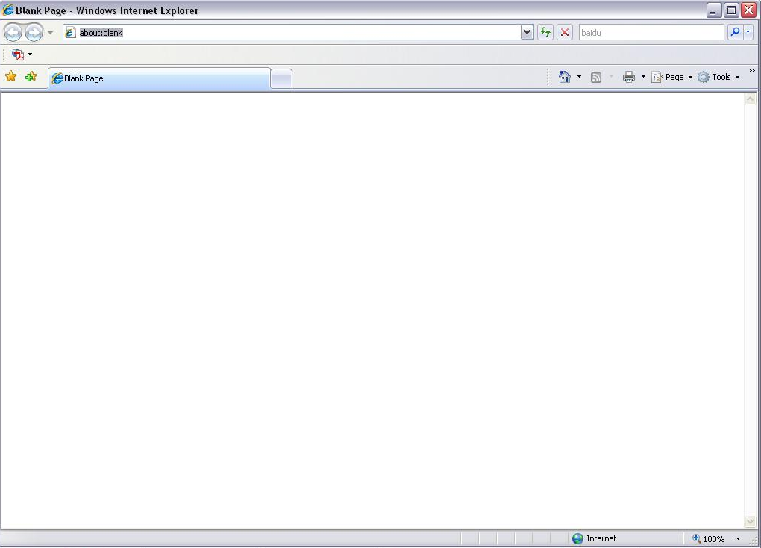
Input your IP address here
Figure 3-1
The login interface is shown as below. See Figure 3-2.
Please input your user name and password.
Default factory name is admin and password is admin.
Note: For security reasons, please modify your password after you first login.
Figure 3-2
If it is your first time to login in, system pops up warning information to ask you whether install control webrec.cab or not after you logged in for one minute. Please click OK button, system can automatically install the control. When system is upgrading, it can overwrite the previous Web too.
If you can’t download the ActiveX file, please check whether you have installed the plug-in to disable the control download. Or you can lower the IE security level. See Figure 3-3.
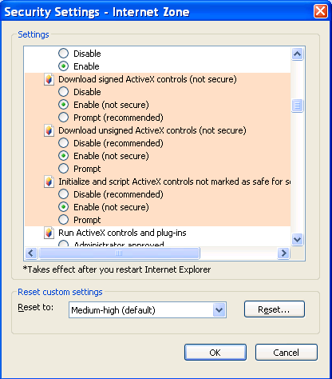
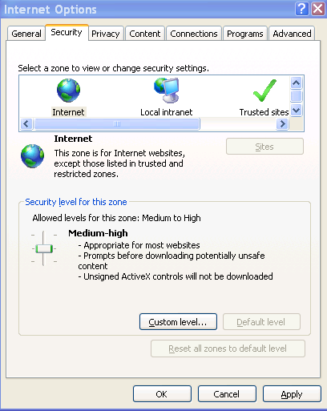
Figure 3-3
After you logged in, you can see the main window. See Figure 3-4.
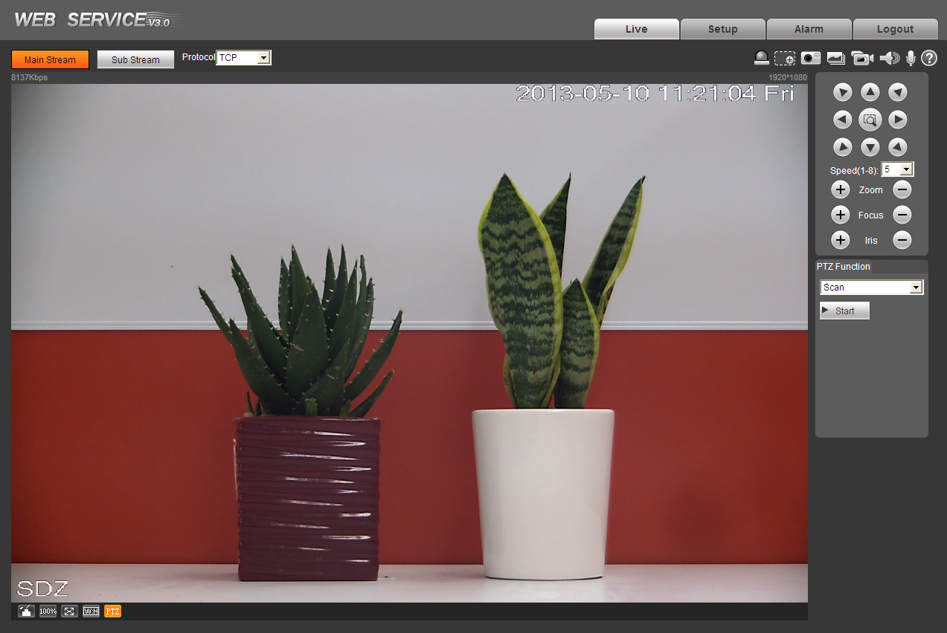
Figure 3-4
Please refer to the High-Speed Positioning System Web Operation Manual included in the resource CD for detailed operation instruction.

FAQ
SYMPTOM | CAUSE | SOLUTION
No self-diagnosis, no video signal when I connect high-speed positioning system to power. | Does not connect the AC power supplying to the socket of the power board or the connection is not secure. | Check power cable connection. Guarantee socket connection is OK.
 | Power outage or transformer malfunction | Check power supplying is OK or not and the transformer working is OK or not.
 | Output voltage of the transformer is too low. | Use multimeter to check load of the PTZ-end to see whether it is lower than the power supplying voltage.
 | Power board malfunction | Please contact you local retailer to replace power socket.
No self diagnosis.  There is a noise | Power supplying voltage is enough. | Replace power socket.
No self diagnosis.  There is a noise | Mechanical malfunction. | Need electrical engineer help.
Self diagnosis is ok.  No video signal | Power connection is too loose. | connect tightly
Self diagnosis is ok.  No video signal | Check the circuit connection. | Connect again
Self diagnosis is ok.  No video signal | Video switch connection is wrong or improper operation. | Please refer to user’s manual for cable connection information.
Self diagnosis is o.k. but I can not control the PTZ. | Control board cable connection is wrong or short-circuit. | Check control cable connection to guarantee its connection is right and is secure firmly.
Self diagnosis is o.k. but I can not control the PTZ. | PTZ address, protocol baud rate setup is not right. | Please refer to Installation Manual for detailed information.
Self diagnosis is o.k. but I can not control the PTZ. | Reverse 485 data cable connection is wrong. | Check reverse 485 data cable in the enclosure to guarantee its connection is right and is secure firmly.
Video signal loss occurs in high speed rotation. | Power supply is not sufficient | Replace power socket.
Video signal is not successive | Circuit connection is too loose. | Connect again.
Video signal is not successive | Video switcher or power circuit problem | Need electrical engineer help.
Video is not clear. | Focus is in manual mode. | Control manually.

Appendix Toxic or Hazardous Materials or Elements
Component Name | Toxic or Hazardous Materials or Elements
Component Name | Pb | Hg | Cd | Cr VI | PBB | PBDE
Sheet Metal | ○ | ○ | ○ | ○ | ○ | ○
Casting fitting | ○ | ○ | ○ | ○ | ○ | ○
PCB | ○ | ○ | ○ | ○ | ○ | ○
Camera Driver | ○ | ○ | ○ | ○ | ○ | ○
Connection Cable | ○ | ○ | ○ | ○ | ○ | ○
Power  (If possible) | ○ | ○ | ○ | ○ | ○ | ○
Bracket  (If possible) | ○ | ○ | ○ | ○ | ○ | ○
Accessories | ○ | ○ | ○ | ○ | ○ | ○
O: Indicates that the concentration of the hazardous substance in all homogeneous materials in the parts is below the relevant threshold of the SJ/T11363-2006 standard.

X: Indicates that the concentration of the hazardous substance of at least one of all homogeneous materials in the parts is above the relevant threshold of the SJ/T11363-2006 standard. During the environmental-friendly use period (EFUP) period, the toxic or hazardous substance or elements contained in products will not leak or mutate so that the use of these (substances or elements) will not result in any severe environmental pollution, any bodily injury or damage to any assets. The consumer is not authorized to process such kind of substances or elements, please return to the corresponding local authorities to process according to your local government statutes.

Note
- This user’s manual is for reference only. Slight difference may be found in user interface.
- All the designs and software here are subject to change without prior written notice.
- All trademarks and registered trademarks mentioned are the properties of their respective owners.
- If there is any uncertainty or controversy, please refer to the final explanation of us.
- Please visit our website for more information.

