Smart Phone Monitoring Software User’s Manual

Version 3.41
Table of Contents
1 Overview 1
1.1 General Introduction 1
1.2 Features 1
1.3 Compatible Models 1
2 Downloading and Installation 2
3 Operation 3
3.1 Remote Monitoring 3
3.1.1 Main Menu 3
3.1.2 Device Manager 4
3.1.3 Live Preview 12
3.1.4 Playback 19
To playback picture: 20
3.1.5 File Manager 21
3.1.6 E-Map 22
3.1.7 Favorites 22
3.1.8 Alarm Manager 24
3.1.9 Local Config 25
3.2 Visual Talk 25
3.2.1 Live Preview 25
3.2.2 Playback 25
3.2.3 Event List 26

Overview

General Introduction
This manual is designed for smart phone to perform monitoring function. It is built on traits of mobile device to include functions of multiple touch control, touch signal recognition, alarm push, P2P function, DDNS analysis and etc. User can preview, control PTZ, play video and etc. from front-end camera, DVR, speed domw under 3G, 4G WIFI environments.
This software supports iOS and Android platforms only while iDMSS suppers iOS, and gDMSS supports Android.

Features
This software has the following features:
- Support multiple channel monitoring and playback with a max of 16 windows.
- Support instant playback in preview window.
- Playback supports quick, slow and by frame modes.
- Support local snapshot and recording. Corresponding files are stored locally.
- Support PTZ control by slide on touch screen.
- Support memory of previous channel viewed.
- Support video window adjustment and bit stream adjustment.
- Support alarm push.
- Support alarm output control from smart phone for alarm push function.
- Support bidirectional talk.
- Support SmartPicture function which zooms in/out picture to view different parts of picture.
- Support E-Map function, to show cameras on an electronic map of household or area.
- Support channel resolution and frame config, and view of HDD info.
- Support VTO visual talk

Compatible Models
Android | Android 2.2 and higher  Note:  To use the push function, you need to create a Google account first.
iphone | IOS 6.0 and higher

Downloading and Installation
The product has Android and iOS versions.
Android:
Open Google Play app in your smart phone. Search gDMSS Lite or gDMSS Plus, download it and install it.
iOS:
Open App Store app in your smart phone. Search iDMSS Lite or iDMSS Plus, download it and install it.

Operation

Remote Monitoring
As in Figure 3- , select the first icon to enter camera, select the second icon to enter door.
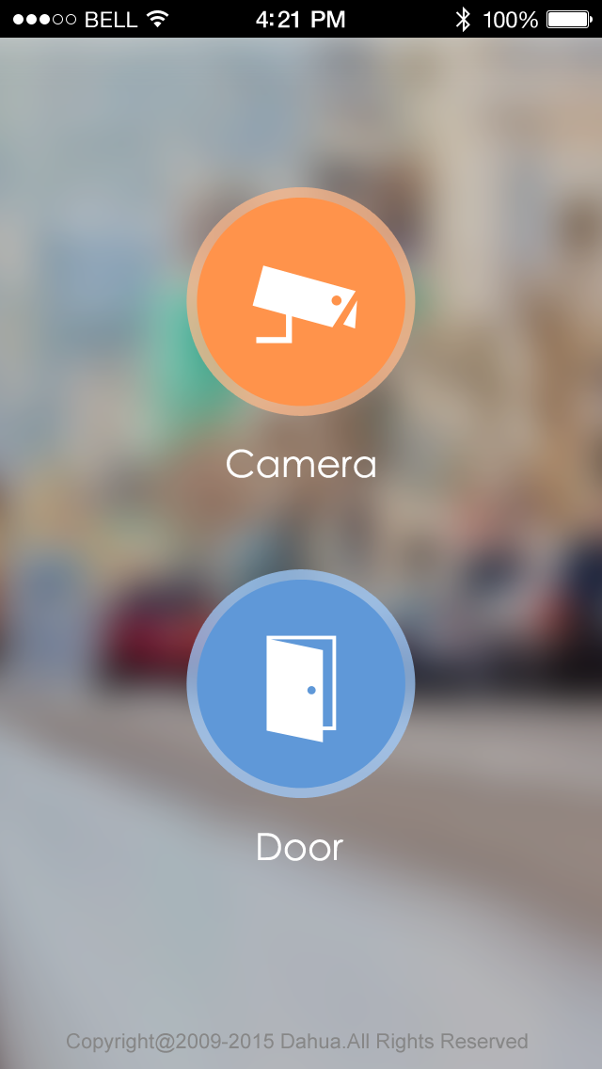

Figure 3-

Main Menu
Enter camera, you will see Live Preview interface in Figure 3- by default.
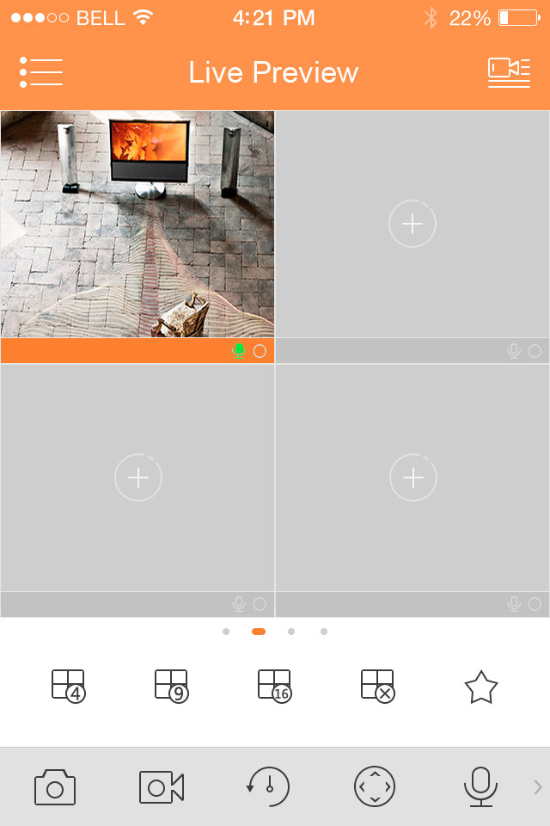

Figure 3-
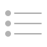
Click on , system displays main menu interface in Figure 3- .
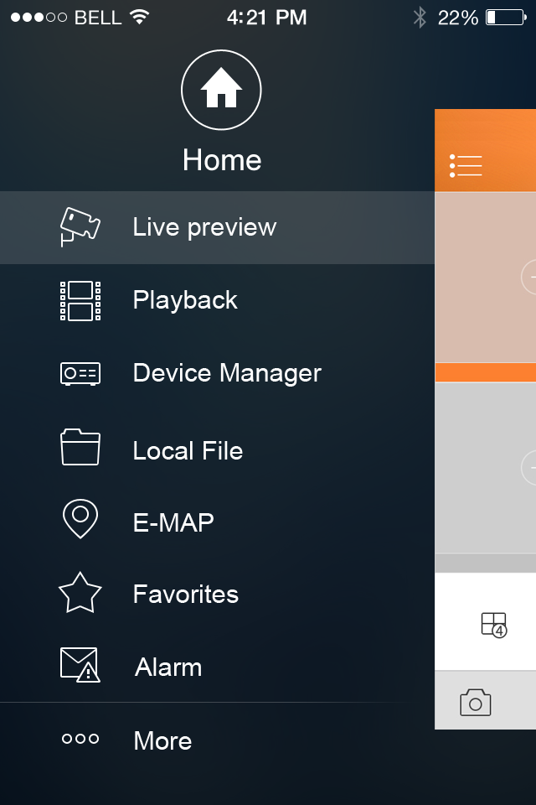

Figure 3-
User can click on function in main menu to enter corresponding function interface.
Main functions includes: Live Preview, Playback, Device Manager, Local Files, E-Map, Favorites, Alarm and etc.

Device Manager
In Device Manager, you can add device, modify device info, remotely configure device, control alarm output, view HDD and delete. You also can import device list on cloud-end. Click on added device in the list, you can see its functional buttons.

Add Device
To add device:
- In device manager interface, click on  to enter add device interface, see Figure 3- .

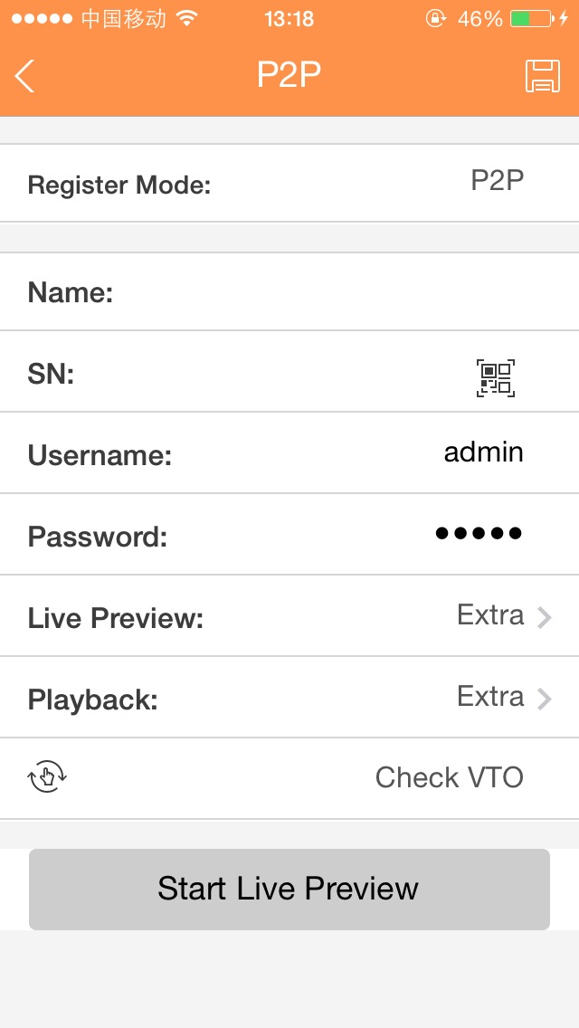

Figure 3-

Parameter | Note
Register Mode | - P2P: for network environment, add device by scanning two-dimension code, inputting SN.  - Dahua/QuickDDNS: for network environment, add device by inputting complete domain name address, and analysis is done by DahuaDDNS and QuickDDNS.  - IP/Domain name: for normal environment, add device by inputting its IP address or third-party domain name.
Name | Device name.
SN | - P2P type: input SN.  - QuickDDNS/Dahua type: input complete domain name.  - IP/Domain name type: input IP address or complete third party domain name.
Username/Password | Device username and password are both admin. If changed, please input new username and password.
Live Preview/Playback | Select main stream or extra stream for live preview and playback.

- Fill in parameter, and click on  to save.
Tips:
- You can click on Start Live Preview to view all channels of the device. System will go to monitoring page and save device info.
- For device supporting P2P, you can scan two-dimension code, input SN to add device.

Modify Device Info
To modify device information:
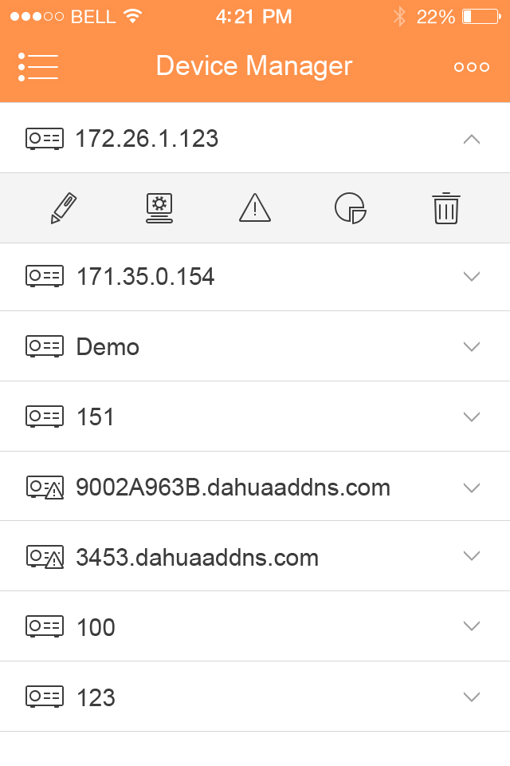
- In device manager interface, click on device. System shows dropdown menu in Figure 3- .

Figure 3-
- Click on  in dropdown menu.
- Change device info, and click on to save.

Delete Device
To delete device:
- In device manager interface, click on device. System shows dropdown menu in Figure 3- .

Figure 3-
- Click on  in dropdown menu. System asks if to delete the device.
- Click on OK.

Remote Configuration
Via remote configuration, you can perform function of motion detect, alarm setting, camera setting, storage manager and user manager.
To configure:
- In device manager interface, click on device. System shows dropdown menu.
- Click on 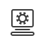 in dropdown list.
- Select correspodning item to remotely configure.

View HDD Information
You can view HDD name, status, free capacity and total capacity.
- In device manager interface, click on device. System shows dropdown menu.
- In dropdown menu, click on  to view HDD information..

Alarm Out Control
You can enable and disable alarm output of channel.
To enable or disable alarm output:
- In device manager interface, click on device. System shows dropdown menu.
- In dropdown menu, click on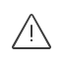.
- Select alarm out channel, click on 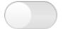to enable or disable alarm out.

WIFI Config Device
In live preview, it provides shortcut to add device, and supports to add product via the same WIFI and two-dimension code scanning which can get device SN filled in chart in App.
Smart config add device:
- User click device list button 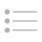, such as in Figure 3- .
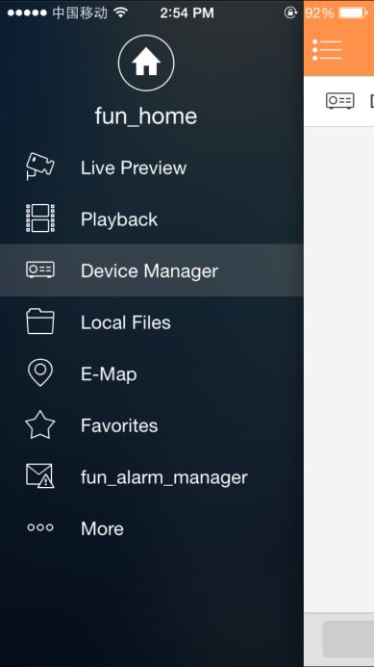
Figure 3-
- Click add device button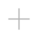, system shows device adding interface, select WIFI config device as in Figure 3- .
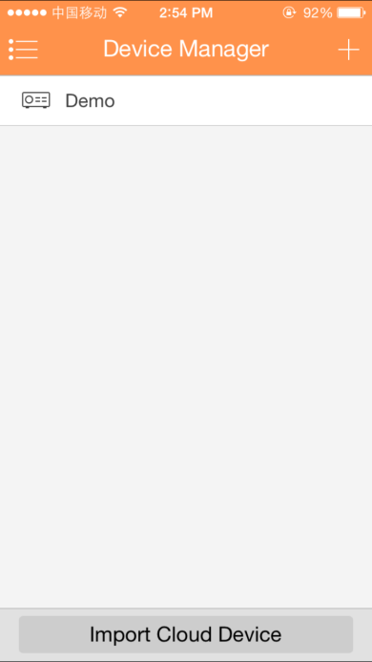
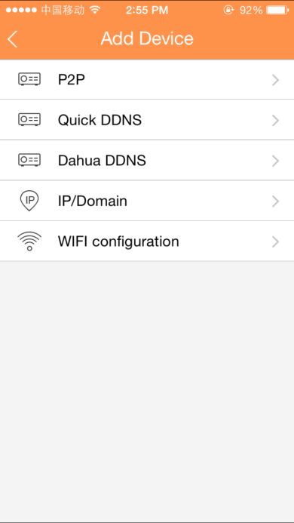

Figure 3-
- Interface displays: name, SN (two-dimension code), username, password, live preview, and playback. See Figure 3- .

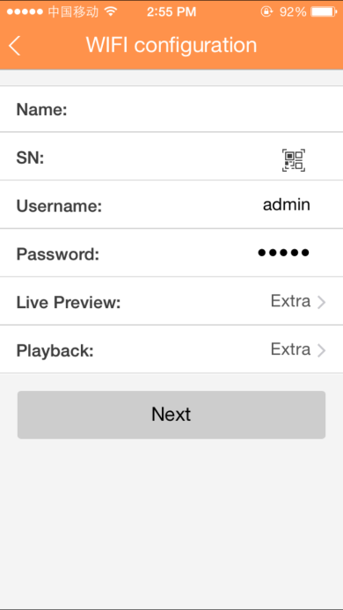
Figure 3-

- User click 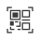, and it shows two-dimension code box, as in Figure 3- .
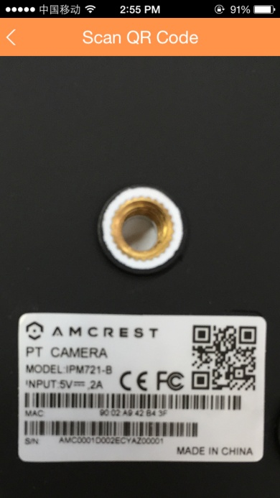
Figure 3-

- Scan two-dimension code of WIFI device, when complete, return to device adding interface. SN will be automatically filled in as in Figure 3- .

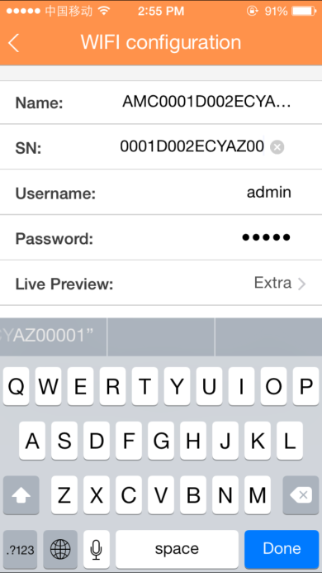

Figure 3-
- When you scan two-dimension code, click back to return to device adding interface.
- Input SN, click input field to input device SN, see Figure 3- .
Figure 3-
- After you complete input, click next, see Figure 3- .

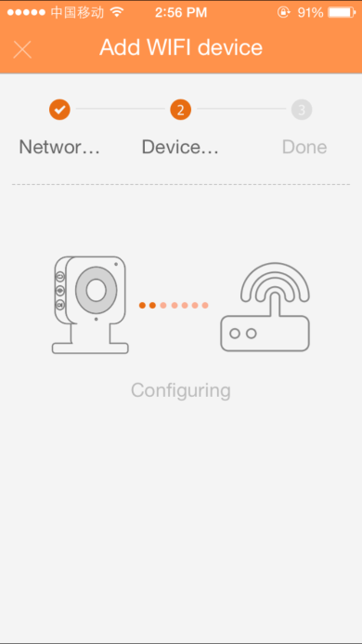
Figure 3-
- System parity user input WIFI password and click next.
- System auto configure (wait).
- If failed, then click try again or repeat the above steps.
- Save data if all config are correct, go to live preview interface, see Figure 3- .
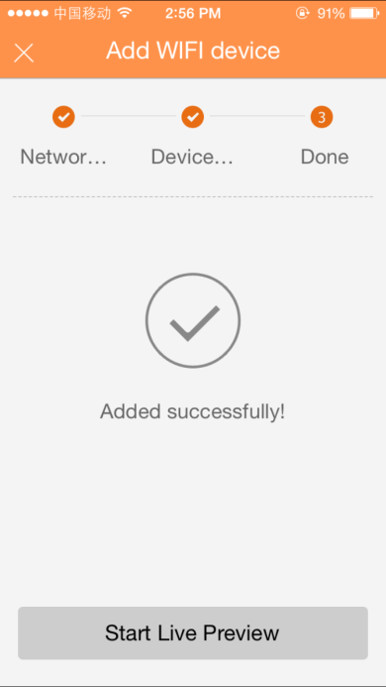
Figure 3-
- When user complete input, click save.
- Save data if parity is correct, go to device list interface.

Import Cloud Device
You can import cloud device. For example, you have a cloud account (i.e. DDNS account or Easy4IP account), and the account is bound with device, then you can import corresponding devices on client without manually adding one by one.
To import cloud device:
- In device manager interface, click on import cloud device button.
- Select cloud account type, and input username and password.
- DahuaDDNS:use cloud account on Dahua DDNS.
- QuickDDNS: use cloud account on Quick DDNS.
- PSP: use cloud account on Easy4IP server.
- Click on Login to import device under the cloud account.

Note:
Device from DDNS account will have “?” mark. DDNS only memorizes IP the binding relationship between the device and domain name. The”?” means there is incomplete information of device user and password which shall be completed later.

Live Preview
Click on and click on Live Preview in main interface to enter live preview in Figure 3- . When you click camera, you will enter see live preview interface by default.
Slice tool bar at the bottom to display more buttons as in:

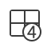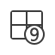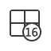 | 1/4/9/16 split
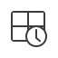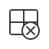 | Open channels;  Close all channels
 | Favorites
 | Snapshot
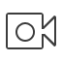 | Start/Stop video in current window
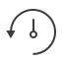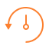 | Start/Stop playback
 | Turn ON/OFF PTZ control panel
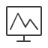 | Turn ON/OFF bit stream control panel
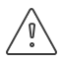 | Turn ON/OFF alarm out control panel
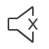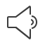 | Turn ON/OFF audio
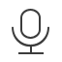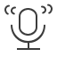 | Turn ON/OFF bidirectional talk
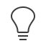 | Turn ON/OFF light control panel
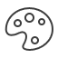 | Turn ON/OFF image adjustment control panel
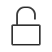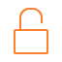 | Unlock
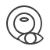 | Fish-eye

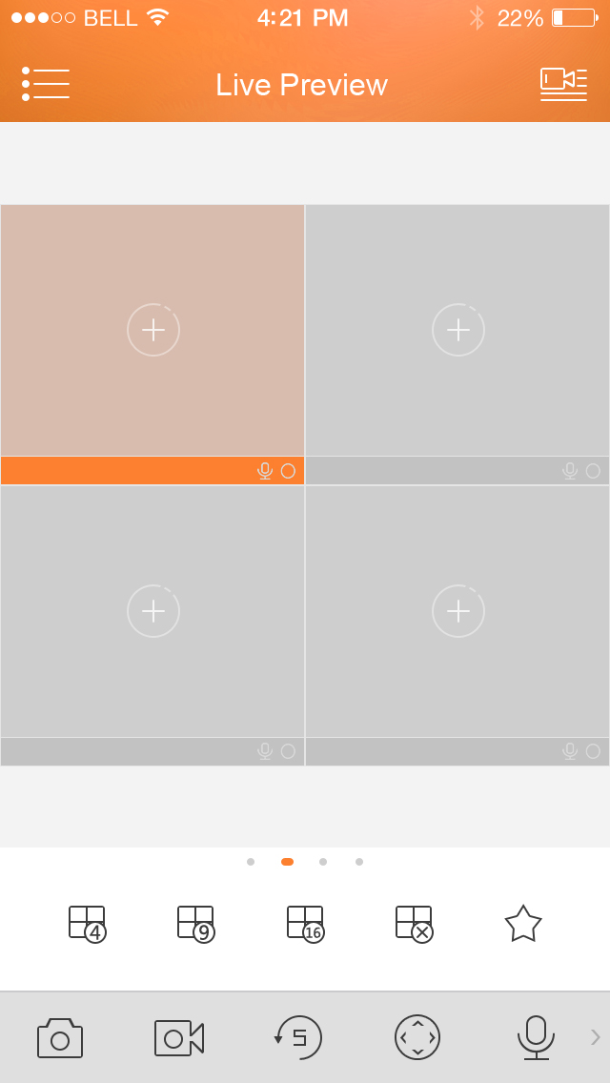

Figure 3-

Enable Monitoring
The app supports 4 methods to open monitoring.
- In corresponding window open monitoring video of a certain window.
Click on 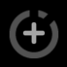 in window, select channel of device displayed as to monitor the selected channel.
- Open monitoring video of multiple windows.
Click on 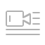 at the upper-right corner, and select one or more channels in displayed device list. Click on Start Live Preview at the lower bottom. System will display monitoring video from first window in sequence as in Figure 3- .
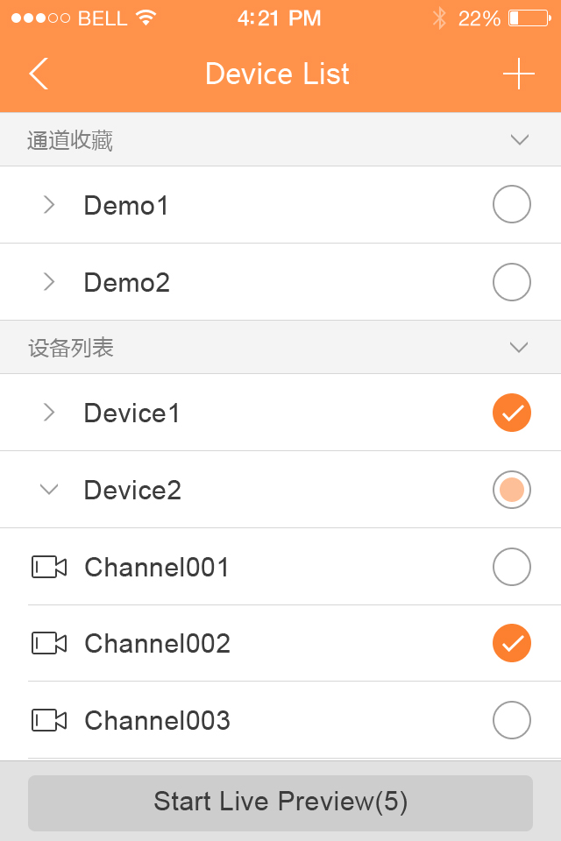

Figure 3-
- Quick preview
After you add device, click on Start Live Preview to enable preview in Figure 3- .

Figure 3-

- Open last channel
Click on to open channel viewed last time

Close Monitoring
System supports two methods to close monitoring.
- Close a single channel.
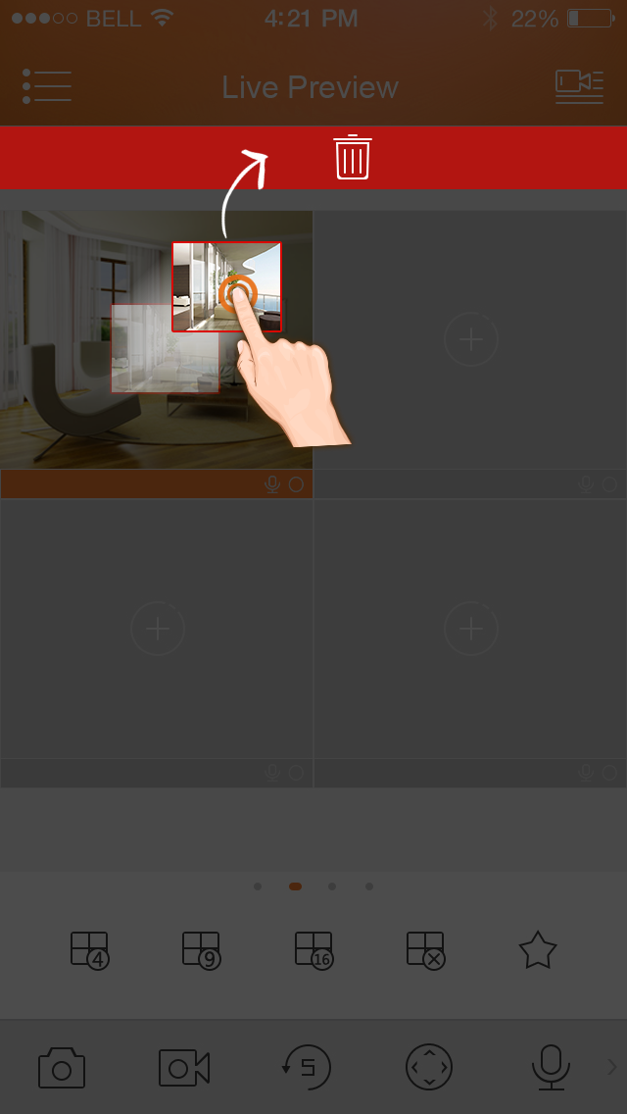
Long press monitoring window you want to close and drag it to the trashcan, it will be deleted. See Figure 3- .

Figure 3-
- Close all monitoring channels
Click on to close all monitoring channels.

Record
Select designated record channel and click on to start record. Record status on bar at the bottom will show a red dot. Click this button again to stop recording of the channel.

Snapshot
Select channel to snapshot, click on to snapshot current channel.
You can view snapshots under local file path. Android device can view snapshots directly under app installation path.

Favorites
System supports favorites.
In live preview interface, select a video window in preview, click on to add it to favorites, see Figure 3- .
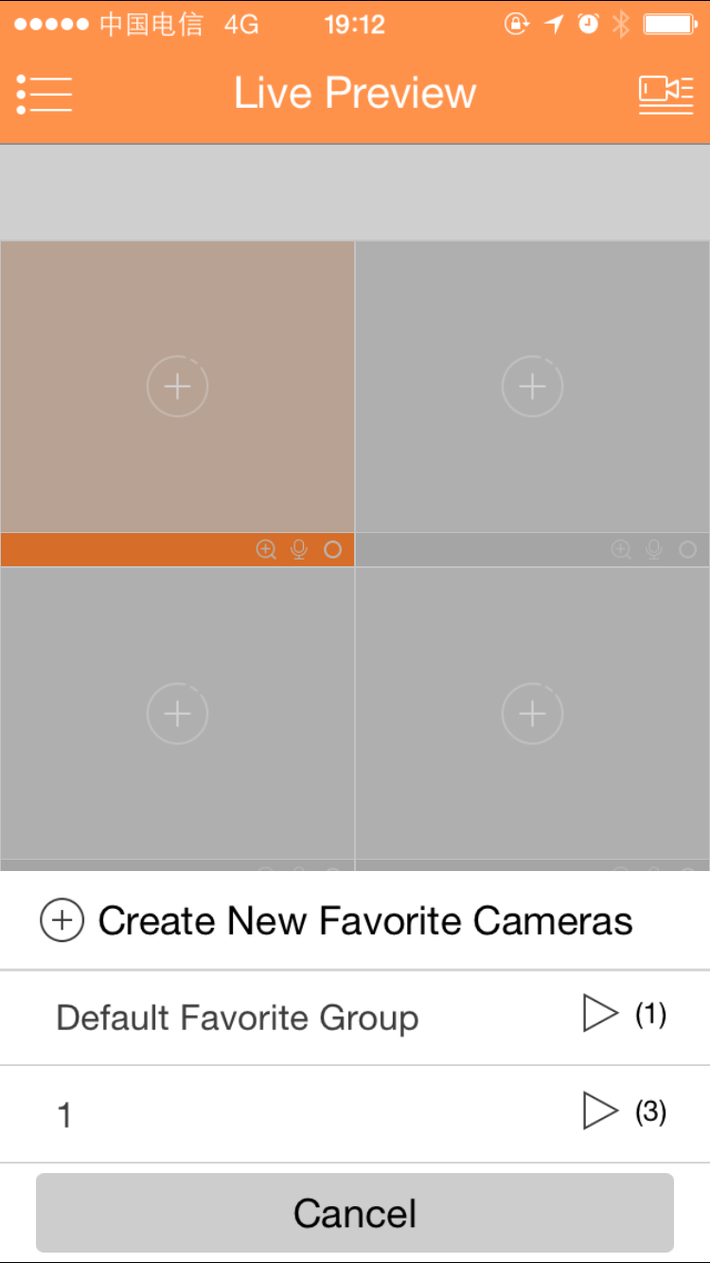
Figure 3-

- Select Favorites, and the process is complete.

Playback

In live preview, click on , the selected channel will play video of the previous 30 seconds.
Note:
System default playback is 30 seconds. You can set playback time in local config.
Click on to end payback and return to monitoring mode.

PTZ

Direction and Zooming
Click on to activate PTZ panel. The selected window will be maximized.

When PTZ control is activated, use hand to control PTZ direction by sliding touch screen:
- PTZ rotation: slide the touch screen toward designated direction to rotate PTZ.
- Focus control: Slide with two fingers to control focus.
You also can:
Icon | Note
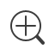 | Zoom control
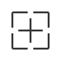 | Focus control
 | Iris control

Preset
On PTZ panel, click on 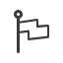, select preset no., and click on 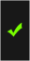 to adjust this preset point.
Note:
PTZ control is only supported by speed dome, camera, EPTZ with PTZ function. Zooming is supported by all devices.

Bit Stream Switch
System switches live preview and bit stream switch.
- Under live preview, select a preview window, click on . System displays bit stream switch panel as in Figure 3- .
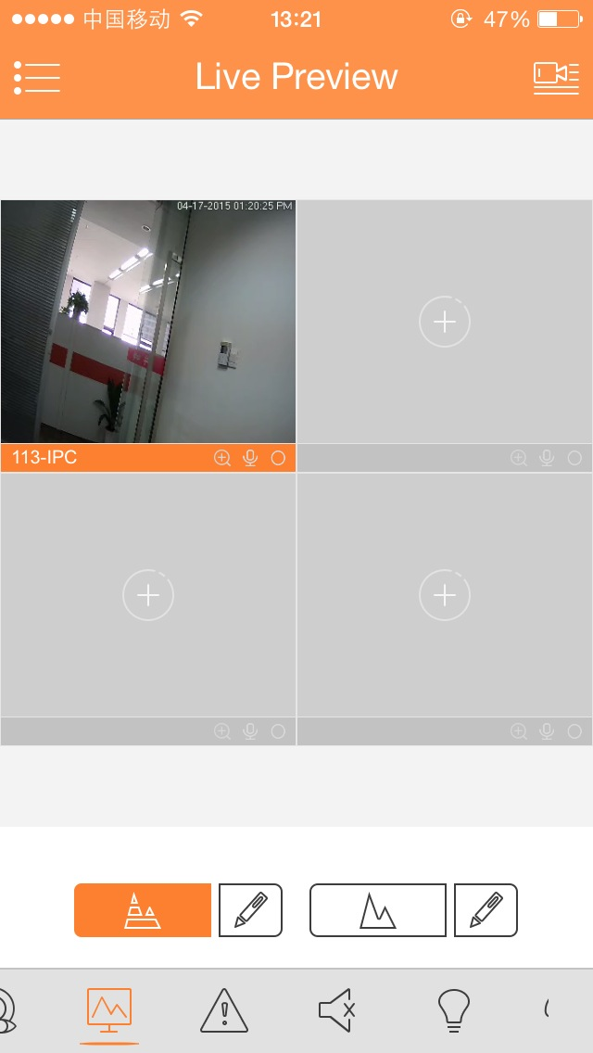

Figure 3-
Icon | Note
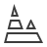 |  | Fluent mode
 |  | HD mode
 |  | Custom mode
- You can switch between main and extra stream.
- Click on , to switch to HD mode (main stream).
- Click on , to switch to fluent mode (extra stream).
- Click on , may customize main/extra stream.

Unlock
Unlock function supports VTO.
Select channel connected to VTO to monitor, click 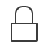 button, and corresponding VTO will unlock door.

Alarm Out Control
System supports to enable or disable device alarm output.
- Under live preview, select a monitoring channel, click on button. Open corresponding alarm output of channel, see Figure 3- .
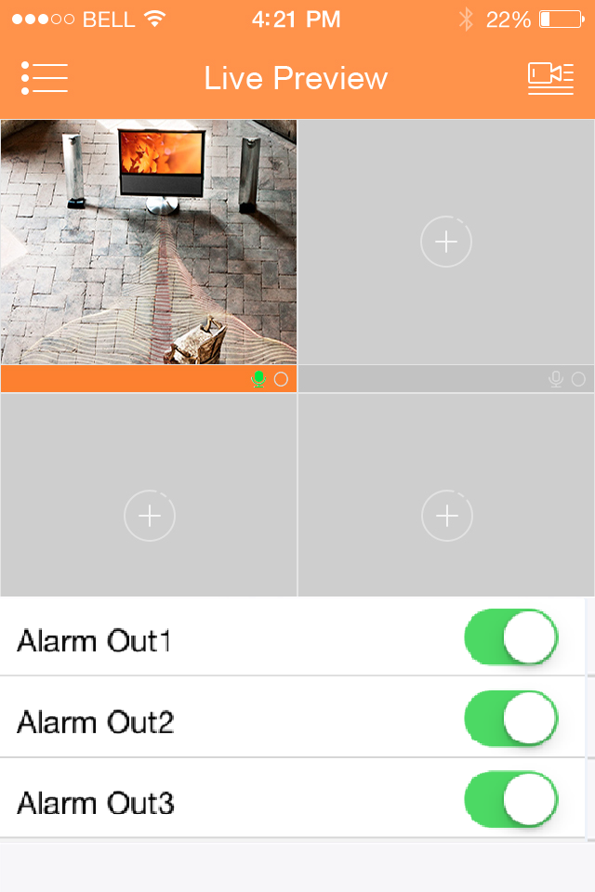
Figure 3-
- Click on enable button to enable or disable a certain alarm output.

Light Control
System supports to enable or disable device compensation light.
- Under live preview, select a monitoring channel, click on button, open corresponding light panel of the channel.
- Click on on/off button to turn on/off compensation light.
- Click on 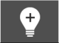 or 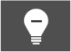 to adjust light.
Note:
Only K100 supports light control.

Image Adjustment
System supports image adjustment including brightness, contrast, saturation and etc.
- In live preview, select a monitoring window, click on button, open image adjustment control panel.
Icon | Note
 | Adjust brightness
 | Adjust contrast
 | Adjust color
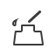 | Adjust saturation
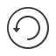 | Reset

- Click on functional icon to adjust corresponding effect. You can increase/decrease parameter by clicking on +/- buttons in monitoring window.

Full Screen
In live preview, screen is rotated and enters full screen mode as in Figure 3- .
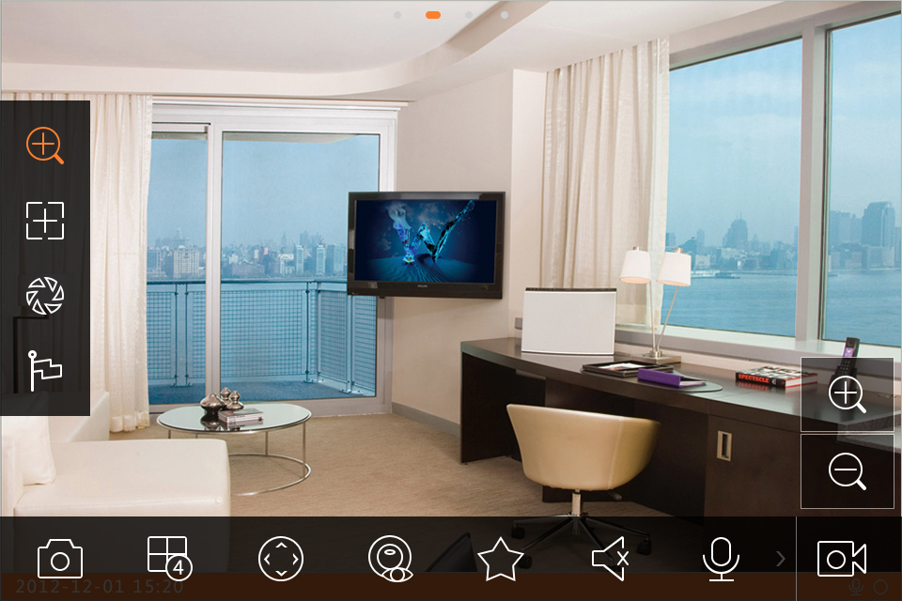
Figure 3-
Note:
If you cannot enter full screen mode, please check the settings of mobile phone.

Zoom In
Via touch signal to zoom in current video, and can drag zoomed video in order to view details in video.

Window Position Switch
Select a window, drag the window to the target window, and the two windows will switch position.

Fish-eye
Enter live preview interface, select one window, click fish-eye button , and the interface shows fish-eye effect. In the fisy-eye effect, you can slide to control the effect. Click fisy-eye button again to exit. (Or double click to exit)

Playback
System supports record playback and picture playback.
Record playback is to play record saved on device; picture playback is to play picture saved on front-end device.
Click on button to view main menu. Click on playback on main menu to enter playback interface. The default is to play record, but you can switch it to picture by clicking on tab above.

Record Playback
To record:
- Click on in window to open device list.
- Select playback period.
- Select record channel to view. System can play video of selected channel in selected window as in Figure 3- .

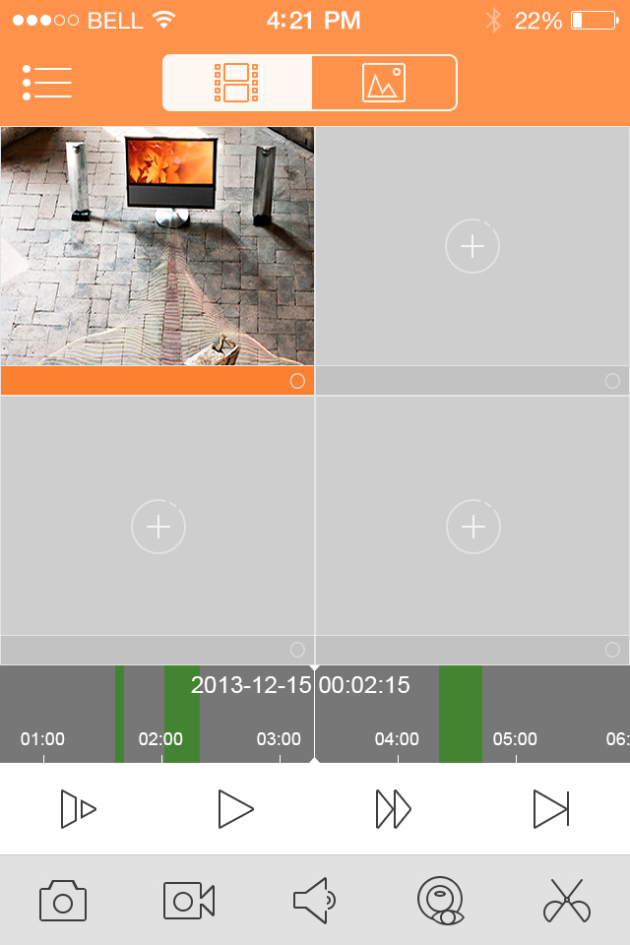

Figure 3-
You can close playback by either of:
- Close a single channel playback: long press video to close playback and drag it to the trashcan above.
- Close all channels’ playback: click on to close all playback.

Parameter | Note
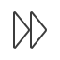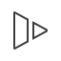 | Quick/Slow  - Quick: quick play with 2x, 4x or 8x speed. Select playing video, click on to 2x play; click on , to 4x play. During 4x play, click on to 8x play and click on it again back to normal speed.  - Slow: slow play with 1/2x, 1/4x and 1/8x speed. Select playing video, click on to 1/2 play; click on to 1/4 play. During 1/4 play, click on to 1/8 play and click on it again back to normal speed.
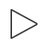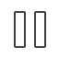 | Play/Pause
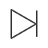 | Play by frame. Click on to play next frame.

Picture Playback

To playback picture:
- Click on button to open deivce list.
- Select playback period.
- Select picture channel to view. System will play picture of selected channel in selected window.
- Click on to close playback.
- Smart mode: during picture playback, click on 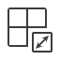 to enter smart mode. Window becomes 4-split. You can zoom in/out in window 2/3/4.

File Manager
System supports viewing, editing, exporting of live preview and snapshot, record during playback.

View File
Click on record file to view. In the interface, you can play, pause, snapshot, play audio, quickly play, slowly play and etc.

Share File
- Click on 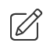or long press file to enter file manager mode.
- Select file to share.
- Click on 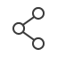 to share file.
Note:
For Android only.

Export File
- Click on or long press local file to enter manager mode.
- Select file to export.
- Click on 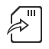 to export video as in Figure 3- .

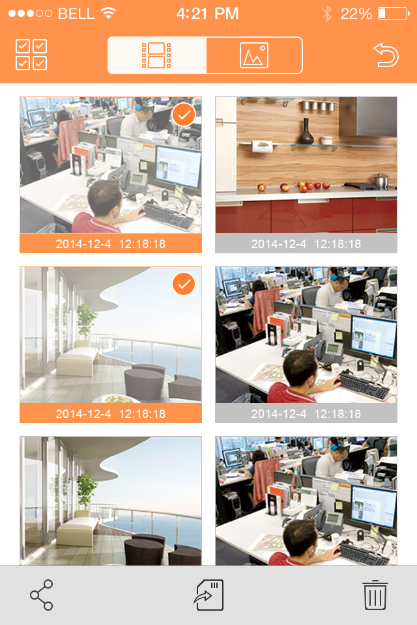

Figure 3-
Note:
Android OS do not need to export picture and user can find picture under installation path.

E-Map

Create E-Map
- Click on 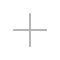 to add one picture as map.
- Click on 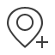 to add monitoring spot on map. Go to device list interface and select channel.
- Place added channel on appropriate location on map and click on to save.

Edit E-Map
Select added e-map, click on  button to editing mode.
- Click on 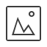 to siwtch map.
- Click on to add monitoring spot.
- Click on  to delete monitoring spot.
- Clcik to rename map.

Favorites
System supports to create new favorites, or add monitoring spot to existing favorites.
- Click on 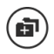 and input name. See Figure 3- .
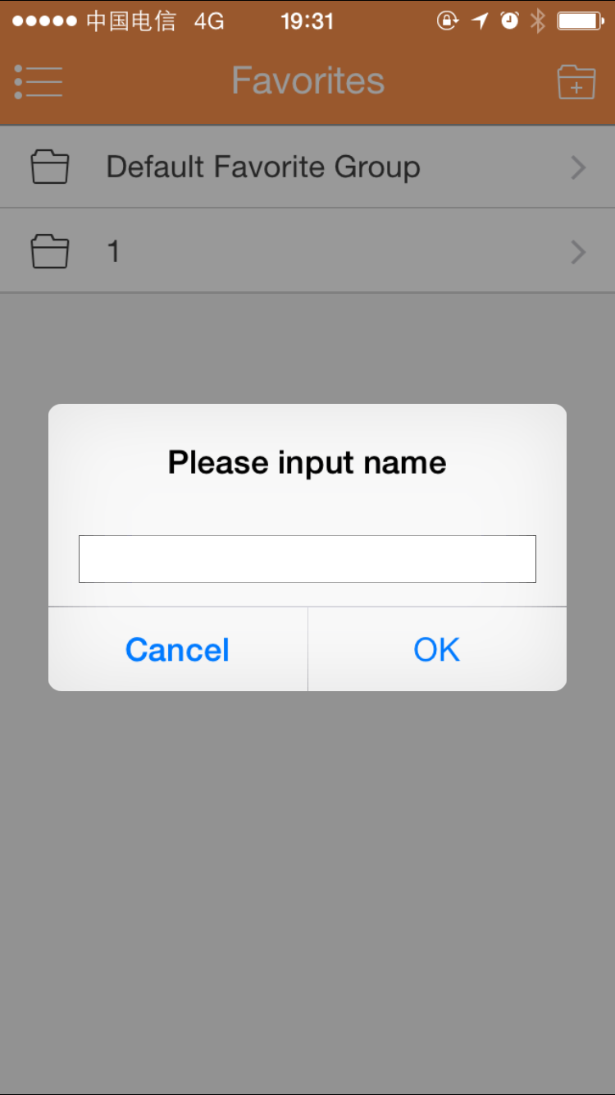
Figure 3-
- Enter a certain favorite group, click on 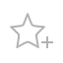 at upper-right corner to enter device list. Check designated channel and click on to add it into favorites. See Figure 3- .
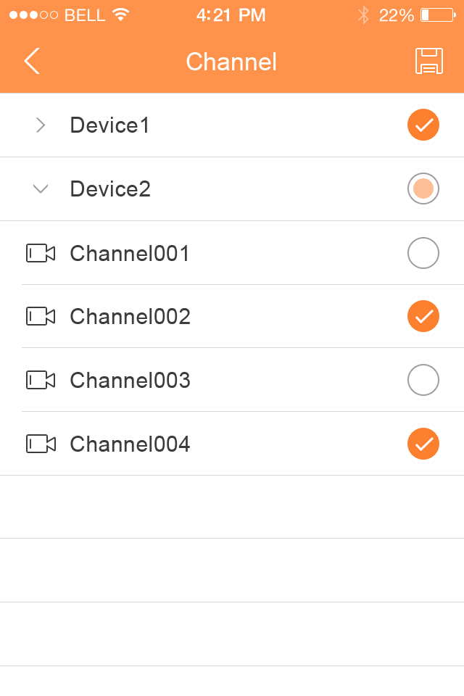

Figure 3-

You can delete favorites:
- Delete favorite (Android): long press favorite to delete and click on delete in pop-up box.
- Delete favorite (iOS): At row of favorite to delete, slide the delete button and click on delete button.

You can remove monitoring spot in favorites:
- Delete video channel in favorites (Android): enter favorites, long press channel to delete. Click on OK to delete it.
- Delete video channel in favorites (iOS): At row of channel to delete, slide the delete button and click on delete button.

Alarm Manager
Alarm push function is the function to push alarm info generated on device to mobile phone by integrating device alarm module. User can view alarm record, preview and playback picture according to push info.

Push Config
- Select device to push.
- Edit valid period and select push type.
Parameter | Note
Valid period | During valid period, you can receive alarm push.  Range: 1～365.
Push Type | In includes video and picture. If current device has record, and this push type is video, so when you receive push info, you can play the record. This is similar for the case of picture.
- Select alarm info, and select channel to push. Click on to save.

Instant View of Alarm Push
After you have set push info, when front-end device generates alarm push, client-end will receive alarm info from the device. You can click on info in notice bar to view detailed info. System will open record/picture according to the priority set by you. If there is no record or picture, system will go to live preview.

Note:
- Android user need to login Google account.
- Video and picture push requires storage medium on front-end device and you must set alarm record.
- System supports to store up to 50 historical records in event list.

Alarm Push Event List
You can view historical record in event list. Click all alarms dropdown list, you can view: face detection/moving detection/other alarm.

Local Config
System supports local configuration including PTZ step, capture mode, push duaration, video mode and etc.
Parameter | Note
PTZ Step | Used to set PTZ step during live preview.  The larger the step length, the higher the speed will be.  Range: 1～8。
Capture Mode | Configure continuous snapshot quantity in live preview interface and etc. There are three modes: 1, 3 and 5.
Push Duration | Set corresponding playback duration of push info, including: 15s, 30s, 1min, 2min, 5min.
Video Mode | Default is higher-performance mode.  If you encounter window split error or system crash, please witch to compatible mode.
Real-time Playback | Set playback period, as 5s～60s adjustable.
Protection | Set password protection of mobile monitoring app.  After you have set password, every time you login, you must verify password for security purpose.

Visual Talk

Live Preview
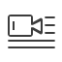
When you first enter, it shows guide to add device. Click icon, you can select/add device.
There are two domain names to add device:P2P and IP. Click edition icon to delete.
Icon | Note
 | Add/edit device
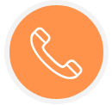 | Talk
 | Unlock
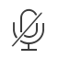 | Mute mode
 | Snapshot
 | Record
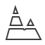 | Bit stream

Playback
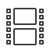
Click dropdown button at the top, you will see icon to enter playback interface.
There are video and picture playback. Click edition icon to delete. See Figure 3- .

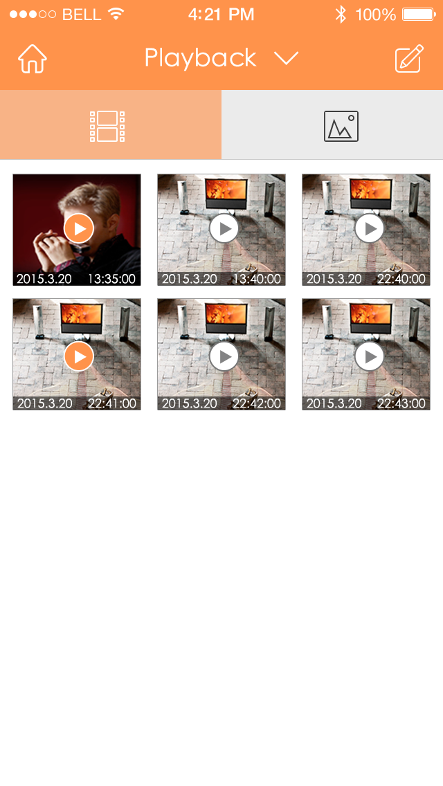
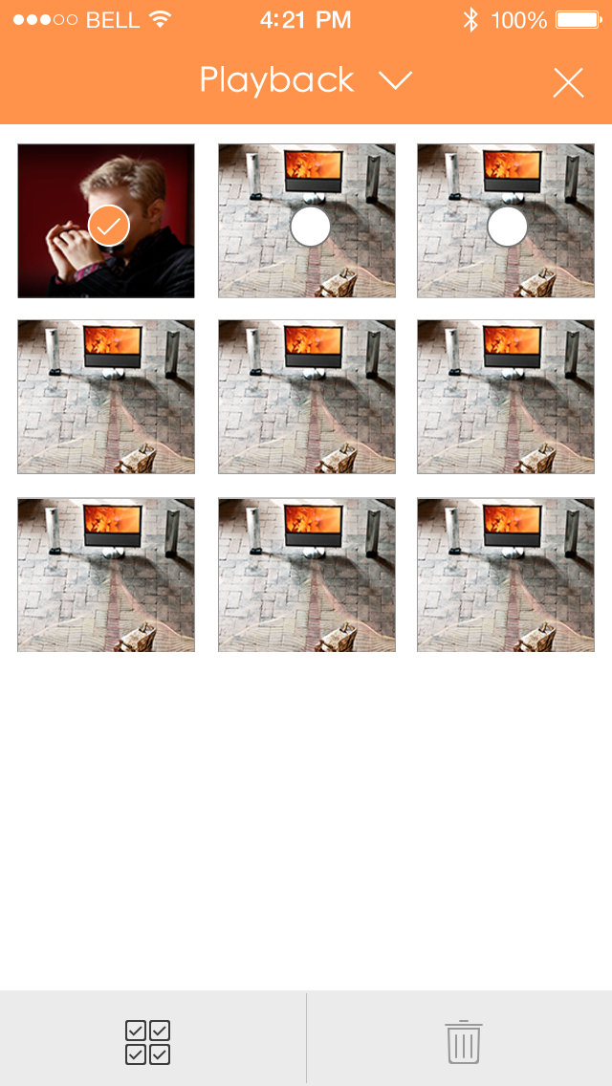

Figure 3-

Event List
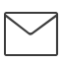
Click dropdown button at the top, you will see event list , click it to enter event list interface.
Record history has two types: call and alarm. There are eight types of alarm: IR, Gas Sensor, Smoke Sensor, Urgency button, door sensor, Stolen Alarm , Perimeter, Door bell, Vandal-proof. Record history supports up tp 50 records. Called/missed and read/unread are distinguished via icons. Slide left to delete event. You cal delete all records by clicking trash can at the upper-right corner. See Figure 3- .

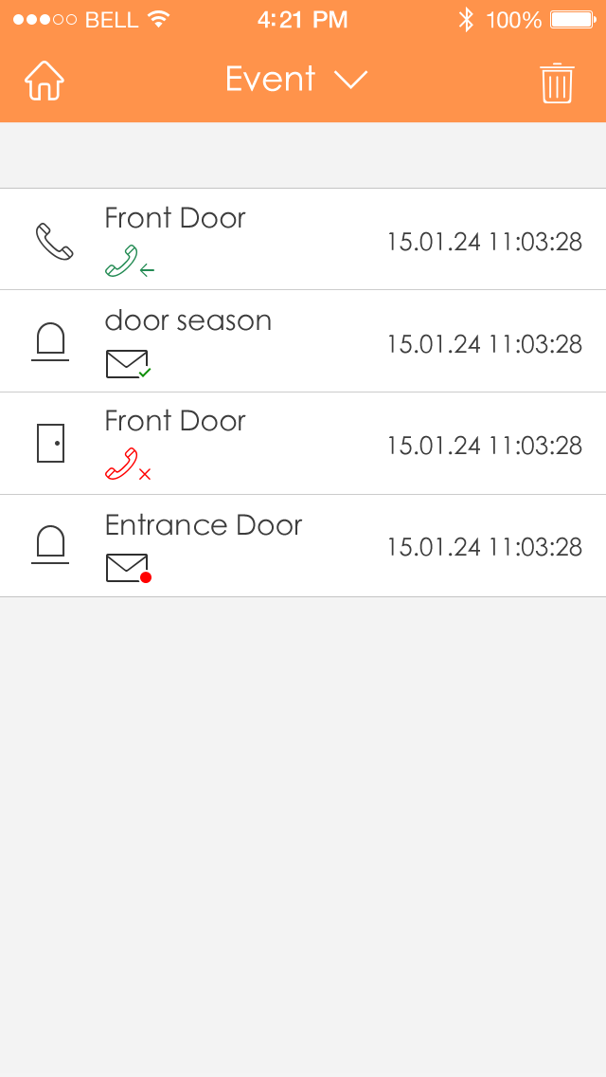
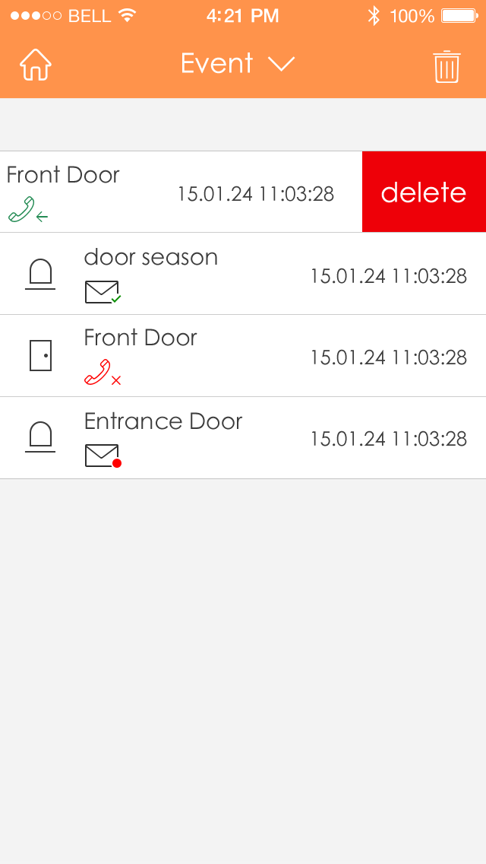

Figure 3-

Note:
- This user’s manual is for reference only. Slight difference may be found in user interface.
- All the designs and software here are subject to change without prior written notice.
- All trademarks and registered trademarks mentioned are the properties of their respective owners.
- If there is any uncertainty or controversy, please refer to the final explanation of us.
- Please visit our website or contact your local service engineer for more information.

