Model V30

- Build in GSM modem
- Working temperature -20 + 60 degrees
- Power 12V
- 5 inputs
- 4 user input zones
- 1 alarm zone
- 1 output – relay 6A/ 240V
- 4 numbers
- SMS

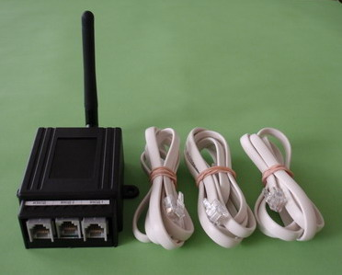

Model V31

- Build in GSM modem
- Working temperature -20 + 60 degrees
- Power 12V
- 8 inputs
- 5 user input zones
- 1 alarm zone
- Analog zone 0-40V
- 3 output – ( 1 relay , 2 open collector )
- 4 numbers
- SMS
- Ringing

