INSTRUCTION
FOR GUARD TOUR SYSTEM L-3000EF-2
1. System Component and Specification
1 | Model Name | Specification
 | Reader L-3000EF-2  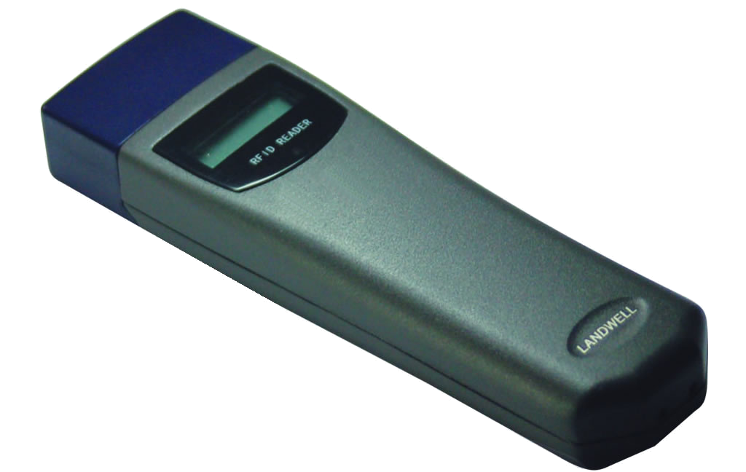 | Material: durable and high quality alloy metal case
 |  | Dimension:147mm*40mm*20mm
 |  | Storage Temperature: -20℃ - +70℃
 |  | Memory: America Original FLASH
 |  | Storage capacity: 10000 records
 |  | Communications:USB connection 1200-19.2kbps
 |  | Battery: 3v lithium battery with 700.000 reading times.
2 | Checkpoint
 |   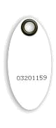 | Type: EM
 |  | Reading Distance: 2-5cm
 |  | Frequency: 125KHZ Material: ABS
 |  | Dimension: Optional
 |  | Thickness:1.2mm
 |  | Environment temperature: -20℃ - +80℃
 |  | Weight:10g
3 | Transmit Cable
 | 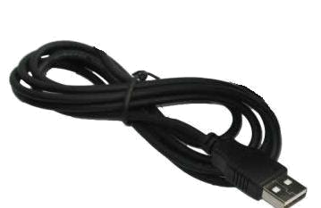 | Dimension: 1M
 |  | Connection:USB connection
 |  | Operating System: Windows 98, Windows 2000, Window XP, Vista...
4 | Event Wallet
 | 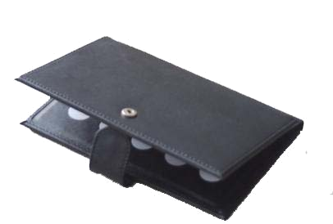 | The Event Wallet allows attachment of information to the
 |  | Report. This accessory consists of a leather jacket and 10
 |  | numeric tags. It should be registered different incidents by
 |  | using software. By reading equivalent numeric codes, the
 |  | data can be shown in the report of software.
4 | Management Software | Different Language choices
 | 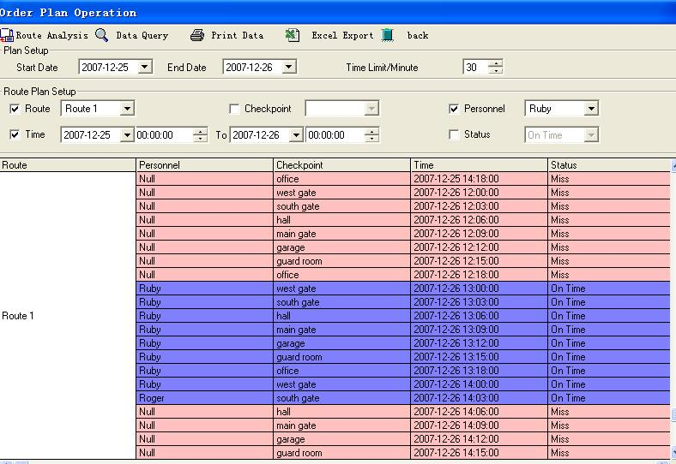 | User-friendly desk-top version support win95/98/2000/XP
Easy to set up checkpoints, personnel, events, route and patrolling plan
Generate multiple patrolling reports

1. Read tag at this end within 3-5cm.
After reading tag, LCD screen will display the numbers of readings, last four bytes of the tag serial number, and then show the present time. If repeatedly read the same tag within 1 minute, there is nothing display on the screen.

1. The red light flashes 3 times to indicate successful reading, meanwhile; the buzzer sounds one time.
2. There is 1 minute time interval for the same tag reading. If the same tag is read repeatedly within 1 minute, the red light will flash continually and no buzzer sounds.

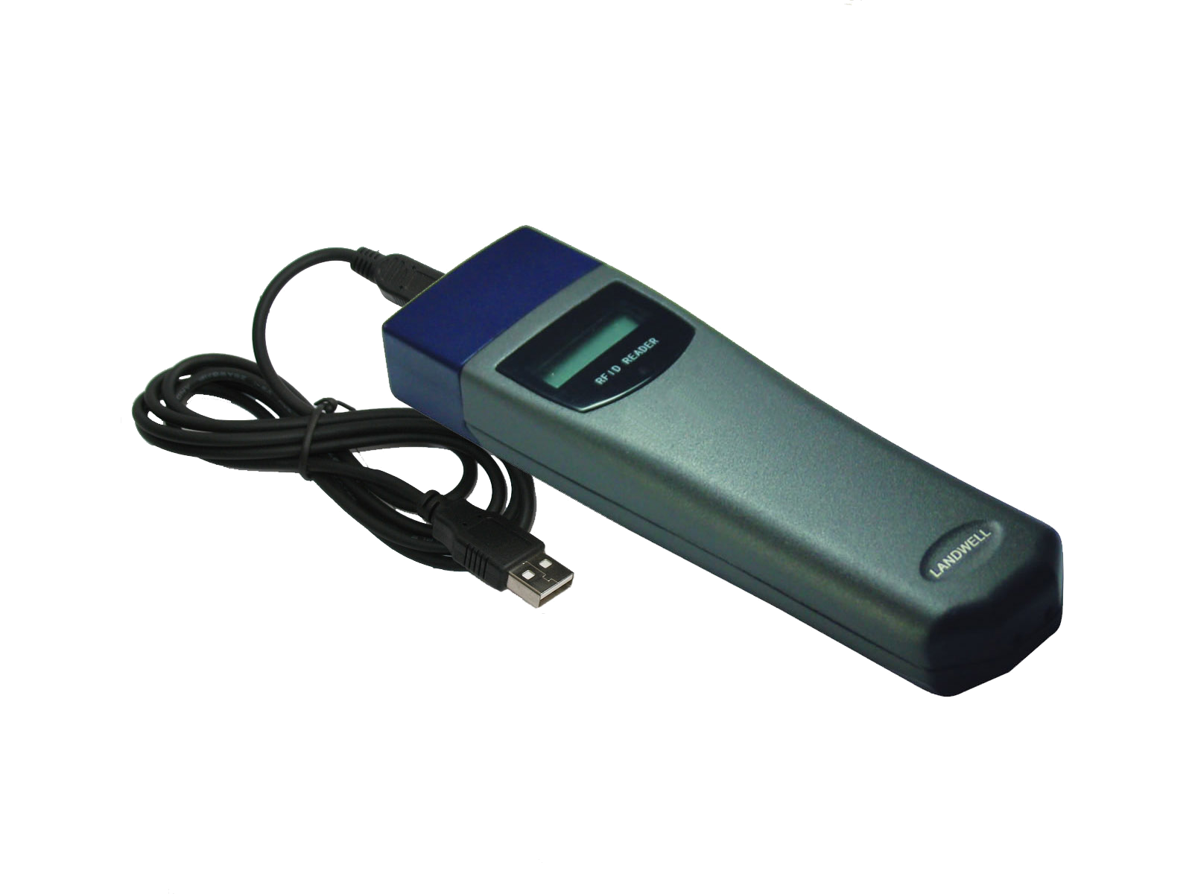
When data downloading, please first remove the rubber cap and then plug in the small end of special USB cable. The other big end is to connect with computer USB interface.

2. Software Installation
In the software CD, there are software setup and USB drive. First click the software setup to finish the installation according to steps. The default password is 333 and please logs on the software.
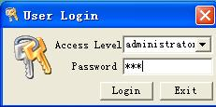

And then please connect Reader through special USB cable with computer.
Please note there will display “found new hardware” at the right bottom of software main menu. Please click the display to accept the related terms and follow the steps to fulfill the USB drive installation. If it shows USB Device not recognized, please check the My computer---Properties—Hardware—Device Manager—Com &LTP USB to UART Bridge Controller (COM 1, 2, 3…). Please click it and install according to the steps.

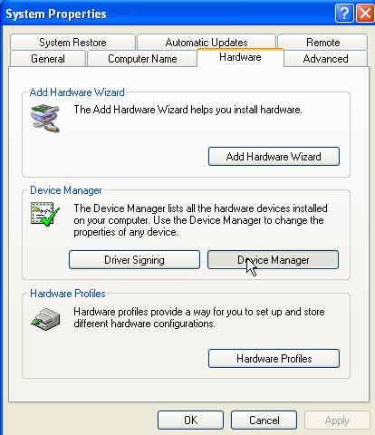

3. Reader Programming
3.1 Model Selection
After log on the software, please first select the right model name, for L-3000EF-2, the corresponding model name is RF model and make sure click “Ok” and then exit the “Model choosing”.
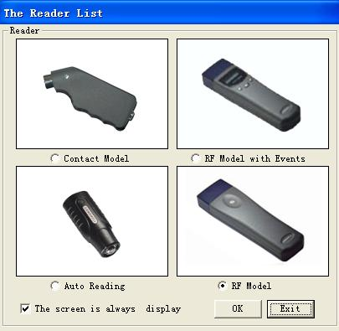

  - In the main menu of the software, please first refer to “Resource Setup” which included” Personnel button setup. Checkpoint button setup, Event Setup, Reader Number setup, System setup”.
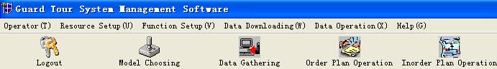

3.2.1 General Information Setup in the System Setup
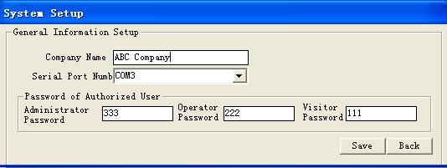

- Users can input their company names and click “save”.
- Please select the right Serial Port Number according to the following steps:
Check My Computer---Properties--Hardware---Device Manager--Com & LTP--CP210+ USB to UART Bridge Controller (COM 1, 2, 3…). This serial Port Number is for L-3000R hardware. Please choose the corresponding number in the Serial Port Number of System Setup.
- The Password of Authorized User is default as 111, 222, and 333 accordingly. If necessary, users can also change it. Make sure that click the Save after the operation.
3.2.2 Clear out the history data in the reader
Please click “Data Gathering” in the main menu and click “Collect Data”. The history data will be listed in the form and then click “Back” to exit.

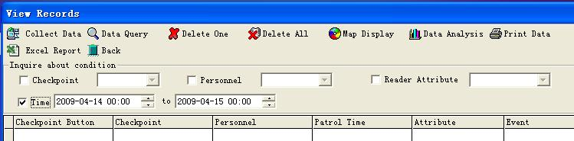

3.2.3 After clearing out the history data, please read the tags which using as Guard ID function. And then download the data into computer, the unique serial number for these tags will be displayed and then input Guards’ name, telephone and address. In order to distinguish the tags, please name each tag with sticker.
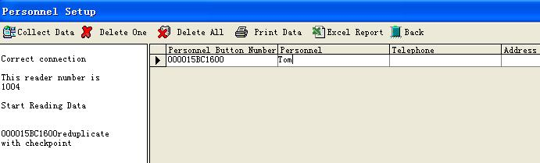

3.2.3 Next please open Checkpoint Button Setup in the Resource Setup. Please read the tags which using as Checkpoints. And then download the data from Reader into computer. The tag information will be listed. Please edit it according the actual needs. In order to distinguish the tags, please name each tag with sticker.
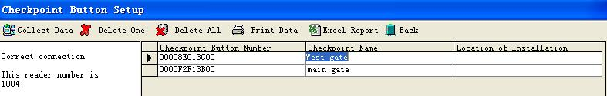

3.2.4 Reader Number Setup
For each Reader, there is a unique Reader serial number. Please click “Collect Data”, the Reader Number will be listed in the right form. It can be registered by editing the “Attribute”.

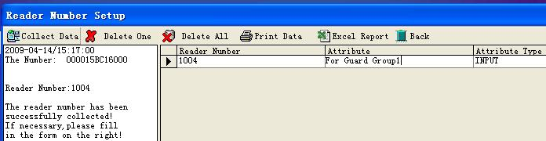

3.2.5 Event Button Setup
The event wallet is optional accessory for the whole guard tour system. The function is to show the incidents happened in the patrol locations such as broken window, on fire, leakage, and door open etc. For Event Button Setup, the Event wallet is necessary which is with 10 tags on the leather wallet. Please read the 10 tags one by one, and then download data into computer from the Reader, please input the possibly happened incidents in the Event column. When guards do the patrolling work, after Read the checkpoint tag and then read the corresponding tag in the Event Wallet. Suggest using notes to name each tag in the Event Wallet to distinguish the incidents.

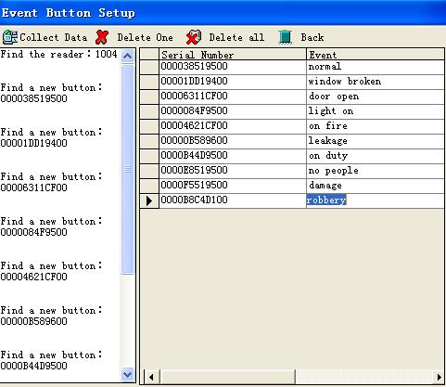

3.3 Function Setup
Please refer to the Function Setup in the main menu, which including Route Setup, Order Plan Setup, Inorder Plan Setup and Multi-day Plan Setup.
3.3.1 Route Setup indicates the patrol loop which including the setup checkpoints. First click “add” in the left bottom and input the Route Name and then click “” in the Select Area to choose the Route Name. Next tick the checkpoints in the list and then click “Set up Route”. Please have a look at the data in the right side. By clicking “Route Preview”, the details will be displayed. The interval means the time needed from this checkpoint to the next checkpoint. It can be changed according actual situation. The order means the sequence for the checkpoints, which is functioned in the “Order Plan Setup”. The order can be changed in the form if needed.

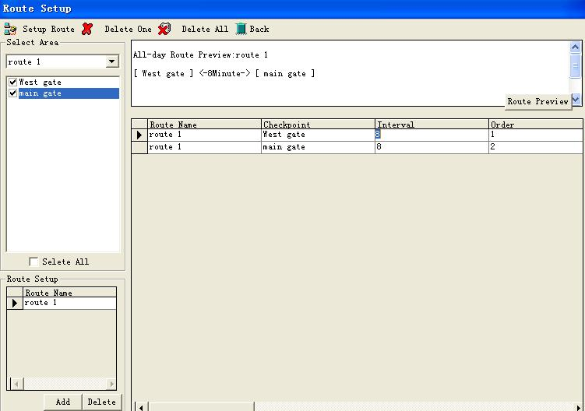

3.3.2 Order Plan Setup is most commonly used. First, please click “” to select Route Name. And choose the start time for each patrol loop. Order Plan require the sequence for checkpoints and Guard must go to every checkpoint in sequence. If not follow the sequence, the report will show “Wrong Order”. If want to delete the data, please first click the line, and it will be turned blue and then click “Delete one”. If want to delete all data, please just click “Delete All”.

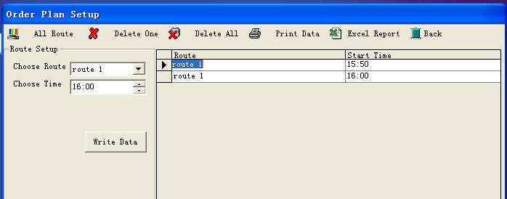

3.3.3 After finish all the setup, the hardware and software programming is done. The Guard can use this system to do patrolling work. First, the guard read the Guard ID tag and then goes to each checkpoint according the setup plan. The data downloading can be done according to actual situation. When downloading, please first click “Data Gathering-Collect Data” and check the data. If want to check the performance for “Order Plan Setup”, please click the Order Plan Operation in the main menu, and then choose the correct Start Date, next click Route Analysis”. The operation for this plan will be listed. There are also several conditions for filtering if needed such as by Route, Checkpoint, and personnel etc.
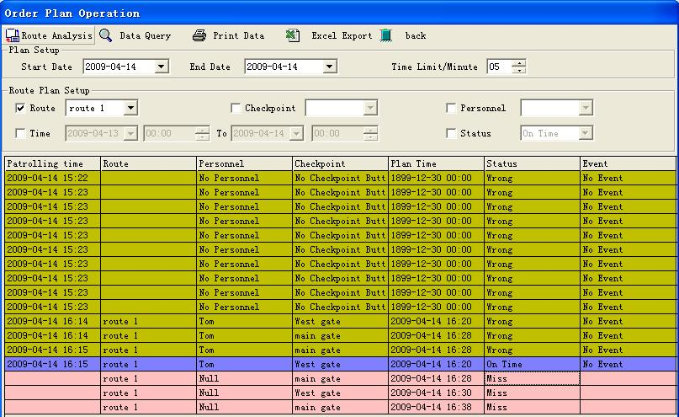

3.3.4 Inorder Plan Setup is another choice for patrolling work. It is not requiring the sequence and only check whether the guard has ever been there within the required time period. First click to select “Route Name” and choose Start Time and End Time. Next click “Save”. The data will be shown in the form. The performance for Inorder Plan Setup needs to check in the Inorder Plan Operation.

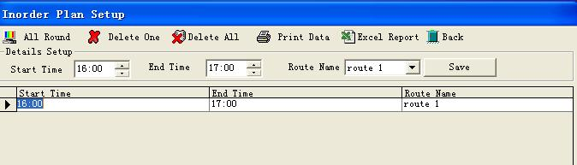

3.3.5 Besides Order Plan Setup and Inorder Plan Setup, there is Multi-day Plan setup in the “Function Setup”. It is applied in the long route patrolling work which need more than one day to fulfill.
First choose the Month and Route Name by click respectively. Please tick the Start Date and End Date and then click “Collect Data”. The Multi-day Plan Operation in the main menu will analyze the work performance.
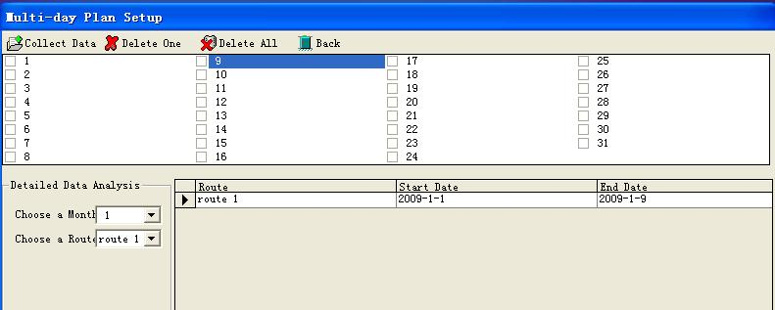

Please note that user can only choose one type of these three plan setup. They can’t be worked compatibly.
  - Data Operation in the main menu is including database backup, database comeback and data initialization.
    - Database backup is easy to operate by storing the data in the any directory.
    - Database comeback is for data restoring function.
    - Data initialization is for all the data initializing.

Hope the instruction can help you for guard tour system application.
Thanks for your attention.

