Software Version DSS Installation Instructor V1.0

1. Preparation
2. Install CentOS 6.4 system. (Note: Software Version DSS only support 32 bit system)
3. Copy the software package to U disk, then insert it into server.
4. Login server through CRT or Xshell: File -> New, input the IP address of server.

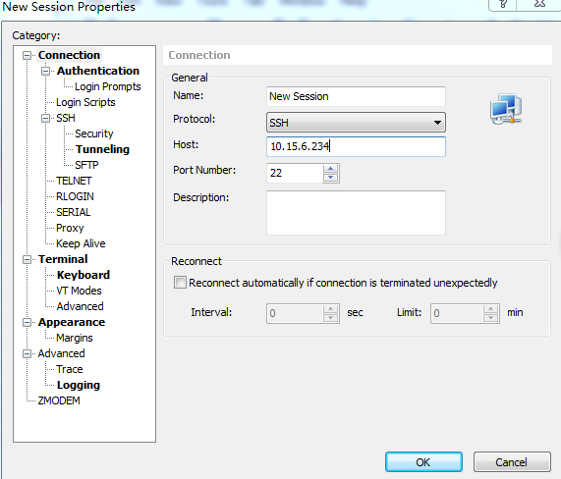

1. Create usbdisk directory: login server, then input mkdir /mnt/usbdisk.



1. Turn to usbdisk directory: input cd /mnt/usbdisk

C:\Users\30029\AppData\Roaming\Tencent\Users\958082691\QQ\WinTemp\RichOle\7LYD`9])E8KKX4([(AYIQJ8.png

1. Gain the path of U disk: input fdisk –l



C:\Users\30029\AppData\Roaming\Tencent\Users\958082691\QQ\WinTemp\RichOle\$KHAQCT}2~JW_]P(WZVM$7G.png

1. Input: mount /usbpath /mnt/usbdisk. The ”usbpath” refers to the U disk path we get in step 6). So here we input: mount /dev/sdb1 /mnt/usbdisk



1. Copy the software package to U disk
2. Setup
3. Enter into opt directory: input cd /opt



1. Unpack the package in opt directory: input tar -xvf General\_DSS\_PRO\_Eng\_Basic\_V3.11.002.R.20151014.tar

C:\Users\30029\AppData\Roaming\Tencent\Users\958082691\QQ\WinTemp\RichOle\(SC89IR59L]G@J$`GD9KB_1.png

1. To give permission: input chmod +x setDeviceName\_manualy.sh



1. Run the program script setDeviceName\_manualy.sh: input ./ setDeviceName\_manualy.sh



1. Reboot



1. Login again the system, enter into dss.pack directory: input cd /opt/dss\_pack



1. Install program: input ./install.sh



(Note : Maybe it will not be successful at first time , please install the program once again by inputting ./install.sh )

1. Reboot



1. Configure the network parameter
   1. Input setup



* 1. Use setup tool to configure
     1. Choose Firewall Configuration , press enter key

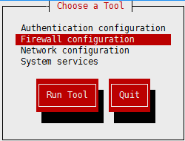

* + 1. Press “space” key to delete “ \* ” before Enable, then choose OK

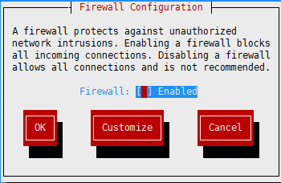

* + 1. Choose Yes to save

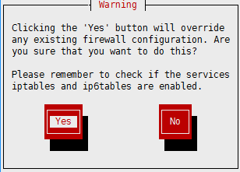

* + 1. Choose Network configuration , press enter key

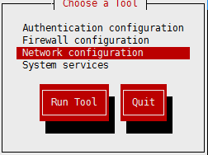

* + 1. Choose Device configuration , press enter key

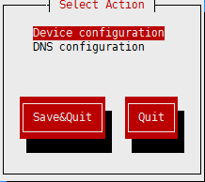

* + 1. Choose eth0

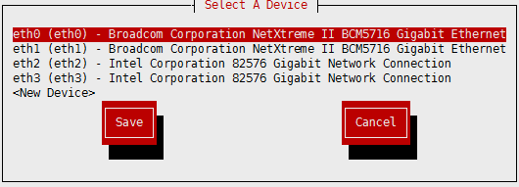

* + 1. Turn to third line, press space key to delete “\*”before Use DHCP , then input IP address, subnet mask, gateway , then choose OK

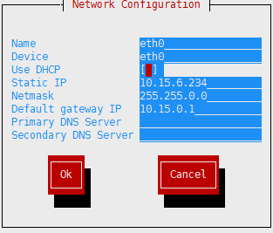

* + 1. Choose Save .

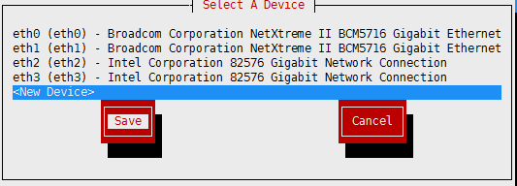

* + 1. Choose Save&Quit

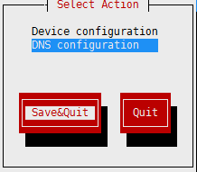

* + 1. Choose Quit.

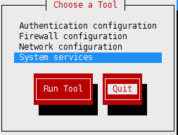

* + 1. Check the document ifcfg-eth0

C:\Users\30029\AppData\Roaming\Tencent\Users\958082691\QQ\WinTemp\RichOle\TOW4LTD_3CM)S5PP]O_{075.png

* + 1. If IPV6INIT=yes，
       1. Press i to enter edit state, then modify yes to no.

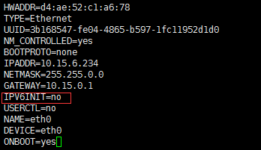

* + - 1. Then input ZQ to save&quit.
    1. Reboot



1. The installation is finished , you can login DSS now, original user name is system, password is 123456.

