Mini 1U DVR
Quick Start Guide

Version 2.0.0
Welcome
Thank you for purchasing our DVR!
This quick start guide will help you become familiar with our DVR in a very short time.
Before installation and operation, please read the following safeguard and warning carefully!

Important Safeguard and Warning
- All installation and operation here should conform to your local electrical safety codes.
- We assume no liability or responsibility for all the fires or electrical shock caused by improper handling or installation.
- We are not liable for any problems caused by unauthorized modifications or attempted repair.
- Improper battery use may result in fire, explosion, or personal injury!
- When replace the battery, please make sure you are using the same model!

Note: All the installation and operations here should conform to your local electric safety rules.

Check Unpacked DVR
When you receive the DVR from the forwarding agent, please check whether there is any visible damage. The protective materials used for the package of the DVR can protect most accidental clashes during transportation. Then you can open the box to check the accessories.
Please check the items in accordance with the list on the warranty card (Remote control is optional). Finally you can remove the protective film of the DVR.

About Front Panel and Rear Panel
For detailed information of the function keys in the front panel and the ports in the rear panel, please refer to the User’s Manual included in the resource CD.
The model in the front panel is very important; please check according to your purchase order.
The label in the rear panel is very important too. Usually we need you to represent the serial number when we provide the service after sales.

HDD Installation
This series DVR has only one SATA HDD. Please use HDD of 7200rpm or higher.
You can refer to the User’s Manual for recommended HDD brand.
Please follow the instructions below to install hard disk.
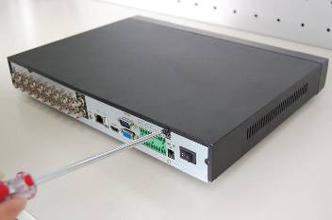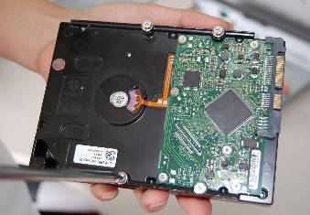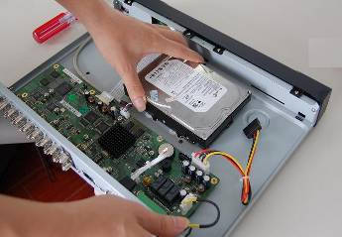
1. Loosen the screws of the upper cover and side panel.
2. Fix four screws in the HDD (Turn just three rounds).

3. Place the HDD in accordance with the four holes in the bottom.

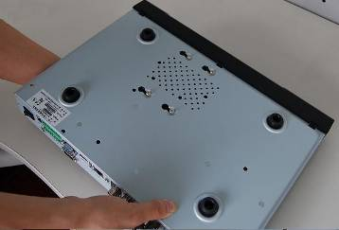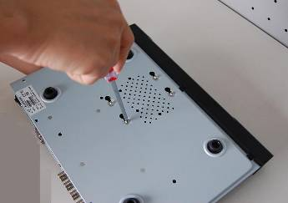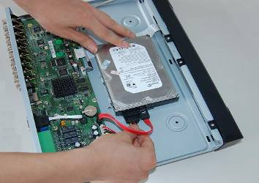
4. Turn the device upside down and then turn the screws in firmly.
in the chassis.
5. Fix the HDD firmly.

6. Connect the HDD cable and power cable.

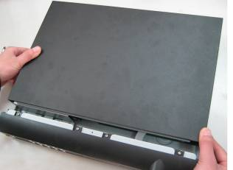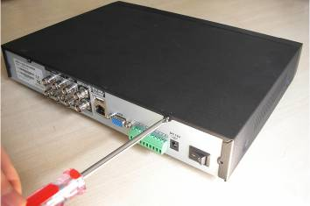
7. Put the cover in accordance with the clip and then place the upper cover back.
8. Secure the screws in the rear panel and the side panel.

Note:
- You can connect the HDD data cable and the power cable first and then fix the HDD in the device.
- Please pay attention to the front cover. It adopts the vertical sliding design. You need to push the clip first and then put down.

Front Panel
The front panel is shown as in Figure 1.
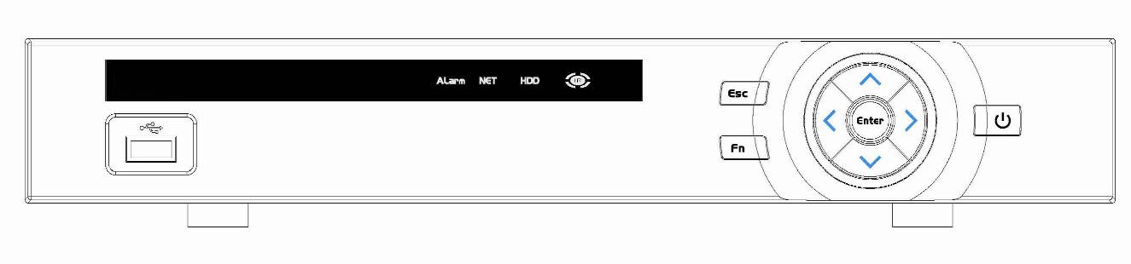
Figure 1
Please refer to the following sheet for front panel button information.
Name | Icon | Function
Power button |  | Power button, press this button for three seconds to boot up or shut down DVR.
Up  Down | 、 | Activate current control, modify setup, and then move up and down.
Up  Down | 、 | Increase/decrease numeral.
Up  Down | 、 | Assistant function such as PTZ menu.
Left  Right | ⧫  | Shift current activated control,
Left  Right | ⧫  | When playback, click these buttons to control playback bar..
ESC | ESC | Go to previous menu, or cancel current operation.
ESC | ESC | When playback, click it to restore real-time monitor mode.
Enter | ENTER | Confirm current operation
Enter | ENTER | Go to default button
Enter | ENTER | Go to menu
Slow play |  | Multiple slow play speeds or normal playback.
Assistant | Fn | One-window monitor mode, click this button to display assistant function: PTZ control and image color.
Assistant | Fn | Backspace function: in numeral control or text control, press it for 1.5seconds to delete the previous character before the cursor.
Assistant | Fn | In motion detection setup, working with Fn and direction keys to realize setup.
Assistant | Fn | In text mode, click it to switch between numeral, English character(small/capitalized) and etc.
Assistant | Fn | Realize other special functions.
USB port |  | To connect USB storage device, USB mouse.
Network abnormal indication light | Net | Network error occurs or there is no network connection, the light becomes red to alert you.
HDD abnormal indication light | HDD | HDD error occurs or HDD capacity is below specified threshold value, the light becomes red to alert you.
IR Receiver | IR | It is to receive the signal from the remote control.

Rear Panel
Here we take the 4-channel series product rear panel as an example. See Figure 2.
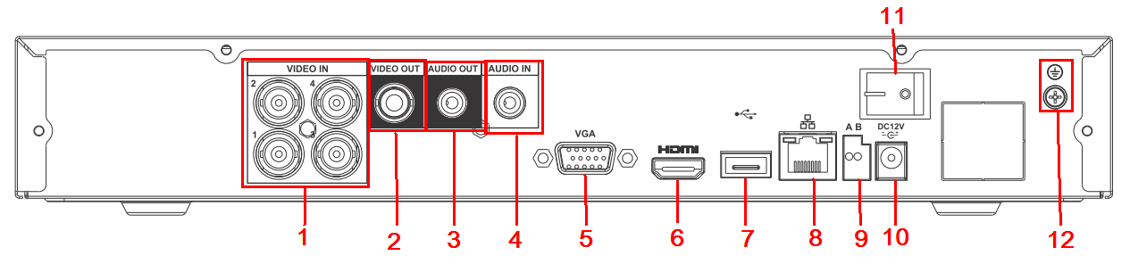
Figure 2
Please refer to the following sheet for detailed information.
SN | Name | SN | Name | SN | Name
1 | Video input | 2 | Video output | 3 | Audio output
4 | Audio input | 5 | Video VGA output | 6 | HDMI port
7 | USB port | 8 | Network port | 9 | RS-485 input port
10 | Power socket | 11 | On/Off button | 12 | GND port

Local Login
After system booted up, default video display is in multiple-window mode.
Click Enter or left click mouse, you can see the login interface. See Figure 3.
System consists of four accounts:
- Username: admin. Password: admin. (administrator, local and network)
- Username: 888888. Password: 888888. (administrator, local only)
- Username: 666666. Password: 666666(Lower authority user who can only monitor, playback, backup and etc.)
- Username: default. Password: default(hidden user)
Note:
For security reason, please modify password after you first login.
Within 30 minutes, three times login failure will result in system alarm and five times login failure will result in account lock!
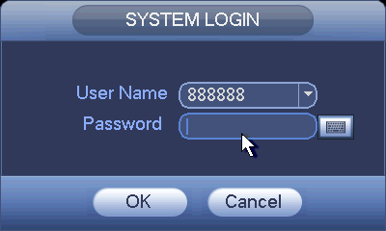
Figure 3

Web
Open IE and input DVR address in the address column. For example, if your DVR IP is 10.10.3.16, then please input http:// 10.10.3.16 in IE address column.
System pops up warning information to ask you whether install webrec.cab control or not. Please click yes button.
If you can’t download the ActiveX file, please modify your IE security setup.
After installation, the interface is shown as below. See Figure 4.
Please input your user name and password.
Default factory name is admin and password is admin.
Note: For security reasons, please modify your password after you first login.
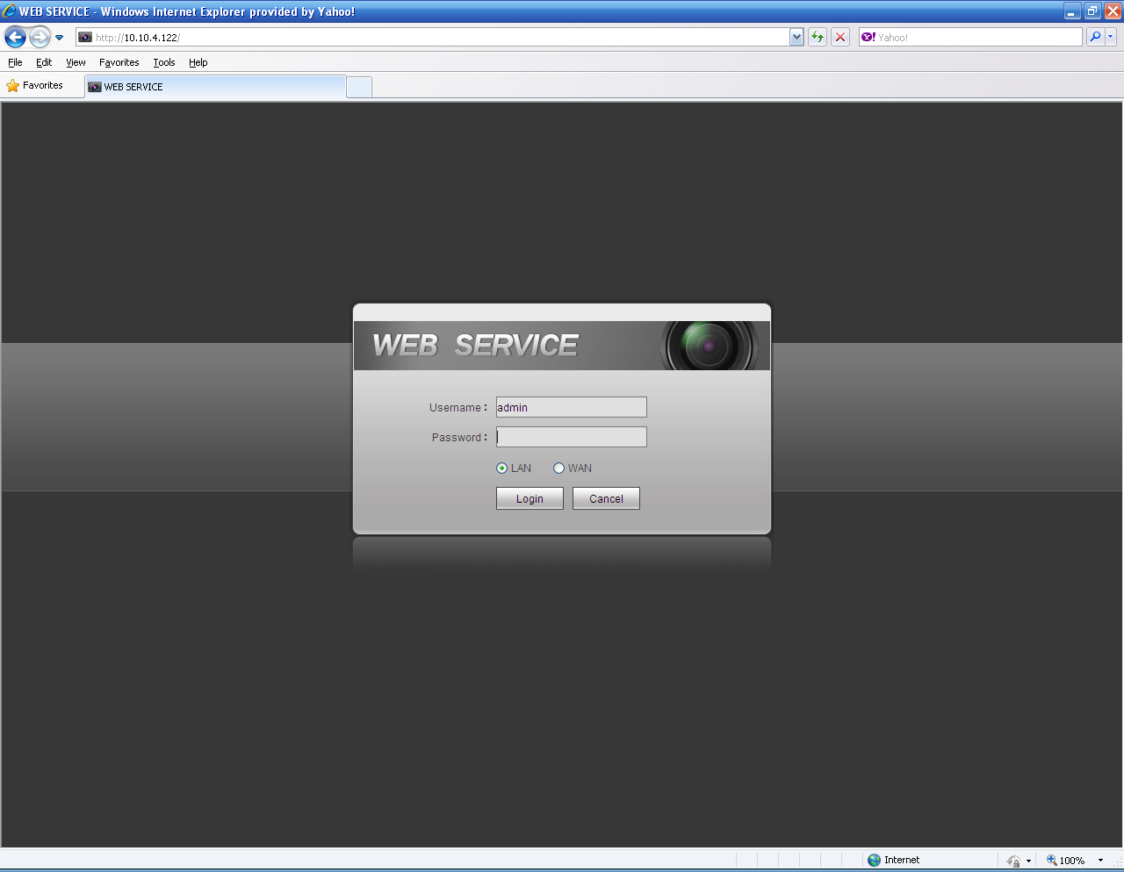
Figure 4
For detailed operation information, please refer to the User’s Manual included in the resources CD.

Appendix Toxic or Hazardous Materials or Elements
Component Name | Toxic or Hazardous Materials or Elements
Component Name | Pb | Hg | Cd | Cr VI | PBB | PBDE
Sheet Metal(Case) | ○ | ○ | ○ | ○ | ○ | ○
Plastic Parts（Panel） | ○ | ○ | ○ | ○ | ○ | ○
Circuit Board | ○ | ○ | ○ | ○ | ○ | ○
Fastener | ○ | ○ | ○ | ○ | ○ | ○
Wire and Cable/AC Adapter | ○ | ○ | ○ | ○ | ○ | ○
Packing Material | ○ | ○ | ○ | ○ | ○ | ○
Accessories | ○ | ○ | ○ | ○ | ○ | ○
Note
O: Indicates that the concentration of the hazardous substance in all homogeneous materials in the parts is below the relevant threshold of the SJ/T11363-2006 standard.

X: Indicates that the concentration of the hazardous substance of at least one of all homogeneous materials in the parts is above the relevant threshold of the SJ/T11363-2006 standard. During the environmental-friendly use period (EFUP) period, the toxic or hazardous substance or elements contained in products will not leak or mutate so that the use of these (substances or elements) will not result in any severe environmental pollution, any bodily injury or damage to any assets. The consumer is not authorized to process such kind of substances or elements, please return to the corresponding local authorities to process according to your local government statutes.

Note
- For detailed operation introduction, please refer to our resource CD included in your package for electronic version of the User’s Manual.
- This quick start guide is for reference only. Slight difference may be found in the user interface.
- All the designs and software here are subject to change without prior written notice.
- All trademarks and registered trademarks mentioned are the properties of their respective owners.
- If there is any uncertainty or controversy, please refer to the final explanation of us.
- Please visit our website or contact your local service engineer for more information.

