Intelligent Auto-Tracking Network Speed Dome
Quick Start Guide

Version 1.0.0

Table of Contents
1 General Introduction 1
2 IVS 2
2.1 Tripwire 2
2.1.1 Definition 2
2.1.2 Features 2
2.2 Cross Warning Zone 2
2.2.1 Definition 2
2.2.2 Features 2
2.3 Perimeter Protection 3
2.3.1 Definition 3
2.3.2 Features 3
2.4 Loitering Detection 3
2.4.1 Definition 3
2.4.2 Features 4
2.5 Abandoned Object Detection 4
2.5.1 Definition 4
2.5.2 Features 4
2.6 Missing Object Detection 4
2.6.1 Definition 4
2.6.2 Features 5
2.7 Illegal Parking 5
2.7.1 Definition 5
2.7.2 Features 5
2.8 Fast Moving 5
2.8.1 Definition 5
2.8.2 Features 6
3 Typical Applications 7
3.1 Single-Scene Track 7
3.2 Multiple-scene Track 10
3.3 Panorama-Scene Tracking-Alarm Activation 11
3.4 Panorama-scene Tack-Manual Activation 12

Welcome
Thank you for purchasing our product!
This quick start guide is designed to be a reference tool for the operation of your system.
Please keep it well for future reference!

Before installation and operation, please read the following safeguards and warnings carefully!

Important Safeguards and Warnings
1．Electrical safety
- All installation and operation here should conform to your local electrical safety codes.
- We assume no liability or responsibility for all the fires or electrical shock caused by improper handling or installation.
- We are not liable for any problems caused by unauthorized modification or attempted repair.

2．Transportation Security
- No heavy stress, violent vibration or water splash are allowed during transportation, storage and installation.
- Please use the original packing material (or the material of the same quality) when you ship it back to the manufacturer.

3．Installation
- Do not apply power to the product before completing installation.
- Do not put object on the product.

4．Environment
- This series product should be installed in a cool, dry place away from direct sunlight, inflammable, explosive substances and etc.
- Please keep it away from the electromagnetic radiation object and environment.
- Please keep the sound ventilation.

5. Daily Maintenance
- Do not use the volatility solvent such as the benzene or thinner, or detergent with strong abradibility. It may result in lens damage or it may adversely affect the device performance.
- If there is too much dust, please use the water to dilute the mild detergent first and then use it to clean the device. Finally use the dry cloth to clean the device

6. About Accessories
Always use all the accessories recommended by manufacturer.
Before installation, please open the package and check that all the components are included in the package:
Contact you local retailer ASAP if something is missing in your package.

General Introduction
This series intelligent auto-tracking network speed dome product can auto monitor, intelligent detect and track the object. It can realize the zoom, tracking, record, alarm, snapshot and etc function once it detects an object. It can realize the effective surveillance without on-site person to view the monitor all the time. It supports various action rules and support the auto tracking and manual tracking at the same time. It is suitable for different monitor environments. It supports single-scene tracking and multiple-scene tour tracking. This series product can be used in the important environments of small person or no person such as bank, exchequer, power station, prison.

There are three tracking types: panorama-scene tracking, single-scene tracking, and multiple-scene tracking. You can set via the IVS setup interface of the WEB. System can analyze the operation of the target and realize the intelligent track.

Please refer to the following contents for the general introduction of the rules and there are typical four setups for your reference.

IVS

Tripwire

Definition
It is to detect the object crossing the tripwire. See Figure 2-1.
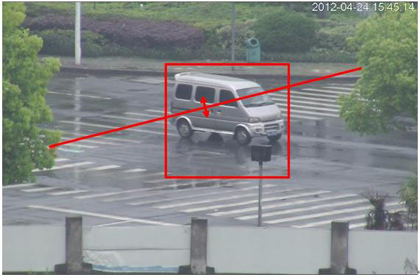
Figure 2-1

Features
- Customized tripwire setup. It can be straight line or the line of any shape.
- Support one-way, dual-way cross alarm detect.
- There are several tripwires in one scene to meet the monitor requirements of complex environments.
- Support object size filter.

Cross Warning Zone

Definition
It is to detect the moving object crossing the specified zone or in the specified zone. See Figure 2-2.
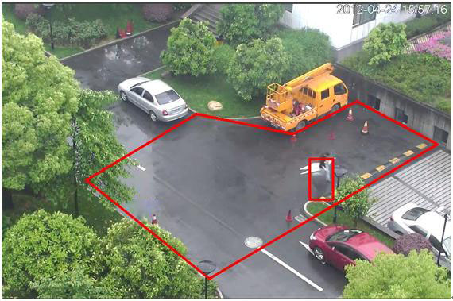
Figure 2-2

Features
- The warning zone shape and amount support customized setup.
- It can detect an object entering or leaving action and generate an alarm.
- It can detect the moving object action in the zone. The activation amount and the stay time are self-defined.
- Support object size filter.

Perimeter Protection

Definition
It is to detect the object is crossing the perimeter. See Figure 2-3.
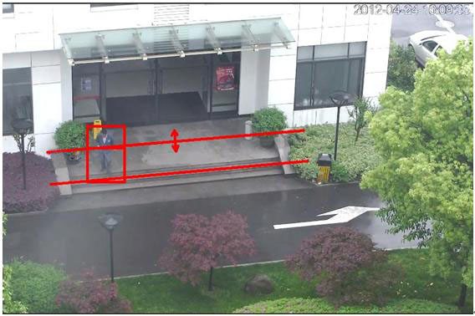
Figure 2-3

Features
- The e-fence supports customized setup. It consists of any two straight lines or two lines of any shape.
- Support one-way, dual-way cross detect.
- Support object size filter.

Loitering Detection

Definition
It is to detect the object stays in the specified zone than the set time. See Figure 2-4.
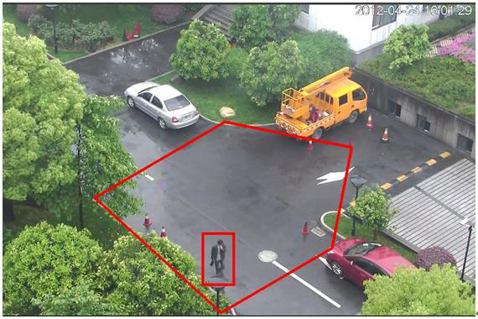
Figure 2-4

Features
- The detect zone shape and amount support customized setup.
- Support time threshold setup.
- Support object size filter.

Abandoned Object Detection

Definition
It is to detect any abandoned object in the specified zone. See Figure 2-5.
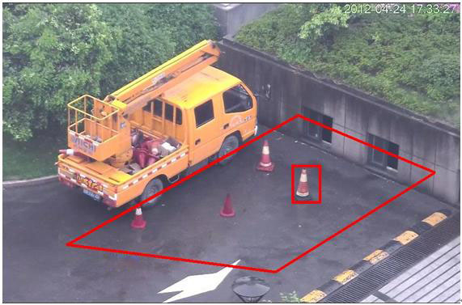
Figure 2-5

Features
- The detect zone shape and amount support customized setup.
- Support time threshold setup.
- Support object size filter.

Missing Object Detection

Definition
It is to detect any missing object in the specified zone. See Figure 2-6.
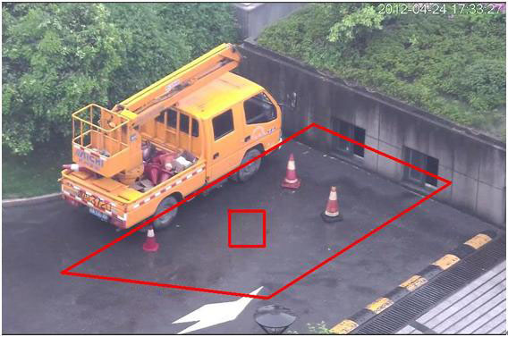
Figure 2-6

Features
- The detect zone shape and amount support customized setup.
- Support time threshold setup.
- Support object size filter.

Illegal Parking

Definition
It is to detect any illegal parking event in the specified zone. See Figure 2-7.
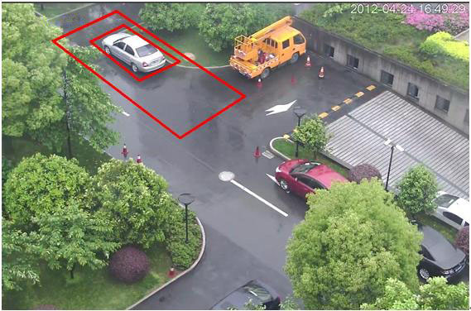
Figure 2-7

Features
- The detect zone shape and amount support customized setup.
- Support time threshold setup.

Fast Moving

Definition
It is to detect any fast moving object in the specified zone. See Figure 2-8.
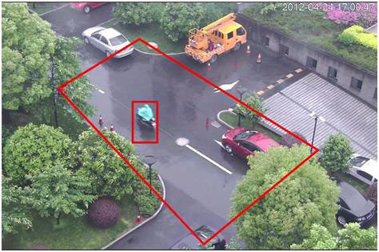
Figure 2-8

Features
- The detect zone shape and amount support customized setup.
- Support speed threshold setup.

Typical Applications

Single-Scene Track
It is suitable for the single-scene monitor zone. You can set the corresponding alarm activation rule here. Once an object is entering the monitor zone and activate the selected rule, system can enable auto track function. For example, you want to set one prohibited area in the monitor zone; you can use the “Cross warning zone” rule. Please follow the steps listed below.
- Login the Web and then click the Set button. Select IVS in the menu tree on the left pane. You can go to the following interface.
- Set track parameter. The interface is shown as in Figure 3-9. Click the Save button to complete the setup. You can see system prompts a dialogue box “Save succeeded” to remind you.
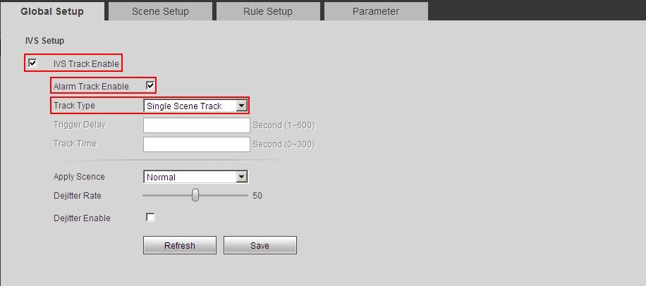
Figure 3-9
- Set scene. Please go to the Scene setup interface, click 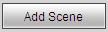 button to add a scene. System saves current monitor area as the new scene by default. You can use the PTZ to adjust the monitor area and click button to set a new scene too. Use the button to adjust the PTZ zoom position. Select a proper zoom rate and the click button; you can set the track process in current scene at the reference rate you set here. Move your mouse to the Scene name, track time, you can edit them. Click the Save button to complete the setup. See Figure 2-5.
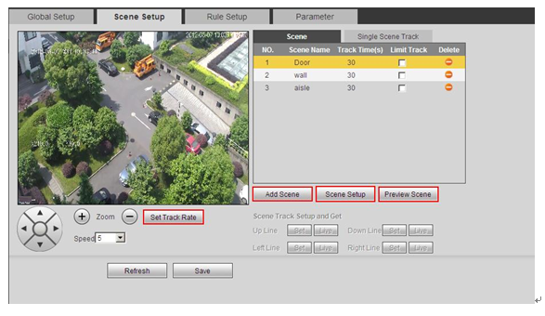
Figure 3-10
- Set limited scene (Optional): Please check the corresponding box to enable the limited track function. Please select the track line at the right pane of the interface. Please use the PTZ direction and zoom button to set the up/down/left/right line. Click the save button to complete setup. See Figure 3-11.
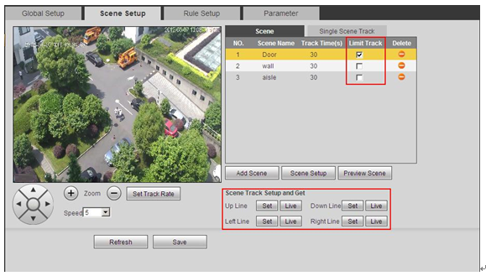
Figure 3-11
- Select track scene. Go to the single-scene track interface and select the monitor scene you want. Click the save button to complete the setup. See Figure 3-12.
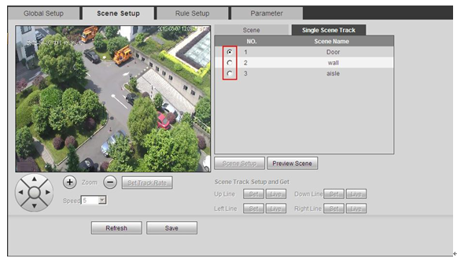
Figure 3-12
- Set intelligent rule: Go to the Rule setup interface to set the monitor scene of the rule. Click to add a rule. System enables the rule by default. Move the mouse to the Rule name; you can edit a customized name here. Move the mouse to the Rule type; you can select a rule (Crossing warning zone) from the dropdown list. Click, you can draw the rule in the preview interface at the bottom left panel. Select both from the direction dropdown list. Click the save button to complete the setup. See Figure 3-13.
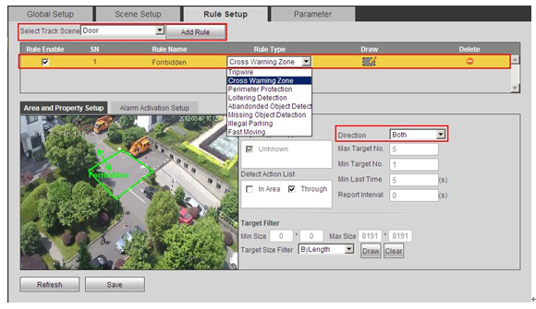
Figure 3-13
- Click the Live button. Please note, when you switch to a new scene, system needs to wait for about 3 seconds to enable the auto track function. Now the speed dome can enable single-scene track function in the specified monitor zone.
Note:
  - Click to draw the rule. In the live pane at the left bottom corner of the interface, left click mouse to begin the draw. Right click mouse to complete. When you draw the area such as a round or a polygon, you can right click the mouse to allow the system auto closes current draw area. When you draw in the perimeter protection rule interface, please draw the fence at the top first and then draw the fence at the bottom.
  - Click to draw the target filter. In the live pane at the left bottom corner of the interface, left click mouse to begin the draw. Adjust the area to the specified size and then right click mouse to complete. The green pane is the max size and red pane is the min size. Click the green pane and then drag the four acmes to set the zone size. Click the Save button, you can see system prompts a dialogue box “Save succeeded” to remind you.

Multiple-scene Track
It is for the monitor of several scenes. You can set alarm activation rule for each scene. Once an object entered current monitor area and activate the specified rule, the system can auto track. For example, you want to use one speed dome to monitor three scenes via tour function: The loitering object around the door, the object crossing the perimeter, the object cross the tripwire of the walkway. For the first scene, we can use loitering detectionrule. For the second scene, we use perimeter protection rule and for the third scene, we use tripwire rule.
- Login the Web and then click the Set button. Select IVS in the menu tree on the left pane. You can go to the following interface.
- Please set the track parameter. See Figure 3-14. Click the save button to complete the setup. You can see system prompts a dialogue box “Save succeeded” to remind you.
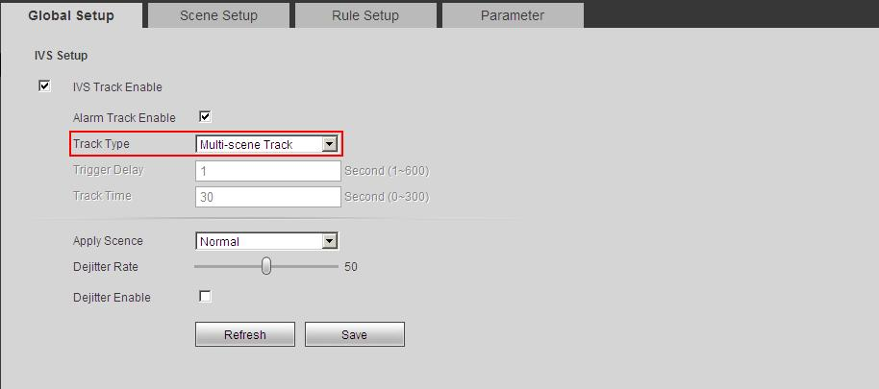
Figure 3-14
- Set scene. In the following figure, you can add the path for the multiple-scene track. The stay time is 30s, 40s, and 50s respectively. See Figure 3-15. Click the save button to complete the setup. You can see system prompts a dialogue box “Save succeeded” to remind you.
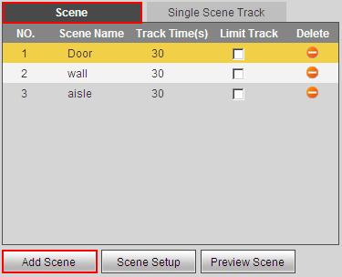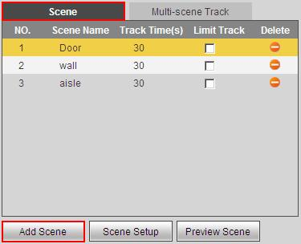
Figure 3-15
- Set rule. Please refer to step 6 in chapter 3.3 Single-scene Track for detailed information. You can see system prompts a dialogue box “Save succeeded” to remind you.
- Click the Live button; you can use the PTZ to set the monitor scene. Please note, when you switch to a new scene, system needs to wait for about 3 seconds to enable the auto track function. Now the speed dome can enable multiple-scene track function in the specified monitor zone.

Panorama-Scene Tracking-Alarm Activation
System can auto track the object when there is any object entering the monitor zone. For example, when there is an object entering the monitor zone, you can set the speed dome to enable auto tracking function after it recognized the object 1 second. You can set it to track the object for 30 seconds and the tracking rate is auto. You can follow the steps listed below to set.
- Login the Web and then click the Set button. Select IVS in the menu tree on the left pane. You can go to the following interface.
- Check the corresponding box to enable IVS track function and alarm track function. Select panorama-scene from the track type dropdown list. Set trigger delay time as 1 second and track time as 30 seconds. See Figure 3-16.
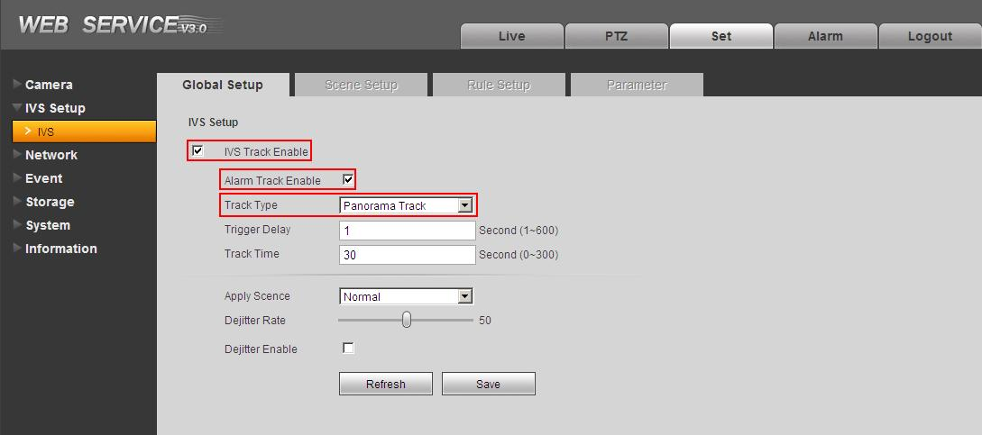
Figure 3-16
- Click the Save button to complete the setup. You can see system prompts a dialogue box “Save succeeded” to remind you.
- Click the Live button; you can use the PTZ to set the monitor scene. Please note, when you switch to a new scene, system needs to wait for about 3 seconds to enable the auto track function. Now the speed dome can enable Panorama-scene track function in the specified monitor zone.
Important
The so called panorama-scene is the current monitor zone of the camera. The default activation rule of the panorama-scene is “Cross Warning zone”，usually you do not need to set.

Panorama-scene Tack-Manual Activation
System can track the object once there is any object entering the monitor zone. For example, you can set the speed dome to track once the object is entering the monitor zone. After the system recognized the object 1 second, you can see the object frame and rule became red and flashes. Now it records the alarm event. You can set to track object manually. Please follow the steps listed below.
- Login the Web and then click the Set button. Select IVS in the menu tree on the left pane. You can go to the following interface.
- Set the parameters. See Figure 3-17.
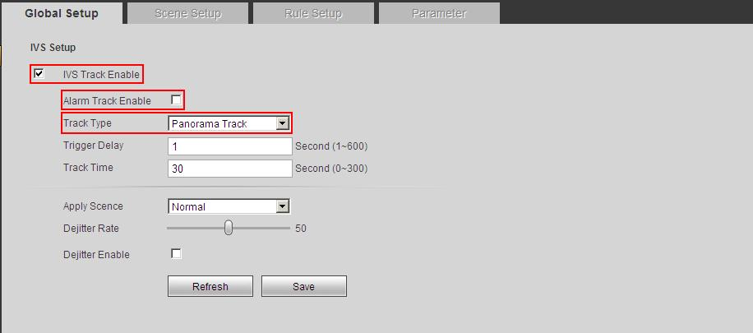
Figure 3-17
- Click the Save button to complete the setup. You can see system prompts a dialogue box “Save succeeded” to remind you.
- Click the Live button; you can use the PTZ to set the monitor scene. Please note, when you switch to a new scene, system needs to wait for about 3 seconds to enable the auto track function. Click the button and select an object in the scene, now the speed dome can enable track function in the specified monitor zone. See Figure 3-18.
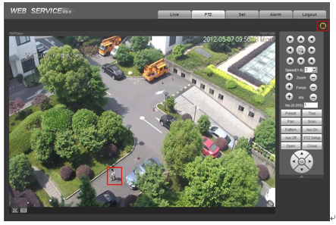
Figure 3-18

Important
In any track type, once there are several objects appearing at the same time, you can click to select the new tracking object manuanlly. During the inlligent auto-tracking enable process, the PTZ needs to stop intelligent track. System can enable the intelligent track automatcially once the PTZ is idle for a period of time.

Note
- This manual is for reference only. Slight difference may be found in the user interface.
- All the designs and software here are subject to change without prior written notice.
- All trademarks and registered trademarks mentioned are the properties of their respective
owners.
- If there is any uncertainty or controversy, please refer to the final explanation of us.
- Please visit our website or contact your local service engineer for more information.

