IR Intelligent Speed Dome Installation Manual

Version 2.0.0

Table of Contents
1 SPEED DOME INSTALLATION 1
1.1 Installation Preparation 1
1.2 Initial Setup 2
1.3 Intelligent speed dome installation 2
1.3.1 Speed dome bracket installation 2
1.3.2 Pipe thread bracket installation 2
1.3.3 Buckle wall mount bracket installation 2
1.3.4 Address and Baud Rate Setup 3
1.3.5 Install the IR speed dome and then connect the cable 4
1.3.6 Secure the speed dome to the flange 4
1.4 Dial Switch Setup 4
1.4.1 Communication protocol and Baud rate 5
1.4.2 Address Setup 6
2 BRACKET DIMENSIONS 7
2.1 Wall Mount Bracket 7
2.2 Hanging Mount Bracket (Multiple Lengths) 7
2.3 Corner Mount Bracket 8
2.4 Pole Mount Bracket 8
3 WALL MOUNT BRACKET INSTALLATION 9
3.1 Component Installation 9
3.2 Installation 9
3.2.1 Installation Requirements 9
3.2.2 Installation Steps 9
4 HANG MOUNT BRACKET INSTALLATION 11
4.1 Component Installation 11
4.2 Installation 11
4.2.1 Installation Requirements 11
4.2.2 Installation Steps 11
5 CORNER MOUNT BRACKET INSTALLATION 13
5.1 Component Installation 13
5.2 Installation 13
5.2.1 Installation Requirements 13
5.2.2 Installation Steps 13
6 POLE MOUNT BRACKET INSTALLATION 15
6.1 Installation 15
6.1.1 Installation Requirements 15
7 APPENDIX Ⅰ THUNDER PROOF AND SURGE PROTECTION 17
8 APPENDIX Ⅱ ABOUT RS485 BUS 18
8.1 RS485 Bus Main Feature 18
8.2 RS485 Bus Transmission Distance 18
8.3 The Problem in Practical Use 18
8.4 RS485 Bus FAQ 19
9 Appendix Ⅲ SAFETY ROPE INSTALLATION 20

Welcome
Thank you for purchasing our speed dome!
Please read the following safeguards and warnings carefully before you install or use the product!

Important Safeguards and Warnings
Safety Measures
1. Qualified Engineer Needed
- The installation engineer or maintenance engineer shall have corresponding CCTV system installation certificate or maintenance qualification certificate and corresponding working experience.
- The installation engineer or maintenance engineer shall have qualification certificate for work at height and corresponding working experience.
- The installation engineer or maintenance engineer shall have the basic knowledge and operation technique for low-voltage cable layout and low-voltage electronic cable connection.
- Please read the installation manual carefully and keep it well for future reference,
- We are not liable for any problems caused by unauthorized modifications or attempted repair.

2. Lifting Appliance Requirement
- Please select the proper speed dome installation mode and use the lifting appliances at the safety environment.
- The lifting appliances shall have the enough capacity to reach the installation height.
- The lifting appliances shall have safe performance.

The precaution measures include two types: Warning and Note.
- Warning: It is to alert you there is an optional risk of death or series injury!
- Note: It is to alert you there is an optional risk of damage or property loss!

Warning
- All installation and operation here should conform to your local electrical safety codes. We assume no liability or responsibility for all the fires or electrical shock caused by improper handling or installation.
- Be sure to use all the accessories (such as power adapter) recommended by manufacturer.
- Do not connect several speed domes to one power adapter. It may result in overheat or fire if it exceeds the rated load.
- Before you connect the cable, install or uninstall, or begin the daily maintenance work, please turn off the power and unplug the power cable.
- Please make sure the produce is secure firmly on the wall or the ceiling.
- Please turn off the power and unplug the power cable, If there is any smoke, disgusting smell, or noise. Please contact your local retailer or customer service centre for help.
- All the examination and repair work should be done by the qualified service engineers. We are not liable for any problems caused by unauthorized modifications or attempted repair.

Note
1. Safety Transportation
- Heavy stress, violent vibration or water splash are not allowed during transportation, storage and installation.
- This series product must use split type package during the transportation.
- We are not liable for any damage or problem resulting from the integrated package during the transportation.

2. When device is malfunction
Shut down the device and disconnect the power cable immediately if there is smoke, abnormal smell or abnormal function. Please contact your local retailer ASAP.

3. Do not try to dismantle or modify the device
- There is risk of personal injury or device damage resulting from opening the shell.
- Please contact your local retailer if there is internal setup or maintenance requirement.
- We are not liable for any problems caused by unauthorized modifications or attempted repair.

4. Do not allow other object falling into the device
- Please make sure there is no metal or inflammable, explosive substance in the speed dome.
- The above mentioned objects in the device may result in fire, short-circuit or damage.
- Please shut down the device and disconnect the power cable if there is water or liquid falling into the camera. Please contact your local retailer ASAP.
- Please pay attention to the camera. Avoid the sea water or rain to erode the camera.

5. Handle carefully
Do not allow this series product fall down to the ground.
Avoid heavy vibration.

6. Installation Environment Requirement
- This series speed dome should be installed in a cool, dry place away from direct sunlight, inflammable, explosive substances and etc.
- This series product shall be away from the strong electromagnetism radiant, please keep it away from wireless power, TV transmitter, transformer and etc.

7. Daily Maintenance
- Please use the soft cloth to clean dust on the shell, or you can use soft cloth with cleaning liquid to clean the shell and then use soft cloth to make it dry.
- Do not use gasoline, dope thinner or other chemical material to clean the shell. It may result in shell transfiguration or paint flake.
- Do not allow the plastic or rubber material to touch the shell for a long time. It may result in paint flake.

SPEED DOME INSTALLATION

Installation Preparation
Basic Requirement
- All installation and operation here should conform to your local electrical safety codes.
- Before installation, please open the package and check all the components are included. Please make sure the speed dome installation environment and installation mode can meet your requirement. If there is special requirement, please contact your local retailer for more information.
- We assume no liability or responsibility for all the fires or electrical shock caused by improper handling or installation.

Check installation space and installation location intension
Please make sure the installation environment has enough space to install the speed dome and its corresponding bracket.
Please make sure the ceiling, wall and the bracket can support the speed dome and its corresponding installation component. The safety factor shall be 8X.

About cable
Please select the cable according to your transmission distance.
The minimum video coaxial-cable requirement is:
- 75 ohm.
- Full cable with copper conductor
- 95% knitted copper shield
International Model | Max Distance  (Ft\M)
RG59/U | 750ft (229m)
RG6/U | 1,000ft (305m)
RG11/U | 1,500ft (457m)
Set dial switch button
Set dial switch button according to control protocol and speed dome address. (Please refer to user’s manual for detailed information.)

Please keep all package material well for future use
Please keep speed dome package material well in case you need to send it back to your local retailer or manufacturer for maintenance work.
Non-original package material may result in device damage during the transportation.

Check Accessories
Before the installation, please check the accessories one by one according to the packing list. Please make sure all the components listed are includes.

Initial Setup
Address: 1.
Baud rate: 9600.

Intelligent speed dome installation

Speed dome bracket installation
The speed dome has several types of installation brackets. You can refer to the following contents for detailed information. Here we are going to install the IR speed dome in wall mount bracket.

Pipe thread bracket installation
Please connect the quick installation port to the wall mount bracket (Pipe thread connection) and then use the M4 stainless steel bolt to fix securely. Then you can connect the integrated cable to the composite cable of the flanges. Please connect the corresponding power cable, video output cable; RS 485 control cable, network cable, alarm input and output cable respectively (Please connect as your actual requirements). Finally, you can connect the flange to the quick installation port，connect flange to the speed dome, and connect the safety rope buckle to the quick installation port. See Figure 1-1.
Please note the analog speed dome does not have the network cable connection. You can connect the RS485, video output cable if necessary.
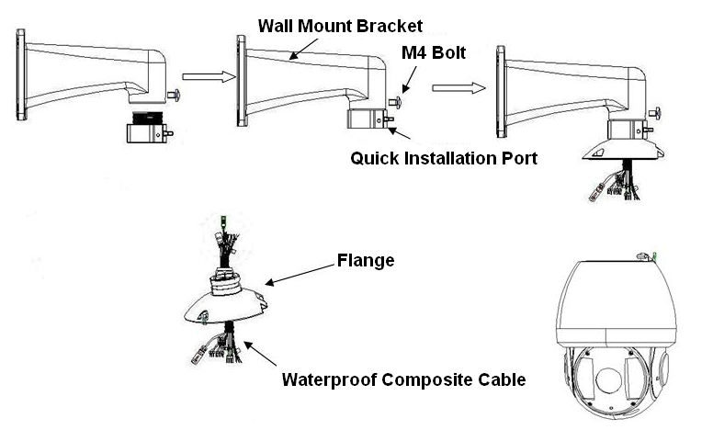

Figure 1-1

Buckle wall mount bracket installation
Please connect the flange to the speed dome device. Connect the cable port of the flange to the slot of the speed dome one by one (It includes power, video, RS485, network cable and alarm input/output. Please note you can connect the network cable or the alarm input/output if necessary.). After you connected the flange to the speed dome, please install it to the bracket. Use the three inner hex screws to secure. Finally connect the safety rope buckle to the quick installation port. See Figure 1-2.
For the corner mount installation or the pole mount installation, you can also refer to these contents.
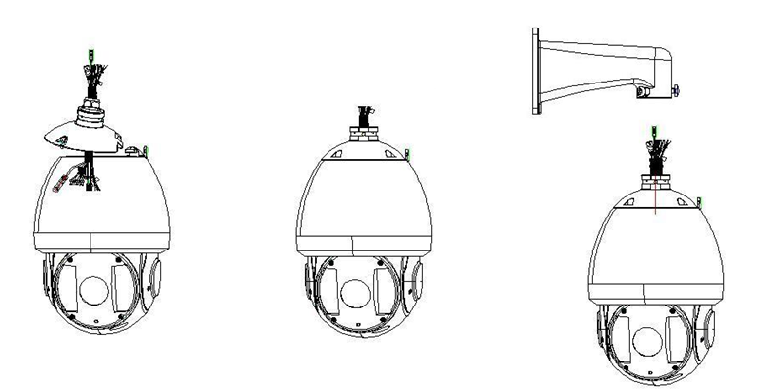
Figure 1-2

Address and Baud Rate Setup
Now you can set the IR speed dome address and baud rate. The IR speed dome interface is shown as below. See Figure 1-3. There are two dial switches: SW1 and SW2. Here you can set the communication protocol, baud rate, address, and etc. Please refer to chapter 1.4 for detailed information.
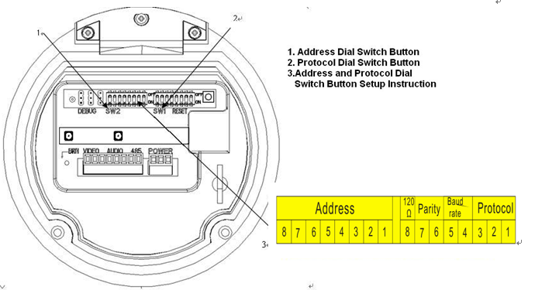
Figure 1-3

Install the IR speed dome and then connect the cable
Hang the IR speed dome device to the flange. Please insert the cable socket to the corresponding slots according to the indication label. See Figure 1-4
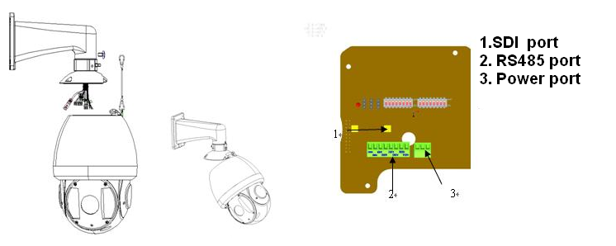
Figure 1-4

Secure the speed dome to the flange
Please check the rubber airproof ring of the speed dome adjacent to the flange is proper or not. Use the internal hex screwdriver to fix IR speed dome and the flange to complete the installation.
See Figure 1-5.
Important
Please make sure the airproof ring is firmly secured in the slot. Please make sure you have secured the inner hex screws firmly. Otherwise, it may result in low waterproof capability and speed dome malfunction.
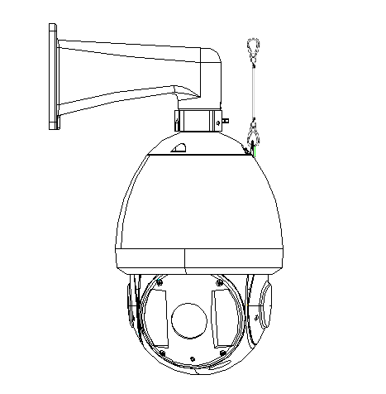
Figure 1-5

Dial Switch Setup
The two dial switches of the speed dome are SW1 and SW2. These are to specify the speed dome parameter such as protocol, baud rate, address and etc. When the button is ON, it is 1. In the SW1 and SW2, 1 is the lowest bit and the 8 is the highest bit. See Figure 1-6.
Please note this series speed dome cans automatically recognize the industrial protocol, PELCO-D. PELCO-P. Usually you do not need to set the protocol.
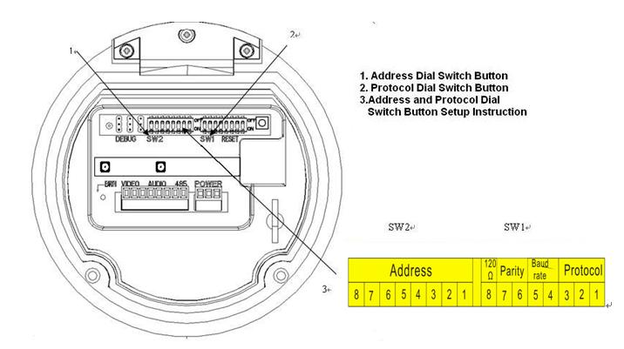
Figure 1-6

Communication protocol and Baud rate
Please refer to the protocol sheets for detailed information.
Protocol |  |  | Baud rate |  | Parity |  | 120Ω | Connect to the 120Ω
1 | 2 | 3 | 4 | 5 | 6 | 7 | 8 |  | ON

1 | 2 | 3 | Communication Protocol
OFF | OFF | OFF | Industrial protocol
ON | OFF | OFF | PELCO-D
OFF | ON | OFF | PELCO-P
X | X | X | Reserved

Please refer to the baud rate sheet for detailed information.

4 | 5 | Baud Rate
OFF | OFF | 9600bps
ON | OFF | 4800bps
OFF | ON | 2400bps
ON | ON | 1200bps
Please refer to the parity setup sheet for detailed information.
6 | 7 | Parity
OFF | OFF | NONE
ON | OFF | EVEN
OFF | ON | ODD
ON | ON | NONE

Address Setup
The speed dome address setup interface is shown as below. See Figure 1-7.
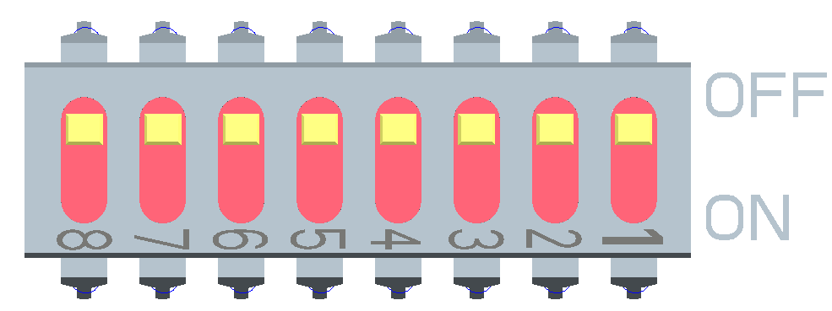
Figure 1-7
The encode mode adopts binary system. 1 to 8 is valid bit. The highest address bit is 255. You can refer to the following sheet for more information.
Address | 1 | 2 | 3 | 4 | 5 | 6 | 7 | 8
1 | OFF | OFF | OFF | OFF | OFF | OFF | OFF | OFF
1 | ON | OFF | OFF | OFF | OFF | OFF | OFF | OFF
2 | OFF | ON | OFF | OFF | OFF | OFF | OFF | OFF
3 | ON | ON | OFF | OFF | OFF | OFF | OFF | OFF
4 | OFF | OFF | ON | OFF | OFF | OFF | OFF | OFF
5 | ON | OFF | ON | OFF | OFF | OFF | OFF | OFF
6 | OFF | ON | ON | OFF | OFF | OFF | OFF | OFF
7 | ON | ON | ON | OFF | OFF | OFF | OFF | OFF
8 | OFF | OFF | OFF | ON | OFF | OFF | OFF | OFF
…… | …………………………………………………………………
254 | OFF | ON | ON | ON | ON | ON | ON | ON
255 | ON | ON | ON | ON | ON | ON | ON | ON

BRACKET DIMENSIONS

Wall Mount Bracket
The wall mount bracket dimensions are shown as below. See Figure 2-8.
Figure 2-8

Hanging Mount Bracket (Multiple Lengths)
The hanging mount bracket is shown as below. See Figure 2-9.
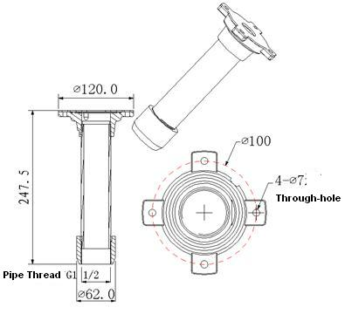
The bracket length setup values are：
- 200mm
- 300mm
- 500mm
You just need to replace the connection pole.
Figure 2-9

Corner Mount Bracket
The corner mount bracket is shown as below. See Figure 2-10.
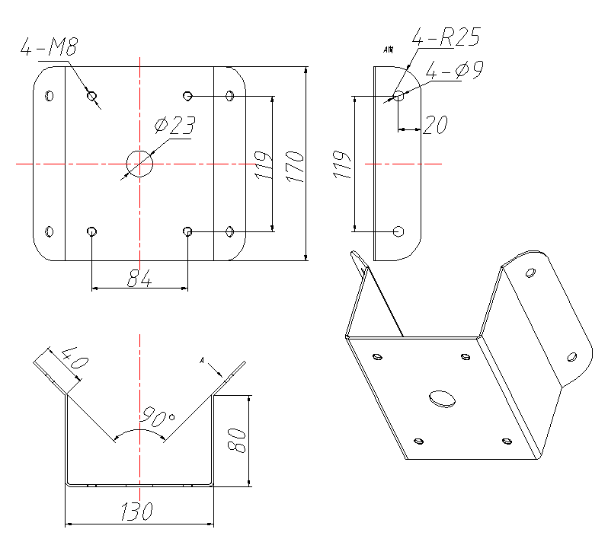
Figure 2-10

Pole Mount Bracket
The corner mount bracket is shown as below. See Figure 2-11.
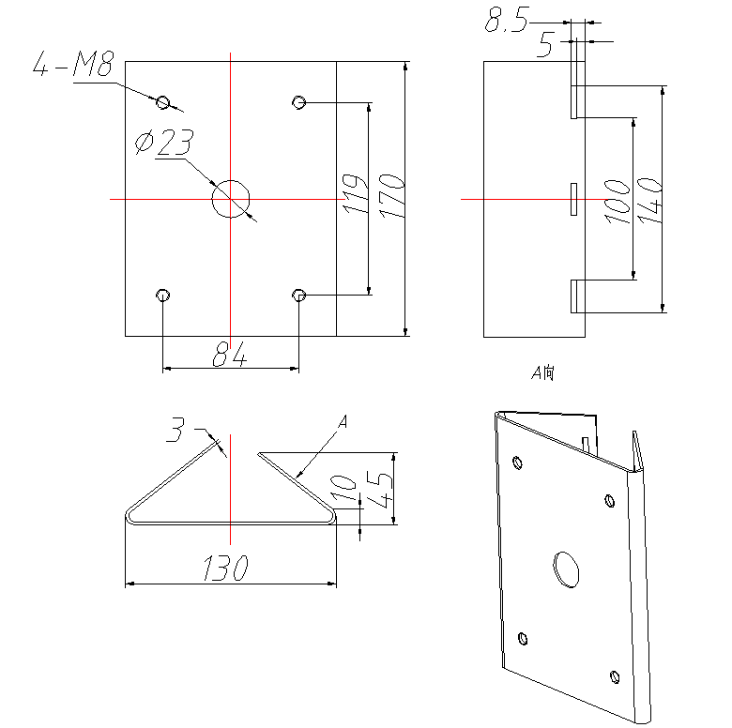
Figure 2-11

WALL MOUNT BRACKET INSTALLATION

Component Installation
Wall mount bracket and its components are shown as below. See Figure 3-12.
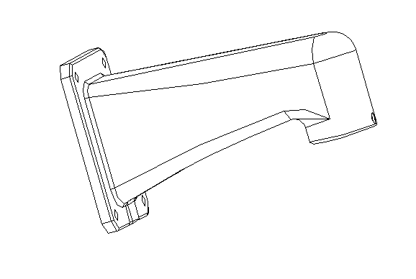
Figure 3-12

Installation

Installation Requirements
The wall mount speed dome can be installed in the hard construction wall in the indoor or outdoor environments. Before the installation, please make sure:
The wall is thick enough to install the expansion bolt.
The wall can at least sustain the 8x weight of the speed dome.

Installation Steps
Please draw four holes position in the wall according to the hole of the bottom of the wall mount bracket. Then you can dig four holes and insert the expansion bolts (not provided). Use four hex bolts and flat washer to fix the bracket in the expansion bolts. See Figure 3-13.
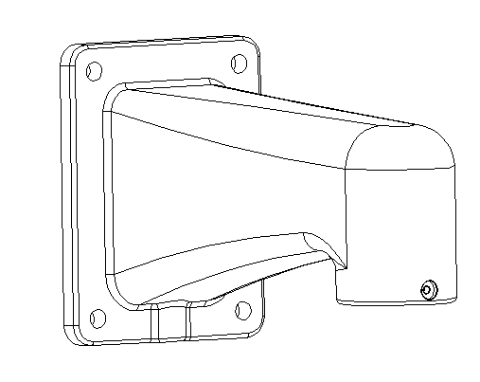
Installation Hole
Figure 3-13
Install the speed dome on the bracket. Finally connect the other end of the safety rope buckle to the quick installation port. See Figure 3-14.
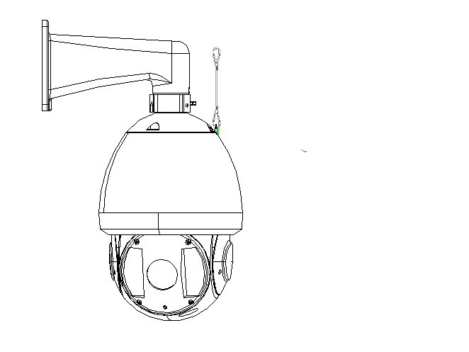
Figure 3-14
Please refer to chapter 1.3 for detailed installation information.

HANG MOUNT BRACKET INSTALLATION

Component Installation
Hang mount bracket and its components are shown as below. See Figure 4-15.
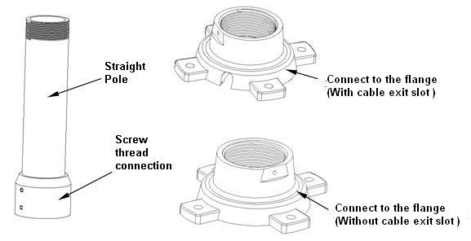
Figure 4-15

Installation

Installation Requirements
The hang mount speed dome can be installed in the hard construction wall in the indoor or outdoor environments. Before the installation, please make sure:
- The wall is thick enough to install the expansion bolt.
- The wall can at least sustain the 8x weight of the speed dome.

Installation Steps
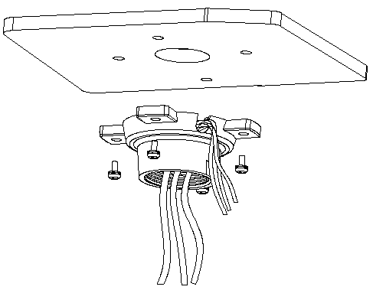
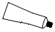
Loosen the M4 bolt in the flange side to separate the flange and steeve. Pull the integration cable through the airproof slot of the bottom of the flange and then connect to the centre hole of the flange. Please secure the flange in the ceiling. See Figure 4-17. Please note, if the speed dome is installed in the outdoor environments, you need to paste the silica gel on the surface of the flange and the surface and the cable exit.
Silica gel

Connect to flange

Figure 4-16
Figure 4-17
Pull the cable through the steeve and then secure the steeve to the flange. Fix the M4 bolt.
Please note, if the speed dome is installed in the outdoor environments, you need to paste enough Teflon tape at the top screw thread of the steeve and then turn the steeve to the flange firmly. Please paste the silica gel on the steeve connection surface to do the waterproof work. See Figure 4-18.
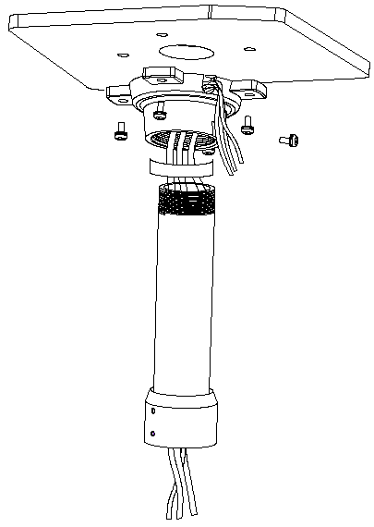
Teflon tape
M4 bolt
Silica gel

Figure 4-18
Please draw four holes position in the wall according to the hole of the bottom of the wall mount bracket. Then you can dig four holes and insert the expansion bolts (not provided). Use four hex but and flat washer to fix the bracket in the expansion bolts.
Install the speed dome on the bracket and connect the other end of the safety rope to the quick installation port. See Figure 4-19.
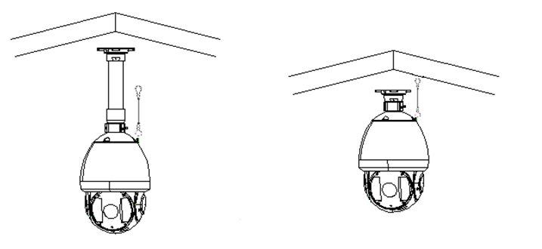
Long pole Without pole

Figure 4-19
Please refer to chapter 1.3 for detailed installation information.

CORNER MOUNT BRACKET INSTALLATION

Component Installation
Corner mount bracket and its components are shown as below. See Figure 5-20.
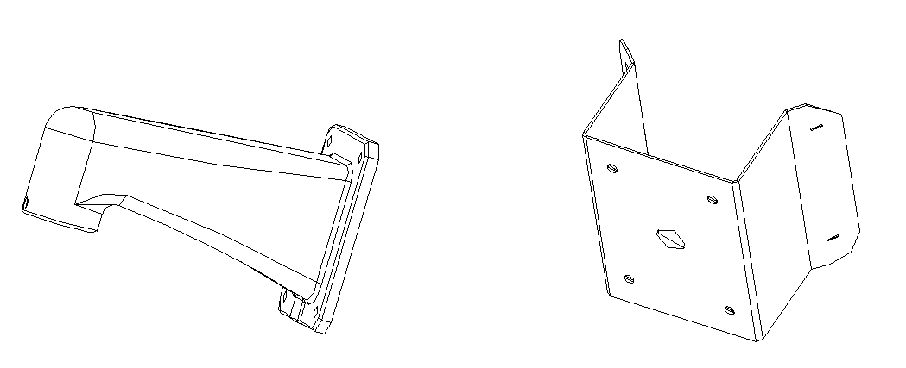
Figure 5-20

Installation

Installation Requirements
The corner mount speed dome can be installed in the hard construction in the indoor or outdoor environments where there is a 90 degrees angle. Before the installation, please make sure:
- The wall is thick enough to install the expansion bolt.
- The wall can at least sustain the 8x weight of the speed dome.

Installation Steps
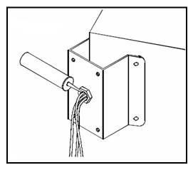
Please draw four holes position in the wall according to the holes of the corner installation accessories. See Figure 5-21.

Installation hole

Figure 5-21
Then you can dig four holes and insert the M8 expansion bolts. Pull the power cable, video/control cable and the alarm cable through the centre hole of the bottom of the corner bracket, the waterproof adhesive, and the centre of the bracket. Please reserve the enough cable connection length and then use the M8 expansion bolt to secure the corer mount bracket chassis on the wall.
Install the speed dome on the bracket and connect the other end of the safety rope to the quick installation port. See Figure 5-22.
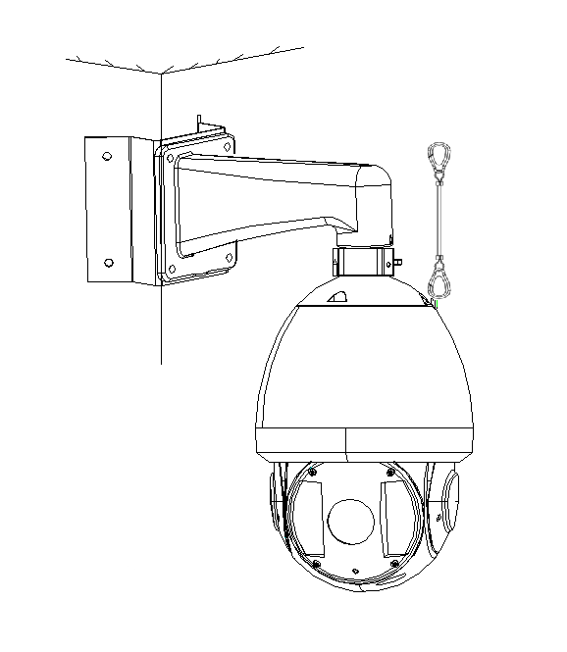
Figure 5-22
Please refer to chapter 1.3 for detailed installation information.

POLE MOUNT BRACKET INSTALLATION
Pole mount bracket and its components are shown as below. See Figure 6-23.
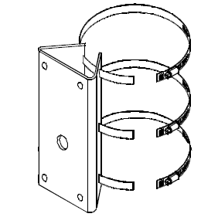
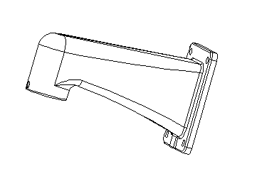
Figure 6-23

Installation

Installation Requirements
The corner mount speed dome can be installed in the hard construction wall in the indoor or outdoor environments.
Before the installation, please make sure the pole bracket can sustain the 8X weight of the speed dome.
The diameter of the pole structure shall comply with the installation dimension of the clamp. Default factory clamp is six inches for the column of φ130-152mm. It can work with the pole installation bracket. You can adjust the diameter and the value (clamp specification) is : φ59-82mm、φ84-108mm、φ103-127mm, φ130-152mm、φ155-178mm、φ180-203mm,φ194-216mm.
The clamp is shown as in Figure 6-24.

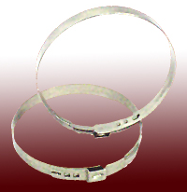

Figure 6-24
For special dimensions, please contact us for more information.

Please refer to Figure 6-25 to install clamp and pole bracket.
Pull the cable out of the pole accessories and then use clamp to fix the pole accessories to the pole. Finally, you can use glass cement to the output hole to secure waterproof.
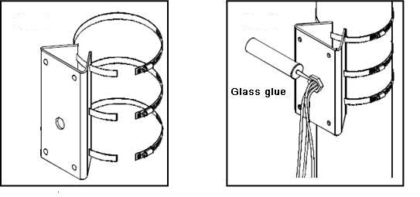

Clamp and pole bracket connection Pole bracket and the pole connection
Figure 6-25
After you installed bracket and external cover, loosen the captive screws and open the panel, pull the power cable through the hanging bracket and then fix the hanging bracket to the wall. Please pay attention to the waterproof between the bracket and the wall.
Install the speed dome on the bracket and connect the other end of the safety rope to the quick installation port. See Figure 6-26.
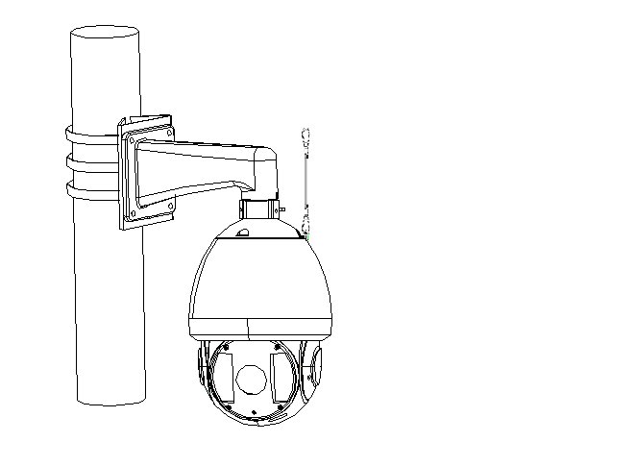
Figure 6-26
Please refer to chapter 1.3 for detailed installation information.

APPENDIX Ⅰ THUNDER PROOF AND SURGE PROTECTION
This series speed dome adopts TVS lighting protection technology. It can effectively prevent damages from various pulse signals below 1500W, such as sudden lighting and surge. While maintaining your local electrical safety code, you still need to take necessary precaution measures when installing the speed dome in the outdoor environment.

- The distance between the signal transmission cable and high-voltage device (or high-voltage cable) shall be at least 50 meters.
- Outdoor cable layout shall go under the penthouse if possible.
- For vast land, please use sealing steel tube under the land to implement cable layout and connects one point to the earth. Open floor cable layout is forbidden.
- In area of strong thunderstorm hit or near high sensitive voltage (such as near high-voltage transformer substation), you need to install additional high-power thunder protection device or lightning rod.
- The thunder protection and earth of the outdoor device and cable shall be considered in the building whole thunder protection and conform to your local national or industry standard.
- System shall adopt equal-potential wiring. The earth device shall meet anti-jamming and at the same time conforms to your local electrical safety code. The earth device shall not short circuit to N (neutral) line of high voltage power grid or mixed with other wires. When connect the system to the earth alone, the earth resistance shall not be more than 4Ω and earth cable cross-sectional area shall below 25 mm2. See Figure 7-1.
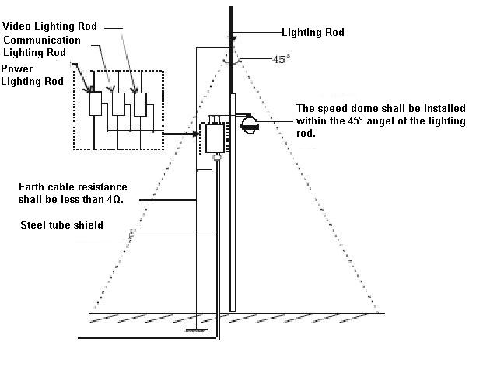
Figure 7-1

APPENDIX Ⅱ ABOUT RS485 BUS

RS485 Bus Main Feature
RS485 is semi duplex communication cable of impedance 120Ω. Its max load amount is 32 effective loads (including main control device and devices to be charged).

RS485 Bus Transmission Distance
When we take 0.56mm (24AWG) twisted-pair as communication cable, the max transmission distance (theoretically) are listed below (according to different baud rates).
Baud Rate | Max Distance
2400 BPS | 1800M
4800 BPS | 1200M
9600 BPS | 800M

In the following situations, the max transmission distance shall become shorter accordingly:
- The communication cable is a little bit thin;
- The surrounding environment has strong electromagnetic interference;
- There are too much devices connected to the RS485 bus;
And vice versa, the max transmission distance shall become longer.

The Problem in Practical Use
In practical usage, we usually adopt star type connection. The terminal resistance shall connect to the furthest two devices (Such as device 1# and device 15# in Figure 8-2 ). But this connection way does not conform to RS485 Bus standard. When the distances between devices are too long, the signal reflection occurs and anti-jamming decreases, thus the signal reliability becomes very low. You can see speed dome is not under control or speed dome is running automatically and can not stop.

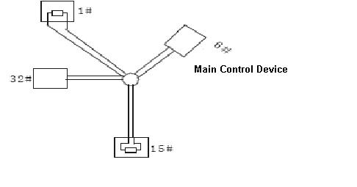
Figure 8-2
In this situation, we recommend RS485 distributor. This device can turn star type connection into the connection that conforms to RS485 bus industry standard, which can avoid the above mentioned problems and enhance communication reliability. See Figure 8-3.
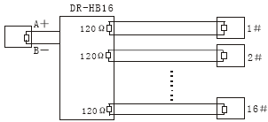
Figure 8-3

RS485 Bus FAQ
Phenomenon | Possible Reasons | Solution
Speed dome can run self-diagnosis but I can not control it. | - Host address(baud rate) and speed dome address(baud rate) are not match;  - Positive and negative end of RS485 Bus are misconnected;  - Connection cable is loose；  - RS485 Bus connection are cut off; | - Modify host or speed dome setup ；  - Switch RS485 positive end and negative end；  - Fix connection cable firmly；  - Replace RS485 Bus.
I can control the speed dome but is not smooth | - RS485 Bus connection are not good；  - One RS485 bus is off；  - The distance between host and speed dome is too far；  - Parallel connected too much speed domes. | - Connect RS 485 Bus again；  - Replace RS485 Bus；  - Add terminal matching resistance；  - Add RS485 distributor.

Appendix Ⅲ SAFETY ROPE INSTALLATION
Please secure one end of the safety rope on the preforming. See Figure 9-4.
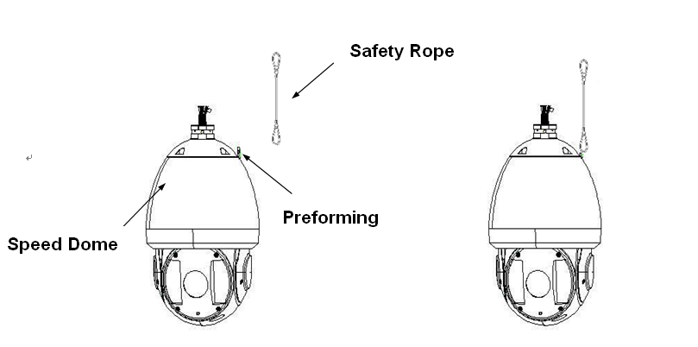
Figure 9-4

Note
- This manual is for reference only. Slight difference may be found in the user interface.
- All the designs and software here are subject to change without prior written notice.
- All trademarks and registered trademarks are the properties of their respective owners.
- If there is any uncertainty or controversy, please refer to the final explanation of us.
- Please visit our website or contact your local service engineer for more information.

