1.3Megapixel HD Cube Network Camera

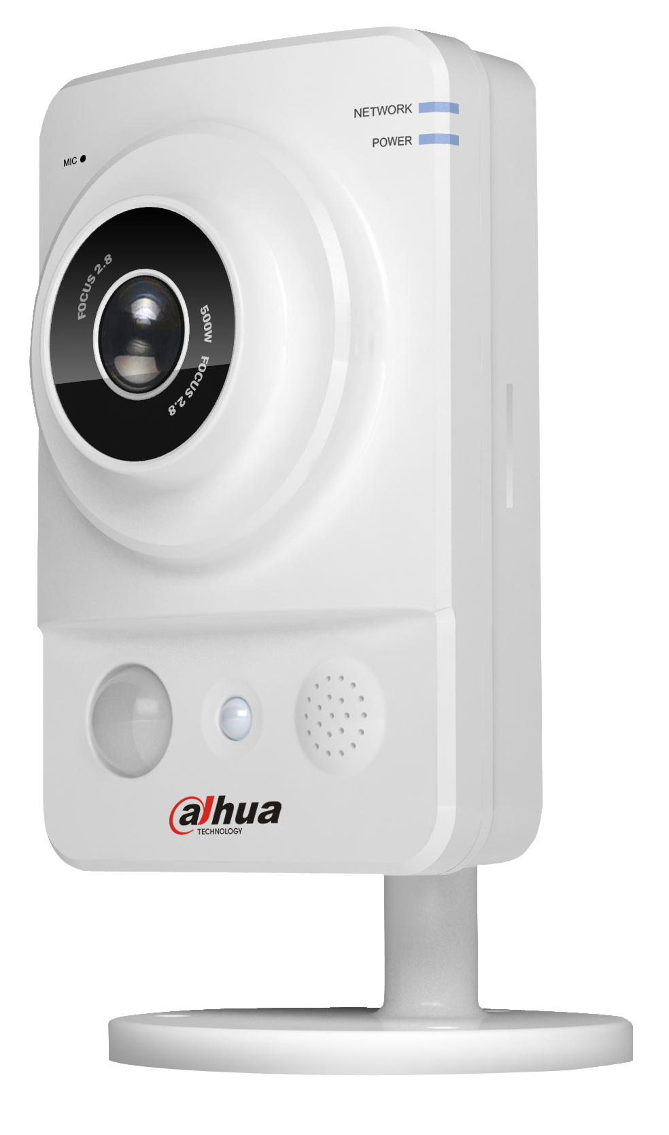

Features
- 1/3” 1.3Megapixel Aptina CMOS
- H.264 & MJPEG dual-stream encoding
- Max 15fps@1.3M (1280×960)/25/30fps@720P(1280×720)
- DWDR, Day/Night, 2DNR, Auto iris, AWB, AGC, BLC
- Multiple network monitoring: Web viewer, CMS(DSS/PSS) & DMSS
- 3.6mm fixed lens
- White LEDs length 10m
- PIR sensor range 6m
- Micro SD memory (K100A&K100W only), PoE (K100&K100A only), Wi-Fi (K100W only)
Technical Specifications
Model |  | DH-IPC-K100 | DH-IPC-K100A | DH-IPC-K100W
Camera
Image Sensor |  | 1/3” 1.3Megapixel progressive scan CMOS
Effective Pixels |  | 1280(H)x960(V)
Scanning System |  | Progressive
Electronic Shutter Speed |  | Auto/Manual 1/3(4)~1/10000
Min. Illumination |  | 0.01lux/F1.8(color),
S/N Ratio |  | >50dB
Video Output |  | N/A
Camera Features
Max. LEDs Length |  | 10m
Day/Night |  | Auto(Electronic) / Color / B/W
Backlight Compensation |  | BLC / HLC / DWDR
White Balance |  | Auto/Manual
Gain Control |  | Auto/Manual
Noise Reduction |  | 2D
Privacy Masking |  | Up to 4 areas
Lens
Focal Length |  | 3.6mm
Max Aperture |  | F1.8
Focus Control |  | N/A
Angle of View |  | 70°
Lens Type |  | Fixed Lens
Mount Type |  | Board-in Type
Video
Compression |  | H.264/MJPEG
Resolution |  | 1.3M(1280x960)/720P(1280x720)/D1/CIF
Frame Rate | Main Stream | 1.3M(1~15fps)/720P/D1(1~25/30fps)
Frame Rate | Sub Stream | D1/CIF(1 ~ 25/30fps)
Bit Rate |  | H.264: 32K ~ 8096Kbps
Audio
Compression |  | N/A | G.711a / G.711u / PCM
Interface |  | N/A | Built-in Mic, Built-in speaker
Network
Ethernet |  | RJ-45 (10/100Base-T)
Wi-Fi |  | N/A |  |  | Wi-Fi(802.11b/g)
Protocol |  | IPv4/IPv6, HTTP, SSL, TCP/IP, UDP, UPnP, ICMP, IGMP, SNMP, RTSP, RTP, SMTP, NTP, DHCP, DNS, PPPOE, DDNS, FTP, IP Filter, QoS, Bonjour
ONVIF |  | ONVIF Profile S
Max. User Access |  | 10 users
Smart Phone |  | iPhone, iPad, Android, Windows Phone
Auxiliary Interface
Memory Slot |  | N/A | Micro SD, Max 64GB |  | N/A
RS485 |  | N/A
Alarm |  | N/A | 1/1 channel In/Out
PIR Sensor Range |  | Up to 6m
General
Power Supply |  | DC12V,PoE(802.3af) |  |  | DC12V
Power Consumption |  | <2.6W | <3.4W |  | <6.2W
Working Environment |  | -10°C~+50°C, 10%~90%
Ingress Protection |  | N/A
Vandal Resistance |  | N/A
Dimensions(W×D×H) |  | 66.6mm×99.5mm×131.2mm
Weight |  | 0.35kg (0.4kg with bracket)
Dimensions (mm)
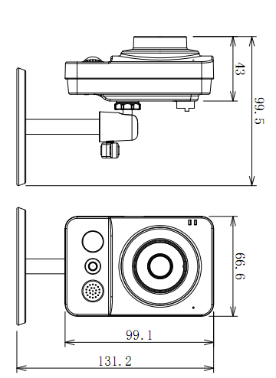

Dahua Technology Co., Ltd.
1187 BinAn Road, Binjiang District, Hangzhou, China
Tel: +86-571-87688883
Fax: +86-571-87688815
Email:overseas@dahuatech.com
www.dahuatech.com
*Design and specifications are subject to change without notice.
© 2013 Dahua Technology Co., Ltd.

