CCIPTV Live Server User Guide

TABLE OF CONTENTS

DOWNLOAD & INSTALLATION
- RUN CCIPTV LIVE SERVER PROFESSIONAL
- RUN CCIPTV PUSH
- PLAY PROGRAM WITH CCIPTV PLAYER (CCIPTV Live
PodCaster OR PLUGIN)

HARDWARE CONFIGURATION AND FEATURES

I. Download and Installation

1. Note:
The installation consists of following 3 parts:
a) CCIPTV Push
b) CCIPTV Live Server Professional Edition
c) CCIPTV Player (CCIPTV Live PodCaster and CCIPTVWebCtrl Plug-in)

CCIPTV Push
CCIPTV Live Server Professional
CCIPTV Player (CCIPTV Live PodCaster)

Install the above-mentioned 3 parts on 3 different machines respectively.
Hereinto,
->CCIPTV Push should be installed on Intel Pentium 4 computer or above.
->CCIPTV Live Server (Professional Edition) needs to run on server.
->CCIPTV Player (CCIPTV Live PodCaster or cciptvWebCtrl Plug-in) runs on client terminal.

2. Installation:
Step 1: Install CCIPTV Push in advance
Double click .EXE file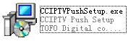, then follow the following illustration and click the red-marked buttons respectively.
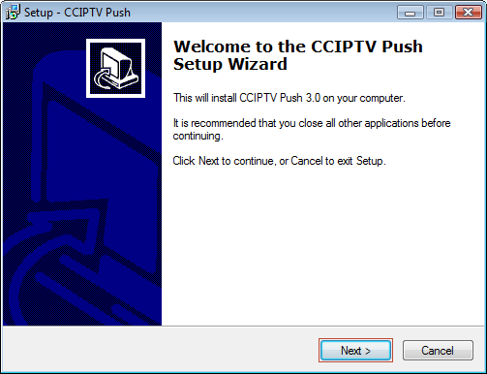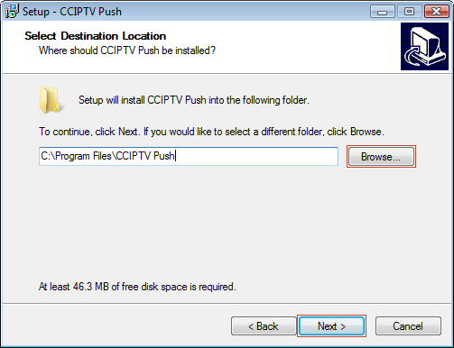
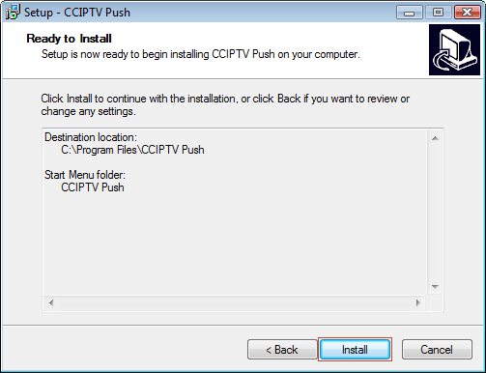
If the above screen appears, the installation finished (sometimes a warning will show to prompt restart the computer.)
Step 2: Follow the same step; install CCIPTV Live Server Professional and CCIPTV Player (that is CCIPTV Live Podcaster or cciptvWebCtrl plug-in) on 2 different computers respectively.

II. Run CCIPTV Live Server Professional
Operations on the computer installed CCIPTV Live Server Professional.

1. Start your computer, click Start -> All Programs, run CCIPTV Live Server Professional
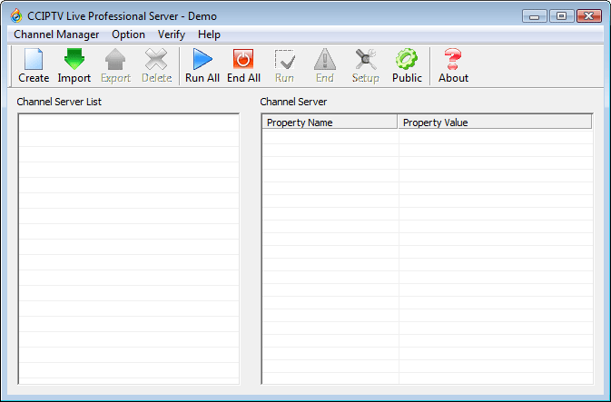

2. Create a new channel:
Step 1: Click New, create a new channel (see following illustration).
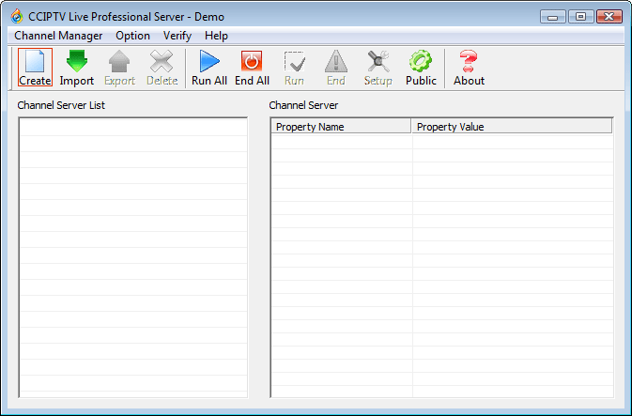
Step 2: Rename the new created channel (see following illustration).
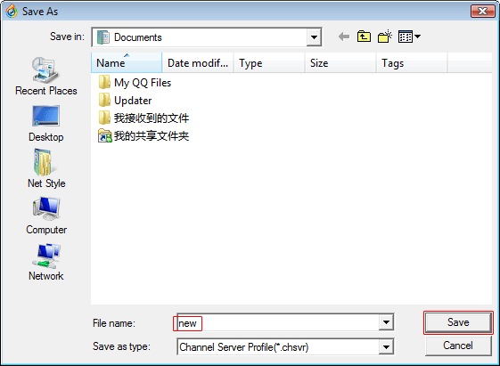

Step 3: Channel setup.
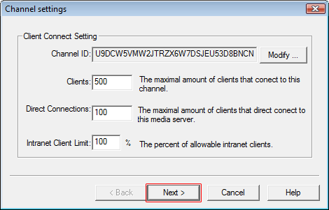
Note: Leave the default settings.
Explanation: the Maximum Direct Connections cannot exceed the maximum loads of server bandwidth. If it exceeds this limit, the performance of the software will be debated. And the sum of direct connections built between multiple channels cannot exceed the maximum loads of server bandwidth, either.

Step 4: Client setup.
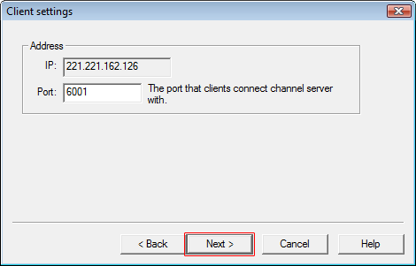
Note: This is the IP address and the port when client accesses. Use defaults.
Explanation: IP is the IP of the server. Port is the port that accessed on client.

Step 5: Push setup.
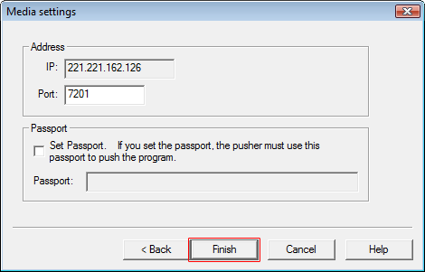
Note: This is the entrance of CCIPTV Push. Use defaults.
Explanation: IP is the IP address of the server. Port is the push port of CCIPTV Push.

Step 6: Channel created successfully; start channel server.
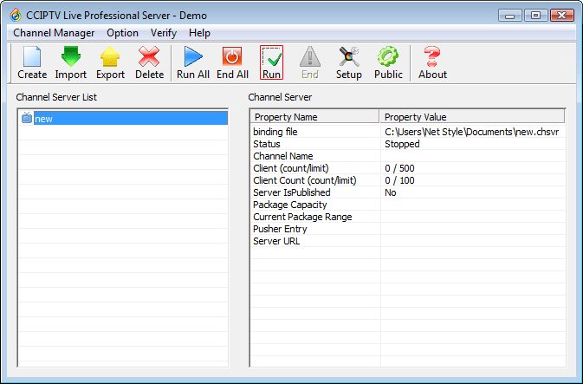
Note: Double click the channel icon, or click Start button, to start channel server.
Explanation: The channel server started. Wait CCIPTV Push to capture signal and push. If you want to set the related parameters again, please stop the channel, and click Set button (see following illustration.)

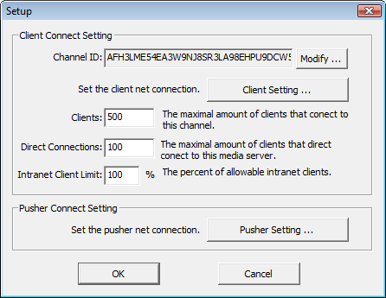

Notes about creating Public Channel and Private Channel:
- How can I create Public Channel?
Step 1: Select Public Setting button.
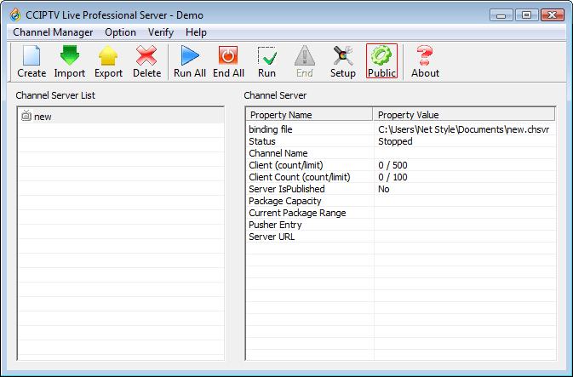
Step 2: Fill the IP of the server and the port. It’s filled default.
Note: Station Server is independent software, and can be downloaded from cciptv.com.
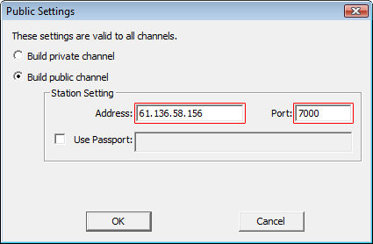
- Public Channel will be created default.
When you create a Public Channel, the program list of this channel will be published to Station Server; other users can search the published program list of this channel by CCIPTV Live PodCaster, and view these programs free.
- How to create Private Channel?
When Private Channel created, the channel list will not be published to Station Server; users can only view the programs from the applied URL. It meets the needs of publishing program individually or building charging channel.
Following is the method:
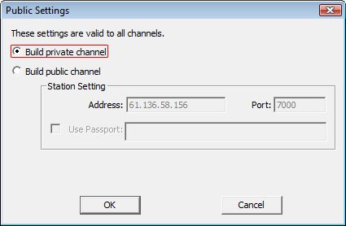

III. Run CCIPTV Push
Operations on computer installed CCIPTV Push.

1. Start CCIPTV Push: click Start -> All Programs to run CCIPTV Push

2. Push programs
There are two ways to push programs: a) push local files, and b) push the program that are captured by devices.

- The steps of push local files as follows:

Step 1: Properties set
Click Properties Set icon
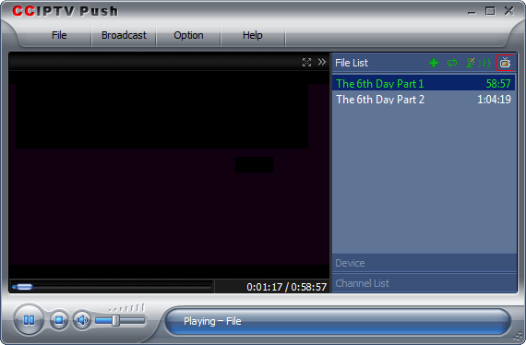

The following picture will appear:
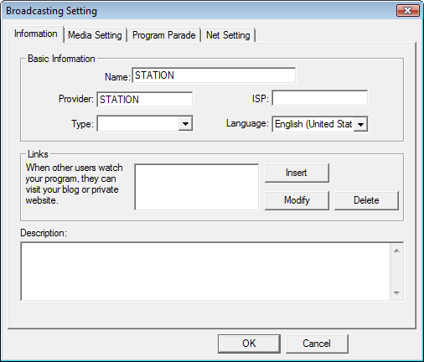
Note: These are accessorial information; please leave default.

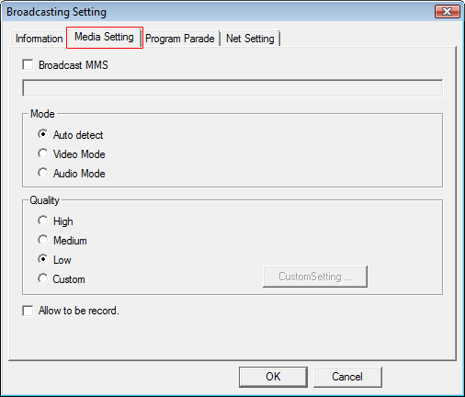
Note: Use default.
Explanation: Broadcast Quality is the options of data rate. The default Middle Quality is 320X240 300K. You can use Custom.
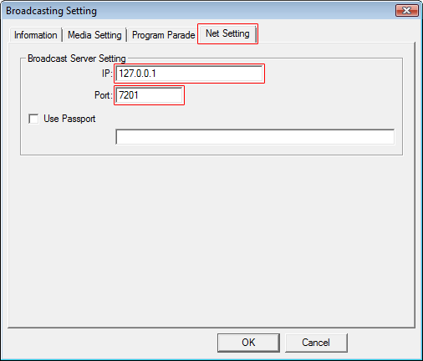
Note: Channel Serve IP is the IP address of the computer installed CCIPTV Live Server Professional.
Port is the port of Push Setup when you install CCIPTV Live Server Professional. Please see the following illustration.
Special Remark: If only CCIPTV Push and CCIPTV Live Server have identical IP address and port, the server can play its role (without validation code set.)

Step 2: Add files.
Click Add Files icon.
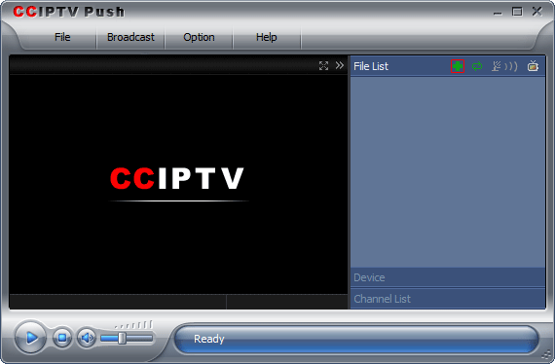
Following windows popped up, select files need to push and open (you can select multiply)
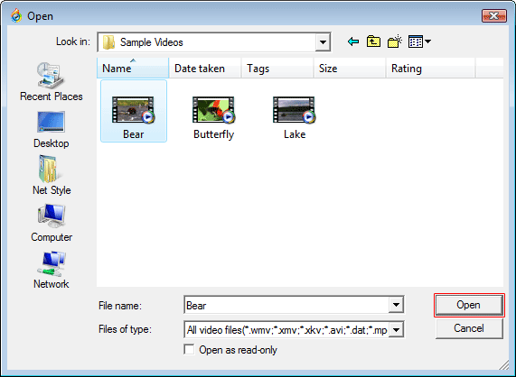

Step 3: Start to push.
Click Start Broadcast icon, push finished.

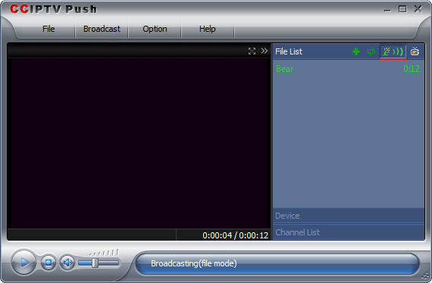

b) Push program using capturing devices
Click following Capturing Device, switch to capturing device window to choose capturing devices (support TV card, compression card, capturing card, CCD, and microphone.) Follow help information takes mounting TV card in computer as an example (same as other devices).
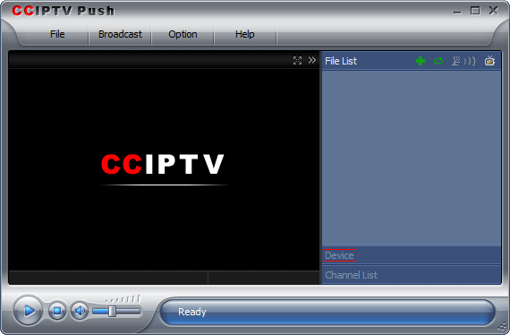
Step 1: Set the properties of capturing devices.
1. Select corresponding audio/video devices in Capturing Device window.
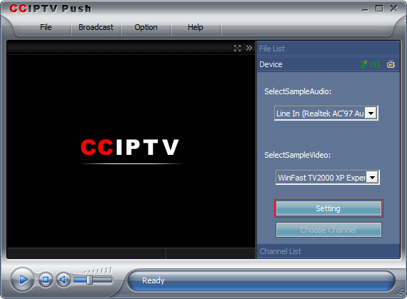

2. Click Set button. According to your needs, set Video Decoder, Video Proc Amp, and Data Rate Format respectively (the system has set the hardware device to default, usually you need not to set them here).
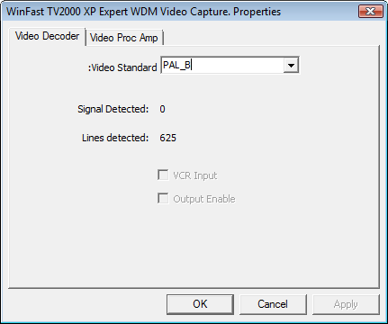

Step 2: Click buttons Preview, Select Channel in turn to select channels. See following illustration.
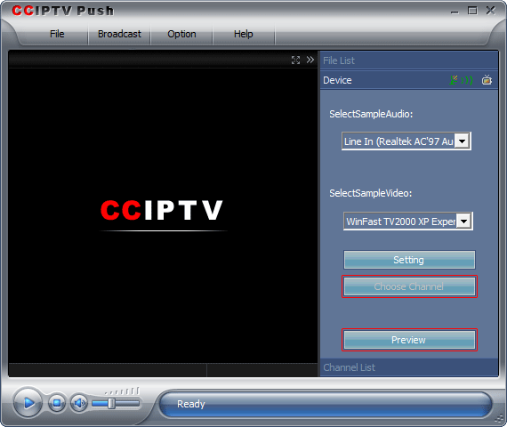

Step 4: Click Stop button to stop preview.
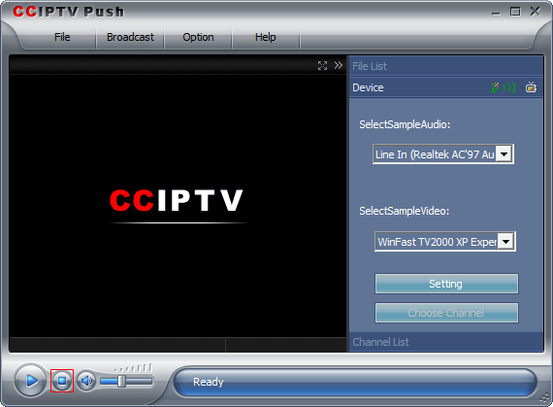
Step 5: Set properties (see above)
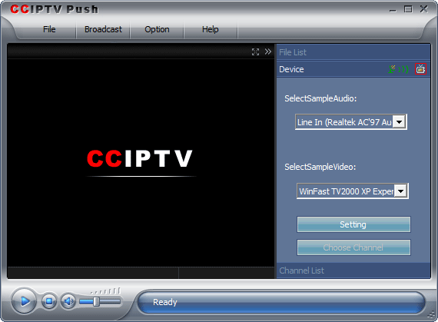

Step 6: Start to push
Click Start Broadcast, push finished.
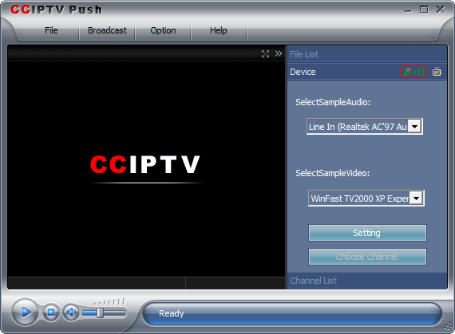

IV. Play Program With CCIPTV Player (CCIPTV Live PodCaster or Plug-in)
Operations on computer install CCIPTV Live PodCaster or Plug-in.

a) Play with CCIPTV Live PodCaster (when Public Channel created)
1. Click Start -> All Programs to run CCIPTV Live Podcaster
Step 1: Search channel
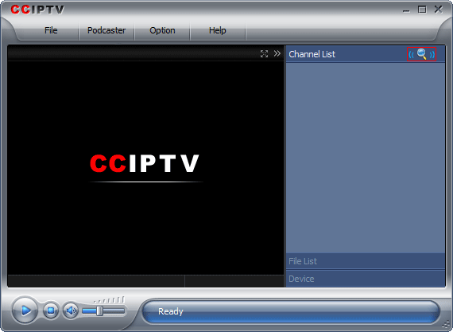
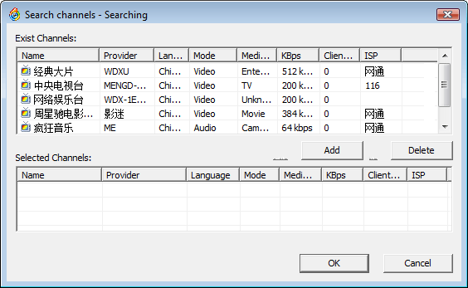
Step 2: Access programs
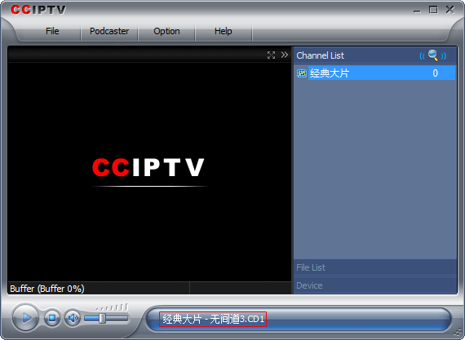
b) Play with IE Plug-in
Step 1: Generate code from CCIPTV Live Server
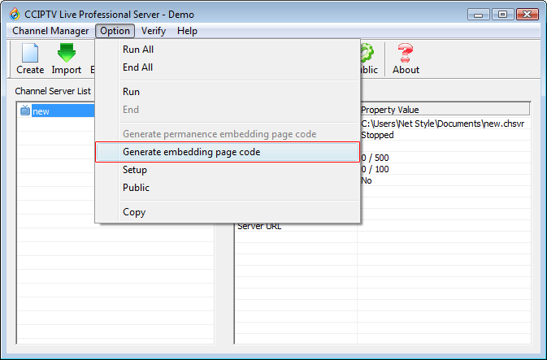
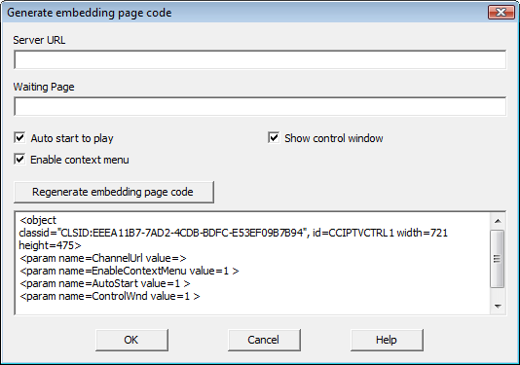
Step 2: Write HTML files (following is a example of source code)

<html>
<tr>
<td>
Prompt: If you cannot view program, please download and install play engine
<a href="http://cnc1.cciptv.com/NetTV/cciptvwebctrl.exe">Download Now</a>
<td>
<tr>
<br>
<br>
<object
classid="CLSID:EEEA11B7-7AD2-4CDB-BDFC-E53EF09B7B94", id=CCIPTVCTRL1 width=721 height=475>
<param name=ChannelUrl value=cciptv://live/SXVNRYMU7DSHCT9D28ABSV2VLH3SU5H6S3ZHLDA>
<param name=EnableContextMenu value=1 >
<param name=AutoStart value=1 >
<param name=ControlWnd value=1 >
</object>
</html>
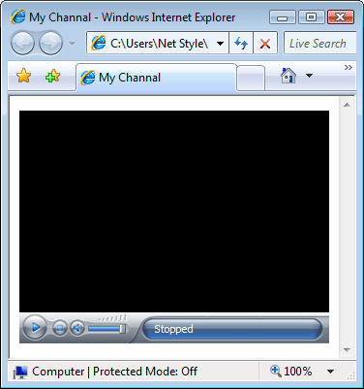

V. Hardware Configuration and Features

A Reference of CCIPTV Live Server:
Lowest hardware configuration:
CPU: P4 2.4G or above
RAM: 1Gb or above
Hard Disk Drive: SCSI 36G or above
Ethernet Card: 100/1000
Performance
Average Malfunction Free Time: more than 1 month
Average Media Data Rate: 100 - 2048Kb/S
Maximum Supporting Channel: unlimited
Program Delay Time: 3-5 minutes
Response Time of Data Stream Control: less than 25 seconds

Network Environment
Every server needs bandwidth of at least 10MB

Performance
Average Malfunction Free Time: more than 1 month
Every server shares 100MB bandwidth exclusively to provide 350 external independent direct connections. After the distribution of P2P, it can serve more than 10,000 users.

A Reference of CCIPTV Push:
Lowest Hardware Configuration:
CPU: P4 2.8G or above
RAM: 512M or above
Sound Card: any compatible
Ethernet Card: 10MB/100MB
Video Capturing Device: (Capturing Card: osprey series), (TV Card). Note: Optional, if play files only, this device is unnecessary.
Network Environment
512K ADSL or above
Performance
Maximum Bandwidth Usage: 95%
Average Malfunction Free Time: more than 1 month
Average Media Data Rate: 100 - 2048Kb/S
Maximum Capturing Channel: 1 channel/set (video), more than 10 channels/set (audio)
Program Delay Time: less than 300 seconds
Response Time of Data Stream Control: less than 5 seconds

Configuration of CCIPTV Client:
CPU: P3 2.8G or above
RAM: 256M or above
Sound Card: any compatible
Ethernet Card: 10/100
Operating System: WIN 2000, WIN XP, and WIN 2003
Broadband: ADSL 512K or above broadband environment

